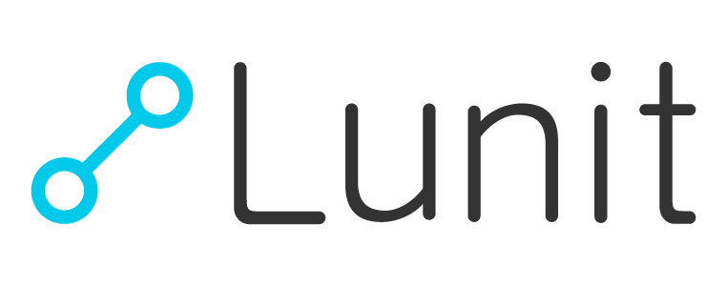
Media Contact:
Jussarang Lee
Communications Manager
julee@lunit.io

About us

Lunit is a medical AI software company devoted to developing advanced medical image analytics and data-driven imaging biomarkers via cutting-edge deep learning technology.
Founded in 2013, Lunit has been internationally acknowledged for its advanced, state-of-the-art technology and its application in medical images. It has been named by CB Insights as one of “AI 100” startups transforming healthcare industry.
Lunit’s mission is to empower physicians with clinically actionable insights that foster accurate and cost-efficient diagnosis and treatment through unprecedented AI-powered imaging biomarkers with cutting-edge, world-leading accuracy.

Perfecting Intelligence, Transforming Medicine

With the recent breakthrough in machine learning and large-scale digital medical data in hospitals, the world of medicine is entering into a new era of data-driven medicine.
Despite the advance, currently, 28% of lung cancer and 32% of breast cancer cases are left unidentified and misdiagnosed. A high portion of the medical cost is also gone wasted, with 95% of mammography being false positive and 50% of diagnostic tests are considered unnecessary.
We want to change that. We believe that improving diagnostic accuracy and reducing medical costs is key in providing quality care for patients. We are confident that our products can provide not just “improved,” but “the best” accuracy and efficiency possible.
With our cutting-edge deep learning technology and vast quality medical data, we discover, design, and develop powerful data-driven imaging biomarkers.

We envision a near future when our solutions become widely implemented in the clinical process around the world,
bringing an unprecedented level of accuracy and increased efficiency in diagnosis and treatment.
Through our state-of-the-art deep learning technology trained with a vast amount of carefully curated, quality medical data, we would like to become a leader and pioneer in transforming medicine into the next level.
We strive to prioritize the performance level of our technology and products, under our corporate vision, “Perfecting Intelligence, Transforming Medicine”.

Proprietary Deep Learning Technology
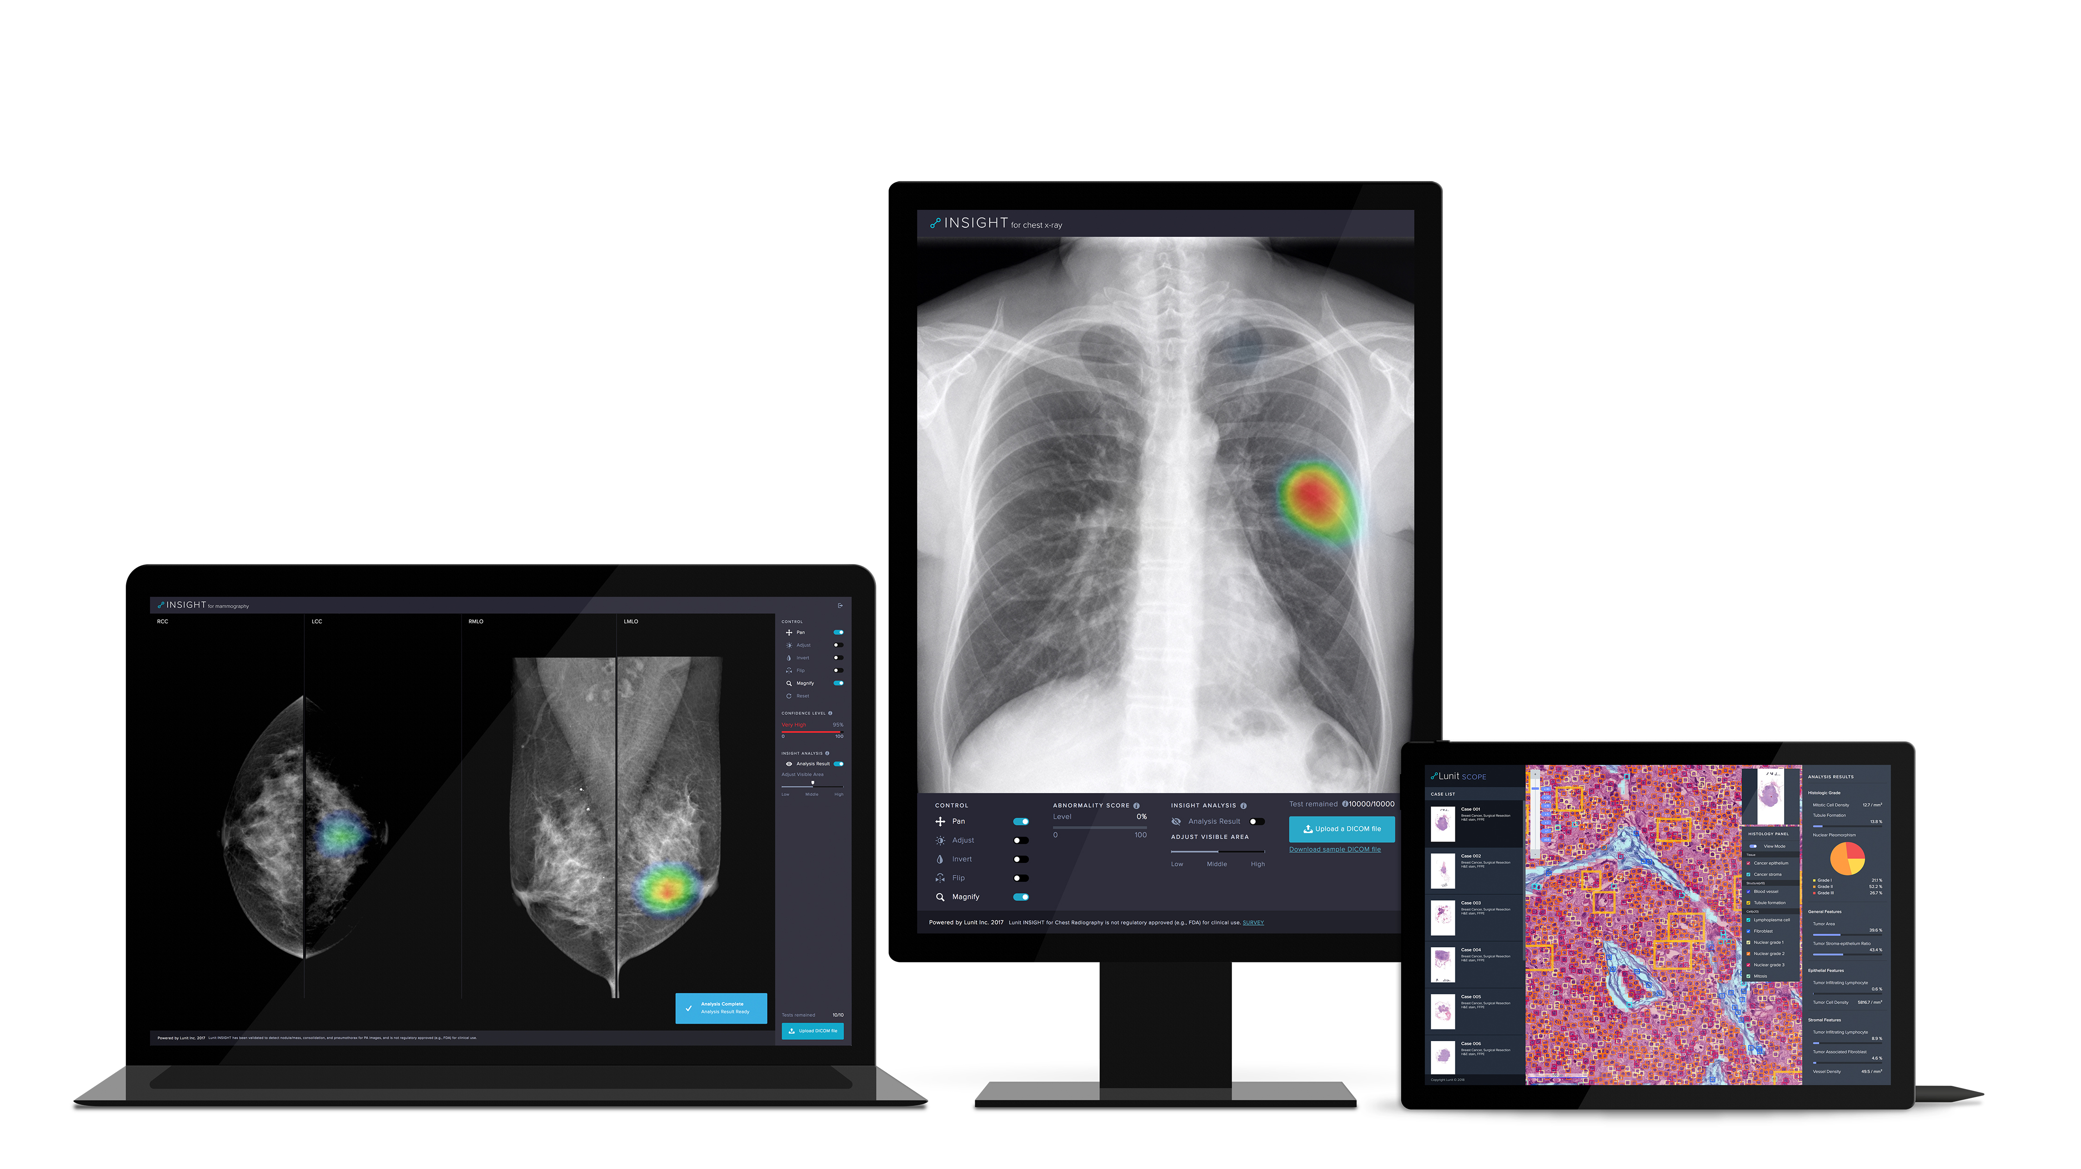
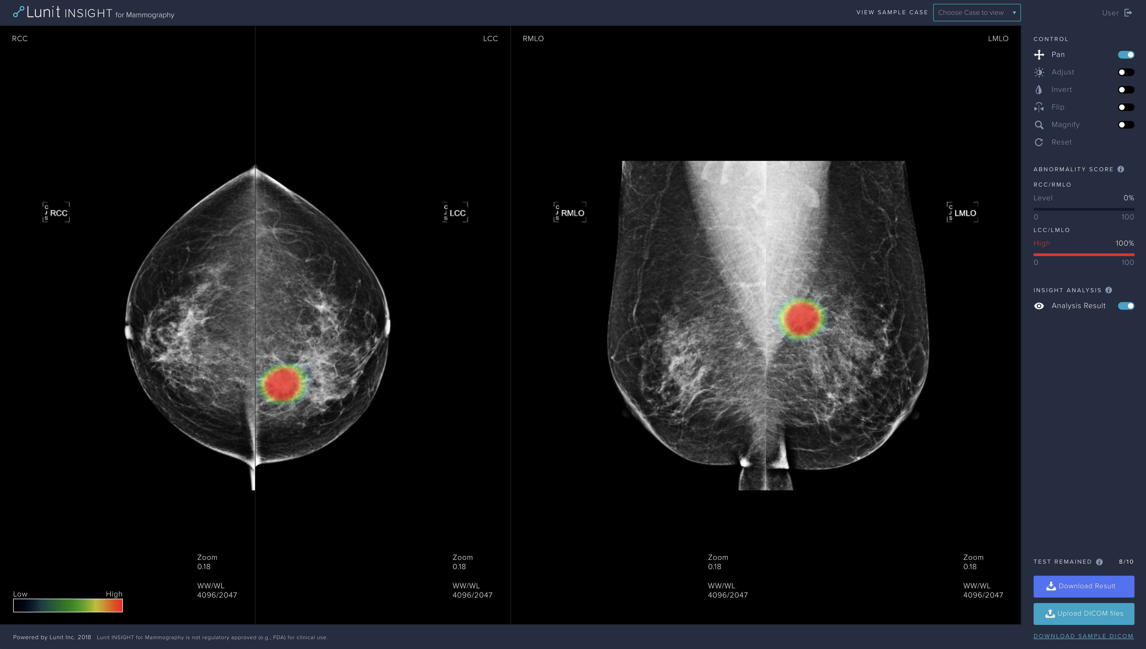
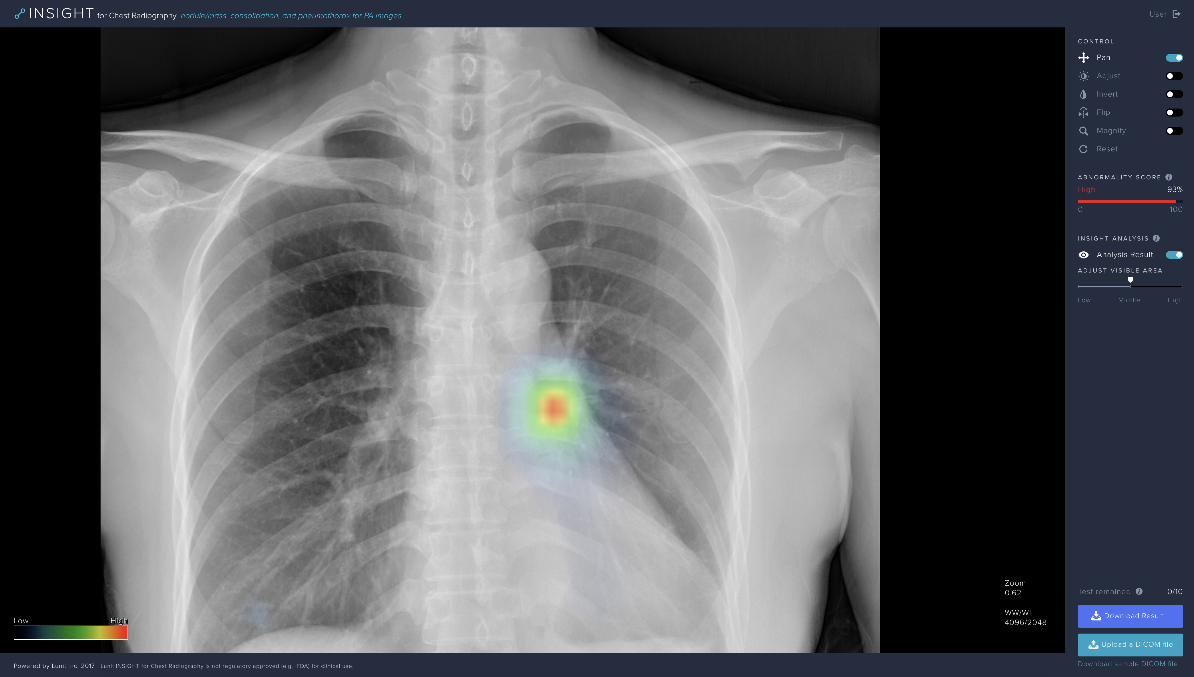
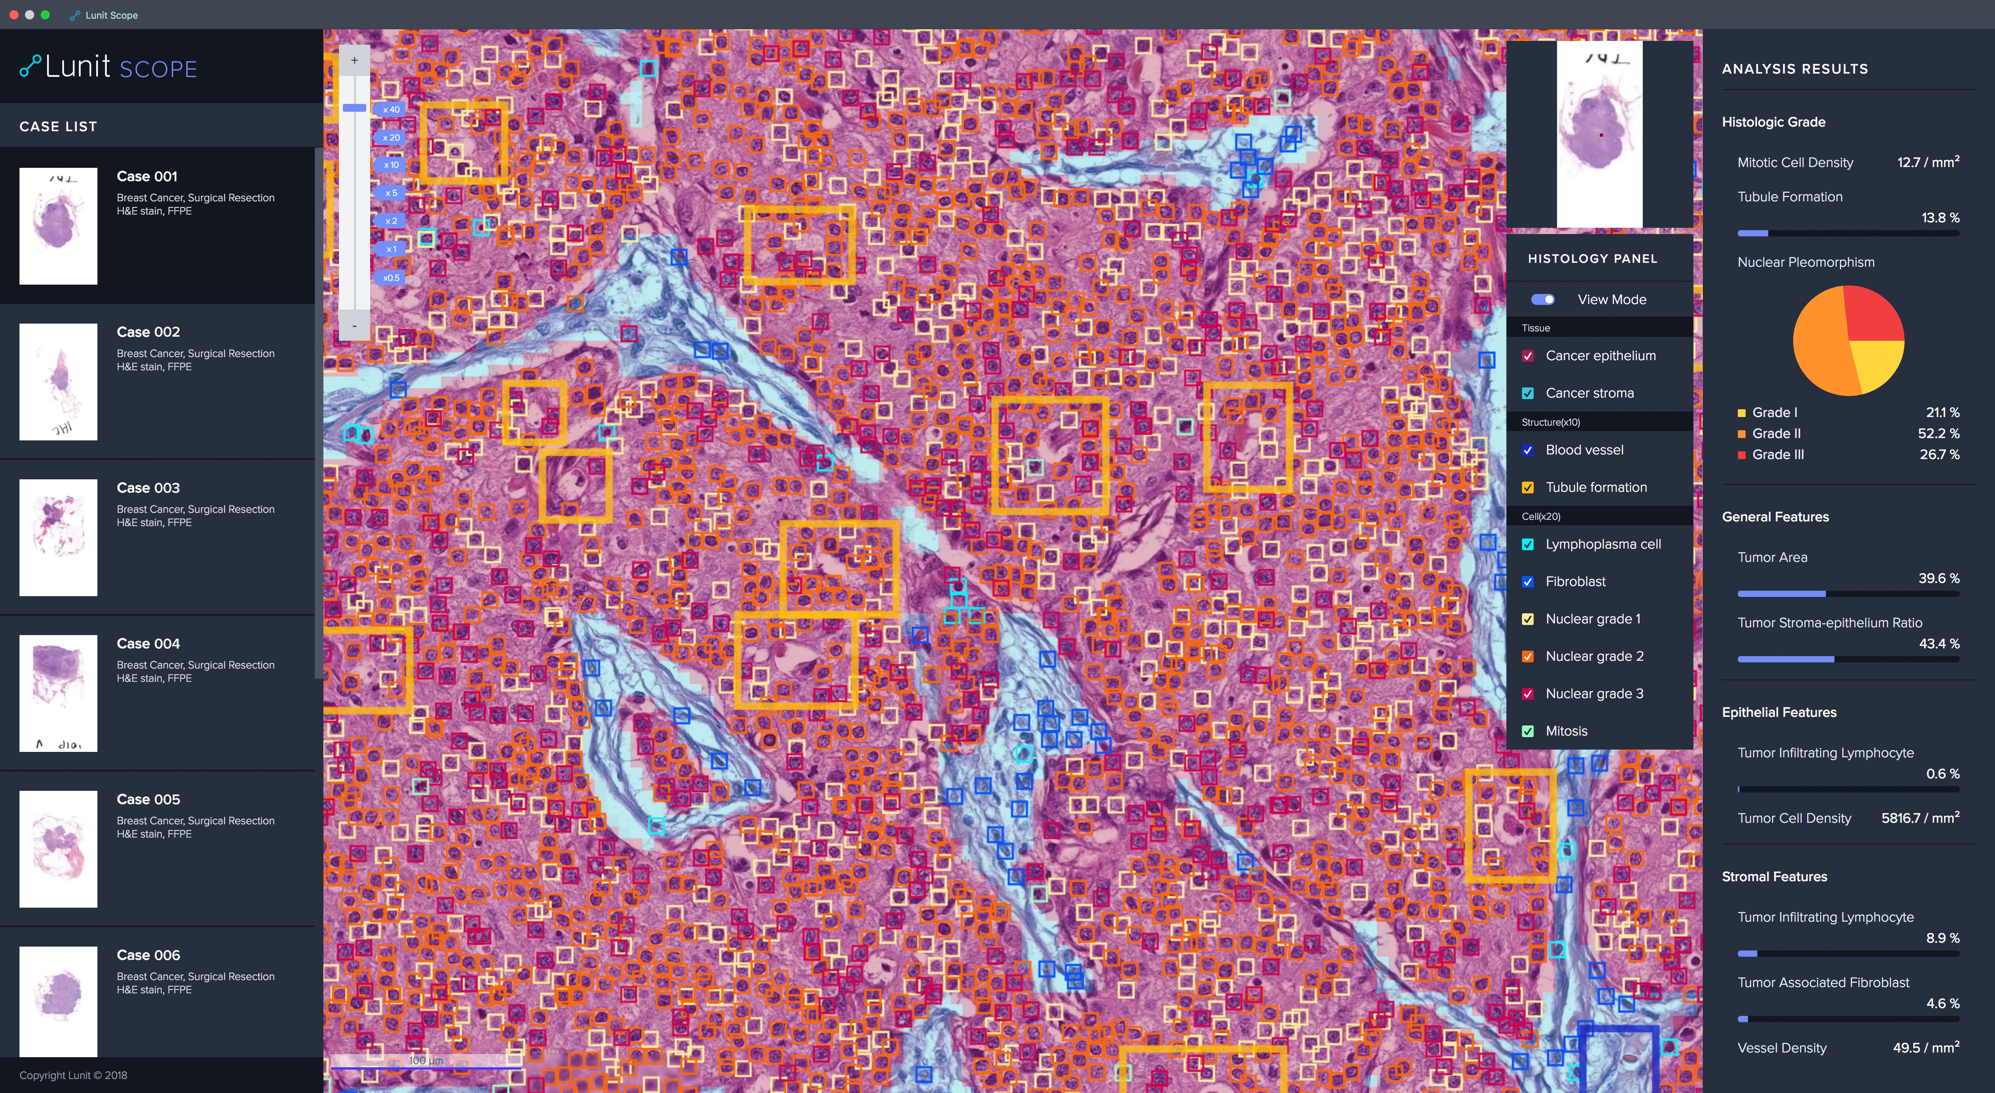
We have more than 20 deep learning experts working full-time to reach the pinnacle of technology. Our AI team was internationally acclaimed in competitions, ranking top places at ImageNet 2015, Tumor Proliferation Assessment Challenge 2016, and Camelyon 2017. Lunit has been chosen by CB Insights as one of top AI startups in the healthcare industry and recognized by NVIDIA as Top 5 AI startups for social impact.

“World-leading AI applied to discover, design, and develop powerful data-driven imaging biomarkers”

Competitive Data Acquisition
Our medical team consists of 6 full-time, board-certified medical directors and more than 15 part-time staff radiologists/pathologists. They steer overall clinical direction, ensuring collection of large-scale high-quality medical data and directly involved in providing expert opinion everytime our AI algorithms are updated. Many of our studies and papers have been published at prestigious publications, as recently at <Radiology>.

Our products
We aim to bring exceptional, clinically-approved accuracy to our products. The accuracy level of our diagnostic products ranges from 97% to 99% depending on the area of diagnosis.
Currently, we are focusing on medical imaging: mainly in chest radiography and mammography, also conducting research and development in digital pathology.
Our ultimate goal is to develop meaningful data-driven imaging biomarkers that would be clinically used to guide diagnosis and treatment. In this journey, we had been developing accurate diagnostic support tools for relatively simpler imaging tests such as chest x-ray.
We also make our product most accessible for our users to improve productivity. Our products can be seamlessly integrated into the clinical workflow, deployed both on-prem and via cloud.
Our AI solution for chest x-ray, Lunit INSIGHT for Chest Radiography Nodule Detection, has been approved by Korea Ministry of Food and Drug Safety in August 2018.

Media Contact:
Jussarang Lee
Communications Manager
julee@lunit.io
