**Reference Monitoring in the Hotel Suite**

Video documentary about room correction with Neumann MA 1 and KH-line speakers

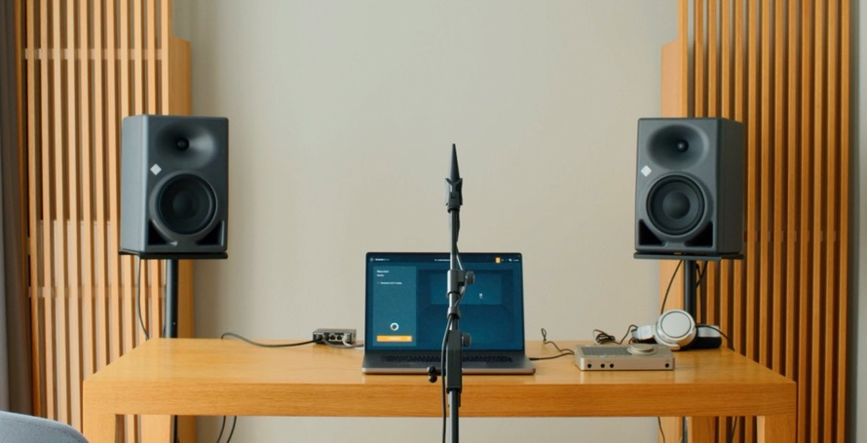

**Berlin, October 28th 2023 - The StrandGut Resort in St. Peter-Ording on the German North Sea coast not only welcomes musically prolific guests, but upon request, it even provides them with Neumann KH 150 studio monitors, a subwoofer, headphones, and a**

**U 87 microphone for songwriting and music production in one of its in-house suites at no additional charge. Complemented - and thus perfected - by the Automatic Monitor Alignment System MA 1, which allows for quick calibration of the monitor system to the room. A short video documentary, now available on the Neumann** [**YouTube channel**](https://www.youtube.com/watch?v=ngYBvNIVPyk)**, showcases the workflow and the surprisingly professional results that can be achieved far away from a professional recording studio.**

The automatic calibration allows switching between different suites and rooms at the StrandGut Resort without the respective acoustic conditions affecting an objective sound assessment.

If Neumann monitors with the MA 1 are also installed in the studio at home, a seamless transition between the studio and hotel suite is possible without having to revisit a mix.

Many celebrities have already discovered this place's magic for themselves, and music artists, in particular, appreciate staying at the StrandGut Resort. The relaxed atmosphere invites thoughts to unfold freely, and any potential writer’s blocks resolve as if by themselves - creative ideas come and go like the sea's tides.

**[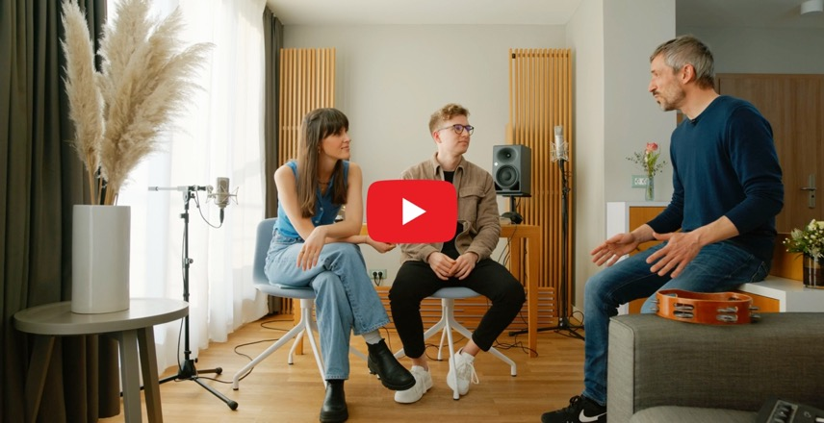](https://www.youtube.com/watch?v=ngYBvNIVPyk)**

**The Basics: The Automatic Monitor Alignment**

The video illustrates how the playback precision can be dramatically improved through successful alignment: Specifically, in the areas of bass and low mids, impressive optimizations of up to 16 (!) decibels can be achieved. Without correction, a reliable sound assessment or even a coherent mix would hardly be possible. A comparison of the measurement curves (before/after) visually highlights the striking difference.

By the way, the MA 1 system also ensures that Neumann speakers of different sizes reproduce audio material consistently. From the small KH 80 DSP, through the KH 150 available at the StrandGut Resort, to the large KH 420 model (with DSP sub), automatic monitor alignment achieves a homogenous sound playback. While the reproduction of deep frequencies naturally varies (casually put: bigger = deeper bass), the overall sound characteristic remains perfectly comparable.

The Automatic Monitor Alignment MA 1 consists of the Neumann measurement microphone of the same name and intuitive software for Mac and PC. The alignment leads to an optimally adjusted amplitude and phase correction, enabling reliable monitoring in virtually all environments. A significant advantage is that no special expertise is needed for successful calibration. Neumann developed the underlying algorithms in collaboration with the Fraunhofer Institute for Integrated Circuits (IIS).

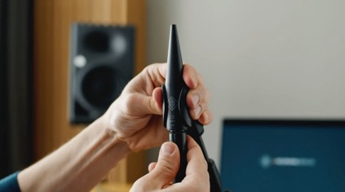 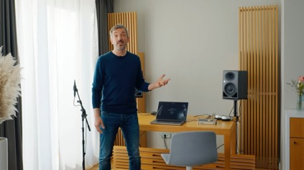

The method is suitable for stereo setups with the Neumann speakers KH 80 DSP, KH 120 II, and KH 150, as well as for all analog (non-DSP-based) Neumann monitors when combined with the subwoofers KH 750 DSP or KH 750 AES67. Neumann models with DSP and network connectivity are required as the correction parameters are stored and processed in the speakers’ internal signal processors.

Experienced users complete the entire alignment process in less than ten minutes. If in a hurry, a significant sound optimization can be achieved even after just a single measurement. The result is a well-defined, tonally balanced sound with a detailed reproduction of deep frequencies and a precise, time-accurate representation of reverb tails and rooms.

The unique Neumann twist: All necessary adjustments are stored in the speakers once calibrated. Unlike systems from other manufacturers, there's no need to run plug-ins or drivers in the background of the DAW that could create additional latencies or cause incompatibilities. The Neumann system operates autonomously and is independent of the connected PC or Mac. It doesn’t burden the computer, which also makes it future-proof.

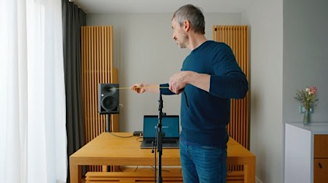 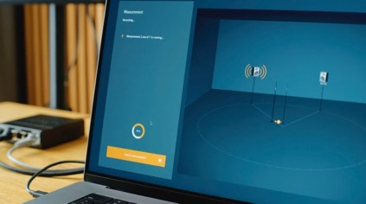

**The StrandGut Resort: Music and Hospitality**

"Privately, I have always been passionate about music and have always enjoyed attending concerts," reveals Karsten Werner, Managing Partner of StrandGut Resort GmbH & Co. KG. "Even before I worked in St. Peter-Ording, I frequently hosted musicians. About twelve years ago, while managing another hotel, I met Johannes Oerding, who was then still performing in small clubs. A week after his stay, his booking agent called and told me how thrilled the band was with their experience with us."

Werner continues, "When Johannes later wanted to work on songs for a new album, he contacted me again, and of course, I was more than happy to reserve rooms for him and his producer. Everything worked out wonderfully, and many great songs came to life at the hotel.

When I transitioned to the StrandGut Resort in St. Peter-Ording ten years ago, I naturally brought Johannes along..." (laughs)

The initial relationship with Johannes Oerding has developed into a friendship that continues to this day and has opened many doors for Karsten Werner in the German music scene. "Many musicians love coming to the StrandGut Resort, both privately and to write songs. In St. Peter-Ording, you remain largely undisturbed despite being famous," reports Werner, pointing out that the so-called "Dünen-Hus" is located nearby: a venue owned by the city, which can be used for tour rehearsals - even with a full band including drums.

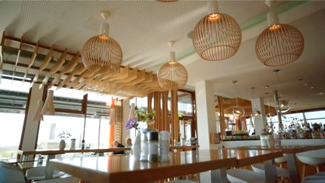 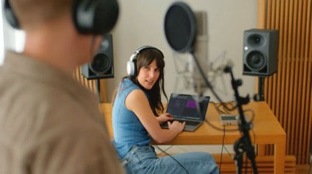

**A Matter of the Heart**

"What's crucial is not just the attractive infrastructure - much more important is that we put our heart and soul into the StrandGut Resort!" explains Karsten Werner. "We offer possibilities that wouldn't be considered elsewhere: for instance, the bar at StrandGut Resort doesn't close precisely at 1 AM if everyone is still having a good time. Fun evenings and long nights are just part of the experience - witnessing the genesis of song ideas in our hotel that later become radio hits is truly special and wonderful for someone with a passion for art and culture!"

Johannes Oerding is a regular at the StrandGut Resort, but artists like Max Giesinger, Wincent Weiss, Revolverheld, Peter Maffay, Sido, Fury in the Slaughterhouse, and others have also been welcomed. Karsten Werner admits that occasionally there are musicians who might not perfectly fit the spirit of the StrandGut Resort: "The chemistry has to be there," says the hotelier.

 

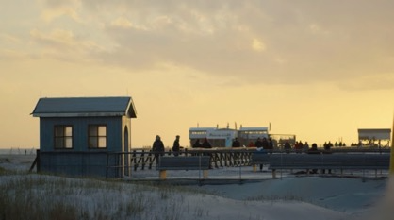 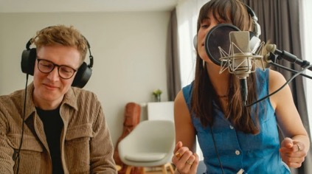

**Tidal Thoughts**

Contemporary design, an unobstructed view of the North Sea, and a friendly "Moin moin" upon arrival: The StrandGut Resort in St. Peter-Ording skillfully combines understated elegance with a charming sprinkle of casualness. Guests are always genuinely thrilled, as the lifestyle hotel ([www.strandgut-resort.de](http://www.strandgut-resort.de/)) on the central promenade of the popular Schleswig-Holstein beach town promises nothing less than pure relaxation with a Nordic-fresh twist.

"Creative ideas come and go like ebb and flow - it's a fitting metaphor that aligns well with the spirit of the establishment," says Thomas Holz, Sennheiser Relations Manager, who has been in close contact with the StrandGut Resort and hotelier Karsten Werner for many years.

"Many artists value the attentive personal service at the StrandGut Resort, so it's not unusual for someone like Max Giesinger to spontaneously grab a guitar during the hotel's Christmas party and give an intimate private concert. It seems the resort has become something of a second home for several musicians."

## Platinum and Gold

The mention of the "second home" corresponds with the content of various showcases set up on the ground floor of the resort: Well-known names in the German music industry express their gratitude for "a wonderful time," "the delicious food and drink," and "the origination of a creative space." Remarkable and somewhat unusual for a hotel is a dedicated drawing by Udo Lindenberg and several gold and platinum records from famous hotel guests.

The special offer to use high-quality Neumann monitoring systems during songwriting stays in the rooms and suites of the StrandGut Resort has been well-received, as Karsten Werner gladly confirms: "Just recently, the lead singer of a very well-known band came to me, quite excitedly, and said with total enthusiasm: 'Karsten, I don't even have speakers as good as the ones at StrandGut Resort at my home!'"

Link: <https://www.youtube.com/watch?v=ngYBvNIVPyk>

Stay up to date and follow us on: [FACEBOOK](https://www.facebook.com/neumann/) I [INSTAGRAM](https://www.instagram.com/neumann.berlin/) I [YOUTUBE](https://www.youtube.com/user/GeorgNeumannGmbH)

**About Neumann**

​Georg Neumann GmbH, known as “Neumann.Berlin”, is one of the world’s leading manufacturers of studio-grade audio equipment and the creator of recording microphone legends such as the U 47, M 49, U 67, and U 87.

Founded in 1928, the company has been recognized with numerous international awards for its technological innovations. Since 2010, Neumann.Berlin has expanded its expertise in electro-acoustic transducer design to also include the studio monitor market, mainly targeting TV and radio broadcasting, recording, and audio production. The first Neumann studio headphones were introduced in 2019, and since 2022, the company has increased its focus on reference solutions for live audio. With the introduction of the first audio interface MT 48, and its revolutionary converter technology, Neumann now offers all the necessary technologies needed to capture and deliver sound at

the highest level. Georg Neumann GmbH has been part of the Sennheiser Group since 1991 and is represented worldwide by the Sennheiser network of subsidiaries and long-standing trading partners. [www.neumann](https://www.neumann.com/).

**Press Contact Neumann:**

Andreas Sablotny

andreas.sablotny@neumann.com

T +49 (030) 417724-19

Raphael Tschernuth

raphael.tschernuth@neumann.com

T +49 (030) 417724-67