Please note that this information is strictly embargoed until July 7, 2022, 8 a.m. PST
Posters courtesy of Netflix

New audio experience now streaming on Netflix

Sennheiser AMBEO 2-Channel Spatial Audio adds exciting sound for viewers without the need for a surround system and gives full control to the re-recording mixer

Wedemark, July 1, 2022 – Netflix and audio specialist Sennheiser have announced a massive audio improvement for all viewers that access streaming (OTT) content with standard stereo equipment: AMBEO 2-Channel Spatial Audio is now streaming on Netflix and delivers an incredibly immersive audio experience with standard stereo speakers. The AMBEO 2-Channel Spatial Audio renderer translates original immersive mixes into 2-channel audio with a spatial experience far beyond stereo. During development, Sennheiser worked with Netflix and other industry partners to fine-tune the system, which is now available to license from Sennheiser. Netflix is the first streaming platform to deliver this significantly improved experience for select titles.

Surveys among viewers have shown that OTT customers often access content with standard stereo equipment – be it on a mobile while traveling, when casually watching via a tablet, or because the home listening space does not allow for a full surround sound set-up. While in the past these viewers were unable to benefit from the growing amount of music and films produced in Dolby Atmos® or MPEG-H Audio, the AMBEO 2-Channel Spatial Audio feature has now changed this.

Netflix’s Stranger Things Season 4 benefits from new audio experience
AMBEO 2-Channel Spatial Audio is a two-channel rendering of an immersive mix that is a drop-in replacement for stereo. It provides an improved audio experience wherever stereo is delivered today, be it standard TV sets, stereo systems, headphones, tablets, or laptops. Netflix is the first streaming platform to deliver this significantly improved experience: On select titles, like Season 4 of Stranger Things, Netflix has made AMBEO 2-Channel Spatial Audio the default stream for any two-channel usage. Netflix viewers watching on a stereo system will automatically receive an improved and enhanced spatial experience – no user changes required.

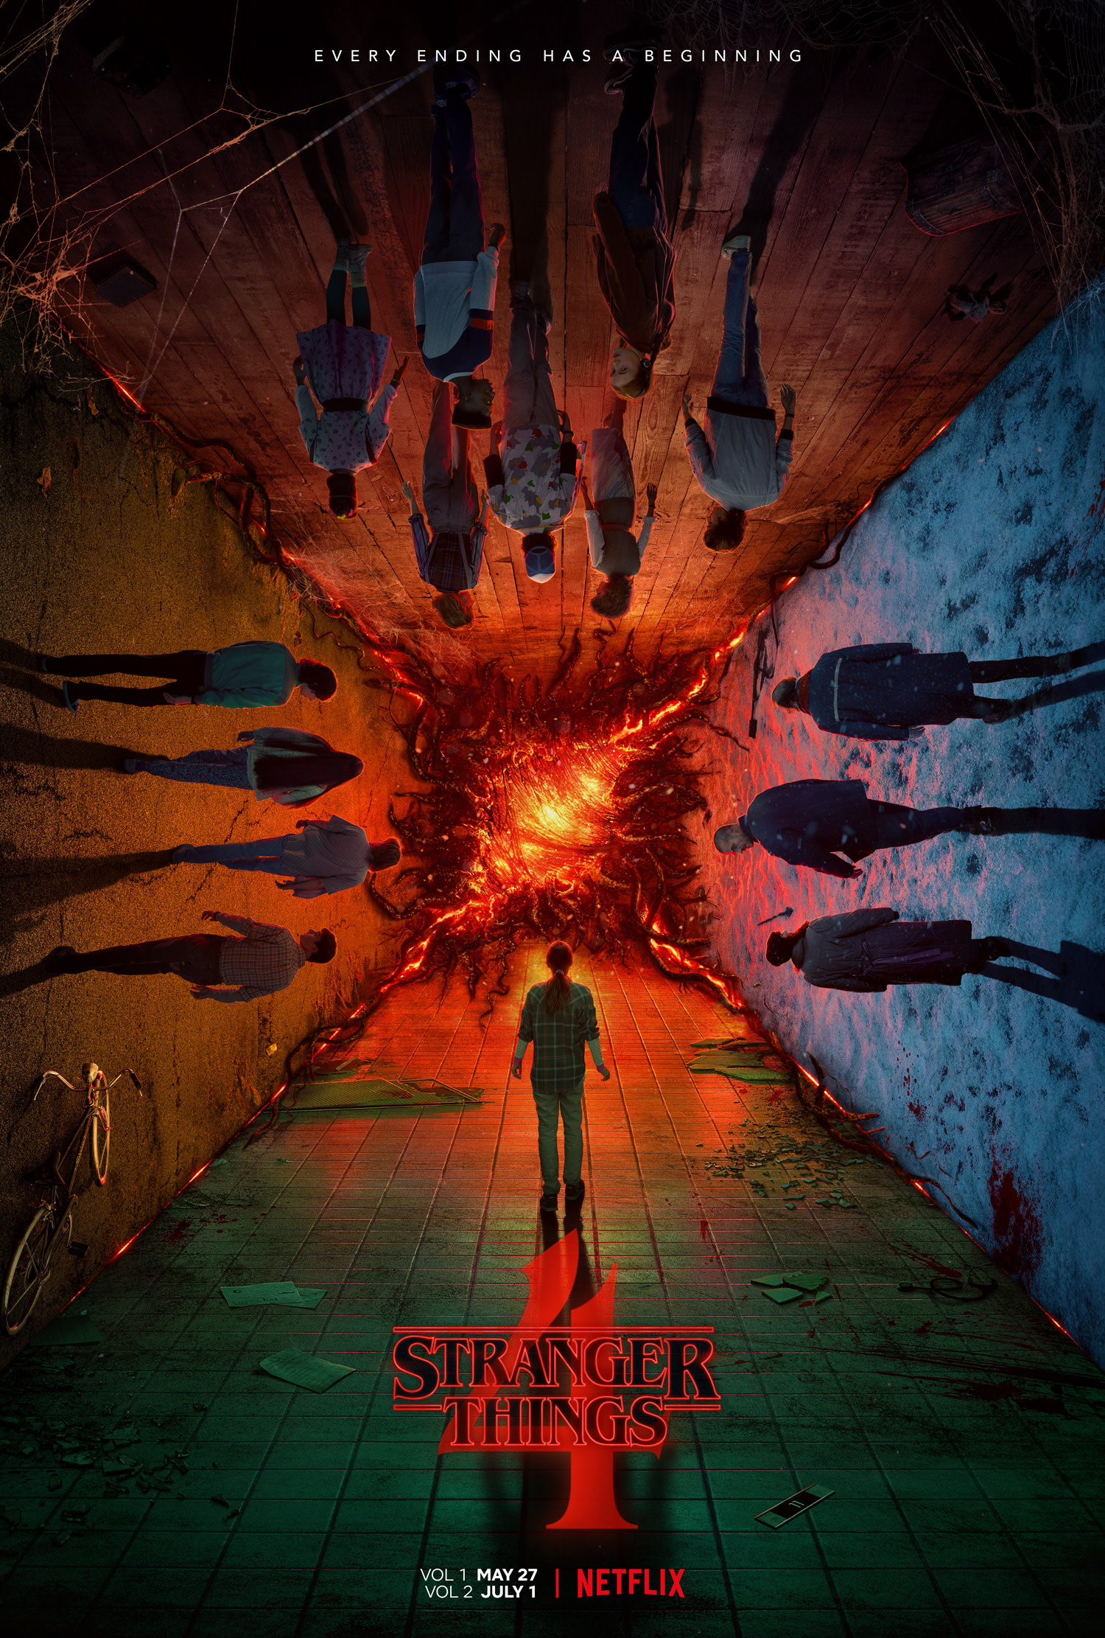 | Netflix goes the extra mile for its viewers – the OTT provider is the world’s first to offer AMBEO 2-Channel Spatial Audio to its customers. The first title to benefit from this enhanced spatial audio experience is Season 4 of Stranger Things  Poster courtesy of Netflix

“Sennheiser firmly believes in the immersive future of audio,” says Dr Renato Pellegrini of Sennheiser’s AMBEO team. “Creators all over the globe have been using our tools to create outstanding immersive works, pushing the boundaries of music and film production. With AMBEO 2-Channel Spatial Audio, we are now taking the next step – making this new audio reality accessible to everyone.”

A sonic experience that is far wider than the playing device itself
Drawing on Sennheiser’s decades of research and innovation in immersive sound, AMBEO 2-Channel Spatial Audio provides immersion far beyond what two-channel speaker systems can normally deliver, but without impacting the mix or tonal balance.

According to Scott Kramer, Manager for Sound Technology at Netflix, “We feel AMBEO Spatial Audio offers a meaningful improvement for Netflix members. Re-recording mixers often tell me that it better translates their detailed immersive mix work to stereo. Crucially, this process preserves the original sound mix and respects creative intent with a remarkably clean sound.”

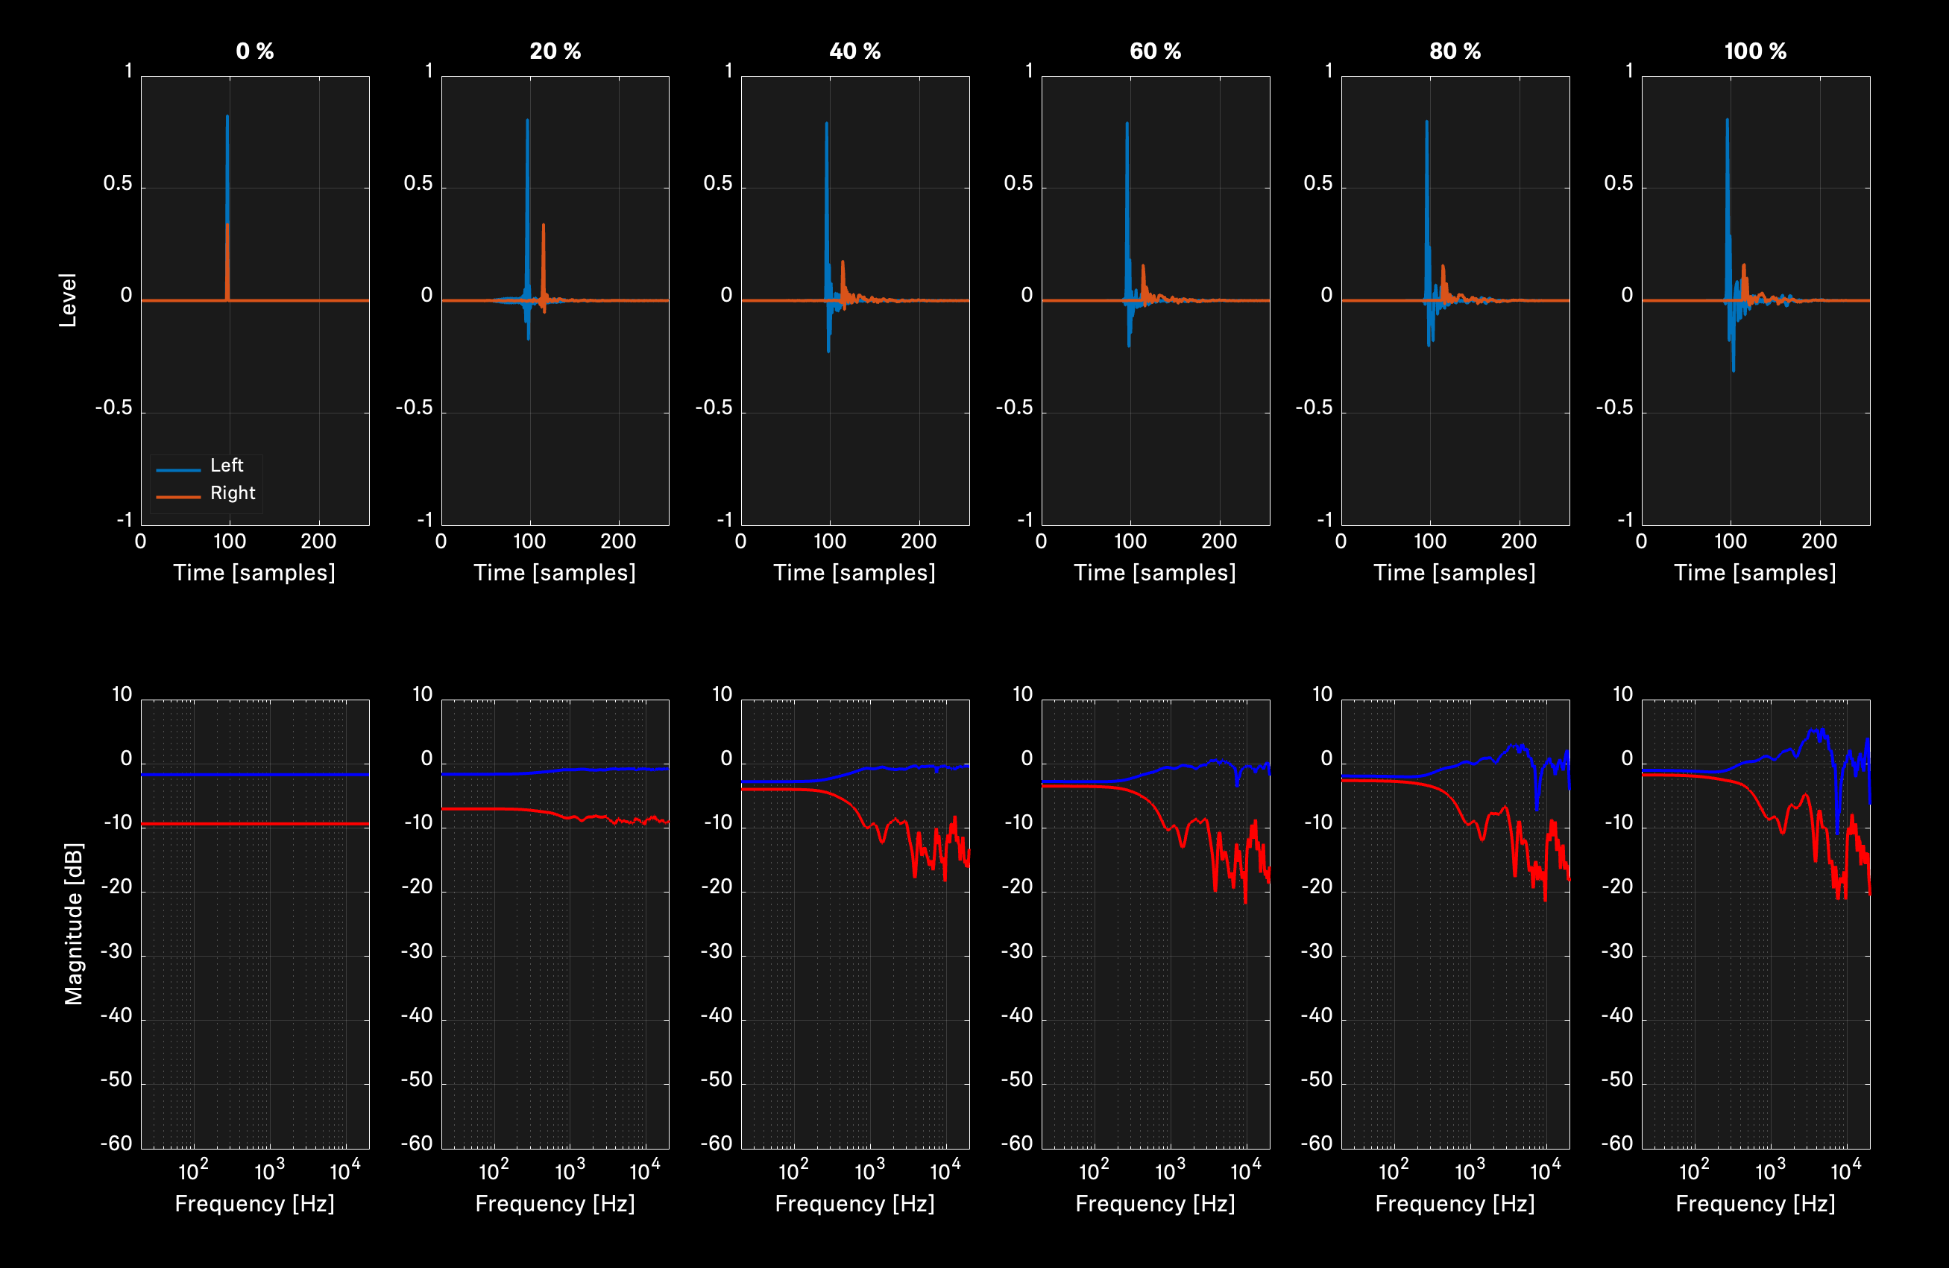
From standard stereo mixdown (left) to full AMBEO effect (right): re-recording mixers can fully control and fine-tune the spatialization

Respecting the original mix while giving all options for fine-tuning
“What sets Sennheiser apart from other solutions is that the AMBEO rendering respects the original mix, tonal balance and dialog integrity, which is exactly what the re-recording mixer is looking for,” explains Pellegrini. “The processing is in line with Sennheiser’s reputation to deliver tools that are ‘transparent’ and do not interfere with the original sound. In a nutshell: Sennheiser 2-Channel Spatial Audio seeks to translate mixer intent, not to overpower it.”

The rendering software runs in the streaming service’s cloud-based encoding pipelines and produces AMBEO 2-Channel Spatial Audio from existing ADM or IAB files, both industry-standard, open formats. It does not require another separate mix. A preview tool enables the re-recording mixer to compare stereo to AMBEO during postproduction and adjust the rendering settings by stems/groups. The renderer offers patented granular control of the spatialization, ranging from full AMBEO effect to standard stereo mixdown, while specific channels can be excluded from modification. For example, dialog can be preserved 100%, or modified slightly to match neighboring immersive scenes.

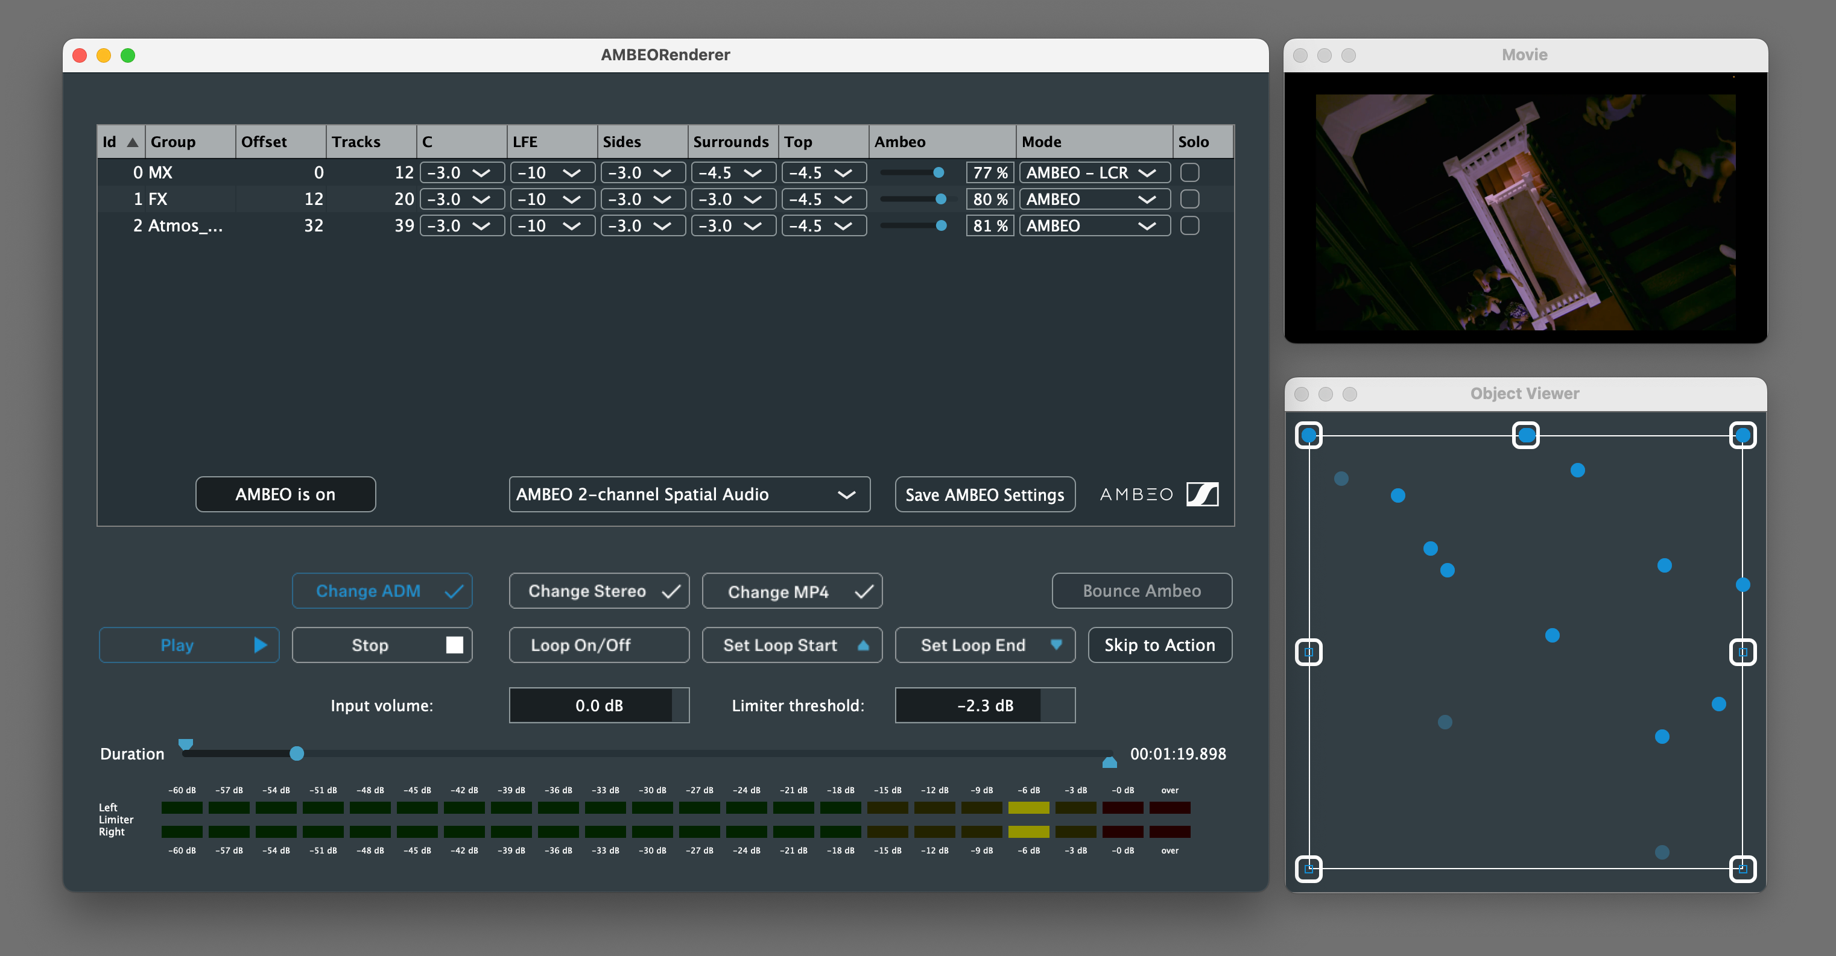
The preview tool of the AMBEO 2-Channel Spatial Audio rendering software. The Object Viewer window at the bottom right shows fixed loudspeaker positions at the edges and individual renderings as blue dots. Pale dots are elevated sound sources

Total loudness is preserved, too, and a music mix can be kept for left and right channels while adding the immersive AMBEO rendering to all other channels. Naturally, all signals are properly time-aligned to match the original content.

Re-Recording Mixer Mark Paterson commented: “I’m a huge fan of AMBEO. I experimented with it a lot on the ‘Fear Street’ movies and was impressed with how the surround channel information was represented. I’m always looking for ways to get that Cinematic sound at home and on ‘The Adam Project’ I was able to make the mix sound really immersive on everything from high end soundbars to iPhones which I believe helps the audience connect more emotionally. It’s been a perfect format on ‘Stranger Things’. In the Atmos mix, Vecna’s voice wraps around you which is an important part of making him scary and larger than life. The fact that AMBEO is able to help recreate that in stereo is very impressive to me.”

For an up-to-date list of content available in AMBEO Spatial Audio, simply enter “Spatial Audio” in the Netflix search field.

Learn more at www.sennheiser.com/ambeo-spatial-audio

(Ends)

Dolby Atmos is a registered trademark of Dolby Laboratories.
Stranger Things S4 posters courtesy of Netflix.

The images accompanying this press release can be downloaded here.

About the Sennheiser brand
We live and breathe audio. We are driven by the passion to create audio solutions that make a difference. Building the future of audio and bringing remarkable sound experiences to our customers – this is what the Sennheiser brand has represented for more than 75 years. While professional audio solutions such as microphones, meeting solutions, streaming technologies and monitoring systems are part of the business of Sennheiser electronic GmbH & Co. KG, the business with consumer devices such as headphones, soundbars and speech-enhanced hearables is operated by Sonova Holding AG under the license of Sennheiser.

www.sennheiser.com
www.sennheiser-hearing.com

Global Pro Audio Press Contact

Stephanie Schmidt
Stephanie.schmidt@sennheiser.com
+49 (5130) 600 – 1275

