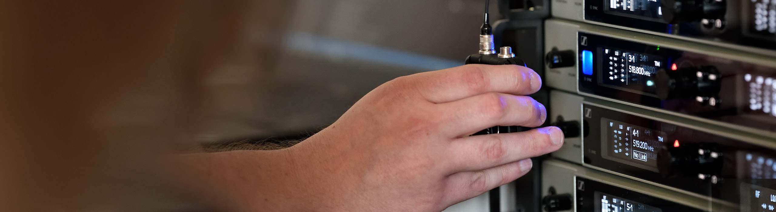

#Dontstoptheeducation

Expand your expertise in RF wireless and digital audio

Wedemark, May 5, 2020 – With the live event sector still on lockdown, many engineers are making the best use of their time by investing in their further education. To support this, Sennheiser’s #Dontstoptheeducation initiative is presenting two exciting opportunities: a round table with Sennheiser RF wireless experts on May 7 and a webinar series on digital audio and digital wireless microphones, which will be launching on May 8.

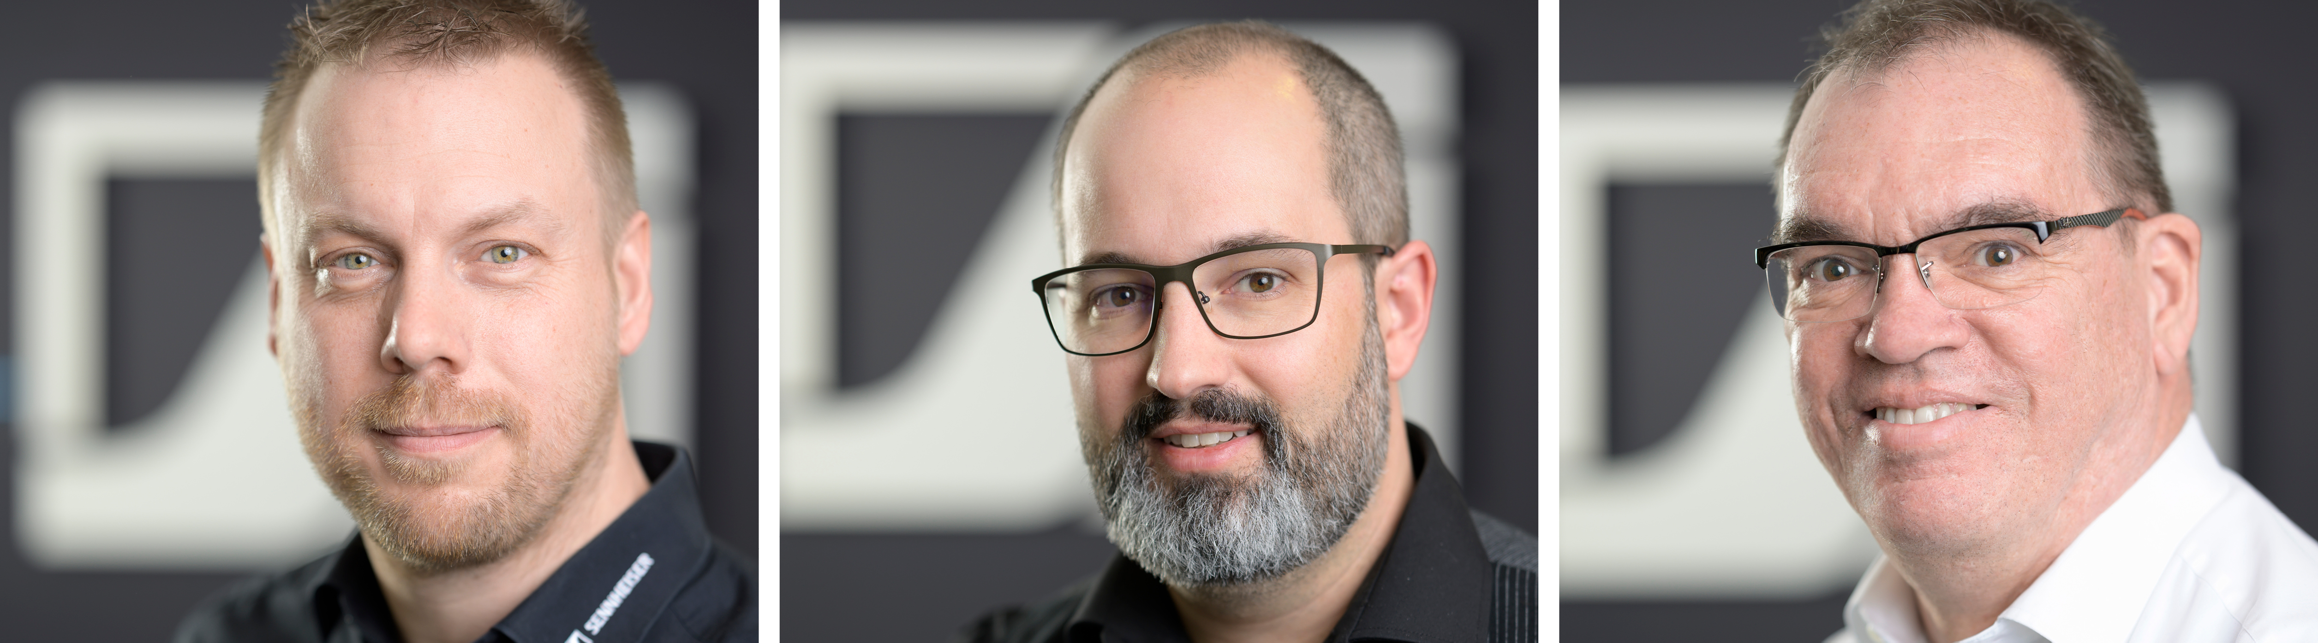
RF wireless experts Jonas Naesby, Vincent Tilgenkamp and Volker Schmitt (from left to right)

Meet your expert
On May 7th at 16:30 CEST, RF wireless experts Jonas Naesby (Denmark), Vincent Tilgenkamp (Netherlands), and Volker Schmitt (Germany) will describe how to ensure trouble-free operation of your wireless microphone systems. Having supported many live audio productions globally, both in the music and the theatrical fields, the panellists bring a vast experience to the table. They are looking forward to answering your questions live and will be illustrating their answers with reference to real-world examples. Registrations are now open at https://zoom.us/webinar/register/WN_CO5-FTfxT1OT494rIlVUMQ

Digital audio and digital wireless microphones
Three sessions are available on May 8 at 8:30, 13:30 and 18:00 CEST to best facilitate access for all time zones. In this webinar, Volker Schmitt will explain the general concepts behind digital audio and digital wireless microphone transmission. He will talk about the advantages and challenges in digital wireless and compare them to analogue wireless transmission, explaining the differences and similarities. Over the two next weeks, Volker will present additional webinars that will build upon this first webinar. Registrations are now open at https://zoom.us/webinar/register/WN_Kfuns1YaS_mimF1r_RL1ng

Expand your expertise with more webinars – totally free
Sennheiser’s SoundAcademy provides a host of popular pro audio training webinars and in-depth product discussions. Please visit https://www.sennheiser.com/webinars for a full, up-to-date list and to register free of charge for a SoundAcademy webinar of your choice. The free training sessions are offered at several different times to allow as many people from around the globe to tune in as possible.

About Sennheiser
Founded in 1945, Sennheiser is celebrating its 75th anniversary this year. Shaping the future of audio and creating unique sound experiences for customers – this aim unites Sennheiser employees and partners worldwide. The independent family company, which is managed in the third generation by Dr. Andreas Sennheiser and Daniel Sennheiser, is today one of the world’s leading manufacturers of headphones, loudspeakers, microphones and wireless transmission systems. In 2018, the Sennheiser Group generated turnover totalling €710.7 million. www.sennheiser.com

Global Press Contact

Stephanie Schmidt
Stephanie.schmidt@sennheiser.com
+49 (5130) 600 – 1275

