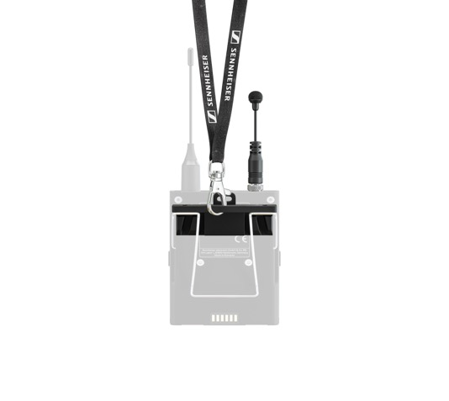
Please note that this information is strictly embargoed until August 29, 2022, 18:00 CEST
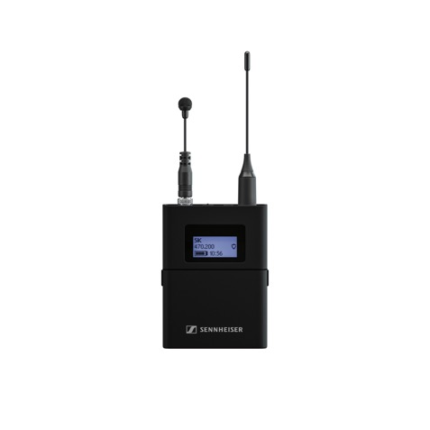

Sennheiser Introduces New Microphone for Presenters

Developed with customers for customers, the new MKE mini provides an easy to wear, no fuss mic solution for speeches and lectures

Wedemark, August 29, 2022 – Sennheiser, the first choice for advanced audio technology that makes collaboration and learning easier, is adding a high-quality, miniature omni-directional lavalier-style microphone to its comprehensive microphone portfolio with the release of the MKE mini. With a total length of 9cm and ultra-light weight (7g), the MKE mini is convenient to wear, while meeting the special challenges of a moderator microphone.

As with much of Sennheiser’s innovation, the MKE mini was developed in response to direct customer feedback and requests. Users demanded a presenter mic that can be worn with any hairstyle, is unobstructive and easy to install, and provides excellent sound quality. In response, Sennheiser has made microphone setup for lectures and speeches extremely easy. All that is needed for setup is to connect the microphone to a bodypack and attach a lanyard. Additionally, the MKE mini is the perfect fit when wearing a hairstyle that doesn’t allow for a head mic or an outfit that offers no possibility to clip a body pack.

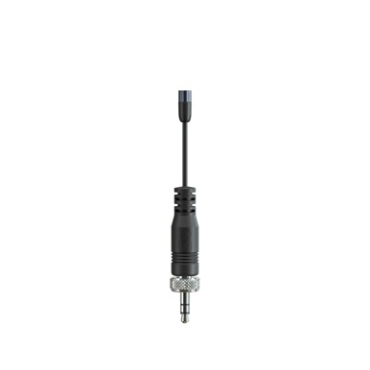
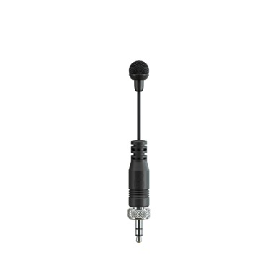
With a total length of 9cm and ultra-light weight (7g), the MKE mini is convenient to wear, while meeting the special challenges of a moderator microphone.

To ensure the premium audio quality one would expect from Sennheiser, Sennheiser equipped the MKE mini with the KE 4 capsule, derived from industry standard MKE 2, which provides a warm and distortion-free signal, even at high sound pressure levels. The MKE mini also features Sennheiser’s Umbrella Diaphragm™ technology, protecting the mic against sweat and other moisture.

“Our customers have often voiced struggles with headmics that don’t fit well over their hair, but many also struggle with where to place a body pack and lavalier mic, if they don’t have a belt or pocket to hook the beltpack to,” commented Inesh Patel, Business Development Manager, Business Communications, Sennheiser. “Therefore, we designed the MKE mini to hang with a bodypack around the neck on a lanyard with placement right under the chin, which is ideal.”

Samantha Butler, IT & AV Support Manager at Bangor University, got the chance to test the MKE mini. “I love it. I think it's great that I don't have to try to find a place on my outfit. I can just clip it, because quite often, there’s nowhere to put it.”

Introducing the Sennheiser Business Communication Microphone Guide 2022
To make it easy for customers, distributors, and integrators to learn more about Sennheiser’s microphone solutions, including the new MKE mini, Sennheiser today announced the availability of the Sennheiser Business Communication Microphone Guide 2022.

By offering a microphone for any situation in the workplace or classroom, Sennheiser’s goal is to make collaboration and learning easier. From the smallest meeting rooms or learning spaces to the largest educational and corporate campus installations, Sennheiser has the right microphone solution to simplify your life.

(Ends)

The Sennheiser Business Communication Microphone Guide 2022 can be downloaded here.
The images accompanying this press release and additional photos can be downloaded here.

About the Sennheiser brand
We live and breathe audio. We are driven by the passion to create audio solutions that make a difference. Building the future of audio and bringing remarkable sound experiences to our customers – this is what the Sennheiser brand has represented for more than 75 years. While professional audio solutions such as microphones, meeting solutions, streaming technologies and monitoring systems are part of the business of Sennheiser electronic GmbH & Co. KG, the business with consumer devices such as headphones, soundbars and speech-enhanced hearables is operated by Sonova Holding AG under the license of Sennheiser.

www.sennheiser.com
www.sennheiser-hearing.com

Global Business Communications Press Contact Global Pro Audio Press Contact
Jeff Horan Stephanie Schmidt
jefffrey.horan@sennheiser.com stephanie.schmidt@sennheiser.com
+1 860-598-7539 +49 (5130) 600 – 1275

