PRESS RELEASE

Untapped potential: New report identifies collagen’s huge scope for further growth

Vilvoorde, 22 April 2021 - Collagen’s star is rising fast – but is it just a passing trend? Not according to industry experts, who say that the protein is set to become a major force in the health ingredients category.

According to an analysis conducted by research firm Frost & Sullivan, the market for collagen peptides – the hydrolyzed and most bioavailable form of collagen – is already growing at about 8% a year (CAGR, 2020-2024). However, sales are still a long way from their peak. With vast untapped potential to expand into new markets, applications, and products, Frost & Sullivan expects momentum to accelerate and growth to reach new heights.

Early-stage product lifecycle
The findings are published in a new report, ‘Is collagen here to stay?’, which was commissioned by PB Leiner, supplier of SOLUGEL® collagen peptides. The report says that, based on the developmental path followed by more mature health ingredients such as probiotics and omega-3, collagen peptides are still in the very early stages of their product lifecycle.

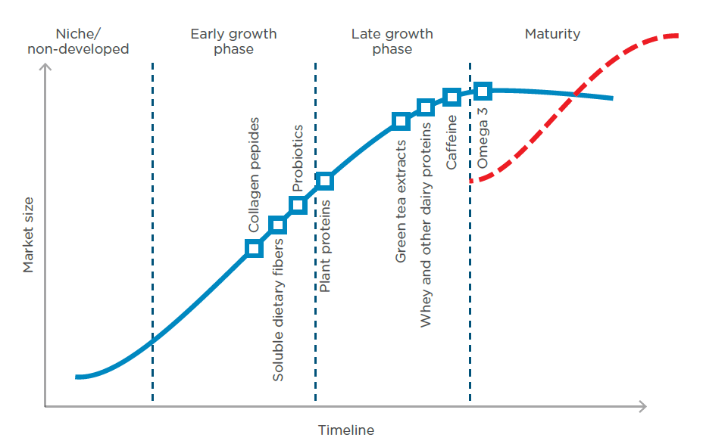

Regional penetration rates
As a result, market penetration for collagen peptide ingredients and products remains relatively low across Europe, North America and Asia-Pacific. In the North American market, for example, collagen peptides’ penetration rate is estimated to be at least 35 times lower than omega-3’s, indicating huge potential for growth.

Critical success factors
The analysis also finds that collagen peptides rank from ‘good’ to ‘excellent’ against the critical success factors for health ingredients. These include scientifically backed health claims, a well-defined end-user group, diversification of health benefits, and the capability to be incorporated into foods and beverages. The authors of the report conclude that collagen peptides have all the necessary characteristics to become a highly successful ingredient that will support the health of millions of people worldwide.

Tomasz Bochenski, Senior Consultant at Frost & Sullivan and lead researcher on the report, said: “In comparison with other, more mature health ingredient categories, collagen peptides are still at a relatively early stage of their evolution across all continents. This means significant opportunities remain for manufacturers, retailers and investors. Developing new applications for collagen peptides in terms of functionality and product innovation will further expand the market, allowing it to reach new customers who might not yet be aware of the many scientifically proven health benefits of collagen peptides.”

Increasing sophistication
Cindy Dekeyser, Global Business Intelligence Manager at PB Leiner, added: “Frost & Sullivan’s analysis perfectly aligns with what we and other observers have seen: collagen peptides are starting to go mainstream, gaining wider acceptance and familiarity among end consumers. This means consumer requirements are becoming increasingly sophisticated, with more and more differentiation in product concepts and quality needed to stand out from the crowd. That is where we, as a global leader in collagen, step in: we assist our customers in translating trends into on-trend concepts. This customized support, ranging from market intelligence to new product development to technical support, significantly enhances customer success.”

ENDS

Visuals and links
- The full report – ‘Is collagen here to stay? A fresh look at the market and its potential’ – is available to download by clicking here
- For further images and other material, please get in touch with the press contacts below

About PB Leiner
PB Leiner, part of Tessenderlo Group, is an established global player with production sites in Asia, Europe, North and South America. PB Leiner supplies a complete range of high quality gelatins and collagen peptides, tailoring solutions to its customers’ applications in food, health, beauty and pharma markets. PB Leiner employs approximately 1,100 people and is part of Tessenderlo Group.

Press contacts
Robin Hackett
Ingredient Communications
+44 (0)7507 277733
robin@ingredientcommunications.com

Sarah De Wulf
PB Leiner
+32 475 20 51 35
communication@pbleiner.com

This press release is available in English, Spanish, and Portuguese on the website www.pbleiner.com

