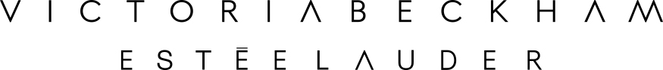

FOR IMMEDIATE RELEASE CONTACT: INSERT DETAILS

ESTÉE LAUDER AND VICTORIA BECKHAM
LAUNCH A LIMITED-EDITION MAKEUP COLLECTION
FOR FALL 2016

NEW YORK, April 15, 2016 —The Estée Lauder brand today announced a partnership with style icon and acclaimed fashion designer, Victoria Beckham, to create a limited-edition makeup collection, Victoria Beckham Estée Lauder. The collection will launch in September 2016 at select retailers around the world, Victoria Beckham stores and on esteelauder.com and victoriabeckham.com.

“We are excited to join forces and bring Victoria’s take on beauty to her many fans around the world,” said Jane Hertzmark Hudis, Group President, The Estée Lauder Companies. “Victoria is an entrepreneur in the true spirit of our founder, Estée Lauder, with a real understanding of what women want, and a commitment to making women look and feel their most beautiful. Victoria has a passion for beauty and we are delighted to welcome her into our brand.”

“I am thrilled to be launching this limited edition makeup collection with Estée Lauder,” said Victoria Beckham. “The whole process has been both inspiring and eye opening - from going back and revisiting the Estée Lauder archives through to working on the product with the Estée team, this feels like the perfect makeup partnership for me and my brand. I had long admired Estée Lauder the woman, and the powerful brand that she created, so I am excited to offer both of our customers this makeup range and play a small part in her vision for women.”

About Victoria Beckham
Since launching in 2008, the Victoria Beckham fashion brand has developed a distinctive and modern language of clothing. Bold, intuitive and refined, its wardrobe of apparel and accessories is now stocked in over 400 stores in over 50 countries internationally. With each collection Victoria adapts her own personal style to the needs and desires of the international women who swear by the label’s luxurious and flattering garments.

About Estée Lauder
Estée Lauder is the flagship brand of The Estée Lauder Companies Inc. Founded by Estée Lauder, one of the world’s first female entrepreneurs, the brand today continues her legacy of creating the most innovative, sophisticated, high-performance skincare and makeup products and iconic fragrances – all infused with a deep understanding of women’s needs and desires. Today, Estée Lauder engages with women in over 150 countries around the world and at dozens of touch points – from in-store to digital. And each of these relationships consistently reflects Estée’s powerful and authentic woman-to-woman point of view.

For more information, visit @victoriabeckham and @esteelauder on Instagram and Twitter. #VBxEsteeLauder

###

