Please note that this information is strictly embargoed until 1 June 2021, 9:00 CEST

Evolution Wireless Digital
Sennheiser makes wireless a breeze

Wedemark, 1 June 2021 – Wireless is meant to make things easier. It gives you freedom to perform. It makes set-up times faster. But for many musicians who are their own technician, wireless microphones can be a nuisance or even intimidating. Now RF expert Sennheiser brings simplicity to wireless with Evolution Wireless Digital. The series introduces an easy, app-based workflow while retaining all the professionality, multi-channel capability and reliability that users have come to expect of UHF and 1G8 microphones.

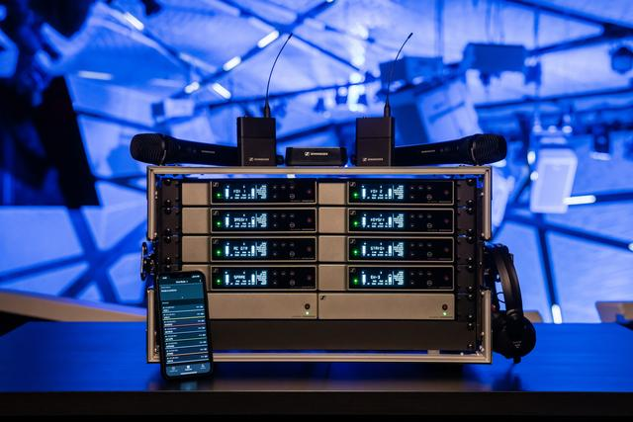 | With an app-based workflow and many professional features under the hood, Evolution Wireless Digital makes wireless easy

“We talked with dozens of bands prior to the development of Evolution Wireless Digital,” explains Oliver Schmitz, product manager for Evolution Wireless Digital. “Many band members are in fact multitasking, driving the gig bus, setting the wireless up, performing on stage, doing the accounting, the marketing, you name it. They do not want to become experts at RF, they do not want to scan a venue for open frequencies, they do not want to battle with settings. They just want something that works right away, so all they have to do is switch on and go.”

“This is why we came up with an app that does all the planning for you and guides you through the set-up,” adds Benny Franke, responsible for the software. “An app, where all the expertise is under the hood, and where you don’t have to be a mechanic to drive the car. There were many details that we sweated over so that you can keep your cool before, during and after the show.”

The engineer in your pocket: The Smart Assist App guides users through the set-up of their wireless microphone system | 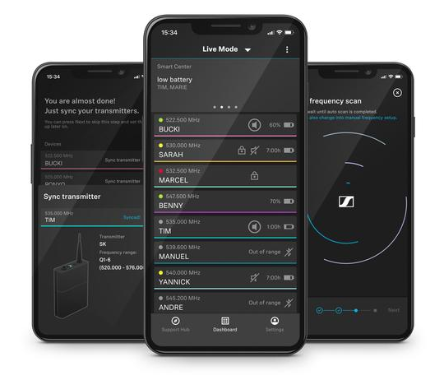
Why is it easy?
- The Smart Assist App
As the engineer in your pocket, the app guides you through the set-up in easy steps. “If you can handle an app, you can handle the RF wireless set-up with ease,” says Benny Franke. An intelligent set-up automatically creates reliable wireless connections, no wireless expertise is required. You can name the channels to make it easy to stay organized, and have access to all system settings. Bluetooth Low Energy allows for remote access to the system and makes sync’ing with the receiver convenient. The app also includes tutorial videos presented by Benny Franke to get you started and provides the operating instructions of the systems all in one place.

- Microphone transmitters that can handle any audio level
Evolution Wireless Digital transmitters have an input dynamic range of 134 dB, five times more than the usual 120 dB. This means that they can pick up everything from a very soft whisper to a jet engine at 50 yards’ distance – and this eliminates the need for a sensitivity setting on the transmitter entirely. The receiver has been set to a gain value covering most applications, which you can easily change if desired. A new user interface makes this super-easy – no complex sub-menus, everything is available at a glance.

- No frequency calculation – and more room to manoeuvre
More and more RF is appearing on stage but Evolution Wireless Digital (EW-D) takes on this complexity and helps you go with the flow. The app will scan the environment to find open frequencies. And as EW-D has borrowed tech from Sennheiser’s top Digital 6000 and Digital 9000 series, the wireless microphone systems do not generate any significant intermodulation products. This not only makes for more room in a given frequency window, but the app can also simply set the wireless links at 600 kHz intervals without any frequency calculation and is therefore able to fit in more frequencies than a standard mic system would be able to.

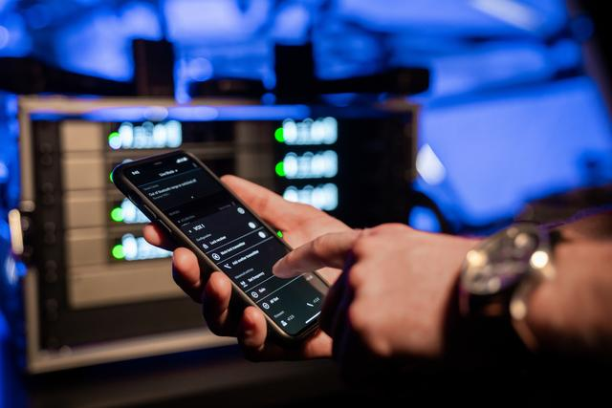 | Tech from higher Sennheiser series makes frequency calculation a thing of the past. Simply let the app scan the room for open frequencies, which can be set at 600 kHz intervals

- Exceptional specs in every detail
EW-D has a low latency of 1.9 milliseconds and a transmitter battery life of up to 12 hours with the BA 70 rechargeable battery pack. This will take you all the way from soundcheck through to the end of the show and beyond. A bandwidth of 56 MHz with up to 90 channels per band makes it easy to find space even in the most crowded of RF environments.

- Fantastic audio
As a digital system, EW-D does not use a compander. Gone are the associated noise floor and artefacts – the system will sound like it’s plugged in with a cable.

- Full range of pro accessories
From newly designed antennas to antenna splitters, boosters, charging sets – you will find everything to expand your system and accommodate larger multi-channel set-ups for in-person and streamed live shows.

The ADP UHF remote antenna features cut-outs to reduce wind load

Good news for vocalists: EW-D handheld transmitters couple with any Sennheiser or Neumann wireless capsule. This includes the Neumann KK 205 and KK 204, the new Sennheiser MM 435 and MM 445 as well as the Digital 9000 capsules – a first at this price level.

A perfect fit for your stage or streaming scenario
“Whether you are a singer/songwriter doing your first gigs and want to use your own microphone system, or a band tech who has mics, IEMs and a mixer in one convenient rack and uses a mixing app – Evolution Wireless Digital will perfectly fit into your preferred usage scenario, no matter whether you are planning an in-person or a streamed live gig,” concludes Oliver Schmitz.

Evolution Wireless Digital is available now, with a choice of handheld, instrument, lavalier, headmic, combo and base sets (see Appendix).

For your social media channels:
Sennheiser Evolution Wireless Digital – as easy as an app but fully professional.

Appendix:
Available Systems
Model |  | Delivery includes
EW-D 835-S SET  (MSRP: EUR 699) |  | - EW-D EM digital ½ 19” single-channel receiver  - EW-D SKM digital handheld transmitter  - MMD 835 mic head  - Microphone clip  - Power supply with country adapters  - Rack mount kit & AA batteries
EW-D CI1 SET  (MSRP: EUR 649) | 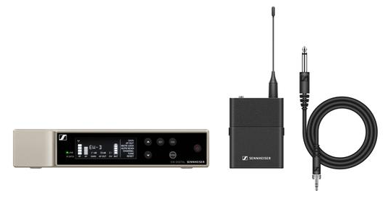 | - EW-D EM digital ½ 19” single-channel receiver  - EW-D SK digital bodypack transmitter  - Ci1 instrument cable  - Power supply with country adapters  - Rack mount kit & AA batteries
EW-D ME2 SET  (MSRP: EUR 699) | 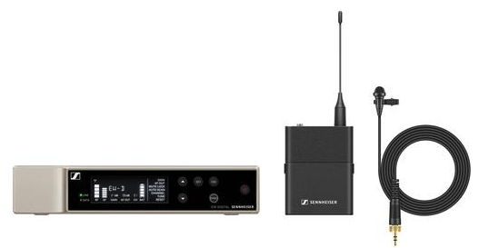 | - EW-D EM digital ½ 19” single-channel receiver  - EW-D SK digital bodypack transmitter  - New ME 2 lavalier mic (omni)  - Power supply with country adapters  - Rack mount kit & AA batteries
EW-D ME4 SET  (MSRP: EUR 699) | 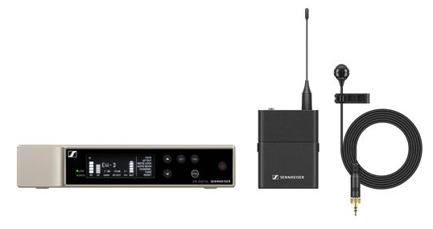 | As above but with new ME 4 lavalier mic (cardioid)
EW-D ME3 SET  (MSRP: EUR 749) | 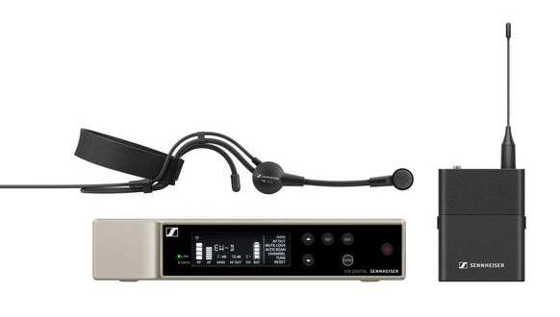 | As above but with new ME 3 headmic (cardioid)
EW-D SKM-S BASE SET  (MSRP: EUR 599) |  | - EW-D EM digital ½ 19” single-channel receiver  - EW-D SKM digital handheld transmitter  - Microphone clip  - Power supply with country adapters  - Rack mount kit & AA batteries
EW-D SK BASE SET  (MSRP: EUR 599) | 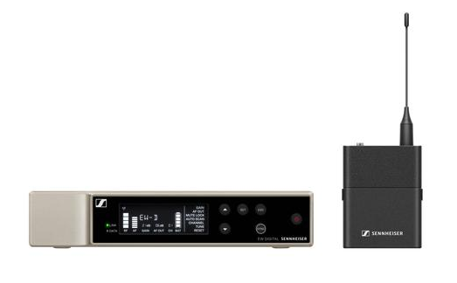 | - EW-D EM digital ½ 19” single-channel receiver  - EW-D SK digital bodypack transmitter  - Power supply with country adapters  - Rack mount kit & AA batteries
EW-D ME2/ 835-S SET  (MSRP: EUR 999) | 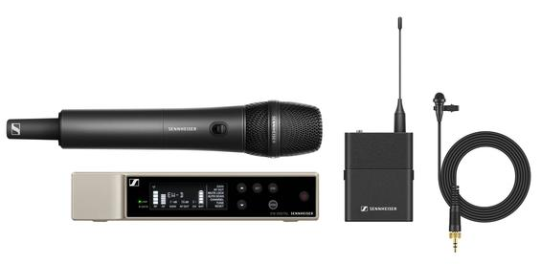 | - EW-D EM digital ½ 19” single-channel receiver  - EW-D SKM-S digital handheld transmitter  - EW-D SK digital bodypack transmitter  - MMD 835 mic head  - Microphone clip  - New ME 2 lavalier mic (omni)  - Power supply with country adapters  - Rack mount kit & AA batteries

Download links
Download product and system specifications
Download high-resolution product photos
Download accessory images
Download high-resolution music application photos
Download high-resolution education and corporate application photos

Evolution – evolving with you: www.sennheiser.com/EW-D

About Sennheiser
Shaping the future of audio and creating unique sound experiences for customers – this aim unites Sennheiser employees and partners worldwide. Founded in 1945, Sennheiser is one of the world’s leading manufacturers of headphones, loudspeakers, microphones and wireless transmission systems. Since 2013, Sennheiser has been managed by Daniel Sennheiser and Dr. Andreas Sennheiser, the third generation of the family to run the company. In 2019, the Sennheiser Group generated turnover totaling €756.7 million. www.sennheiser.com

Global Press Contact

Stephanie Schmidt
Stephanie.schmidt@sennheiser.com
+49 (5130) 600 – 1275

