AN ENHANCED HOME AUDIO EXPERIENCE
Sennheiser announces AMBEO|OS and a major software update to its Smart Control app

Sydney, Australia, 29 March 2022 – Sennheiser has released the all-new AMBEO|OS to provide AMBEO Soundbar users with an even more immersive 3D home audio experience. Additionally, Sennheiser has completely updated its Smart Control app with an intuitive and new user experience to give Soundbar and headphone users effortless sound control and personalisation.
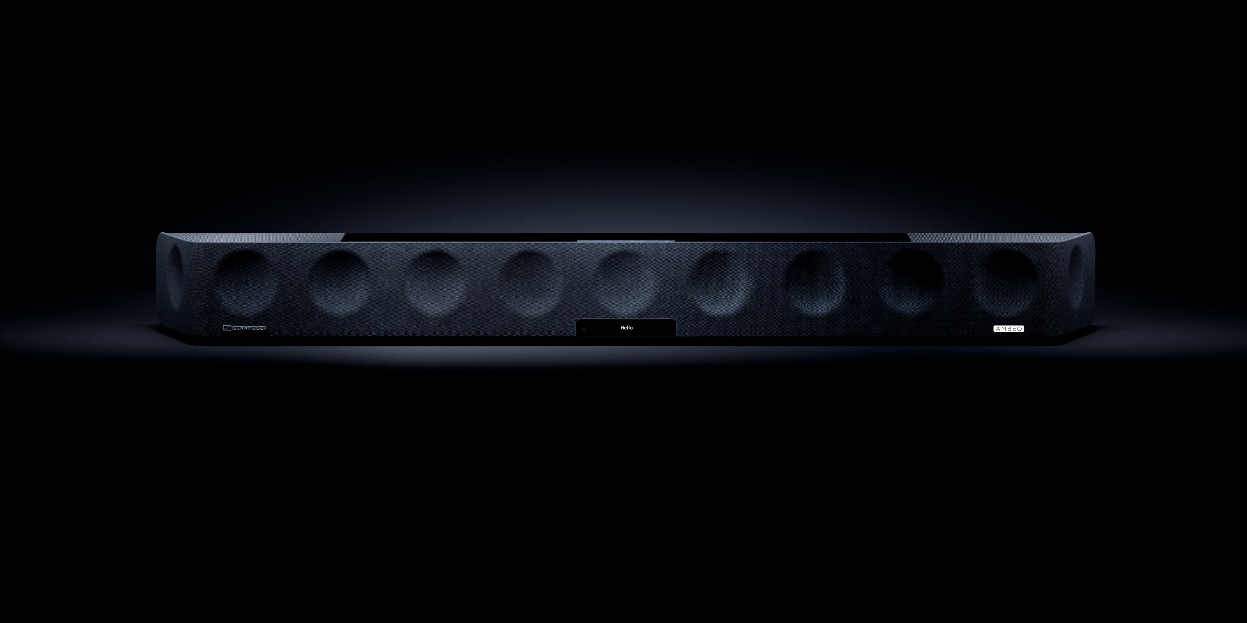
With the launch of AMBEO|OS, the AMBEO Soundbar receives a major update. The operating system expands the Soundbar ecosystem, introduces new functionalities, and elevates the user experience to greater heights.

With AMBEO|OS, which is available for all AMBEO Soundbars, listeners now have even more ways to enjoy incredibly immersive sound. The update supports Apple AirPlay 2, Spotify Connect, and Tidal Connect, providing even more options for high-quality listening.

Every aspect of AMBEO|OS has been meticulously optimised to ensure a smooth and enjoyable experience. By utilising Wi-Fi rather than Bluetooth Low Energy to connect to the Sennheiser Smart Control app, the user experience is faster and more responsive. The operating system also guarantees greater security and stability.

“The all-new AMBEO|OS is a gamechanger for our AMBEO Soundbar, and we are certain our customers are going to love it,” says Maximilian Voigt, Product Manager for Sennheiser AMBEO Soundbar. “By offering even more audio streaming providers and an improved user experience, Sennheiser customers will enjoy personalised high-resolution audio streaming with enhanced features.”

An app update with all-new functionalities
AMBEO|OS can be accessed through the completely rebuilt Smart Control app. The all-new app elegantly merges modern aesthetics with a more personal, relevant, and rewarding intuitive user experience.
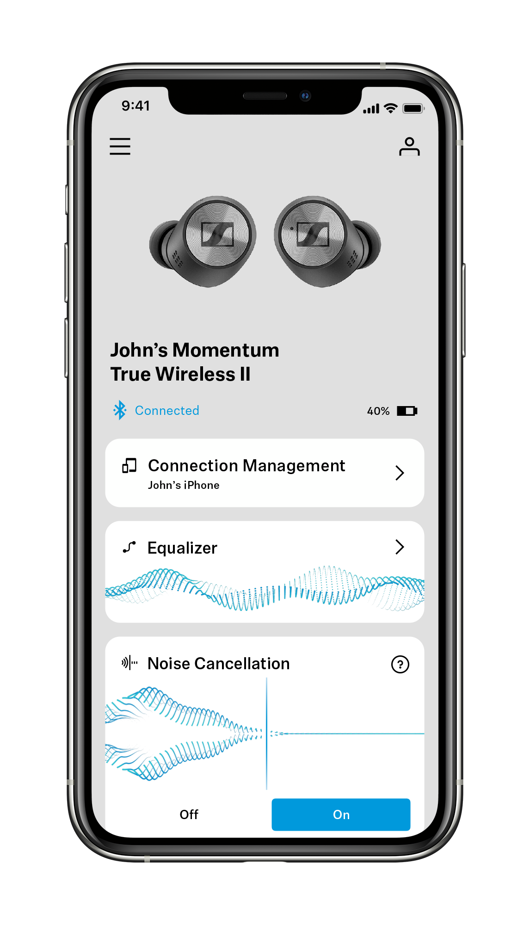
On top of that, Smart Control offers users exciting new features to improve the functionality of their Sennheiser headphones, including Sound Check and Sound Zones. Sound Check guides users through three easy steps to find the perfect EQ preset according to their tastes. Sound Zones let True Wireless users tailor EQ settings, Noise Cancellation, and Transparent Hearing to defined places – whether home, the office, or on the go – and dynamically adjust audio settings according to the user's location.

Smart Control also offers users a higher level of personalisation. User accounts make it even easier to transfer settings and customisations between Sennheiser devices. The in-app Discovery area provides relevant product news and updates from the Sennheiser world.

“The next update to our Sennheiser Smart Control app will offer our customers a level of personalisation that they have never experienced before,” says Polina Gartenfluss, Product Manager for Sennheiser Consumer Mobile Applications. “On top of individualised EQ presets and tailored sound setting for different locations, we are giving our customers access to personalised content to better meet their needs.”

The Smart Control app also includes an intuitive equaliser, pulls up digital user manuals, and provides the latest software and firmware for Sennheiser consumer products.

Control beyond the app
To offer as much flexibility as possible, users can also opt to control their AMBEO Soundbar via the dedicated web interface. They will have access to the same precise control and effortless ease of use along with a range of future-proof options to integrate their Soundbar into their digital environment.

The free software and firmware update will go live to all Smart Control and AMBEO Soundbar users on 29 March.
ABOUT the Sennheiser Brand
We live and breathe audio. We are driven by the passion to create audio solutions that make a difference. Building the future of audio and bringing remarkable sound experiences to our customers – this is what the Sennheiser brand has represented for more than 75 years. While professional audio solutions such as microphones, conference systems, streaming technologies and monitoring systems are part of the business of Sennheiser electronic GmbH & Co. KG, the business with consumer devices such as headphones, soundbars and speech-enhanced hearables is operated by Sonova Holding AG under the license of Sennheiser.

www.sennheiser.com
www.sennheiser-hearing.com
Global Press Contact
Sennheiser Consumer Audio GmbH
Paul Hughes
Head of PR and Influencers
T +49 (0)162 2921 861
paul.hughes@sennheiser-ce.com

