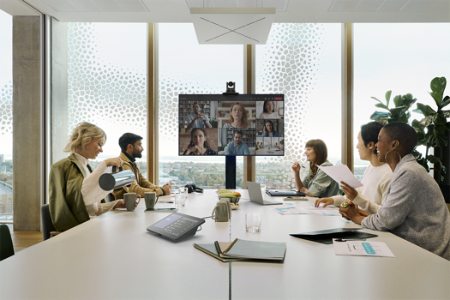

Sennheiser @ InfoComm 2024

Sennheiser to Showcase its Global Partnerships and Alliances at InfoComm 2024
Interactive Screen Experience, Scavenger Hunt and Partner Booth Exhibits All Await Attendees Eager To Discover Sennheiser’s Collaborative Innovations With Industry Partners.

LAS VEGAS — June, 2024— Sennheiser, the first choice for advanced audio technology that makes collaboration and learning easier, is excited to showcase its industry partnerships and alliances at InfoComm 2024 in Las Vegas from June 12 – 14.

Located in Central Hall of the Las Vegas Convention Center, the Sennheiser booth (C5335) will feature an interactive touchscreen and a scavenger hunt, allowing attendees to discover Sennheiser technology and collaborations designed to streamline integration and deliver engaging experiences.

At InfoComm 2024, integrators, consultants, and end-users can explore the full potential of Sennheiser products when paired with solutions produced by its global partners and alliances. Throughout the event, Sennheiser is collaborating with 20 leading manufacturers within its partner network, including Airtame, Crestron, Datavideo, Lightware, Lumens, Q-SYS, Xilica, and more, to deliver an in-show campaign that highlights the benefits of their combined solutions.
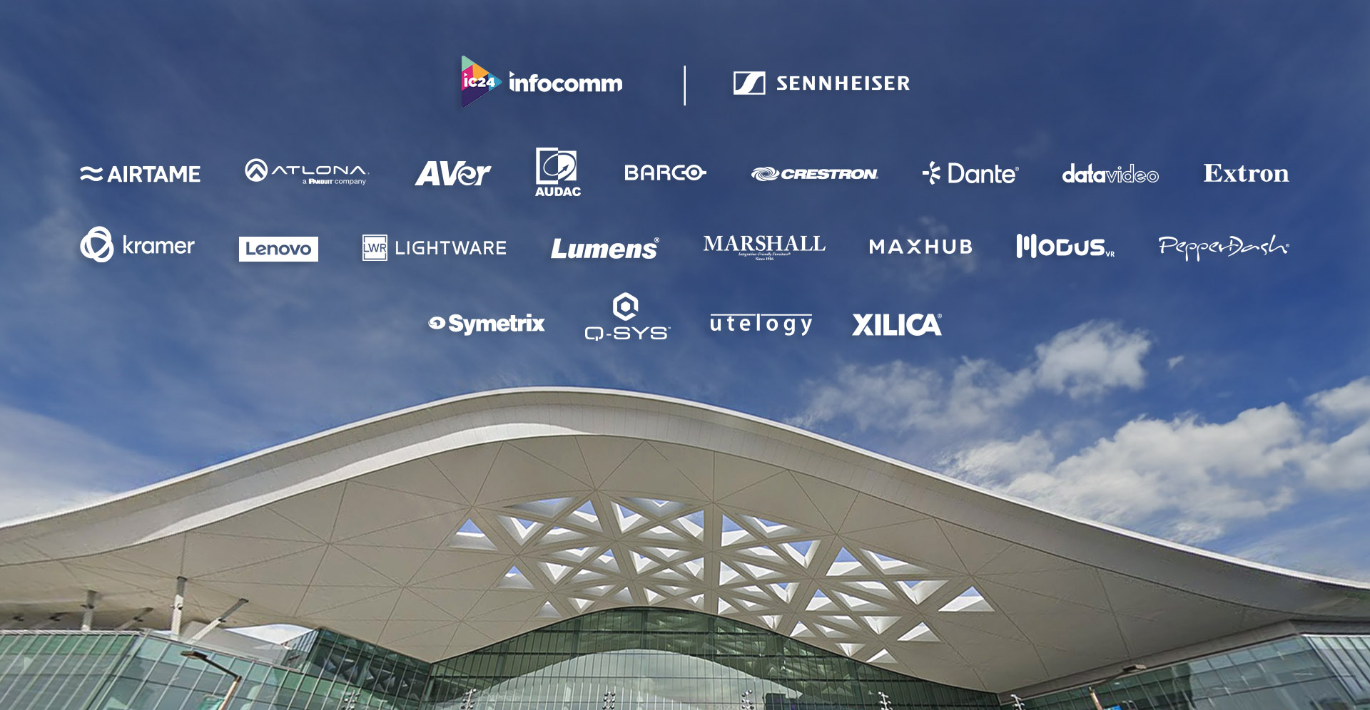

In the past few months, Sennheiser has made several announcements with some of its key industry partners. Most notably, Sennheiser has gained support for its TeamConnect Ceiling Medium — with announcements with AVer, Crestron, and Lumens — detailing how Sennheiser’s newest ceiling microphone works seamlessly with their solutions to provide camera tracking and high-quality audio. These partnerships, as well as many others, will be on full display everywhere at InfoComm 2024.

After a huge success at ISE 2024 Sennheiser is inviting InfoComm attendees to participate in an app-led scavenger hunt that includes Sennheiser and partner booths. Participants will be rewarded with exclusive — and incredibly comfortable — Sennheiser-branded socks and the chance for one person to win a Sennheiser TeamConnect Bar M.

Attendees can participate in the scavenger hunt by completing the following steps:
- Download the Scavify app.
- Search for ic24 and join the hunt.
- At the event, complete a series of tasks, with each task worth points. Tasks can be completed in any order, and the more points earned, the more chances to win. Just for entering and getting started with the activities, entrants will receive a free pair of Sennheiser socks.
- Visit Sennheiser booth C5335 to claim free Sennheiser socks.
- Engage with the touchscreen experience to learn more about Sennheiser’s partners and how to get the most out of an investment in Sennheiser solutions.

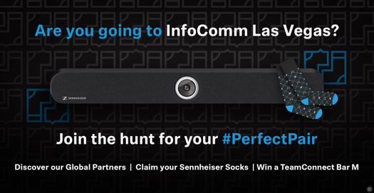

More information about Sennheiser at InfoComm can be found here. To book an appointment during the show, please get in touch with the press contact listed below.

###

About the Sennheiser brand
We live and breathe audio. We are driven by the passion to create audio solutions that make a difference. Building the future of audio and bringing remarkable sound experiences to our customers – this is what the Sennheiser brand has represented for more than 75 years. While professional audio solutions such as microphones, meeting solutions, streaming technologies and monitoring systems are part of the business of Sennheiser electronic GmbH & Co. KG, the business with consumer devices such as headphones, soundbars and speech-enhanced hearables is operated by Sonova Holding AG under the license of Sennheiser.

www.sennheiser.com
www.sennheiser-hearing.com

Local Press Contacts
Kirsten Spruch
kirsten.spruch@sennheiser.com
+1 (860) 598-7484

InGear
Peter Schuyler
peter@ingearpr.com
+1 917-496-8970

Global Press Contact
Jeff Horan
jeffrey.horan@sennheiser.com
+1 860-598-7539

