For immediate distribution

Sweetwater Studios to Host Pro Tools Master Class in May
Students Will Learn Tips and Techniques from Sweetwater Studios Senior Producer/Engineer Mark Hornsby
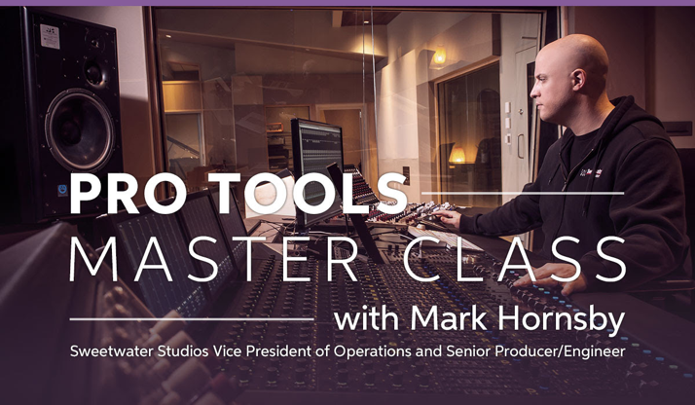
April 1, 2019, Fort Wayne, IN – Whether an amateur musician using Pro Tools for the first time or a seasoned studio professional, users of the digital audio workstation can join Sweetwater Studios Senior Producer/Engineer Mark Hornsby for three days of immersive and highly interactive learning from 9:00 a.m. to 6:00 p.m. on Thursday, May 9 to Saturday, May 11, at Sweetwater Studios, the commercial recording arm of Sweetwater Sound.
The course is an excellent opportunity for both beginners and advanced users and will be held in Sweetwater Studios and Sweetwater University. Registration is just $795 and will include:
- Pro Tools 101 Official Courseware by Frank D. Cook;
- A copy of the session files;
- A certificate of completion;
- Lunch every day;
- Dinner on Thursday with Mark Hornsby.

Topics covered during the three day course will include the following:

THURSDAY (Sweetwater Studio A)
- Session File Structure
- Pro Tools Navigation
- Edit Modes/Tools
- Recording Audio
- Capturing MIDI and Using Virtual Instruments
- Exploring Playlists and Comping Performances

FRIDAY (Sweetwater Studio A)
- Setting Up for a Mix
- Signal Routing
- Using Compression, EQ and FX
- Utility Automation
- Printing Your Final Mix and File Management

SATURDAY (Sweetwater University)
- Get Hands-on in Front of Your Own Pro Tools System
- One-on-one Collaboration with Mark
- Group Lab Exercises
- Keep Your Session Files
To register, please email studio@sweetwater.com or call (800) 386-6434. For more information, please visit https://sweetwaterstudios.com/pro-tools-master-class/
About Sweetwater Studios
Sweetwater Studios is a wholly owned subsidiary of Sweetwater Sound, Inc., the largest online music instrument retailer in the country. With three world-class studios designed by Russ Berger and access to a greater diversity of musical equipment and professional audio gear than any other recording studio in the world, Sweetwater Studios is able to accommodate just about any recording, mixing or mastering project, no matter how simple or complex. With renowned staff producer Mark Hornsby at the helm, who has worked on many Grammy-award winning albums, Sweetwater Studios also has an exceptional staff of producers, engineers, session musicians and studio technicians. For more information on Sweetwater Studios, please visit http://www.sweetwaterstudios.com.
Media contacts
Steve Bailey
Public Relations
Hummingbird Media
+1 (508) 596 9321
steve@hummingbirdmedia.com

Jeff Touzeau
Public Relations
Hummingbird Media
+1 (914) 602 2913
jeff@hummingbirdmedia.com

