For more information, please contact Marta de Paco
On +34 670 780 664 or email press@comunicahair.com

Important:
These images are only available for editorial content.
Credits must be included.
Notification of their publication is expected.

MANUEL MON
IRIS Collection

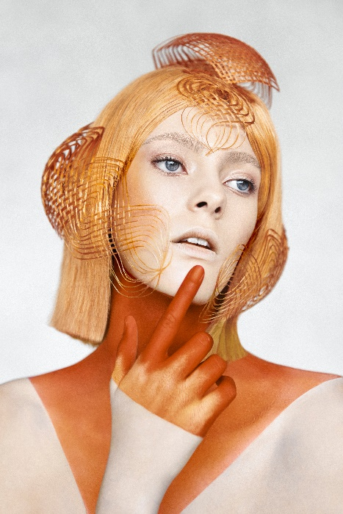
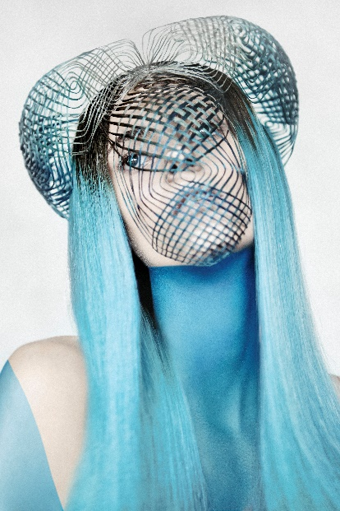
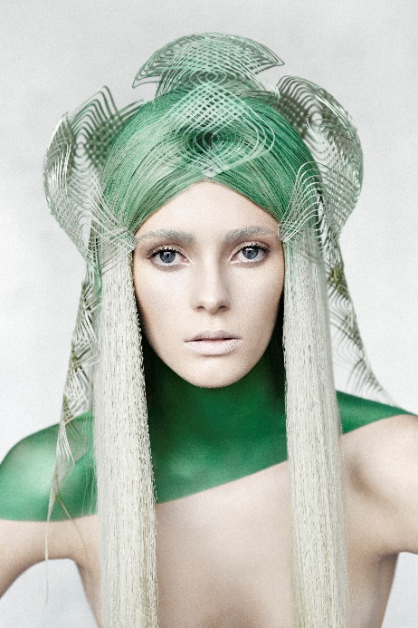

Hair: Manuel Mon | @manuelmonoficial
Photographer: Bernardo Baragaño | @vertigoestudio
MUA: Lorena Fernández | @lorenafernandezmua
Model: Cristina Pérez
Products: Revlon Professional Instagram: @revlonprofessional_es

MANUEL MON
IRIS Collection

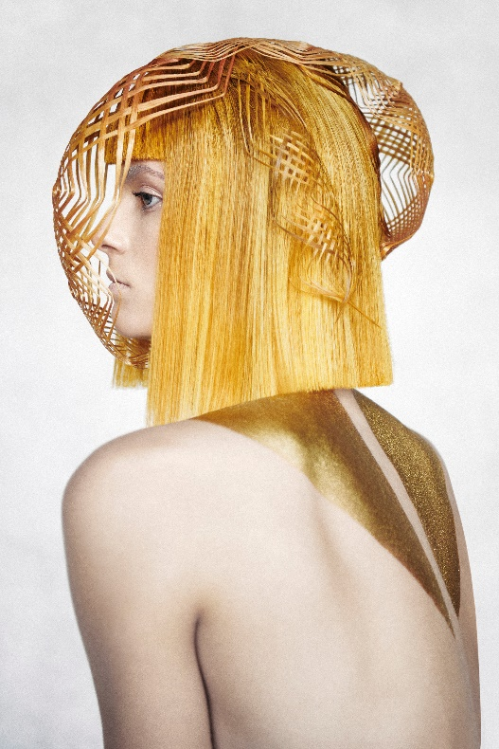

The collection explores the process by which fashion, at its most innovative extreme, invades the mind and creates trends.
Each look combines neatness and harmony in forms, illogical and unreal, held in the limbo of the ethereal.
Everything is executed with an artisan meticulousness that develops new manual, laborious and ancient techniques that take on new expression as innovation and infinite fashion.
The hair strands are subtly woven in colors that flow naturally to the body, uniting the two into a conceptual, irreverent and contemporary whole.

