**Avalanche Dog 2.0: The New Mammut Barryvox® S2**

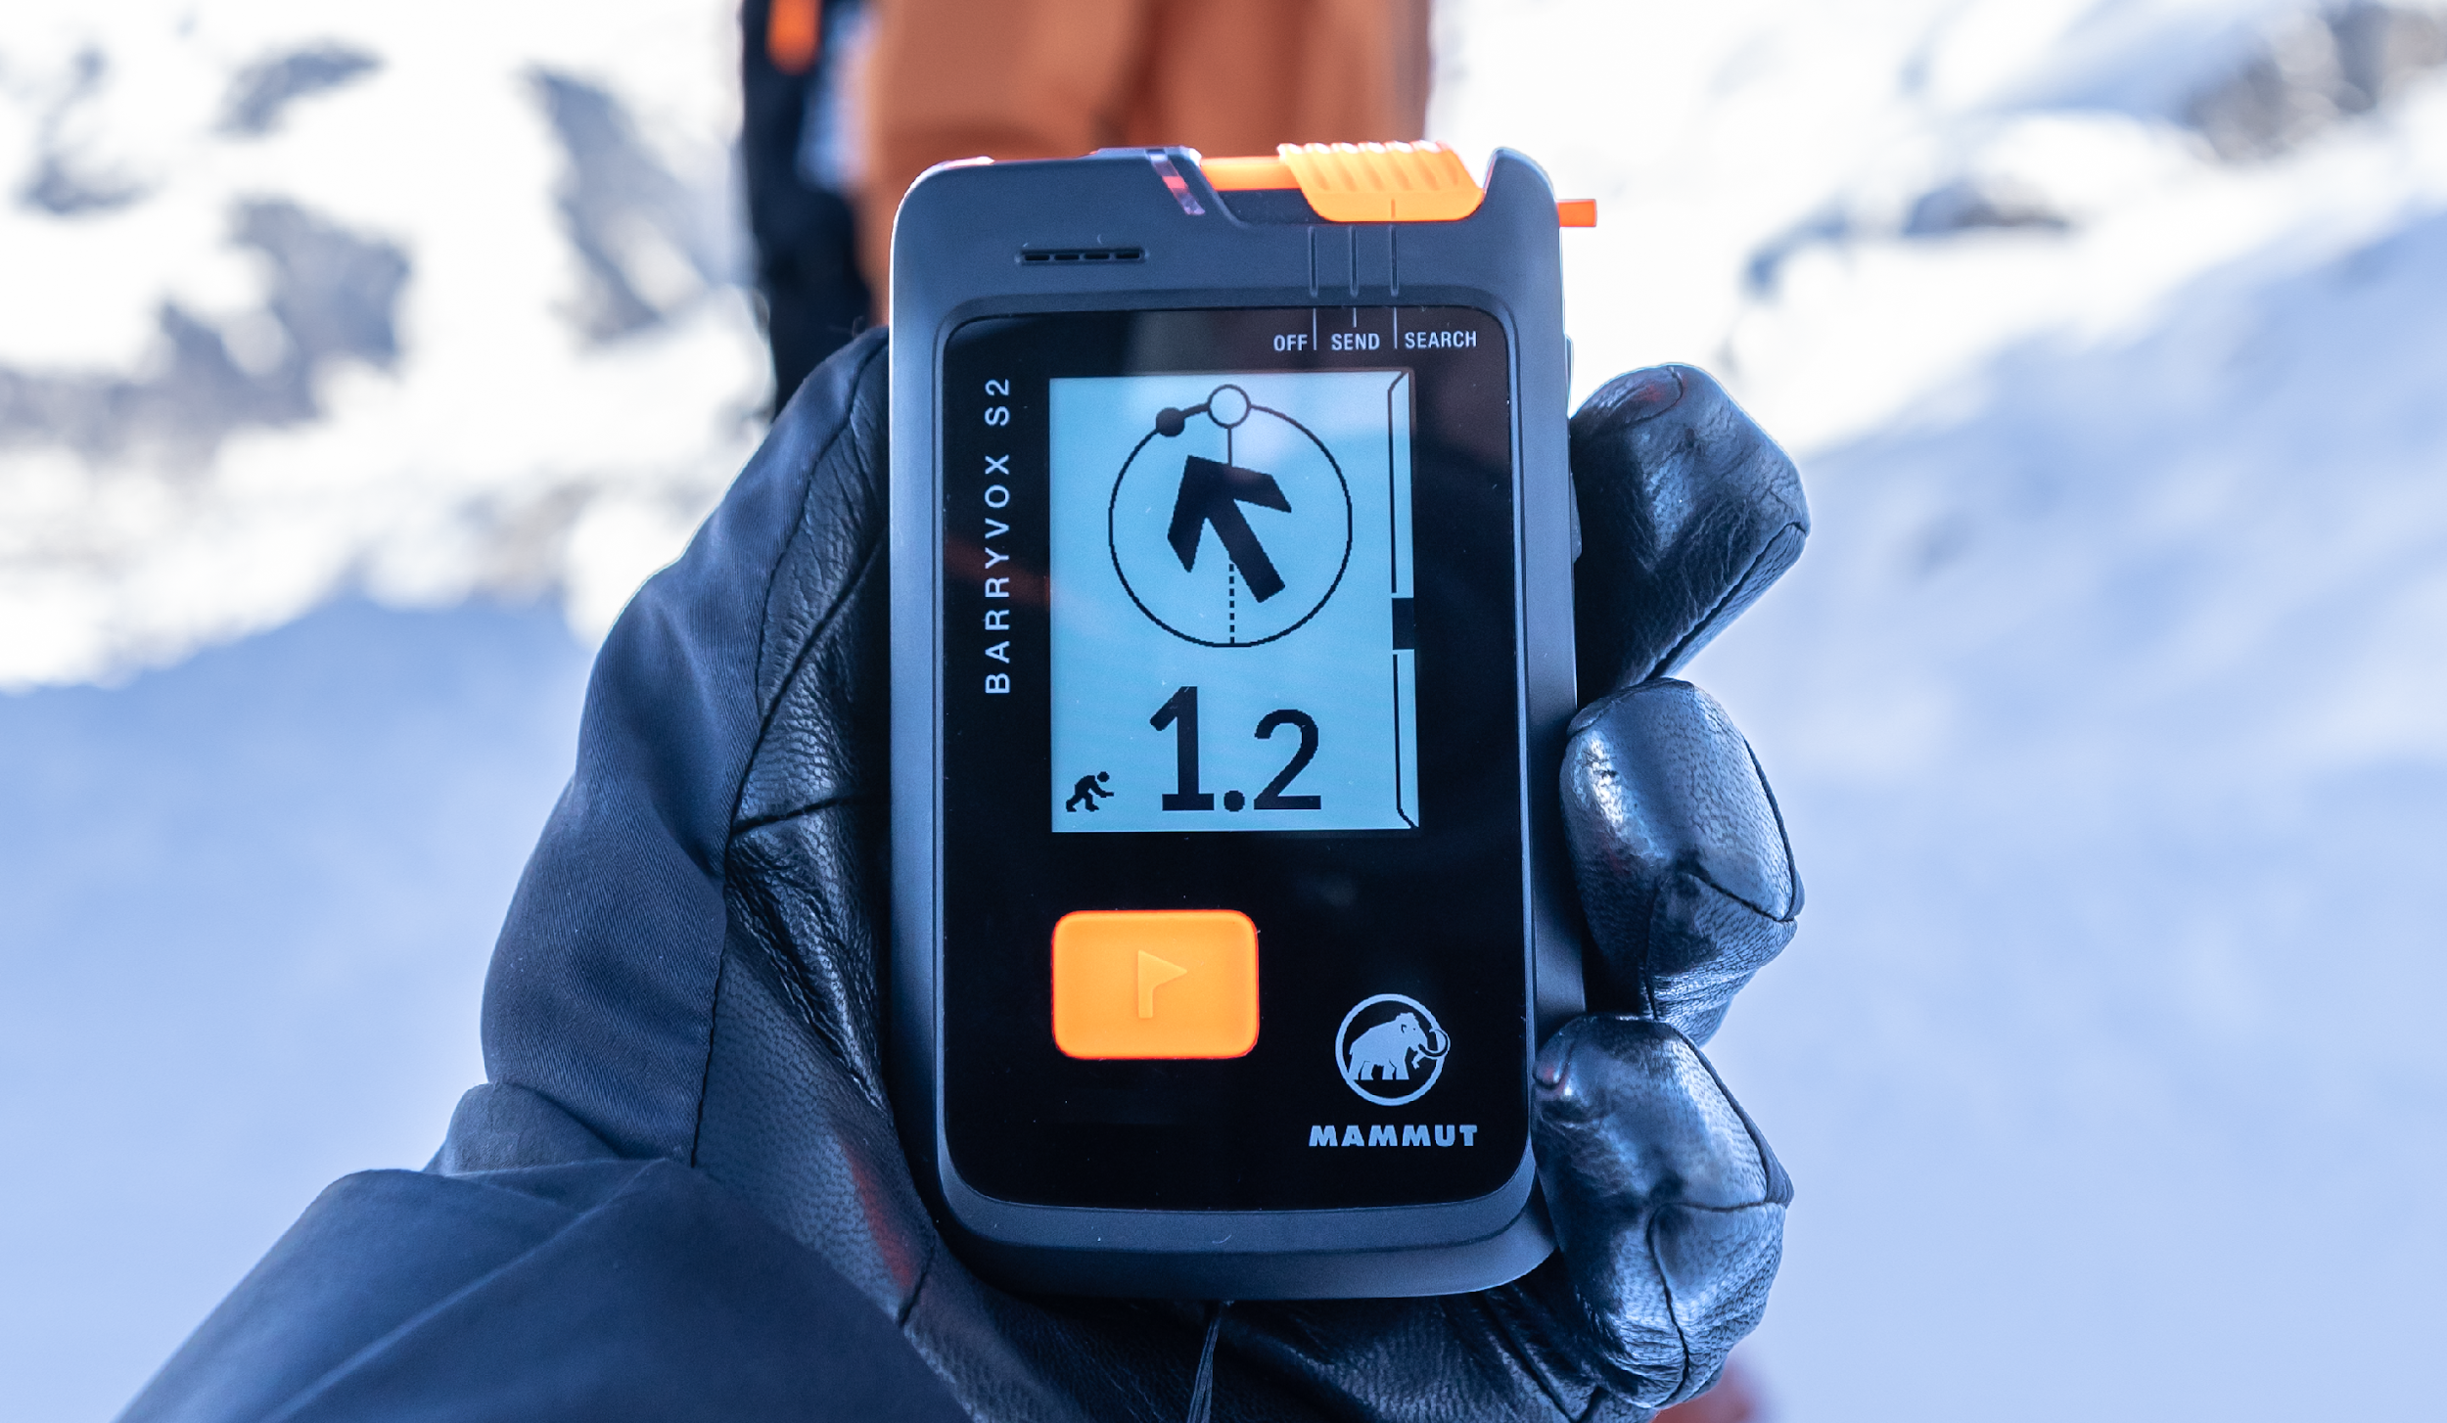*The Barryvox® S2 combines intuitive operation with advanced search support, setting new standards in avalanche rescue. ©Mammut Sports Group AG*

**Smaller, smarter, faster. Mammut Sports Group AG proudly presents the new Barryvox® S2, a groundbreaking avalanche transceiver that marries compact design with intuitive operation and modern technology. After years of development and continuous optimization, the Barryvox® S2 offers more efficient and precise support for rescuers, raising the bar for avalanche safety.**

Whether you're a ski touring beginner or a professional freerider: safety is paramount. The new Barryvox® S2, now 6 mm thinner, is one of the smallest avalanche transceivers on the market— without sacrificing search performance. Like its two predecessors, this three-antenna device maintains a search strip width of an impressive 70 meters, saving crucial time in emergencies. Its intuitive operation, combined with advanced search capabilities, sets a new benchmark in avalanche rescue technology.

One of the standout new features is the **Memory-in-Pixel (MIP) display**, designed for optimal readability in all conditions—even in direct sunlight or while wearing polarized glasses. The energy-efficient screen also reduces power consumption, extending battery life for longer use in critical situations.

In addition to visual signals, the Barryvox® S2 provides **acoustic cues**, which are especially valuable in the early stages of a search when covering large distances quickly is essential. The device's **intelligent fine search guidance** is another innovation that sets the Barryvox® S2 apart from other devices. Using a sophisticated algorithm, the device calculates the nearest point to the buried subject and visually guides the rescuer through the fine search process. The **probing indication** also shows the burial depth, helping rescuers transition to pinpointing the exact location. The **Interference Guard** feature further enhances rescue operations by detecting electronic interference and either boosting transmission strength (for passive interference) or reducing interference from active electronic sources. For added safety, the transceiver includes a **rescue SEND function** with automatic transmission switching, crucial for rescuers who are assisting but not conducting the avalanche transceiver search themselves.

*"We have developed an avalanche transceiver that not only guarantees personal safety at the highest level but also optimizes search performance with reliable support. Our goal was to create a compact, comfortable device that’s so easy to wear, you’ll forget it’s there. We also prioritized making searches more intuitive, thanks to the MIP display, a redesigned user interface, an improved intelligent fine search guide, and enhanced acoustic feedback,"* summarizes **Alexander Weijnman, Head of** Avalanche Safety at Mammut.

**Digital connectivity and training support app**

In addition, the integration of the Barryvox® app enables digital connectivity with functions such as firmware updates and access to the new "Barryvox® Training Park". This feature enables users to train in realistic simulated scenarios to improve their avalanche search skills and be better prepared for an emergency.

Since Mammut launched the first avalanche transceiver in 1968, the flagship product has become synonymous with Swiss innovation and reliability. The Barryvox® S2 is now more than just an avalanche transceiver; it is a comprehensive safety system that supports more or less experienced mountaineers alike. By combining advanced technology with user-friendly design, the Mammut Barryvox® S2 sets new standards in avalanche safety, proving that compactness, high performance, and intuitive operation can go hand in hand.

**About Mammut**

Founded in 1862, Mammut is a Swiss outdoor company that provides high-quality products and unique brand experiences for fans of mountain sports around the world. This leading international mountain sports brand has stood for safety and pioneering innovation for over 160 years. Mammut products combine functionality and performance with contemporary design. With its combination of hardware, shoes, and clothing, Mammut is one of the most complete suppliers in the outdoor market. Mammut Sports Group AG operates in around 40 countries and employs around 850 people.

**mammut.com**