INTERNAL AND CONFIDENTIAL
Sony Contacts:
Cheryl Goodman, Corporate Communications
selpr@sony.com
858.942.4079

Caroline Mizuki, Imaging Products & Solutions Americas
caroline.mizuki@sony.com
858.951.6271

Sony Announces “Visual Story,” a New iOS App with Cloud Storage for Professional Wedding and Event Photographers

Visual Story Allows for Fast Editing and Instant Delivery of Curated, Edited Galleries for Clients

- Free iOS app for wedding and event photographers
- Automated image transfer from compatible Sony Alpha cameras to the Cloud
- Immediately edit and deliver curated digital albums to clients
- Utilizes AI and camera metadata to assist image selection and organization

SAN DIEGO – December 1, 2020 – Today, Sony Electronics announced “Visual Story” – a new application for wedding and event photographers that simplifies gallery creation, cloud storage and web delivery. Unique to Sony camera users and available for iOS, Visual Story offers professionals a solution to expand their business and increase overall client satisfaction by allowing them to immediately share their gallery with their friends and family via social media.

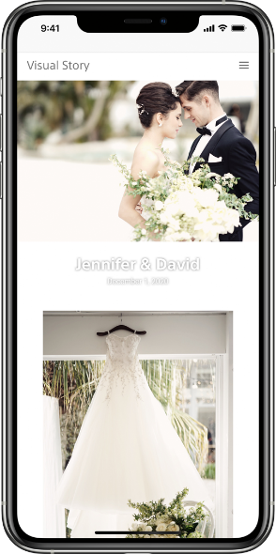

“The voice of our customer is at the center of everything we do,” said Neal Manowitz, deputy president of Sony Imaging Products and Solutions Americas. “Today’s professional photographers constantly challenge themselves to deliver higher quality content faster than ever to their clients. Visual Story allows them to streamline their workflow, ultimately giving them the ability to edit, select and send photo galleries to their clients on the day of the ceremony or event. Sony continues developing innovative hardware and software solutions empowering content creators to capture, communicate and share in ways never before possible.”

A Professional Workflow Simplified
With Visual Story, photographers can now deliver a fully edited and curated photo gallery instantly, on site and on the day of the big event – eliminating days of work previously spent organizing and editing assets. This is made possible by the connection of the app to a compatible Sony camera. While the photographer is shooting, all images are automatically transferred from the camera to a connected smartphone or tablet, as well as Sony’s cloud service. Images are then automatically organized using Artificial Intelligence (AI), and can be sorted based on metadata, star ratings, shooting timeframe, focus position and more.

AI will also sort based on different types of images from the event, including cake and ring ceremony, speeches, first dances and others, automatically detecting if a subject’s eyes are closed in an image. Additionally, when reviewing images shot with more than one camera, the photographer can also filter images by camera for added sorting options.

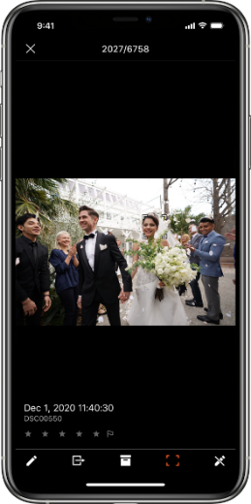
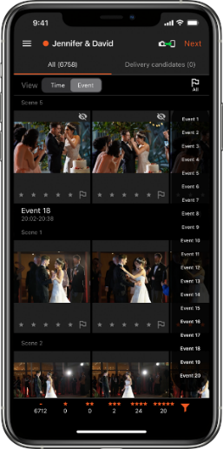

Effortless Edits
Using Visual Story’s auto preset application, wedding photographers can automatically apply edit presets that they have created or fixed presets – significantly reducing time spent editing images. By simply registering an edit preset prior to shooting, users can apply that preset to all images saving time and effort all while maintaining a consistent look throughout the entire shoot. The application is also equipped with a variety of editing functions, from basic corrections such as exposure, white balance and contrast, to more advanced corrections such as hue, saturation and luminance.

Sharing Made Simple
Using cloud collaboration, images can be synchronized on multiple mobile devices for easy viewing. Visual Story also allows wedding photographers to automatically create an online gallery for their clients, which can be delivered instantly on site. This can be offered to their client as an additional service, or complimentary and included in their wedding or event package.

Ratings and selections made while creating a photo gallery can be downloaded as an XMP file, then transferred to another application on a PC to simplify the final delivery process. As a bonus, photographers can also embed a logo, their social media information and more, directly on the images within the photo gallery – making it easier than ever to brand and market their business, especially when their clients share the images on various social media platforms.
Visual story is perfect for a variety of events from weddings to parties and corporate events to family photos and more. It is ideal for any situation where many photos are taken that need to be delivered instantly. Visual Story will continue to evolve in these various applications, reflecting our customers’ needs.
Compatibility and Availability
Visual Story is available now for iOS in the Apple App Store for free and is compatible with select Sony cameras including: Alpha 7C, Alpha 7R IV, Alpha 7S III, Alpha 9, Alpha 9 II^{i}. Alpha 7 III will be supported in a future firmware update planned for Spring 2021.

Sony’s new Visual Story is available to download for free HERE, and development on additional platforms is under discussion.

Exclusive stories and exciting new content shot with Sony's imaging products can be found at www.alphauniverse.com, a site created to educate and inspire all fans and customers of Sony α - Alpha.

###

About Sony Electronics Inc.
Sony Electronics is a subsidiary of Sony Corporation of America and an affiliate of Sony Corporation (Japan), one of the most comprehensive entertainment companies in the world, with a portfolio that encompasses electronics, music, motion pictures, mobile, gaming, robotics and financial services. Headquartered in San Diego, California, Sony Electronics is a leader in electronics for the consumer and professional markets. Operations include research and development, engineering, sales, marketing, distribution and customer service. Sony Electronics creates products that innovate and inspire generations, such as the award-winning Alpha Interchangeable Lens Cameras and revolutionary high-resolution audio products. Sony is also a leading manufacturer of end-to-end solutions from 4K professional broadcast and A/V equipment to industry leading 4K and 8K Ultra HD TVs. Visit http://www.sony.com/news for more information.

Notes:

Please refer to the website for a full list of compatible models. Firmware must be updated on cameras to ensure compatibility.
Membership to “Visual Story” account and app on smartphone required with connection to Wi-Fi. See “Visual Story” terms and conditions/privacy policy for details.
iPhone/iPad: iOS 13.0 -14.2.

