AES NY: RME Updates SteadyClock Technology in its Interfaces,
Brings Self-Jitter within a Femtosecond

SteadyClock FS’s low phase noise oscillator results in ultra-clear sonic image

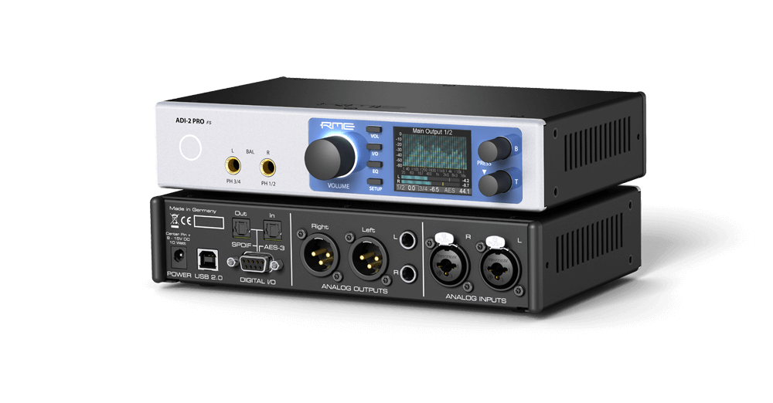
New York, NY, October 8, 2019 – RME, [AES NY Booth 413], premier German manufacturer of audio interfaces, has officially rolled out its SteadyClock FS, the latest version of its SteadyClock technology that offers synchronization and jitter suppression in digital audio signals. This ultra-stable femtosecond clock takes self-jitter to an all-time low by improving its second, analog PLL circuit and referencing both Direct Digital Synthesis and PLL to a low-phase noise quartz crystal. The result is a stunningly clear sonic image.
“SteadyClock FS provides users with the lowest jitter they can possible get,” said Derek Badala, Director of Sales, Americas for Synthax — RME’s U.S. distributor. “The outstanding clock performance in our interfaces enable end-users to optimize their recordings and mixes because the soundstage has more depth and clarity.”
Say ‘goodbye’ to jitter
SteadyClock was originally developed to gain a stable and clean clock from the heavily jittery MADI data signal. Self-jitter is measured through DA conversion and now reaches levels that are usually only available in master quartz clock mode, while Steady Clock continues to run in PLL mode. Despite if it’s an internal or external clock, the sound is exactly the same. The low phase noise oscillator driving the updated circuit reaches jitter specs lower than a picosecond to an area called femtosecond (fs).
SteadyClock FS features a few small improvements in the latest FS version, including even more efficient filtering and a design based on a super low jitter reference clock.
A breakthrough in clocking: ADI-2 DAC
RME’s recently released ADI-2 DAC converter is the first product in the RME family to feature SteadyClock FS. The ADI-2 DAC is a versatile 2-in/4-out studio-quality AD/DA converter that can be used as a USB audio interface, a double headphone amplifier, a high-end AD/DA frontend and headphone amp for iOS devices, a multi-format converter (AES, SPDIF, ADAT) with monitoring function, a DSD record and playback solution, and an AD/DA frontend for audio measurement up to 768 kHZ sample rate. The new SteadyClock FS technology provides the ADI-2 Pro FS with ultra-stability.
For more on RME, visit the Synthax booth 413 during AES New York 2019 or visit rme-usa.com.

About Synthax, Incorporated
Synthax Inc. is the exclusive USA distributor for RME digital audio solutions, Digigram broadcast audio systems, Appsys digital audio tools, Ferrofish advanced audio applications, myMix personal monitoring systems and ALVA cableware. We supply a nationwide network of dealers with these products for professional audio, broadcast, music industry, commercial audio, theater, military and government applications. For additional information, visit the company online at http://www.synthax.com.

Media Contacts:
Katie Kailus
Public Relations
Hummingbird Media
+1 (630) 319-5226
katie@hummingbirdmedia.com

Jeff Touzeau
Public Relations
Hummingbird Media
+1 (914) 602 2913
jeff@hummingbirdmedia.com

