**Milan Fashion Week**

**Emilio Pucci Spring/Summer 2017**

Hair Design by James Pecis for Moroccanoil

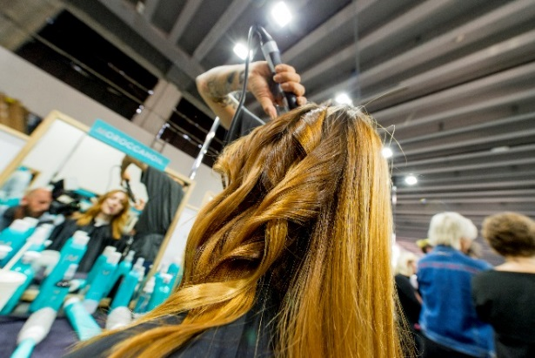 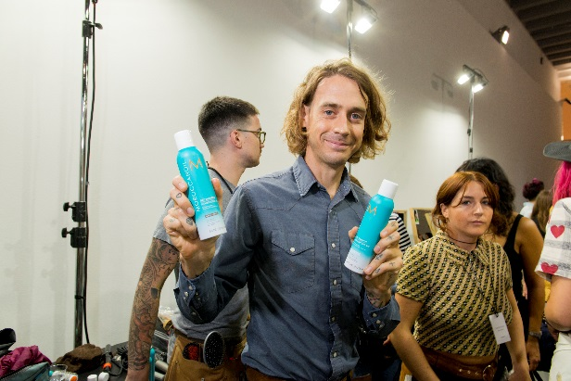

**Inspiration:**

The Emilio Pucci Spring/Summer 2017 Collection is full of color and vitality. To further enhance this, James Pecis created fluid, feminine hairstyles; sexy and intriguing.

**Get The Look:**

* Prep the hair using **Moroccanoil Treatment** to form the perfect foundation for styling while hydrating the hair, controlling frizz and giving shine to the look.
* Then, spray the hair with **Moroccanoil Root Boost** from roots to tips to achieve volume and structure. Depending on the hair type, use **Moroccanoil Dry Shampoo** (Light or Dark tones) to absorb excess oils and create definitive texture.
* Using the **Moroccanoil Professional Series Hair Dryer** and the **Moroccanoil Paddle Brush**, gently blow dry the hair to achieve a soft and feminine effect. Once dry, create a deep central parting at the crown of the head.
* Take random 1’’ sections of hair, and use a medium curling iron to wrap each strand, leaving out the tips, letting each curl fall naturally.
* Dispense a small amount of **Moroccanoil Smoothing Lotion** onto hands and use fingers to open and define the curls with swift, light movements.
* To finish, spray **Moroccanoil Luminous Hairspray Medium** for moveable hold.

