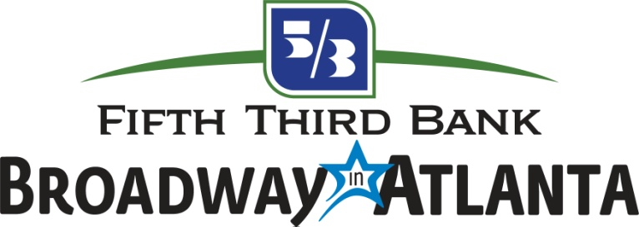

FOR IMMEDIATE RELEASE
MEDIA CONTACT:
Claire McKenzie
BRAVE Public Relations
404.233.3993
cmckenzie@bravepublicrelations.com

Broadway in Atlanta offers discounted student rush tickets
for THE KING AND I at the Fox Theatre September 26 – October 1

ATLANTA (September XX, 2017) - Local college students looking for a steal are in for a treat as Fifth Third Bank Broadway in Atlanta offers a special $25 Student Rush Ticket for the Atlanta engagement of THE KING AND I, playing at The Fox Theatre September 26 – October 1 to kick-off to the 2017/2018 season. Students simply need to bring valid college student identification with them to the Fox Theatre Box Office two hours prior to each performance. The Student Rush Ticket price will be valid for all performances with a two-ticket limit per student ID. Student Rush Tickets are subject to availability and will be sold from best available, which may include limited view locations.

One of Rodgers & Hammerstein’s finest works, THE KING AND I tells the story of the unconventional and tempestuous relationship that develops between the King of Siam and Anna Leonowens, a British schoolteacher, whom the modernist King, in an imperialistic world, brings to Siam to teach his many wives and children. Set in 1860’s Bangkok, this musical is directed by Tony Award® winner Bartlett Sher and has received four 2015 Tony Awards® including Best Revival of a Musical. THE KING AND I boasts a score that features such beloved classics as “Getting To Know You,” “Hello Young Lovers,” “Shall We Dance,” “I Have Dreamed” and “Something Wonderful.”

THE KING AND I will play at Atlanta’s Fox Theatre September 26 – October 1. The performance schedule is as follows:

Tuesday-Thursday 7:30 p.m.
Friday 8 p.m.
Saturday 2 p.m., 8 p.m.
Sunday 1 p.m., 6:30 p.m.

For more information, visit broadwayinatlanta.com.

About Broadway in Atlanta
BROADWAY IN ATLANTA is a member of the Broadway Across America network. Broadway Across America is part of The John Gore Organization family of companies, which includes Broadway.com and is operated by John Gore (Owner & CEO). BAA is the foremost presenter of first-class touring productions in North America, operating in 38 markets. Current and past productions include Beautiful, Chicago, Fiddler on the Roof, Finding Neverland, Million Dollar Quartet, Hairspray, On Your Feet!, The Producers, and CATS. Broadway.com is the premier theater website for news, exclusive content and ticket sales. For more information please visit BroadwayAcrossAmerica.com and Broadway.com.

# # #

