Powersoft UNVEILS MEZZO AT INFOCOMM 2019

announcing the ultimate smart solution for corporate, hospitality, education

Orlando, FL
June 12, 2019
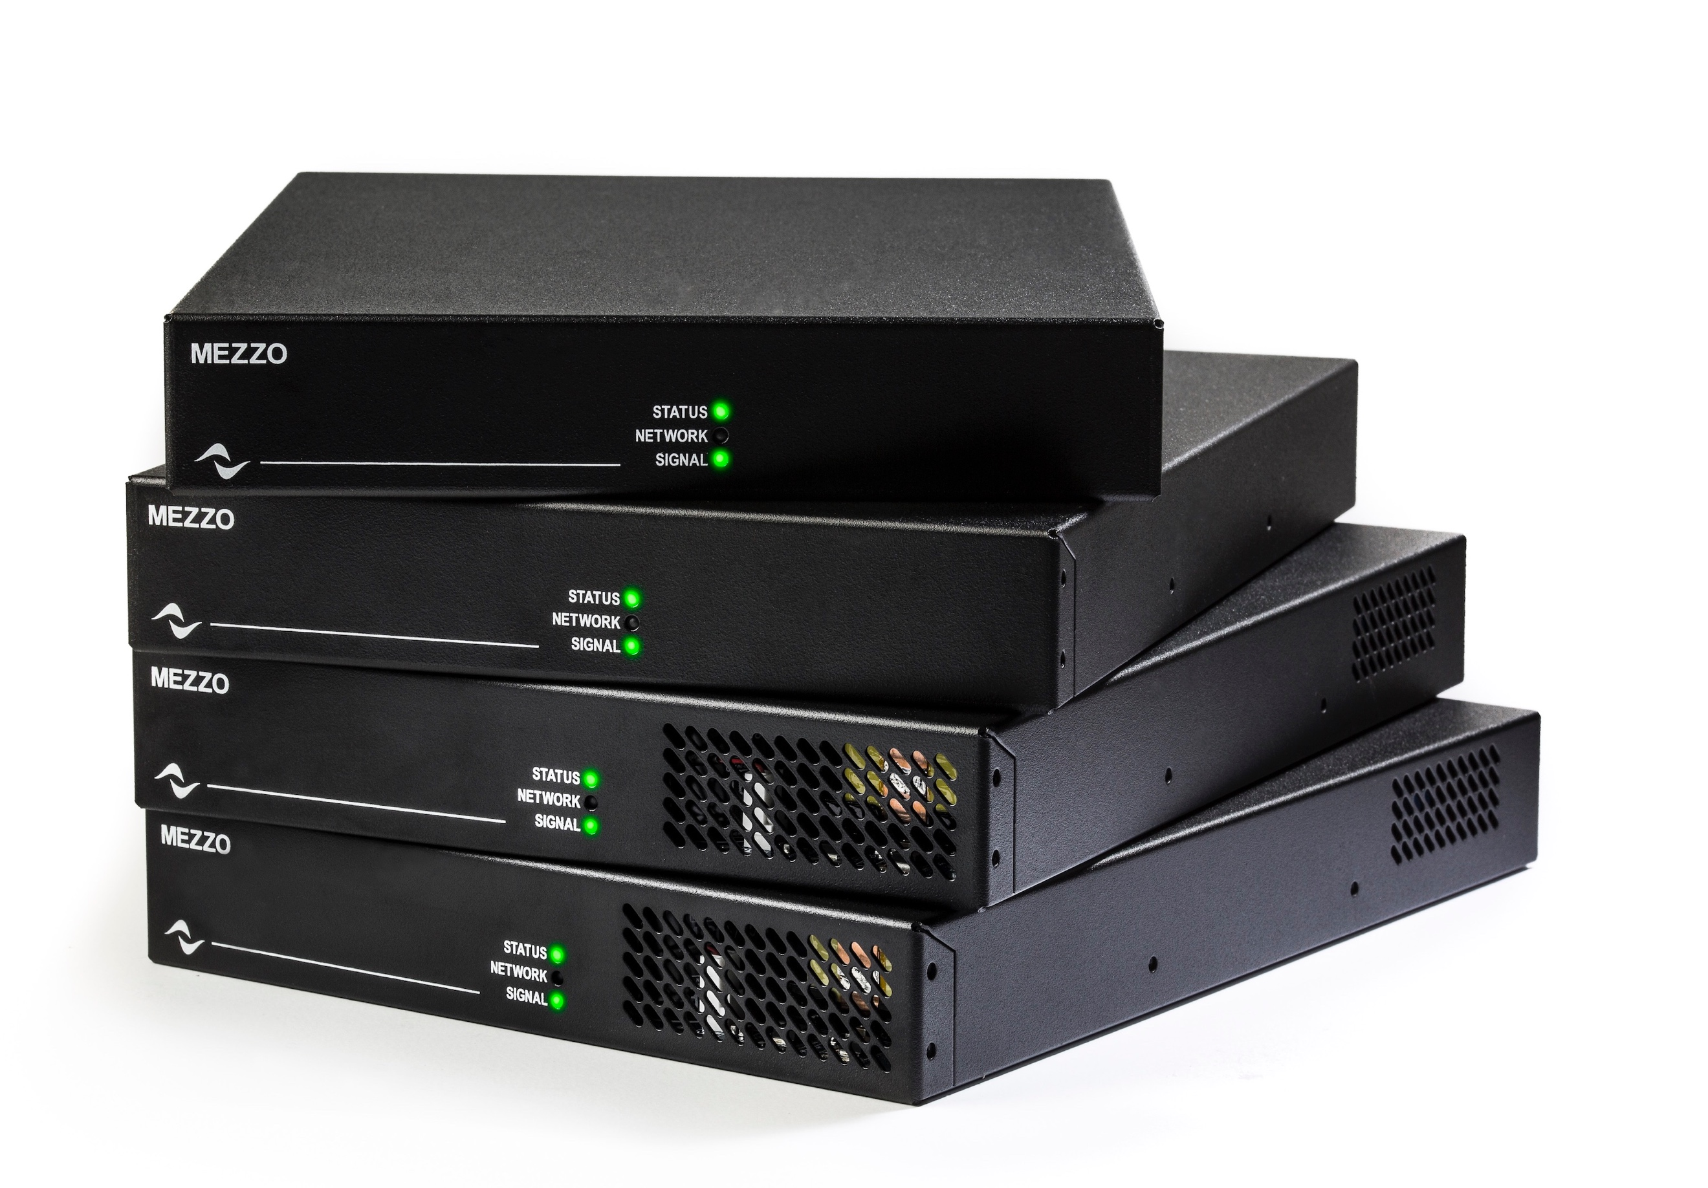
Italian audio innovator Powersoft unveiled its newest amplifier platform at InfoComm 2019 [Booth 6681, West Level 2] during a press conference today for industry media and VIP guests. Mezzo, a new line expressly designed for the AV/IT market, consists of eight amplifier models, each offering different power and connectivity options. Mezzo, which is perfectly suited for corporate, hospitality and educational environments, is a self-configuring amplifier system that delivers unprecedented power and flexibility in a highly compact, Class-D technology design that is easy to install and operate.

Mezzo is a highly reliable and flexible system from one of the leading innovators in amplifier technology — making it ideal for a range of fixed application scenarios. Further, Mezzo is simple to set up and can be monitored remotely, making it attractive to integrators seeking reduced installation times and more efficient deployment of A/V staff in the field.

“Until now, AV/IT integrators and end-users might have experienced limited flexibility in existing low power solutions to drive audio in corporate, hospitality and education environments,” commented Klas Dalbjorn, Product Manager, Powersoft. “Our new Mezzo platform delivers the quality and reliability Powersoft is already known for, but with smaller power configurations that are highly adaptable for a range of different fixed installation environments. We recognize there are many system designers and integrators that seldom need more than 250W and can often make do on as little 15W on a channel — Mezzo covers these needs.”

Mezzo: power to fit your needs
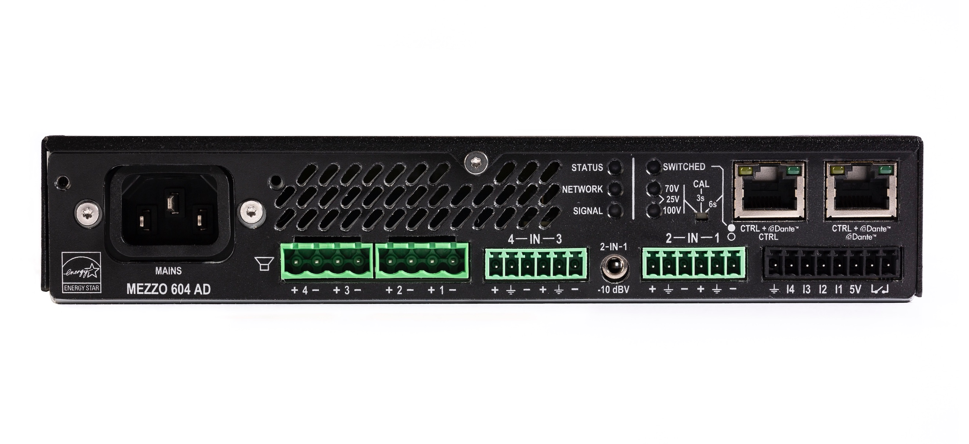
The eight available models in the new Mezzo line consist of four power sizes, each offering an option with “A” (Analog) or “AD” (Analog-Digital), which adds Dante/AES67. The power sizes include smaller option of 320W in 4 x 80W and 2 x 160W variants, and a larger option of 600W in 4 x 150 or 2 x 300W. All of the eight models are networkable and feature automatic setup for audio parameters, significantly reducing deployment time during installation. Further, all of the units offer load monitoring, so users can monitor system parameters such as temperature, power usage and performance over time. These parameters can be monitored and controlled via Powersoft’s own Armonía system manager, or through an external control system or a plug-in in a DSP matrix platform.

The AD models include Dante and AES67 integration, and also add an internal Gigabit Ethernet switch and a second port, meaning that multiple products can share the same network cable. This feature can convenient in a retrofit, or if the user needs to share a network connection between a projector and an amplifier for instance.

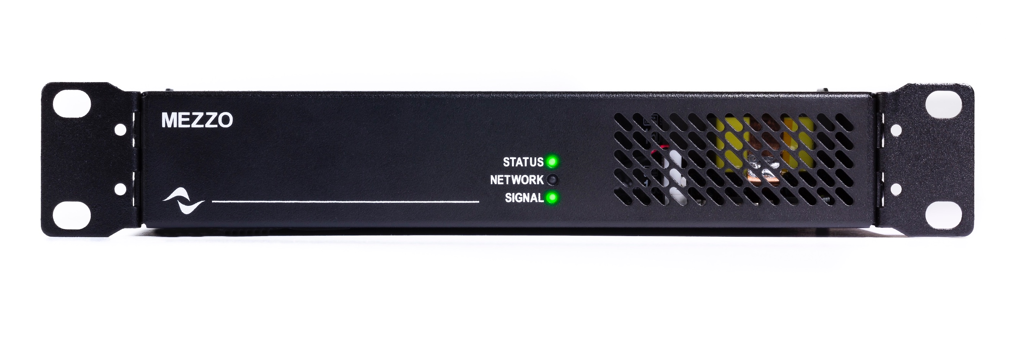
Perhaps most impressive is Mezzo’s overall flexibility and power sharing capabilities. The smaller 320W power sized models are able to deliver 80/160W per channel into 2, 4, 8 or 16 ohms as well as 100, 70 or 25V. Meantime, the larger 600W power sized models can deliver 4 x 150W or 2 x 300W, and can drive two 16 ohm as well as 25, 70 or 100V. While this is impressive in terms of flexibility, each channel has sufficient headroom for power sharing according to the specific installation needs. This means one model can drive zones of varying sizes, and design changes can be accommodated ‘on the fly’ without having to alter equipment choice.

Mezzo: maximum flexibility where it counts
“The power sharing capabilities of Mezzo offer the maximum flexibility in allocating power to different channels,” explains Marc Kocks, Powersoft’s Business Development Manager. “Many times, users can be faced with a system that has a couple very hungry loudspeakers, and then one or two in adjacent areas that don’t require as much power. Mezzo will automatically recognize high impedance and low impedance loads and configure the system to accommodate these variances. This means greater power efficiency and significantly less set up time.”

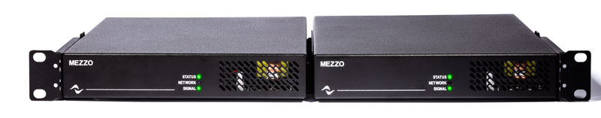
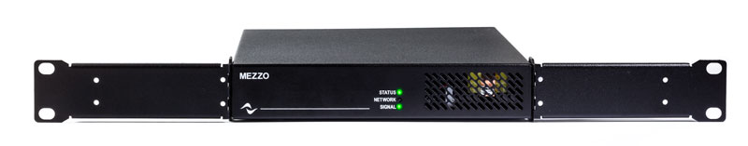
Mezzo also features equally impressive installation options. Each unit comes with rack mount accessories to fit two units into a standard 19” rack, or 1 unit in a 11” compact rack. Alternatively, the unit can stand alone on rubber feet in a credenza or be mounted on the wall — for instance behind a video screen. The unit is ultra-quiet and requires no ventilation and can therefore be used in dusty environments, under a desk or in locations where an audio closet may not available. Further, in terms of performance, Mezzo also delivers enough power to drive many subwoofers. This potentially means a significant space savings in locations that will no longer require 19” racks.

“Many fixed installation environments these days consist of both analog and digital,” Kocks continued. “Mezzo is perfect for these environments, since it can accommodate inputs on both analog and digital. Further, each Mezzo can be set up as a decentralized unit, enabling each unit to be part of a larger system with local feeds from Dante network. This can lead to massive cost savings in cabling expenses as well as significantly increased monitoring and control functionality. A user can retain full control over features as if it was a centralized rig.”

Mezzo is priced starting from $915 (USD MSRP)
For more information and full specifications, please visit http://www.powersoft-audio.com/en/

For further information

Francesco Fanicchi  POWERSOFT FIRENZE  francesco.fanicchi@powersoft.com  +39 339 6381206 | Jeff Touzeau  Hummingbird Media  jeff@hummingbirdmedia.com  +1 (914) 602-2913

ABOUT POWERSOFT:
Powersoft is the world leader in lightweight, high power, single rack space, energy efficient amplifiers for the professional audio market. Founded in Italy in 1995, headquartered in Florence, Italy, with offices in New Jersey, Powersoft couples the experience and precision of its production department with exceptional components to deliver products with perfect audio response and high-performance reliability. Its state-of-the-art amplifiers can be found in an array of markets, ranging from stadiums, sporting arenas, theme parks, performance venues and airports to convention centers, churches, and clubs, and are used by the world's leading tour sound companies. For more information, visit the Powersoft website: www.powersoft.com

