

Biuro prasowe better. gaming agency
bettergamingagency.prowly.com

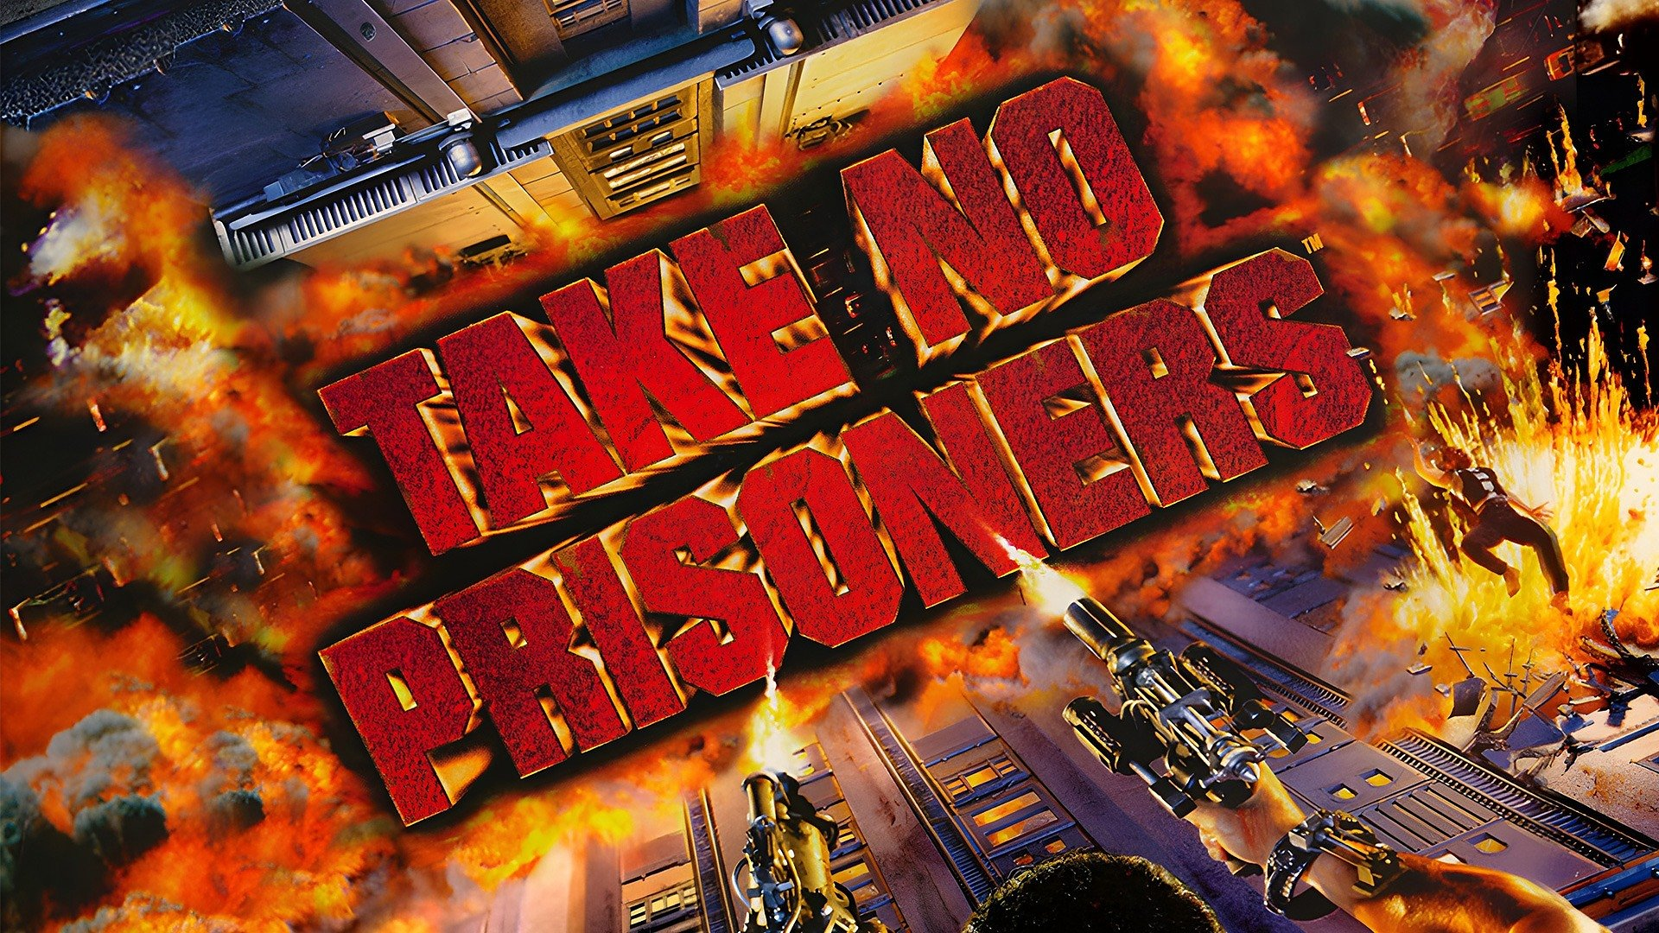

Take No Prisoners, CyClones and Necrodome – SNEG brings three classic shooters to life now!

SNEG, the publisher who brought us modern ports of retro titles, gives gamers an opportunity to play three cult classics today. Take No Prisoners, CyClones and Necrodome are true legends developed by Raven Software and published back in the 90s by SSI and Mindscape. Now, once again, they are available on GOG.com and Steam, and you can purchase them with a 20% launch discount. Shoot through, not one, but three dystopian futures and relive some of the most intense firefights of the nineties!

SSI and Mindscape were legendary publishers known for their RPG and Strategy games, but in the late 90s, they also ventured into the shooter genre, releasing FPS and top-down/isometric titles. Among these hidden gems were Take No Prisoners, CyClones, and Necrodome. These games offered diverse experiences, with intense shooting action and unique visions of the future. We were captivated by their addictive gameplay, and they introduced cool ideas that influenced subsequent games. Let's relive the mayhem of the nineties once again!

- says Oleg Klapovskiy, co-founder of SNEG.

Take No Prisoners

Buy now on GOG and Steam


https://www.youtube.com/watch?v=uJv6lFX5QG8

Blitz out, for the lads! You are Slade. Before the nuclear war, Special Ops commando. Now, survivor. Killing had never been your first initiative, but you were good at it... very good. And your time for killing has begun.The road to salvation, to the Dome, is littered with the corpses of those who sought its life-giving secrets. But no one person has the technology to breach the Done. Each Zoner group has a piece of the answer. All you have to do is separate them from the information that they hold. Time to kill, or be killed.

CyClones

Buy now on GOG and Steam

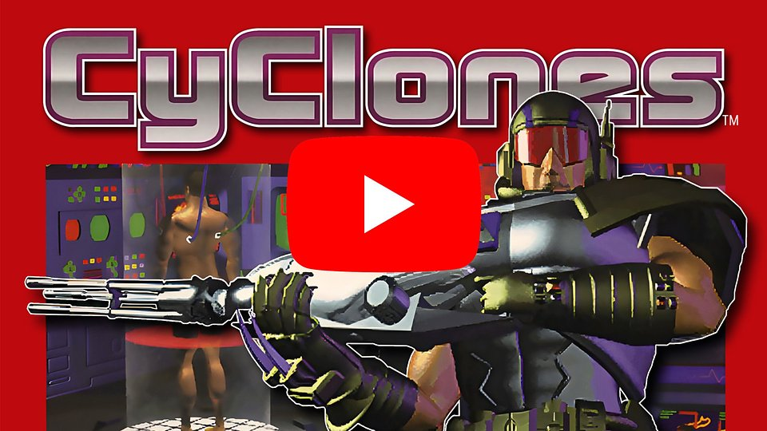
https://www.youtube.com/watch?v=wGeWo1uoX9s

Meet cyclones head-on! No, this isn’t about twisters that take out trailer parks in the Midwest. We’re referring to Cybernetic Clones, deadly creations of an alien race bent on Earth’s conquest.To add insult to injury, these CyClones are actually captured human beings transformed into flesh-steel monstrosities! As Earth’s defender armed to the teeth with the highest of hi-tech weaponry, you’re dying to jump into action.No wonder: CyClones is a white-hot multi-media explosion from the 90s! It features everything that was cool at that time - full-motion videos, cinematics, digitized voices, sizzling sound effects and breath-taking music. Smooth scrolling, head-on perspective puts all the action right where you want it - in your face.

Necrodome

Buy now on GOG and Steam

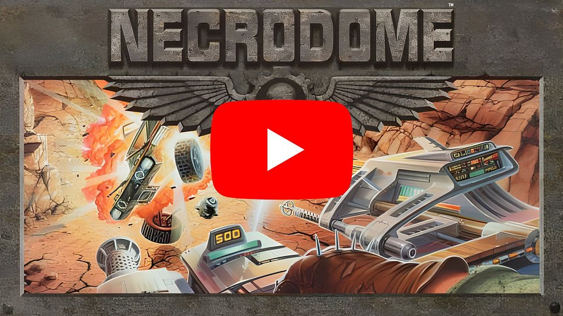
https://www.youtube.com/watch?v=uKwJd_-Y6f4

In the battle for your life, there is no second place! In the future, racing has become a deadly bloodsport - where staying alive is the only prize. Necrodome is a real-time, 3D, futuristic motorized mayhem that puts you at the wheel of an incredibly powerful armored vehicle - bristling with hi-tech weapons. Win or die in 30 daunting arenas. Keep on winning and you’ll make it to the Necrodome!Not to be mistaken for one of those boring race games, Necrodome is first and foremost about survival. Drive around and blast anything that moves! And if your vehicle gets thrashed, don't give up - run for your life, commandeer another vehicle, or continue the battle on foot!This old-school 3D real-time shooter features a “super-realistic” environment from the 90s. Performance-based vehicle upgrades. Multiple camera angles. And more gut-twisting action than you can handle!

SNEG has also bright other SSI titles to modern PC gamers. These include:🕹️ Veil of Darkness on GOG and Steam🕹️ Star General on GOG and Steam🕹️ Dark Legions on GOG andSteam🕹️ The Summoning on GOG and Steam

More titles are yet to come with the upcoming release of WarBreeds, which you can already wishlist on GOG and Steam.

The full presskit is available here.

About SNEG:SNEG is a small boutique publisher focused on reviving old gaming gems. We have an admiration for classics and a desire to bring back more interactive entertainment from all eras of the gaming culture.

