
bettergamingagency.prowly.com

Please note that all the information and the trailer are under embargo until December 9th, 6:00 PM CET (5:00 PM UTC / 12:00 PM EST / 9:00 AM PST).

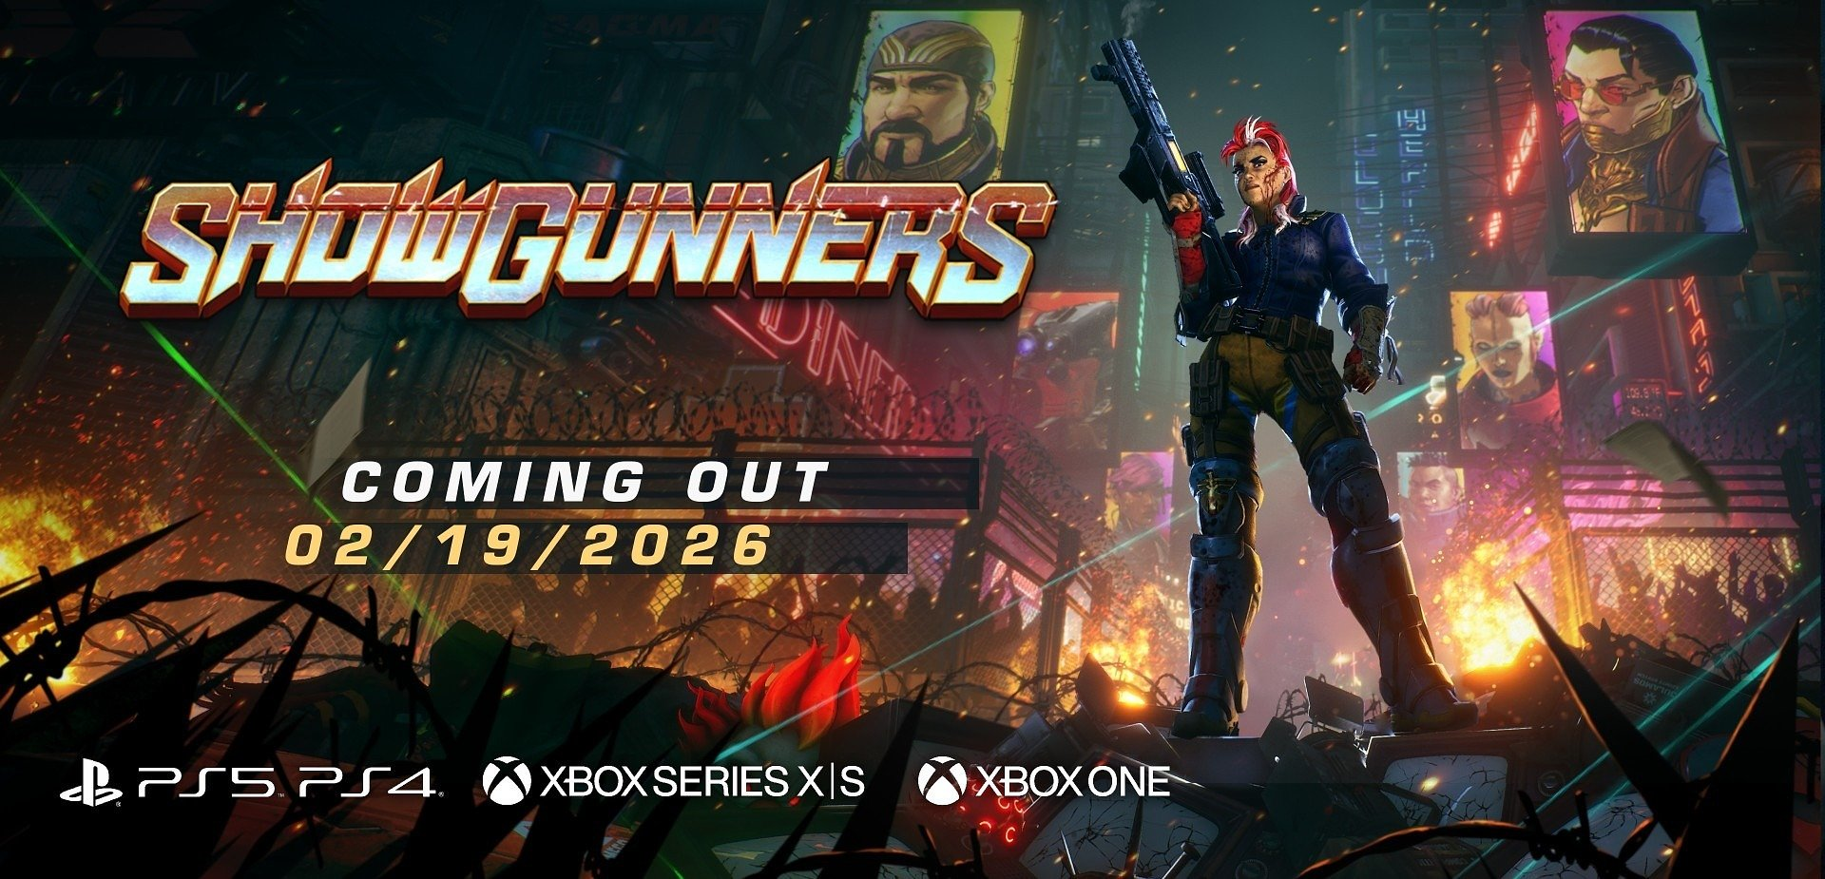

Showgunners – the brutal reality show comes to consoles this Winter!

Showgunners arrives on PlayStation and Xbox on February 19, 2026. Pre-orders now open.

Join the fight to the death for the crowd’s excitement in a dark, dystopian future.

Warsaw, Poland | December 09, 2025 – Klabater, Good Shepherd Entertainment, and Artificer are excited to announce that Showgunners, the acclaimed turn-based tactical combat game, will launch on PlayStation 5, PlayStation 4, Xbox Series X|S, Xbox One, and the Microsoft Store on February 19, 2026. Pre-orders are now live, including exclusive bonuses on PlayStation. An Xbox demo is also available.

In Showgunners, you take on the role of a participant in a brutal reality show, one of the most-watched spectacles in this dystopian world. Life or death is on the line, and the cyberpunk arenas are extremely cruel, leaving no room for mistakes. You play as Scarlett Martillo, entering the program to seek revenge. Your path to justice will be long and dangerous, facing not only psychopathic competitors willing to kill for fame and money, but also deadly traps set by the show’s director, interested only in ratings.

Watch the latest trailer:

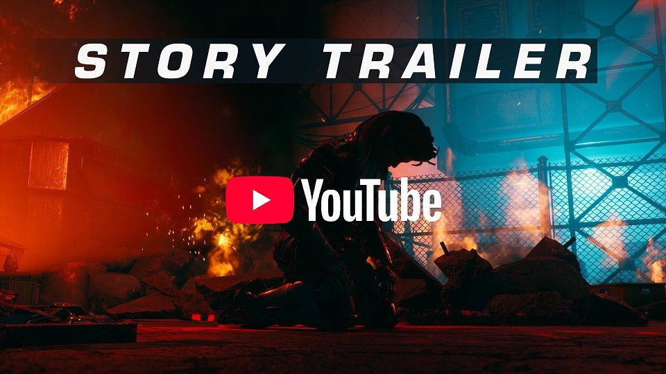
https://youtu.be/lafpHHffZP0

The title from Artificer studio is a tactical turn-based game, with each level carefully designed to offer unique challenges. During your adventure, you will command a team of bold characters, each with their own traits and abilities. As you overcome the challenges lurking in the urban maze of a cyberpunk city, your characters’ skills will grow, unlocking new paths and tactical possibilities. But never forget – the show is what truly matters! Your growing fame attracts sponsors, providing extra resources to strengthen and expand your arsenal.

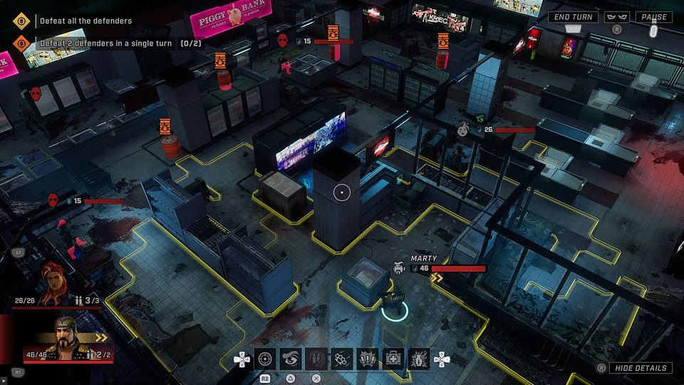

Game editions:

● Showgunners (standard edition) – Base game plus the Security Breach DLC

● Costumes & Weapons Pack – A bundle of 5 DLCs: 3 costumes and 2 weapon reskins for Scarlett

● Platinum Edition – Includes the Showgunners standard edition, the Costumes & Weapons Pack, and the Neon Justice DLC, a costume exclusive to this edition

Pre-order Bonus (PlayStation Only)

● Platinum Edition at the price of the standard edition

● Cyber Runner DLC – a futuristic new costume for Scarlett, exclusive to PlayStation pre-orders

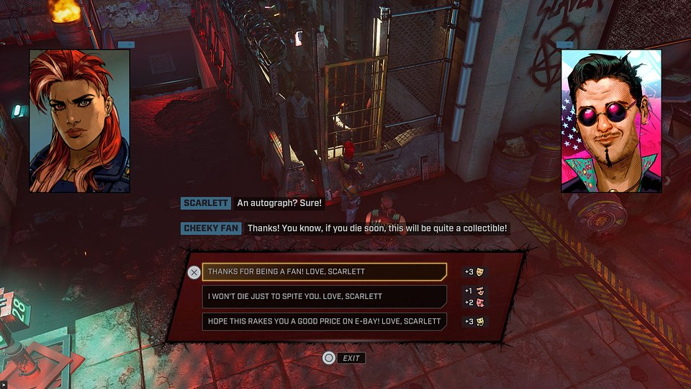

Demo on Xbox

Showgunners demo is featured on Indie Selects Demo Fest, running until December 31st. The Demo delivers a high-octane combat scenario – small, yet showcasing Showgunners at its best. Face a demanding tactical challenge in a brutal arena, where every move requires calculated planning to survive and win the crowd’s adoration.

● Pre-order (PlayStation): Showgunners Platinum Edition

● Wishlist (Xbox): Showgunners standard edition
● Try demo (Xbox): Showgunners Demo

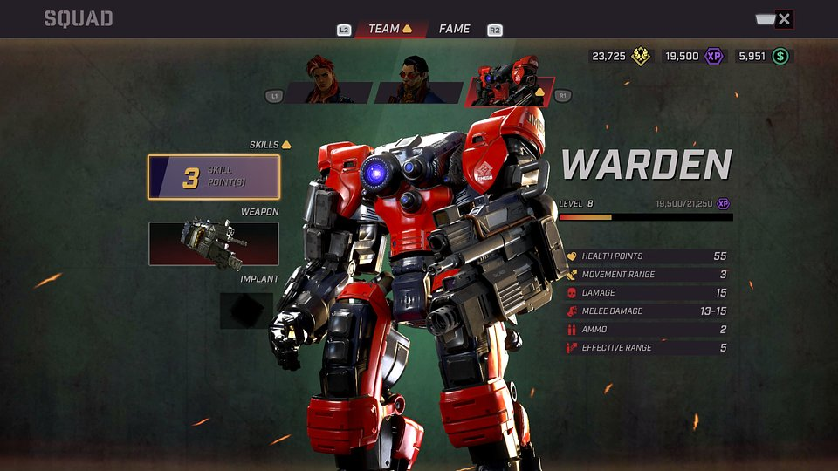

Showgunners – key features:

● Turn-based action – Showgunners is a tactical turn-based game, where battles take place on carefully designed and hand-polished levels, offering challenges tailored for each mission.

● The cameras are rolling – enter a brutal show that entertains the corrupted masses of a dystopian city. Battle ruthlessly, cut down anyone who stands in your path, and pursue your revenge.

● Only ratings matter – stay alive and take down opponents in the most spectacular ways to boost your fame. The more fans you gain, the better your chances of attracting sponsors and surviving until the last episode of the show.

● Be and have – a bold team of characters with diverse traits and abilities, each growing stronger over time and unlocking new possibilities. Buy weapons, gear, and powerful implants to dominate on the battlefield.

PRESS KIT

For keys and press inquiries, please drop us an email at jakub.smolak@bettergaming.pro or contact@klabater.com

About Artificer
Artificer is a small Warsaw-based game development studio made up of 14 passionate creators. Founded in 2019, the studio has established itself as a standout in the tactical and strategy genre, following the critically and player-acclaimed releases of Showgunners (2023) and Sumerian Six (2024). Known for its distinctive visual style, smart design, and sharp tone, Artificer continues to push genre boundaries with each new project. The team is currently working on Minos, an innovative maze-building roguelite due for release in 2026. https://www.artificer.com/

About Good Shepherd

Good Shepherd Entertainment is an award-winning video game publisher dedicated to creating long-term partnerships that create high calibre, high-quality entertainment. ‍We have established a strong global presence, having released dozens of hits; such as Monster Train, the Transport Fever series, Phantom Doctrine, Hard West and the critically acclaimed John Wick Hex. https://www.goodshepherd.games/

About Klabater

Klabater is an indie game developer and publisher established in 2017, in Poland. With a catalog of 30+ games published on PC and consoles, the studio aspires to be a recognized and acclaimed porting and publishing partner for indie game developers. https://klabater.com/

