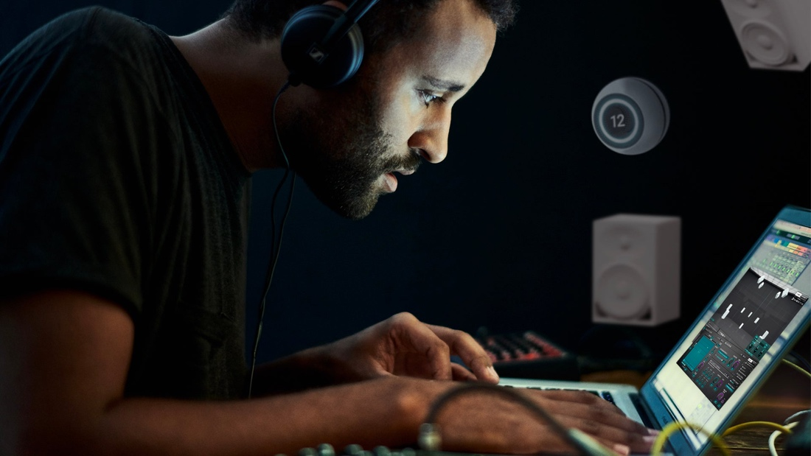

Everything you need to start producing immersive audio
Dear Reality updates its dearVR MONITOR multi-channel mix room plugin and releases a new IMMERSIVE BUNDLE

Düsseldorf, 17 January 2023 – Dear Reality introduces the latest version of dearVR MONITOR and the new IMMERSIVE BUNDLE, combining two powerful plugins that supercharge any spatial mixing workflow. dearVR MONITOR provides access to an immersive mixing room through regular headphones to create great mixes anytime, anywhere, and in any format. The latest V1.13 update adds four new headphone profiles, Dear Reality’s license manager, and Pro Tools® M1 Native support. In combination with Dear Reality’s dearVR PRO spatializing solution, users have everything at their fingertips to start producing immersive audio.

Spatial audio technology is constantly shaping the way audio is created and consumed. With the latest dearVR MONITOR update and the new IMMERSIVE BUNDLE, users benefit from the perfect match to dive into professional spatial audio production. “The new IMMERSIVE BUNDLE combines two of our most-loved professional plugins, dearVR MONITOR and dearVR PRO, that expand your creative and technical horizons and provide an easy transition into the immersive world,” explains Felix Lau, Product Owner at Dear Reality. With professional studio headphones like the recently integrated Sennheiser HD 800 S or the Neumann NDH 30, users will mix with greater accuracy and ease in a personal acoustic reference room they can rely on.

dearVR MONITOR V1.13 – The immersive mix room updated
dearVR MONITOR gives you access to your immersive mixing room through headphones and lets you mix in a reliable environment – wherever you are. The virtual immersive mix room combines the analytic advantages of headphone listening, such as high detail resolution and good spatial representation, with the perception of mixing in a perfectly matched mix room.

The latest update adds four new spatial headphone profiles, including Sennheiser’s HD 800 S and Neumann’s NDH 30. Furthermore, dearVR MONITOR now offers full Pro Tools® M1 Native support, utilizing Apple’s M1 Silicon architecture.

dearVR MONITOR combines the analytic advantages of headphone listening, such as high detail resolution and good spatial representation, with the perception of mixing in a perfectly matched mix room | 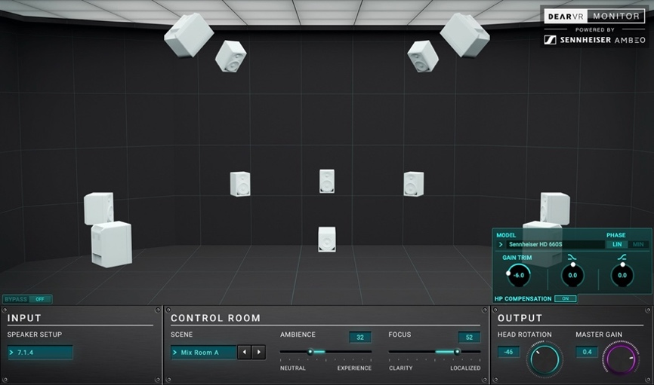

With the V1.13 update, Dear Reality introduces its license manager to the second virtual monitoring solution. “With the use of our license manager, we strive towards a tighter connection with our customers to provide direct support, personalized solutions, and enabling increased participation and feedback loops,” says Christian Sander, co-CEO of Dear Reality.

“We will constantly focus on delivering next-level features and cutting-edge tools for stereo and immersive audio production on our website and through our increasing partner network while leveraging synergies within the Sennheiser Group,” adds Achim Fell, co-CEO of Dear Reality.

Dear Reality dearVR MONITOR – No longer available at Plugin Alliance
From January 17, dearVR MONITOR won’t be part of the Plugin Alliance’s MEGA Bundle subscription anymore. Active MEGA XL and XXL bundle subscribers will receive a full license of the last V1.11.0 dearVR MONITOR legacy installer through PA to be able to open existing sessions.

Customers who purchased a perpetual license of dearVR MONITOR at Dear Reality or at Plugin Alliance before January 17, 2023 can transfer their license for free. Please visit https://www.dear-reality.com/pages/license-upgrade and request the latest V1.13 version and any future updates.

Two professional software solutions for immersive audio production: The IMMERSIVE BUNDLE
For anyone working with sound, the IMMERSIVE BUNDLE is the ultimate tool set for creatively transitioning to the immersive world. The combination of a dearVR MONITOR immersive mixing environment and the state-of-the-art dearVR PRO spatializer enables the user to easily position tracks in a 360° sound field and access the virtual immersive mix room through studio headphones. Creating compelling spatial audio productions was never easier!

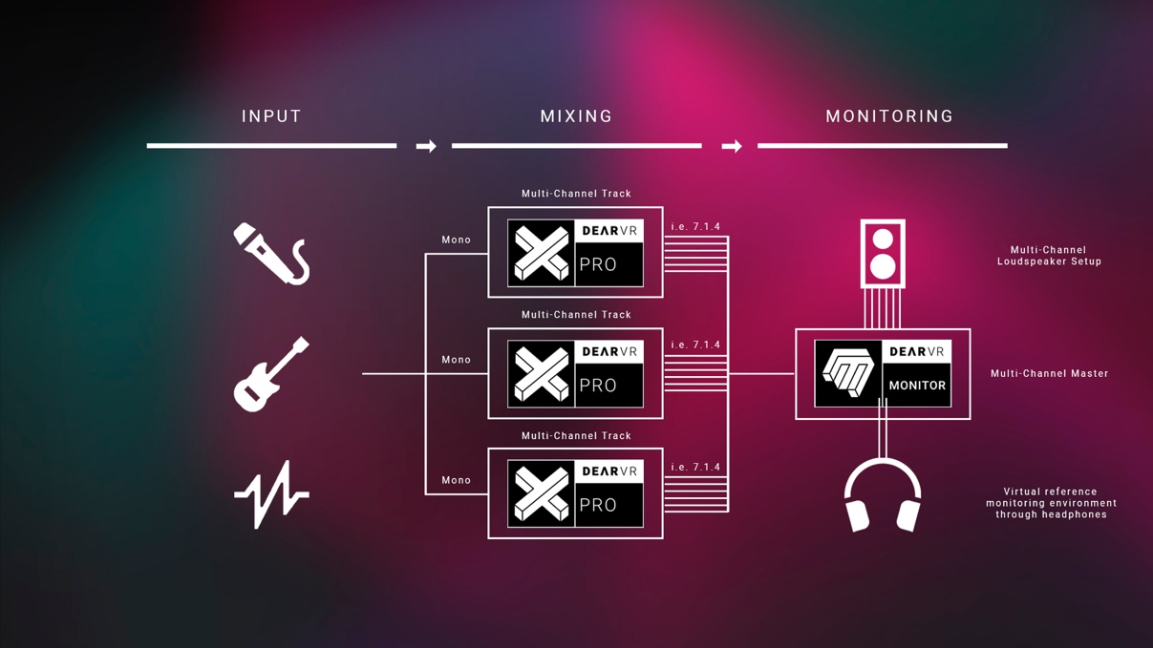
The IMMERSIVE BUNDLE enables you to intuitively spatialize your tracks and monitor immersive mixes through headphones

All-in-one spatializer: dearVR PRO
Inserted on individual audio channels, dearVR PRO enables the user to place audio tracks at any point or distance in a 3D space. The 360° immersive panner supports 26 multi-channel loudspeaker formats up to 9.1.6 as well as binaural, and Ambisonics output. 46 vivid virtual acoustic environments – from a small car to a large church – suit any professional need, each offering unique spatial imaging and depth.
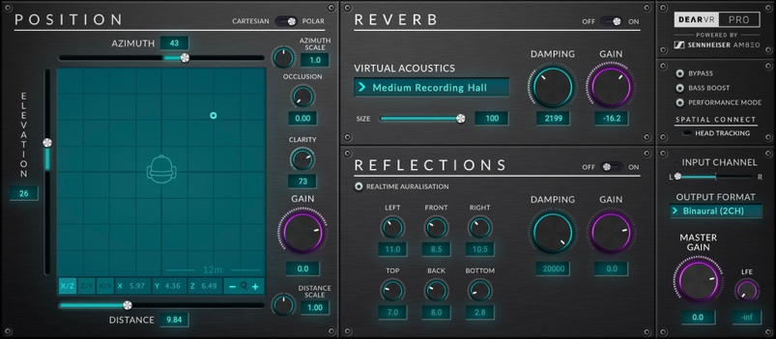 | Spatialize any audio source with dearVR PRO. 46 vivid virtual acoustic environments are perfectly suited for professional spatial audio productions

dearVR MONITOR V1.13 is available now in the Dear Reality store. During the introduction phase until 31 January 2023, the plugin is available for USD 129 (+ local VAT). From 1 February, the price increases to USD 249 (+ local VAT).

The IMMERSIVE BUNDLE is available now in the Dear Reality store. During the introduction phase until 31 January 2023, the plugin is available for USD 279 (+ local VAT). From 1 February, the price increases to USD 399 (+ local VAT).

(Ends)

The images accompanying this press release can be downloaded here.

Apple is a trademark of Apple Inc., registered in the U.S. and other countries and regions.
Pro Tools® is a trademark or registered trademark of Avid Technology, Inc. or its subsidiaries in the United States and/or other countries.

About Dear Reality
Dear Reality is a leading company in the field of immersive audio controllers, best known for its binaural, Ambisonics, and multi-channel encoders with totally realistic room virtualization. The company's products are used worldwide by sound engineers, sound designers, broadcasters, and musicians. Founded in 2014 by Achim Fell and Christian Sander, Dear Reality strives to deliver high-quality, cutting-edge 3D audio software for interactive and linear audio production. Since 2019, Dear Reality has been proud to be a part of the Sennheiser Group.

Local Press Contact Global Press Contact

Kai Detlefsen
press@dear-reality.com

