**3D Audio Reference Listening Room with   
Neumann KH 310 STUDIO MONITORs**

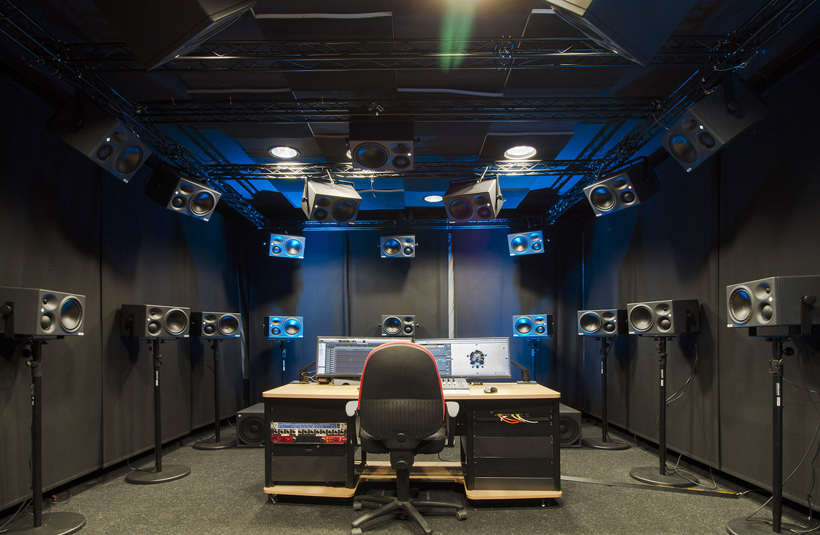

***Sydney / Ilmenau, April 5, 2019 – The Fraunhofer Institute for Digital Media Technology IDMT at Ilmenau, Germany, set up a new reference listening room for their SpatialSound Wave technology. This impressive installation was outfitted with thirty Neumann   
KH 310 A studio monitors, supported by KH 805 subwoofers.***

3D Audio promises an intense, immersive listening experience, but with many playback systems the localization suffers outside of the optimal listening position. SpatialSound Wave, developed at Ilmenau in the German province of Thuringia, offers breathtaking razor-sharp localization throughout almost the entire room. As if it were an actual acoustic environment, the listener can approach (virtual) sound sources; levels change in a natural way. The main fields of application for SpatialSound Wave are theaters, installations, and planetariums. Its list of users includes the Opernhaus Zürich, the Staatsoper Berlin, and the Zeiss Planetarium in Jena.

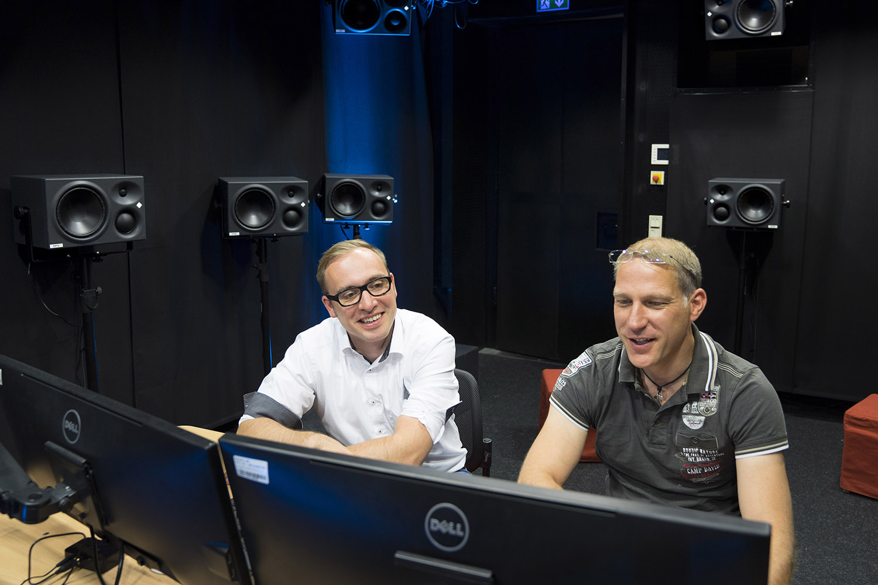Dr.-Ing. Daniel Beer, Head of Electroacoustics, adds: “The intelligence is in the algorithm that controls the loudspeakers. Originally, SpatialSound Wave was based on wave field synthesis, which controls the loudspeakers so the individual signals are superimposed in such a way that the sound field is reproduced. In recent years, however, we included a lot of psychoacoustics. The algorithm was altered in such a way that the reproduction of the sound field is not physically correct anymore, but the loudspeakers may now be spaced further apart.”

Dr.-Ing. Daniel Beer, Head of Electroacoustics, (right) and Christoph Sladeczek, Head of Virtual Acoustics (left) in the new reference listening room of Fraunhofer IDMT at Ilmenau.

**The Optimal Loudspeakers**

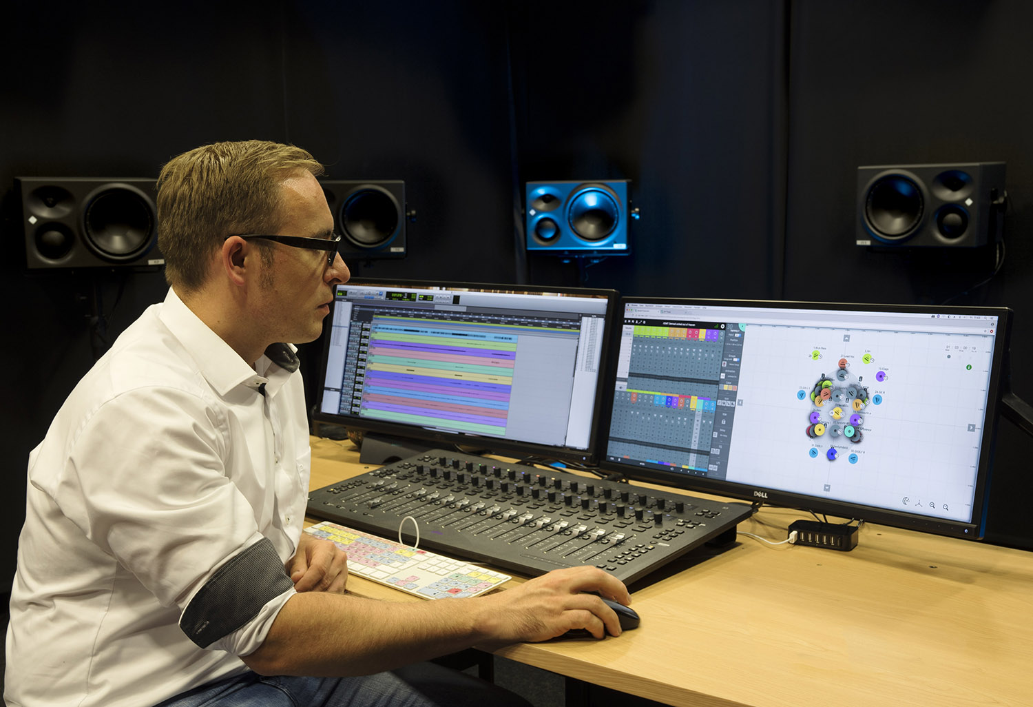In order to find the optimal loudspeakers for the new reference listening room Monitor speakers from a large number of manufacturers were compared in an elaborate test setup. Christoph Sladeczek, Head of Virtual Acoustics: “We used classic listening test methods. […]. All systems were room calibrated, and the levels were matched precisely. Next we prepared a test procedure in which fifteen participants reviewed various parameters, which we later evaluated statistically.

“Apart from sound and high level handling, the KH 310 also impressed with its sharp localization,” Daniel Beer explains. Product consistency plays a major part in this: “Later, before installation, we measured the individual loudspeakers and could confirm that the differences in frequency response were below 1 dB.” The result speaks for itself: SpatialSound Wave in the new reference listening room of Fraunhofer IDMT at Ilmenau sounds absolutely breathtaking!

Christoph Sladeczek demonstrating the 3D-Panner of the Spatial SoundWave software.

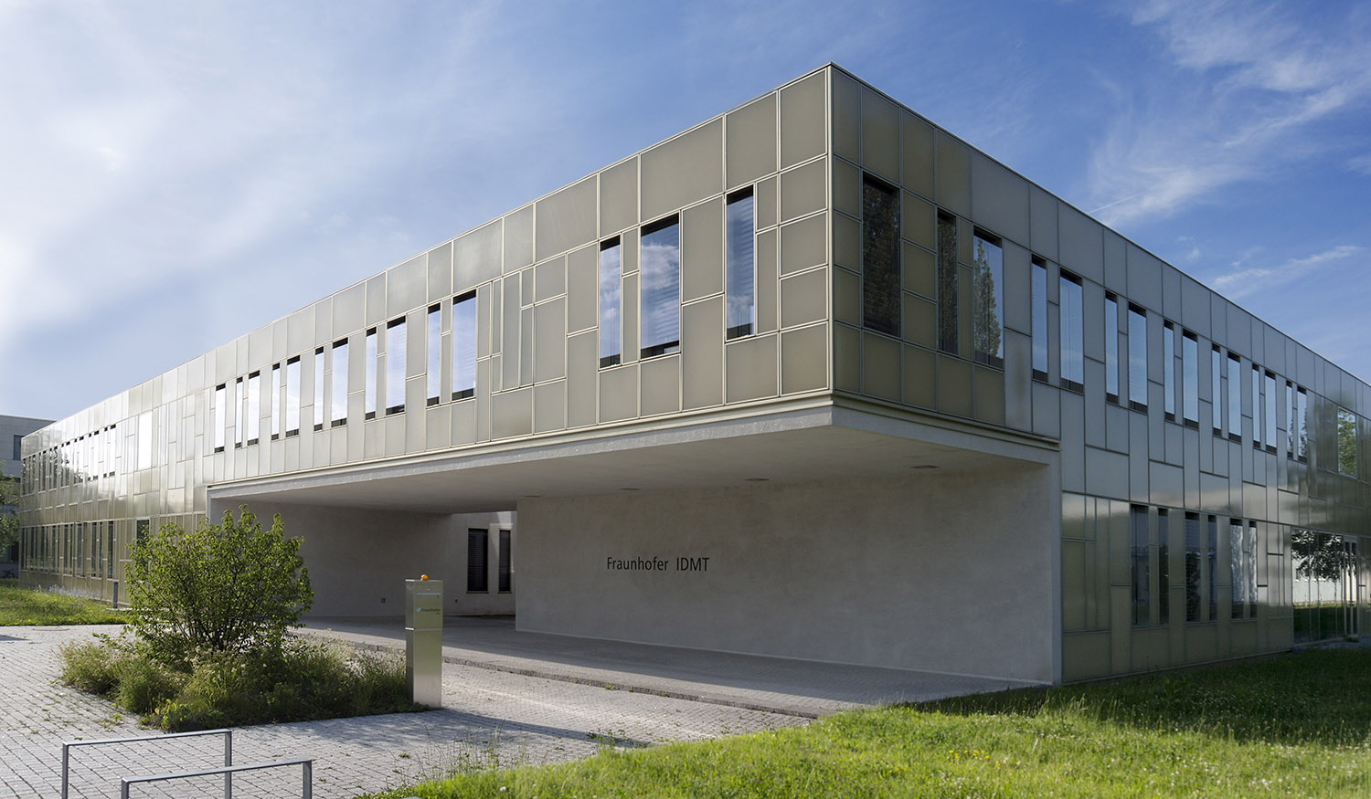

The Fraunhofer Institute for Digital Media Technology IDMT in Ilmenau, where the SpatialSound Wave technology was developed.

**Link for photo and text material:**[**https://www.neumann.com/exchange/Neumann-Fraunhofer.zip**](https://www.neumann.com/exchange/Neumann-Fraunhofer.zip)

**About Neumann**

Georg Neumann GmbH, known as “Neumann.Berlin”, is the world’s leading manufacturer of studio microphones and the creator of recording legends including the U 47, M 49, U 67 and U 87. Founded in 1928, the company has been recognized with numerous international awards for its technological innovations. Since 2010, Neumann.Berlin has expanded its expertise in electro-acoustic transducer design to also include the studio monitor market, mainly targeting TV and radio broadcasting, recording, and audio productions. The first Neumann studio headphone was introduced at the beginning of 2019. Georg Neumann GmbH has been part of the Sennheiser Group since 1991, and is represented worldwide by the Sennheiser network of subsidiaries and long-standing trading partners. Website: www.neumann.com.

**Press contacts:**

Heather Reid

[Heather.Reid@sennheiser.com](mailto:Heather.Reid@sennheiser.com)

T: +61 (2) 9910 6700

Andreas Sablotny

andreas.sablotny@neumann.com

T +49 (030) 417724-19