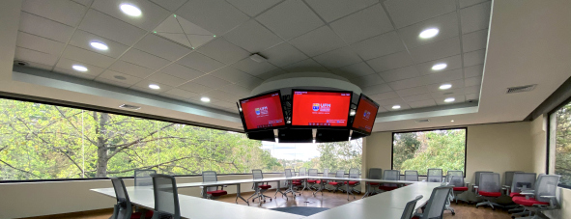Sennheiser TeamConnect Ceiling 2 revolutionizes connectivity and communication at Guatemala’s Universidad Francisco Marroquín
The leading educational institution in Latin America selects Sennheiser TCC2 technology to future-proof 52 of its classrooms with touchless audio

Wedemark, July 5, 2021 - The Universidad Francisco Marroquín in Guatemala City, also known by its abbreviated name UFM, is one of the top universities in Latin America. For 50 years, UFM has been ardently following its mission of teaching and disseminating the ethical, legal and economic principles of a society of free and responsible individuals. The university is the original founder of the ITA scholarship program which identifies the most highly qualified and motivated students among Guatemala’s poorest and makes it possible for them to earn a life-changing UFM degree. Recently, the university’s IT and AV team worked with installer FAREI to deploy Sennheiser TeamConnect Ceiling 2 (TCC2) microphones in 52 of its classrooms and various faculty auditoriums.

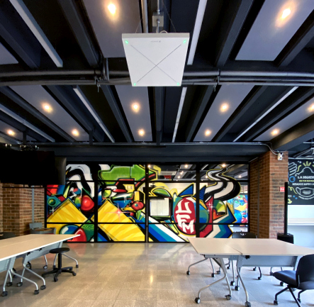 | Universidad Francisco Marroquín is one of the top universities in Latin America. To future-proof its campus, UFM worked with installer FAREI to deploy Sennheiser TeamConnect Ceiling 2 microphones in 52 of its classrooms and various faculty auditoriums

Whilst the plans for getting a new professional audio system had been in place for several years, the pandemic acted as a catalyst in the modernization of the university’s AV and IT infrastructures. The situation also resulted in adaptations to UFM’s collaboration and communication strategy, which now prioritizes hybrid teaching models, social distancing and touchless audio.

“To start with, we had to follow certain protocols and reduce the student capacity in all of our classrooms by distributing everyone into two groups of in-classroom and remote attendants,” said Víctor Zetina, Chief of Network Infrastructure at UFM. “We then had to find a way to simultaneously teach and support both of these groups effectively by offering live sessions where everybody could join in.”

With its 50-year reputation of being at the forefront of turning the campus learning environment into a dynamic collaborative process, UFM worked with FAREI, which specializes in the implementation of high-end audio solutions that would play a key part in the university’s new era of hybrid learning.

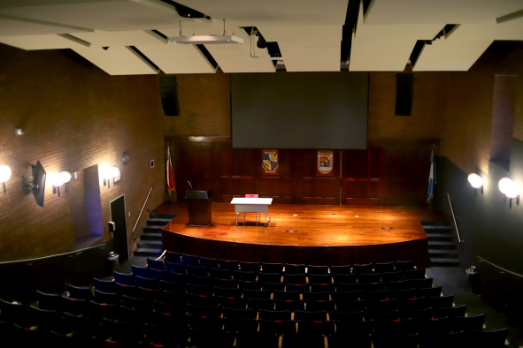 | UFM made touchless audio a key element of its collaboration and communication strategy

“When UFM’s team came to us to work together on finding the best audio solution for their needs, we knew straight away that beamforming microphone technology would be the right way to go forward as it’s one of the latest touchless audio innovations and has really proved its value as an effective and hygienic AV solution over the last year,” said Fernando Falla, General Manager, FAREI.

After speaking with the university’s IT and audiovisual team to determine their exact requirements, Falla and the FAREI team learned that UFM’s top priority was achieving as natural a seminar experience as possible for both in-room and remote participants. This included crystal-clear audio and the technical convenience of not needing to pass microphones from one contributor to another.

“Sennheiser TeamConnect Ceiling 2 has completely revolutionized connectivity and communication in conferences, meeting rooms and virtual situations by offering extremely clear audio,” said Annie Falla, Project and Service Manager at FAREI. “Additionally, with TCC2, you don’t need to think about things like RF interference or worry about microphone hygiene - that’s the beauty of a touchless audio solution.”

Apart from its easy installation and great sound quality, TCC2’s price point gave the system a competitive edge over other available solutions: “We compared it to some other devices on the market and TCC2 was the one that convinced us the most because of the way it functions and also its price,” explained Víctor Zetina.

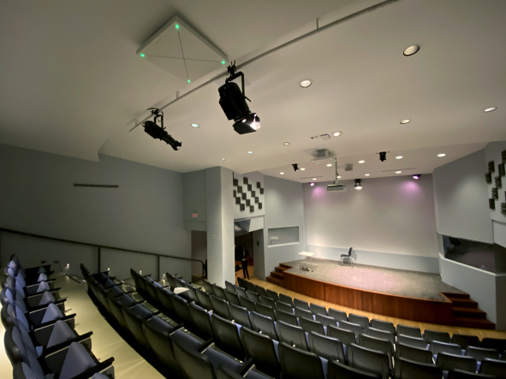 | 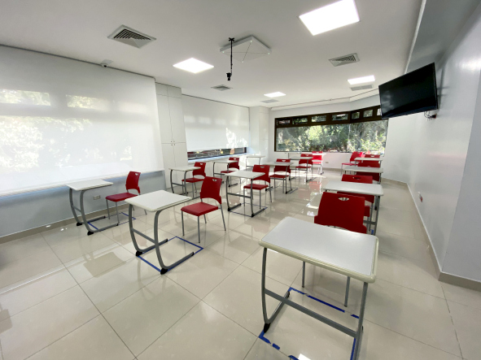
With each room having its unique acoustics, UFM developed detailed scenarios for different types of rooms to ensure optimum audio pick-up

According to UFM’s AV Coordinator, José Luis Milina, the main part of the project was adapting the rooms to be fully hybrid. This involved looking at different scenarios for different types of classrooms and determining the best environment and microphone coverage for each.

“With each room having unique acoustics, we had to find a perfect spot for TCC2 in each individual classroom so that teachers’ as well as students’ voices can be perfectly captured no matter where they sit or even move in the room,” added Elder de León, AV Technical Installer at FAREI.

Once the best locations for the TCC2 had been determined, installation was quick and straightforward

Thanks to TCC2’s latest firmware update in February, the team was able to make full use of the innovative TruVoicelift function, as well as select five exclusion zones and a priority zone in each classroom. “By defining different zones of exclusion, not only could we eliminate unwanted noises, but we could also effectively stop room reflections from building up,” explained Annie Falla.

Sennheiser’s Hernán Domínguez, Business Communication Manager Latin America, worked closely with the FAREI team on this complex project and provided his support and expertise where necessary.

“We would like to thank Hernán and the rest of the Sennheiser team for their contribution and the help they offered us for this project,” concluded Fernando Falla. “Thanks to the great teamwork between UFM, FAREI and Sennheiser, we managed to successfully finish the project on time, bringing touchless audio into the heart of UFM’s facilities and future-proofing their organization for many years to come.”

(Ends)

The high-resolution images accompanying this press release plus additional photos can be downloaded here.

Watch a video about the project here (Spanish with English subtitles) | 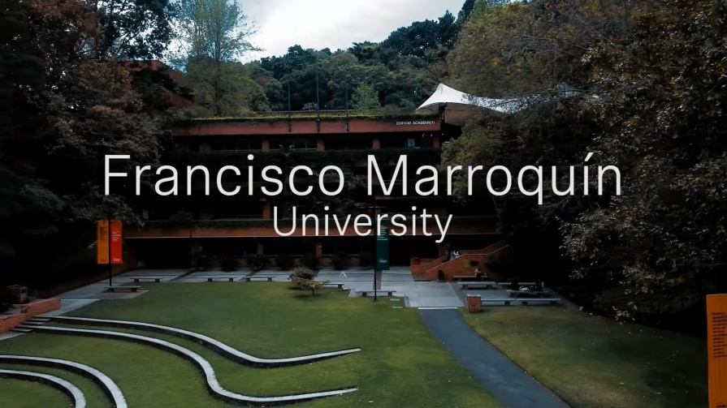

About Sennheiser
Shaping the future of audio and creating unique sound experiences for customers – this aim unites Sennheiser employees and partners worldwide. Founded in 1945, Sennheiser is one of the world’s leading manufacturers of headphones, loudspeakers, microphones and wireless transmission systems. Since 2013, Sennheiser has been managed by Daniel Sennheiser and Dr. Andreas Sennheiser, the third generation of the family to run the company. In 2019, the Sennheiser Group generated turnover totaling €756.7 million. www.sennheiser.com

Local press contact Global press contact

Rocío Rendón Stephanie Schmidt
rocio.rendon@sennheiser.com stephanie.schmidt@sennheiser.com
+52 1 (55) 5412 6497 +49 5130 600 1275

