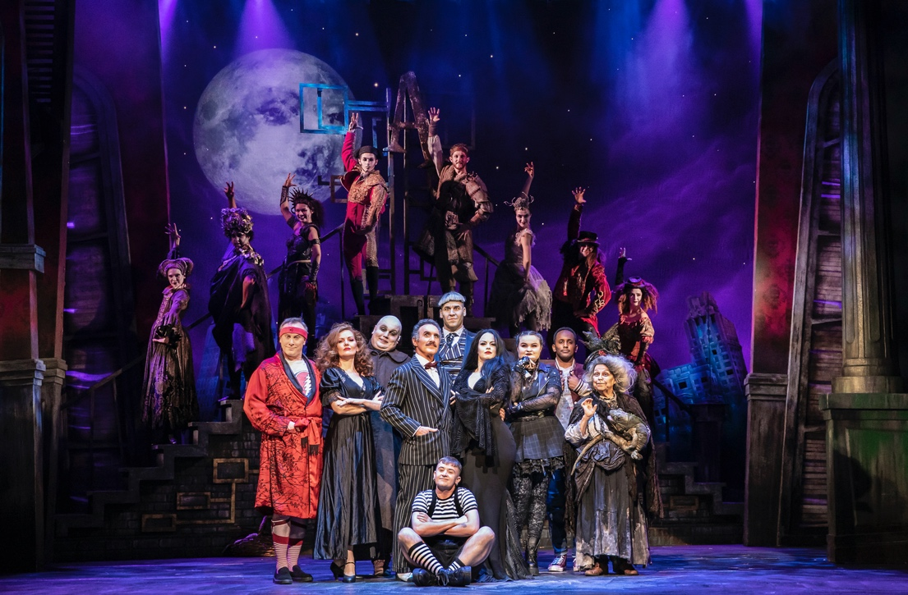Sennheiser celebrates all theatre professionals and lovers on World Theatre Day on March 27th
Audio specialist hears the story of Richard Brooker, renowned theatre sound designer and long-time Sennheiser user, who worked as NHS ambulance driver during the pandemic

March 2022 – Having been involved in theatre and live sound for much of his life, Richard Brooker is one of the UK’s top sound designers. He has worked on shows such as Dreamgirls, The Bodyguard, Chess, Annie, Sister Act, Funny Girl, West Side Story and Bend It Like Beckham, as well as BBC Proms and Glastonbury Festival among others. Theatre, as with so many others who work in the industry, is more than just a job for Brooker; it’s his life and something that defines him as a person.

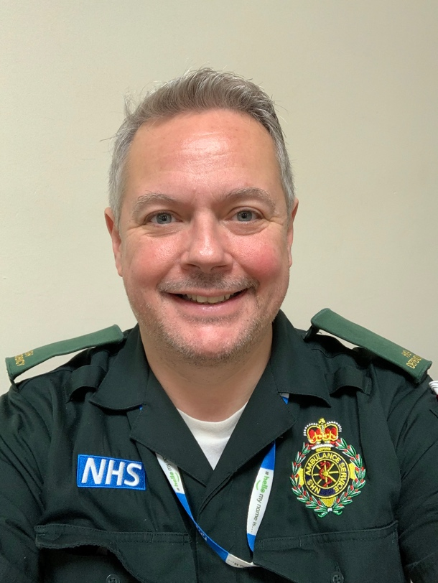 | Theatre sound designer and long-time Sennheiser user Richard Brooker worked as an ambulance driver during the pandemic

When the global pandemic brought the theatre and entertainment industry to a screeching halt, and the curtain went down on the world’s theatre venues, thousands of people lost their jobs overnight, Brooker included.

“When it all stopped, suddenly we were very much on our own and hung out to dry,” Brooker recalls. “It’s easy to moan at the producers, but how could they look after us when they had no money coming in? There was no other option but to shut the doors.”

Living in the countryside and being close to nature, Brooker felt very privileged that he and his wife could shut themselves away from overcrowded city life and enjoy the safer, greener space around them. However, with no financial means of support and no real focus, life soon became daunting.

“This is a piece of history that our kids will learn about,” says Brooker. “Everyone will have their own stories about the pandemic, but I remember asking myself ‘Who am I?’. I’d given 30 years of my life to professional live sound, so it was only natural for that job to become ‘me’, and for it to define me. I spoke to a lot of people who felt the same way. That they didn’t have a purpose anymore. The inherent need in us all to put a show on is huge and the knock-on effect was enormous – businesses such as restaurants and bars rely on their local theatre to bring in the crowds every night; all that just fell apart.”

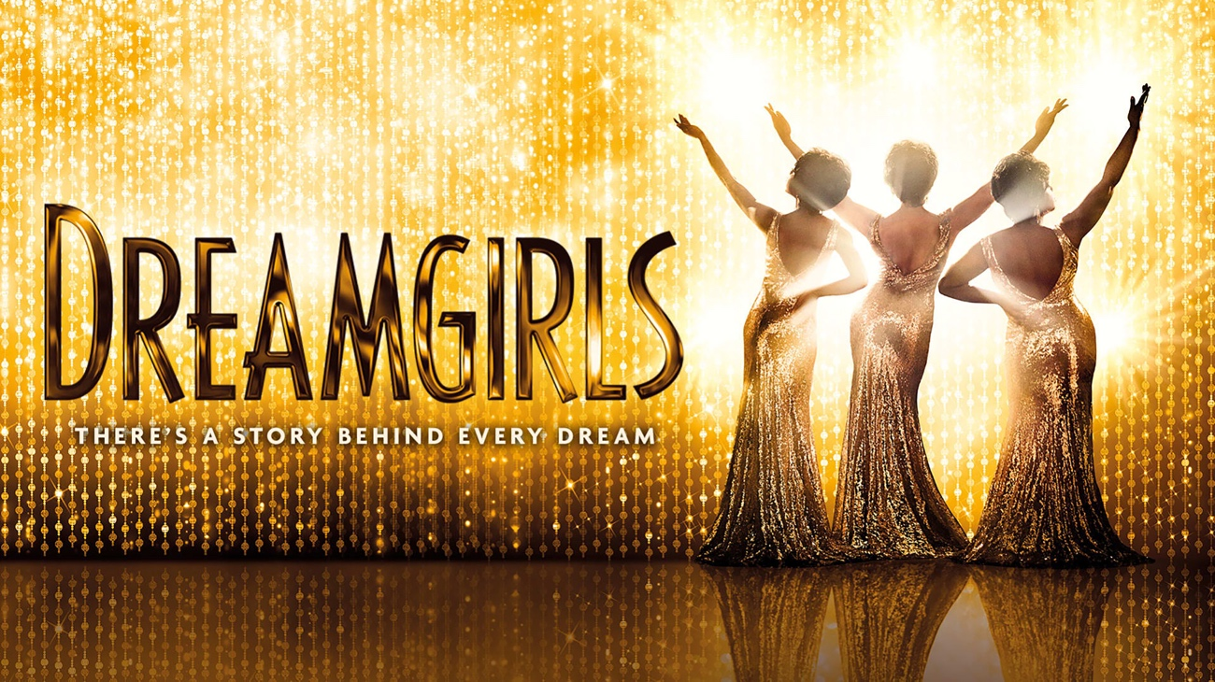 | Dreamgirls, The Bodyguard, Chess, Annie, Sister Act, Funny Girl, West Side Story and Bend It Like Beckham are some of the shows Richard Brooker has worked on

Being a voluntary ambulance responder for over 10 years, Brooker always enjoyed helping others so when he was contacted by the West Midlands Ambulance Service in January last year, asking if he would like to step up and take a role as an NHS ambulance driver, for Brooker it was a no-brainer.

“It gave me the focus I craved and some income to support my growing family,” he explains. “Responding to emergencies, dealing with Covid patients that were very sick – all that was emotional and traumatic, but also incredibly rewarding.”

Brooker also liked the idea of being trained to a higher standard and knowing more, something he feels trickled down from the ever-learning and continually evolving entertainment industry.

“To go and do the extra training to then be able to wear that green uniform with pride was beyond fulfilling, informative, draining and exciting in equal part,” he shares.

Since the situation has eased, Brooker is back in the world of sound design and engineering but intends to carry on volunteering for the Ambulance Service. “It’s an interesting juxtaposition. Working on an ambulance is almost a complete opposite of what we do in entertainment. When someone calls an ambulance it’s because they’re at a really low point and need urgent help. Whereas the people you meet in a theatre environment are there to enjoy and have a good time. The difference between the two is incomparable, and I feel privileged and humbled to be able to step into both worlds.”

Speaking about what’s in store for 2022, Brooker is hopeful that after two difficult years the curtains are finally going up again, and theatres across the world are starting to rebound from the devastating effects of pandemic.

“I think it’s interesting to see what happens this summer,” he says. “The shows are starting to come back and people like me are being asked to do projects again, which we all feel exuberant about. There will certainly be challenges, from winning back theatre audiences to rebuilding a depleted workforce of experienced freelancers as, sadly, there are a lot of very talented people who have permanently gone from the industry or continue to suffer from mental illness from having been isolated and stuck indoors for so long. I hope everyone will have a propensity to be a bit kinder to each other following this experience.”

The Dreamgirls UK Tour, Grease and The Addams Family musical UK tour are among the productions that Brooker will be working on later this year together with his fellow, both old and new, theatre professionals, who he jokingly refers to as “a bunch of misfits that all fit together”.

The Addams Family musical UK tour is among the other productions that Brooker will be working on later this year

Photo credit: Pamela Raith

“It’s about stretching out our arms and welcoming anyone who wants to be part of our industry,” concludes Brooker. “Theatre has always been a safe home for some who weren’t accepted elsewhere. If more people from different backgrounds are coming to see theatre, then even more people like them will work in it. Diversity is rolling out across the entertainment industry, and we should all embrace it wholeheartedly!”

(Ends)

The high-resolution images accompanying this press release can be downloaded here.

About the Sennheiser brand
We live and breathe audio. We are driven by the passion to create audio solutions that make a difference. Building the future of audio and bringing remarkable sound experiences to our customers – this is what the Sennheiser brand has represented for more than 75 years. While professional audio solutions such as microphones, meeting solutions, streaming technologies and monitoring systems are part of the business of Sennheiser electronic GmbH & Co. KG, the business with consumer devices such as headphones, soundbars and speech-enhanced hearables is operated by Sonova Holding AG under the license of Sennheiser.

www.sennheiser.com
www.sennheiser-hearing.com

Global Press Contact

Stephanie Schmidt
Stephanie.schmidt@sennheiser.com
+49 (5130) 600 – 1275

