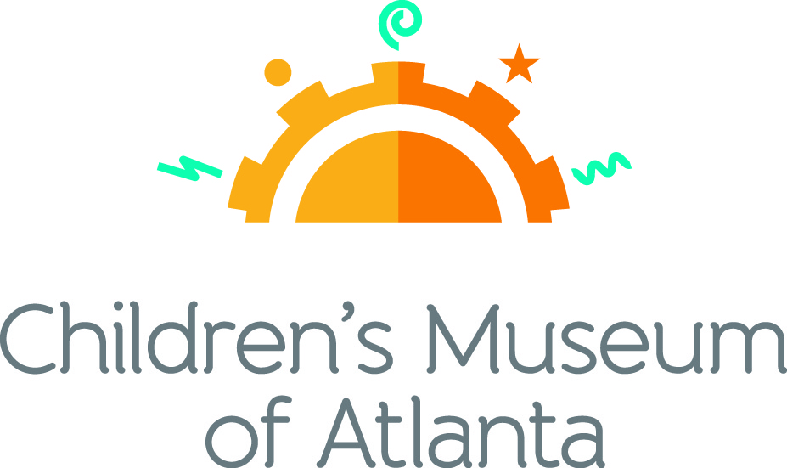
CONTACT
Becca Meyer / Jennifer Walker
BRAVE Public Relations
404.233.3993
bmeyer@bravepublicrelations.com/
jwalker@bravepublicrelations.com

*MEDIA ADVISORY*

Up, Up and Away! Superhero Science Night soars into Children’s Museum of Atlanta!
Families are invited to save the world with science on Saturday, March 18

ATLANTA (February 24, 2017) – Superheroes and mad scientists unite! Children’s Museum of Atlanta invites families to discover the magical powers behind science at its annual Superhero Science Night on Saturday, March 18 from 6:30 – 8:30 p.m. Kids can come dressed up as their favorite superhero and learn how the powers of science, technology, engineering and mathematics can help them take over the world! The special event will consist of various hands-on activities set up throughout the Museum, and Professor Labcoat will end the evening with a bang during the grand finale! Special guests The GroveBots, a FIRST® LEGO® League Robotics Team from Oak Grove Elementary School, will also be on-hand to share their robot creation with attendees.

WHAT: Superhero Science Night at Children’s Museum of Atlanta

WHEN: Saturday, March 18
6:30 – 8:30 p.m.

WHERE: Children’s Museum of Atlanta
275 Centennial Olympic Park Drive, NW
Atlanta, GA 30313

HOW: Space is limited, so families are encouraged to act quickly! Tickets are $8 for members/$18 for non-members. Tickets must be purchased in advance. Tickets will not be available at the door. For tickets, visit bit.ly/SuperheroScienceTickets or call 404.527.3693.

MORE INFO: bit.ly/SuperheroScienceNightCMA

For more information or to support Children's Museum of Atlanta, visit childrensmuseumatlanta.org
or call 404.659.KIDS [5437]

###

