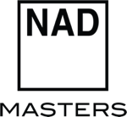

NAD EPITOMISES BOLD MODERNITY THROUGH NEW MASTERS M10 V2 BLUOS STREAMING AMPLIFIER

Continuing the “just add speakers” revolution started by its highly- acclaimed predecessor, the M10 V2 adds support for Dolby Digital Surround and includes an IR remote control

PICKERING, ONTARIO, CANADA, AUGUST 12, 2021 -- NAD Electronics, the highly regarded manufacturer of high-performance audio/video components, announced the new and improved NAD Masters M10 V2 BluOS Streaming Amplifier, which continues its “just add speakers” revolution of Hi- Fi. The M10 V2 features 100 watts per channel of amplification and BluOS streaming capabilities, and adds the capability to expand with Dolby Digital Surround decoding, an enclosed IR remote control, and updated gain algorithms. It ships globally in August 2021 and will retail for US $2,749 (€2,999).

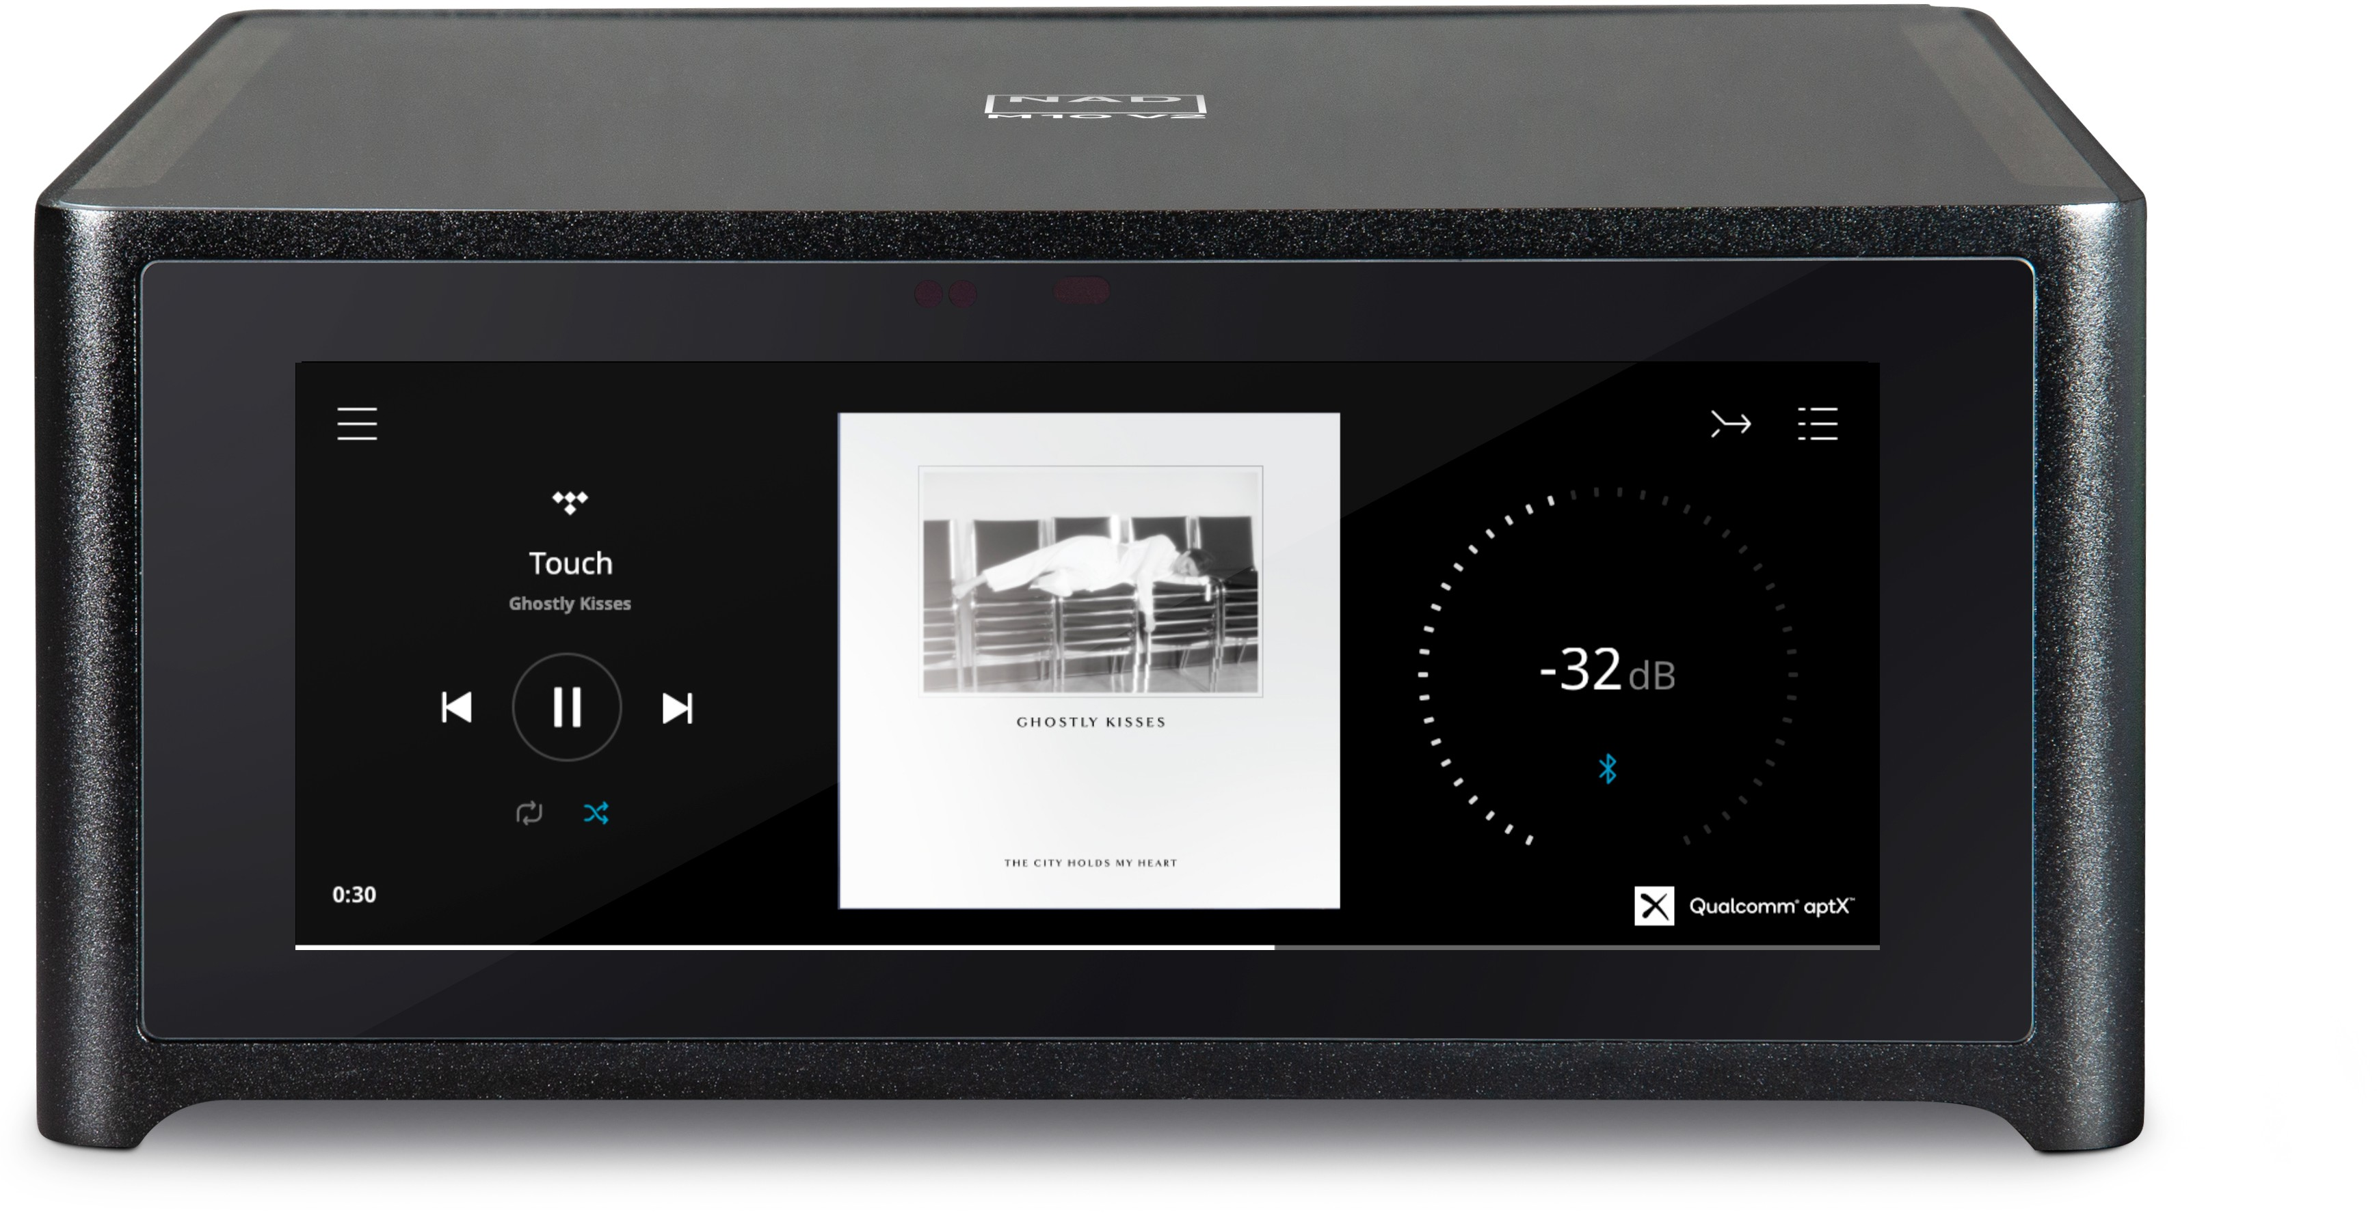

"The original M10 caught the industry off-guard and made audiophiles and non-audiophiles reimagine what hi-fi can and should be,” stated Cas Oostvogel, Product Manager for NAD Electronics. “The M10 V2 continues where the first left off and adds even more versatility as a two-channel or potentially a wireless home theatre system.”

JUST ADD (MORE) SPEAKERS
The M10 V2 includes audiophile–grade speaker terminals and two independent subwoofer jacks. Output settings for the subwoofer are easily controlled and adjusted through the BluOS Controller app. Home theatre fans can easily build a Dolby Digital Surround Sound wireless 4.0, 4.1 or 4.2 immersive home theatre system using a pair of BluOS surround-enabled wireless speakers or amplifiers. The M10 V2 is capable of transmitting to rear channels wirelessly, with very low latency, making connecting wires around the room unnecessary.

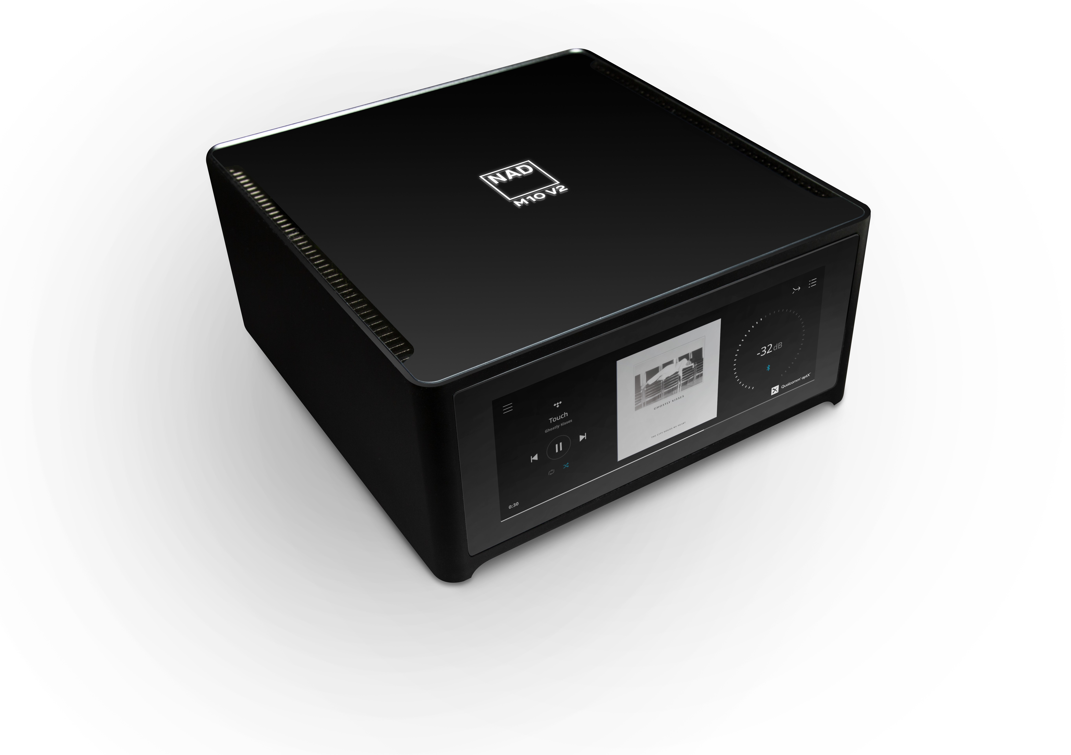

TOTAL CONTROL
The M10 V2 offers an abundance of control options the most captivating of which is a beautiful full- colour touchscreen front panel. New to this iteration of the product is an included an IR remote control for easy access to basic audio controls and presets. Streaming music can be controlled through the BluOS app, which includes dozens of natively integrated music streaming services and thousands of Internet radio stations. The M10 V2 supports AirPlay 2, Bluetooth aptX HD, is Roon Ready, and can be used with popular voice control assistants. For smart homes, the M10 V2 can be integrated into

Control4, Crestron, Lutron, and other home-automation systems, so you can control music playback, along with other home systems like lighting, shades, HVAC, and security.

SMALL AND MIGHTY
Bringing everything but the speakers to the hi-fi experience, the M10 V2 features audiophile-grade amplification and DAC, with built in sources and pre-amp capabilities. Featuring an upgraded 7” IPS colour touchscreen, the M10 V2 delivers purer colours and a wider viewing angle than its predecessor. Renowned nCore amplification technology conservatively rated at 100 watts per channel is included behind the full-colour display that doubles as an intuitive touchscreen controller for volume, sources and other audio controls. The M10 V2’s updated gain algorithms allow for higher output levels with inefficient speakers. Higher gain is also included in the subwoofer outputs, which allows for a wider range of subwoofer-main speaker combinations. Its highly acclaimed ESS Sabre DAC effortlessly handles BluOS audio streams, which processes up to 24-bit/192kHz, and supports MQA and other lossless and high-resolution audio formats from streaming services such as Amazon Music Ultra HD, Deezer, Qobuz, and Tidal.

ROOM FRIENDLY
Created by the award-winning design firm DF-ID, the M10 V2 features a solid brushed aluminium chassis and Gorilla Glass top and front panels. The minimalist design allows for the M10 V2 to fit into any living space, With the addition of Dirac Live room correction, any listening room can achieve acoustic perfection. The enclosed calibrated microphone allows for measurement of the room’s acoustic anomalies, helping to correct peaks and dips caused by the room’s acoustics up to 500Hz (a full-bandwidth version is available through Dirac). Up to five listening profiles can be uploaded and saved to create a tailored experience if there are multiple listening positions, you have two or more channels active or want to compensate for whether or not the curtains are drawn, for example.

THOROUGHLY MODERN HI-FI

The NAD Masters M10 V2 epitomises thoroughly modern hi-fi for today’s listener featuring a variety of different playback options. Through the user-friendly BluOS app, listeners are able to play music from their favourite streaming service, as well as locally stored music. The M10 V2 includes RCA analogue, optical and coaxial digital, HDMI eARC, and USB Type A inputs, to connect compact disc players, game consoles, external drives, media adapters, flat-panel displays, and other components. Two-way aptX HD Bluetooth is also featured showcasing the versatility of the M10 V2. Listeners are further able to choose their listening medium of choice such as stereo loudspeakers, wireless headphones, a surround sound setup or a multi-room set-up of up to 63 other BluOS wireless players. The NAD Masters M10 V2 BluOS Streaming amplifier is a modern system for the modern listener.

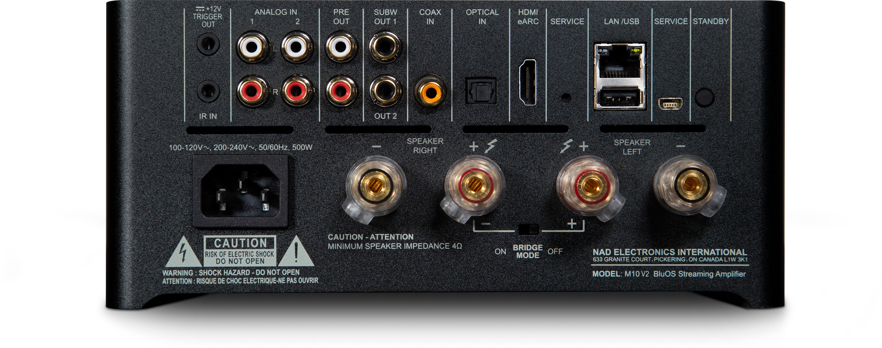

Features & Details
M10 V2 BluOS Streaming Amplifier
- Wireless 4.0, 4.1 and 4.2-channel surround sound options
- Hybrid Digital nCore Amplifier with updated gain algorithms
- Continuous Power: 100W into 8/4 Ohms
- Dynamic Power: 160W into 8 Ohms 300W into 4 Ohms
- 32-bit/384kHz ESS Sabre DAC
- Dirac Live Room Correction
- IPS Color LCD display
- Infrared remote control handset included
- Amazon Alexa & Google Assistant voice control skills
- AirPlay 2 integration, with support for Siri Voice Assistant
- Roon Ready
- Spotify Connect and Tidal Connect
- Two-way Qualcomm aptX HD Bluetooth
- NFC Bluetooth pairing for compatible smart devices
- BluOS multi-room compatible
- Gigabit Ethernet; Wi-Fi 802.11ac (WiFi 5)
- HDMI eARC,USB Type A inputs
- Stereo line analogue and coaxial/optical digital inputs
- Preamp output, two independent subwoofer outputs with updated gain algorithms
- IR Input, 12V Trigger Out
- Apps for iOS, Android, macOS, Windows, Crestron, Control4, RTI, URC, Elan, Lutron, iPort
- Wide variety of premium music services supported in BluOS app, including Amazon, Spotify, Tidal, TuneIn, Napster, Deezer, Qobuz and many others
- Support for all major lossless and lossy formats, including WAV, FLAC, AIFF, ALAC, AAC, MP3, Ogg Vorbis, and others
- MQA decoding and rendering

About NAD Electronics
Founded in 1972 and now sold in over 80 countries, NAD Electronics is renowned for its award- winning line of high quality components for audio, home theatre and custom installation applications. Since the beginning, NAD’s commitment to four core values – innovation, innovation, simplicity, performance, and value – have earned it a cult-like following that catapulted it to becoming a household name amongst audiophiles and music lovers alike. To this day, the brand continues to design and manufacture some of the most acclaimed and affordable hi-fi components that include modern features and technologies meant to appeal to a new generation of audiophiles.

LINKS
Website: https://nadelectronics.com
Images: https://nadelectronics.webdamdb.com/bp/#/folder/9750341/
Facebook: https://www.facebook.com/nadelectronics
Twitter: https://twitter.com/nadelectronics
Instagram: https://www.instagram.com/nadelectronics/

# # #

