For more information, please contact Marta de Paco
On +34 670 780 664 or email press@comunicahair.com

Important:
These images are only available for editorial content.
Credits must be included.
Notification of their publication is expected.

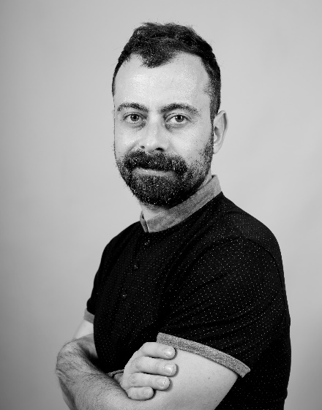
LA BARBERÍA DE OLIVER
ÉGALITÉ Collection

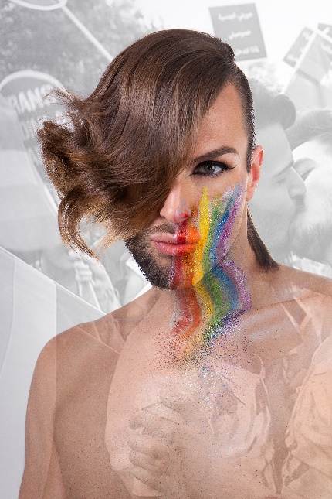
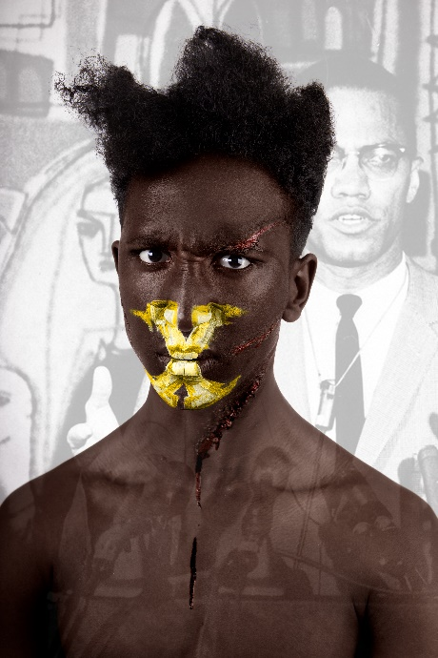
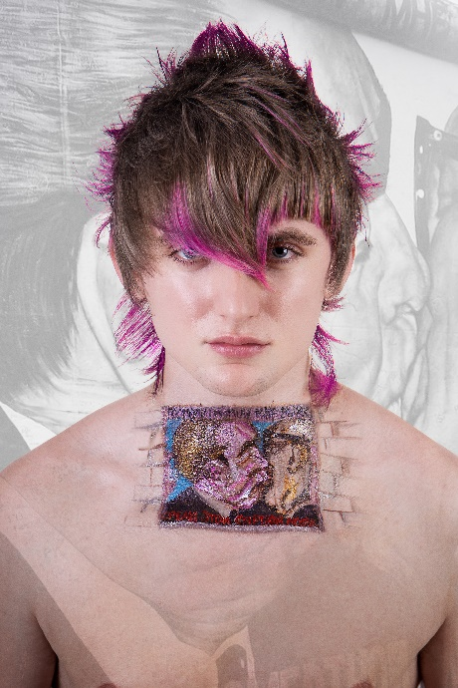

Hair: La Barbería de Oliver @Salvador_Oliver__
Hair Instagram: @labarberiadeoliver
Hair Assistant: Monica Moreno @monica_moreno_c
Photography: Juan Francisco Pagan @juanfranciscopagan
Retouche: Javier Villalabeitia @javiervillalabeitia
MUA: Monica Moreno @monica_moreno_c
Styling: Salvador Oliver @Salvador_Oliver__
Spontaneous Realism Artist: Raquel Moreno @mokart_raquel

LA BARBERÍA DE OLIVER
ÉGALITÉ Collection

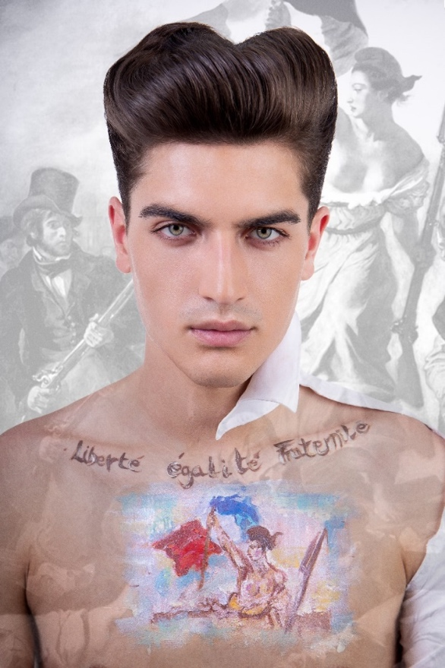

Human beings have fought fiercely throughout history to claim the right to equality, and that demand is what inspires this collection. Each model symbolizes an area of conquest.
Jorge, with his neat and aristocratic volume, represents the French Revolution, the beginning of what made us all free and equal.
Cheru, with his disparate lengths, refers to slavery. The X on the mouth links him to Malcolm X, but also to the fact that the slaves' words were not heard. The marks on his skin represent the lashes.
Harry, with the image of the kiss on the Berlin Wall and his mullet with pink tips, represents the lack of freedom of expression and thought until the Fall of the Wall in Eastern Europe.

LA BARBERÍA DE OLIVER
ÉGALITÉ Collection

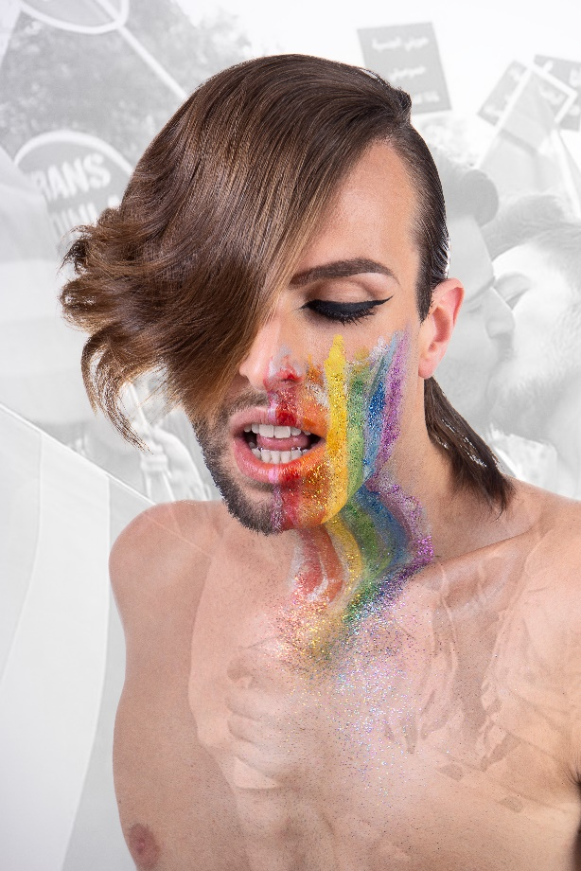

The latest model, Fernando, claims with his asymmetric haircut respect for difference, for the sexual freedom of people, gays, lesbians, trans... to sexually orient ourselves to where we feel. In addition, the message is reinforced with the presence of watercolors, with a technique of spontaneous realism that shows the strong link between the art of painting and the art of hairdressing. These were created by Mokart.

