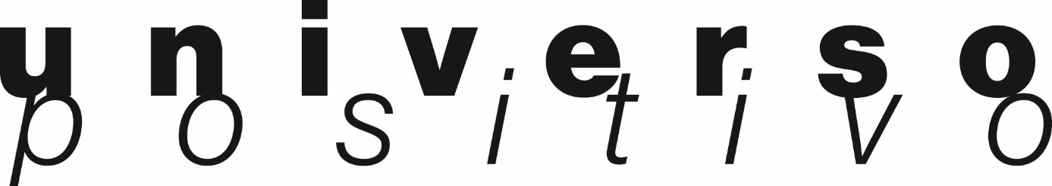
During this year's edition of MAISON&OBJET, from September 8 - 12 2017,
Universo Positivo will present the Monolit collection to the press and public for the first time.
Paris will always have special meaning to Universo Positivo, because the very first collection of the brand was launched at MAISON&OBJET in 2013. This prestigious trade fair dedicated to lifestyle, decoration, and design is without a doubt the perfect stage to reveal these new signature Universo Positivo pieces.
Through the belief that a single object can define a space, Universo Positivo created the Monolit collection. It is a cumulation of symmetrical designs and contrasting attributes. The collection is available in 3 different finishes. These contemporary pieces, with a particular complex simplicity in their design, are shaped by metal and wood.
Universo Positivo is more than a collective of vanguard designers, by deeply caring about the product design, quality, endurance, and sustainability. Basically, we truly care about how the products can fit into the worlds and lives of the clients.
Universo Positivo can be found on the Ethnicraft booth in Hall 7 Stand A69. The booth is a reflection of the entire Ethnicraft Group philosophy and identity, but with respect for the individual characters of the brands within the group.

MONOLIT SIDEBOARD:
A square frame embraces the light oak and creates an object centered around practicality and aesthetics.
MONOLIT TV CUPBOARD:
The contrasting characteristics of wood and the rectangular metal frame create a unique backdrop for all modern media equipment.
MONOLIT BEDSIDE TABLE:
Practicality without sacrificing style. The minimalistic bedside table offers ample storage and serves as a convenient stand for bedside essentials.
MONOLIT SIDE TABLE:
Balance and function come together in the side table. It attracts attention without diverting it from the object you choose to display.
MONOLIT CONSOLE:
Styling and function are weaved together in the console. Art and accessories can be presented on a prominent level, without distraction. That is the beauty of the complex simplicity of the collection.

