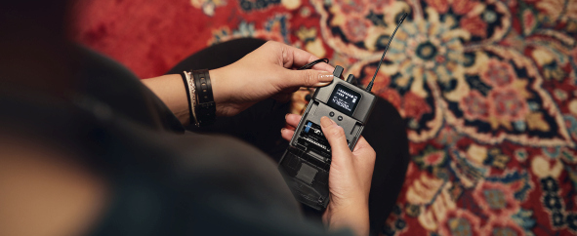Sennheiser launches XS Wireless IEM in-ear monitoring system
New system promises a big leap in performance quality for up-and-coming bands and singer-songwriters

Wedemark, 26 April 2022 – At some point in their career, musicians realize that they need better gear to improve the overall quality of their performance. An important element in taking the audio quality to the next level is an in-ear monitoring system. Sennheiser, manufacturer of the acclaimed Evolution Wireless IEM systems, now launches XS Wireless IEM for musicians seeking to professionalize their shows by switching from floor wedges to wireless IEMs.

Sennheiser XS Wireless IEM is a complete starter set for musicians who want to professionalize their performances by switching to wireless IEMs | 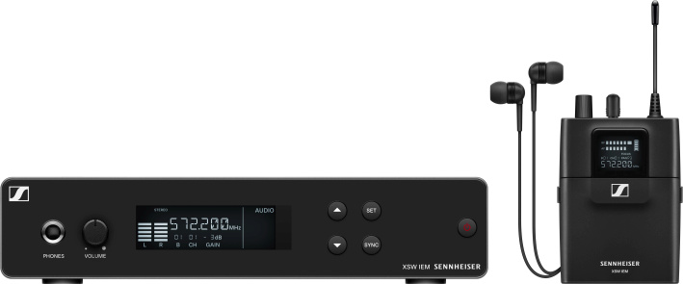

XS Wireless IEM (or XSW IEM for short) is a complete starter set for personal monitoring and has been designed to set a new standard for simple, flexible, and reliable wireless in-ear monitoring. The system enables users to quickly establish an easy-to-manage wireless connection in the professional UHF range.

“No matter what your musical genre, whether you are rehearsing or performing live, XSW IEM will level up your sound and give you total freedom of movement,” says Bertram Zimmermann, product manager at Sennheiser. “Being able to hear yourself with clarity is a pre-requisite for a great performance. XSW IEM will give you consistency, reliability, and quality audio, and will let you focus on playing and singing your best.”

Hearing yourself and other band members well is a prerequisite for a great show

Never go back
“Once musicians have tried out wireless in-ears, they will not want to go back to wedges,” says Zimmermann. “The difference in sound is just too obvious. Hearing yourself well through floor monitors, side fills, or even the PA can be a real struggle. The sound changes constantly, especially when you move around, and is also very different from venue to venue. Trying to hear yourself better by increasing the monitor volume makes things worse, even to the point of causing hearing damage. Also, the overall sound for the audience will deteriorate substantially.”

All this can take a performer away from a good rehearsal or a great show as they can neither hear themselves properly nor how they blend in with the other musicians. In-ear monitoring eliminates these problems: XSW IEM gives musicians a consistent, reliable sound that is independent of the location and their position on stage. The detail and transparency they hear helps them finetune and improve their performance. Any risk of feedback is greatly reduced.

Regardless of tech experience, XS Wireless IEM systems are easy and fast to set up. They will put an end to stage clutter – and give musicians back more space in their rehearsal room.

Feature-packed starter set
XSW IEM uses the UHF band to provide a professional-level wireless connection. Aligned and pre-calculated frequency presets get musicians started with ease and in a snap. If desired, transmission frequencies can also be selected manually.

Backlit displays on both the receiver bodypack and the rack-mount transmitter help to clearly see settings even in poor lighting conditions. In addition, the system offers a limiter to protect user’s hearing and a high-frequency boost to increase detail and intelligibility.

For their monitor sound, users can opt for a mono mix (one mix, and the pan control adjusts the volume for the left and right ear) or a stereo mix. The latter provides two options: With Focus mode switched off, the pan control will change the left/right volume; with Focus mode switched on, it will determine which of the two input signals will be heard louder, creating a personal mono mix tailored to the musician’s needs.

An infrared sensor helps to easily sync multiple bodypack receivers to one transmitter.

XS Wireless IEM features reliable UHF transmission and a special Focus mode to tailor monitor sound to the musician’s needs. An infrared sensor helps to sync multiple bodypack receivers to one transmitter | 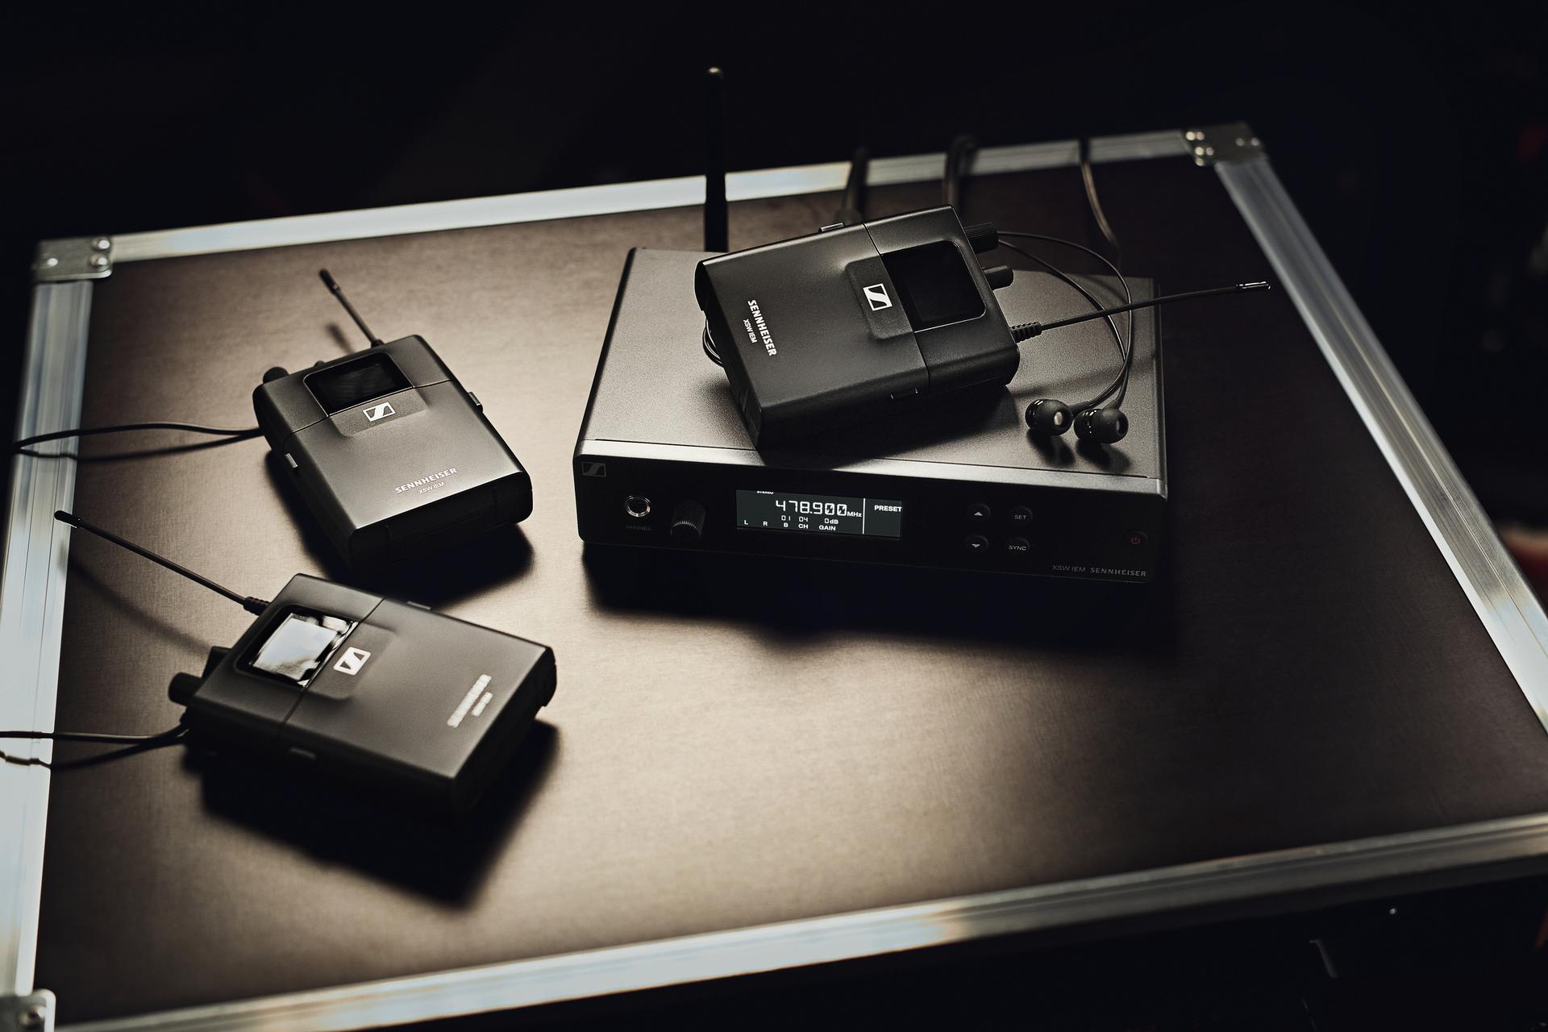

What’s in the box?
XSW IEM includes a stereo bodypack receiver complete with in-ears and batteries and a stereo transmitter with antenna, rack-mount kit and a power supply with various country adapters.

When starting out, using one transmitter and any number of bodypack receivers is a very cost-effective way to monitor a band’s sound. At a later point in their career, they may want to create more individual mixes, and can do so by simply adding an additional IEM transmitter.

XSW IEM retails at EUR 599 (MSRP), additional receivers and transmitters at EUR 349 (MSRP) each.

XSW IEM is available in five UHF frequency ranges which are aligned with the XSW family of wireless microphones and instrument transmitters (see Technical Data below).

(Ends)

Technical Data

XSW IEM SR Stereo Transmitter
Modulation: FM stereo
Frequency ranges and max. RF power:
A: 476 - 500 MHz (30 mW)
B: 572 - 596 MHz (30 mW)
C: 662 - 686 MHz (30 mW)
E: 823.2 - 831.8 MHz (30 mW)
K: 925.2 - 937.3 MHz (10 mW)
Switching bandwidth: up to 24 MHz
AF frequency response: 45 Hz to 15 kHz
Audio inputs: 2x XLR-3 / ¼“ (6.3 mm) jack combo socket, electronically balanced
Total harmonic distortion (THD): <0.9 %
Signal-to-noise ratio: ≥88 dB
Temperature range: 0 °C to +40 °C
Input rating: +12 V DC
Current consumption: approx. 400mA (depending on volume level)
Dimensions: approx. 200 x 128 x 42 mm
Weight: approx. 700 g

XSW IEM EK Stereo Receiver
Switching bandwidth: up to 24 MHz
Signal-to-noise ratio (1 mV, peak deviation): ≥88 dB
Total harmonic distortion (THD): ≤1 %
AF output level at 3.5 mm: 2 x 1.25 V_{rms} at 16 ohms
High Boost (EQ): +10 dB at 13 kHz
Limiter: -10 dB
AF frequency response: 45 Hz to 15 kHz
Temperature range: 0 °C to +40 °C
Power supply: 2 AA batteries, 1.5 V
Operating time: approx. 6 hrs (depending on volume level)
Dimensions: approx. 95 x 70 x 26 mm
Weight (incl. batteries): approx. 110 g

IE 4 In-ear Headphones
Transducer: dynamic
Frequency response: 40-20,000 Hz
SPL (1 kHz, 1 mW): 106 dB
Nominal impedance: 6 ohms
Cable length: 1.4 m
Connector: 3.5 mm (1/8”) stereo plug, gold-plated
Temperature: –5 °C to +50 °C

The images accompanying this press release plus additional photos can be downloaded here.

About the Sennheiser brand
We live and breathe audio. We are driven by the passion to create audio solutions that make a difference. Building the future of audio and bringing remarkable sound experiences to our customers – this is what the Sennheiser brand has represented for more than 75 years. While professional audio solutions such as microphones, meeting solutions, streaming technologies and monitoring systems are part of the business of Sennheiser electronic GmbH & Co. KG, the business with consumer devices such as headphones, soundbars and speech-enhanced hearables is operated by Sonova Holding AG under the license of Sennheiser.

www.sennheiser.com
www.sennheiser-hearing.com

Global Pro Audio Press Contact

Stephanie Schmidt
Stephanie.schmidt@sennheiser.com
+49 (5130) 600 – 1275

