RME Ensures Compatibility with New macOS Catalina

RME’s drivers are all written in-house and not outsourced to third parties, so customers can use latest operating systems without interruption or delay
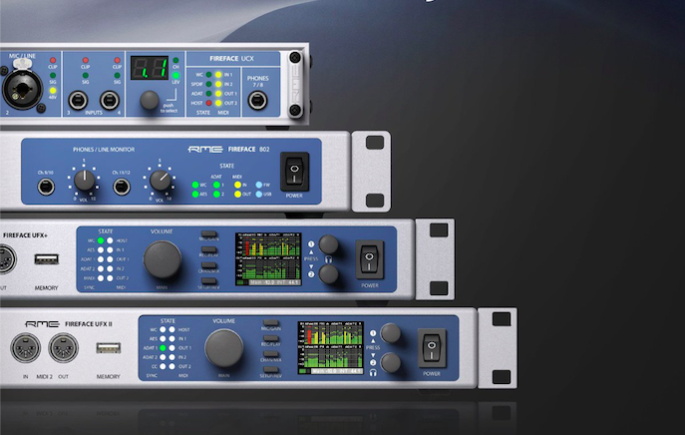
Fort Lauderdale, Florida, October 3, 2019 – RME, German manufacturer of premium interfaces, announced today that its interfaces are already compatible with the latest macOS Catalina 10.15.x which was released this month. Since RME drivers are written in-house and not outsourced to third party developers, RME’s users are able to update their firmware immediately and continue working without interruption or delay.
Recently, several pro-audio manufacturers and interface manufacturers have issued warnings to customers advising them not to upgrade their operating software, presumably due to compatibility issues with the new OS. Other companies have issued announcements referencing possible delays in supporting the new operating system, or even loss of data.
RME Users Rest Easy
RME interfaces compatible with Catalina include: Babyface Pro, Digiface AVB, Digiface Dante, Digiface USB, Fireface 802, Fireface UC, Fireface UCX, Fireface UFX II, Fireface UFX+, MADIface Pro, MADIface USB and the MADIface XT. Apps must be fully 64-bit and drivers should be “notarized” as required for operation with Catalina OS 10.15.x.
RME’s non-USB interfaces, including the PCle, Thunderbolt and FireWire, have beta drivers available for download now so its customers do not experience interruption or delay in their projects.
No Third-Party Drivers
Since RME writes all of its drivers in-house and does not depend on third parties for this process, its hardware is able to stay ahead of operating system updates.
“One of the cornerstones of our company has always been customer support and dependability,” commented Derek Badala, Director of Sales, Americas, for Synthax, RME’s U.S. distributor. “We are proud to say that all of our drivers are written in house — unlike many of our competition. Further, updates are automatically handled by FPGA technology, which is present in all our interfaces. The combination of these things — along with our known product dependability — means that our customers will continue to experience superior performance without interruption.”
For more on RME, visit rme-usa.com

About Synthax, Incorporated
Synthax Inc. is the exclusive USA distributor for RME digital audio solutions, Digigram broadcast audio systems, Appsys digital audio tools, Ferrofish advanced audio applications, myMix personal monitoring systems and ALVA cableware. We supply a nationwide network of dealers with these products for professional audio, broadcast, music industry, commercial audio, theater, military and government applications. For additional information, visit the company online at http://www.synthax.com.

Media Contacts:

Katie Kailus
Public Relations
Hummingbird Media
+1 (630) 319-5226
katie@hummingbirdmedia.com

Jeff Touzeau
Public Relations
Hummingbird Media
+1 (914) 602 2913
jeff@hummingbirdmedia.com

