Sennheiser appoints Ron Holtdijk as Director Business Communication

Wedemark, May 6, 2019 – Audio specialist Sennheiser has appointed Ron Holtdijk as Director Business Communication. He will be responsible for driving forward Sennheiser’s strategy and success in business communications, particularly in the field of ceiling array microphones and in the further growing of Sennheiser’s education market.

“The outstanding breadth, depth and international scope of Ron’s experience is an ideal fit for Sennheiser’s ambitious vision and company culture,” said Peter Claussen, COO at Sennheiser. “He will bring his broad experience and insight to our BizCom management team and play an instrumental role in driving forward our strategy in B2B markets.”

Ron Holtdijk will take on his new role with Sennheiser on June 1, 2019. He will be based at Sennheiser’s headquarters in Wedemark and report directly to Peter Claussen.

An accomplished audio industry executive with 25 years’ experience in the sector, Ron Holtdijk joins Sennheiser from Bang and Olufsen, where he was Director of its Global Business-to-Business Division and played a key role in developing the company’s portfolio and go-to-market strategy in this field.

Ron Holtdijk has been appointed as Director Business Communication | 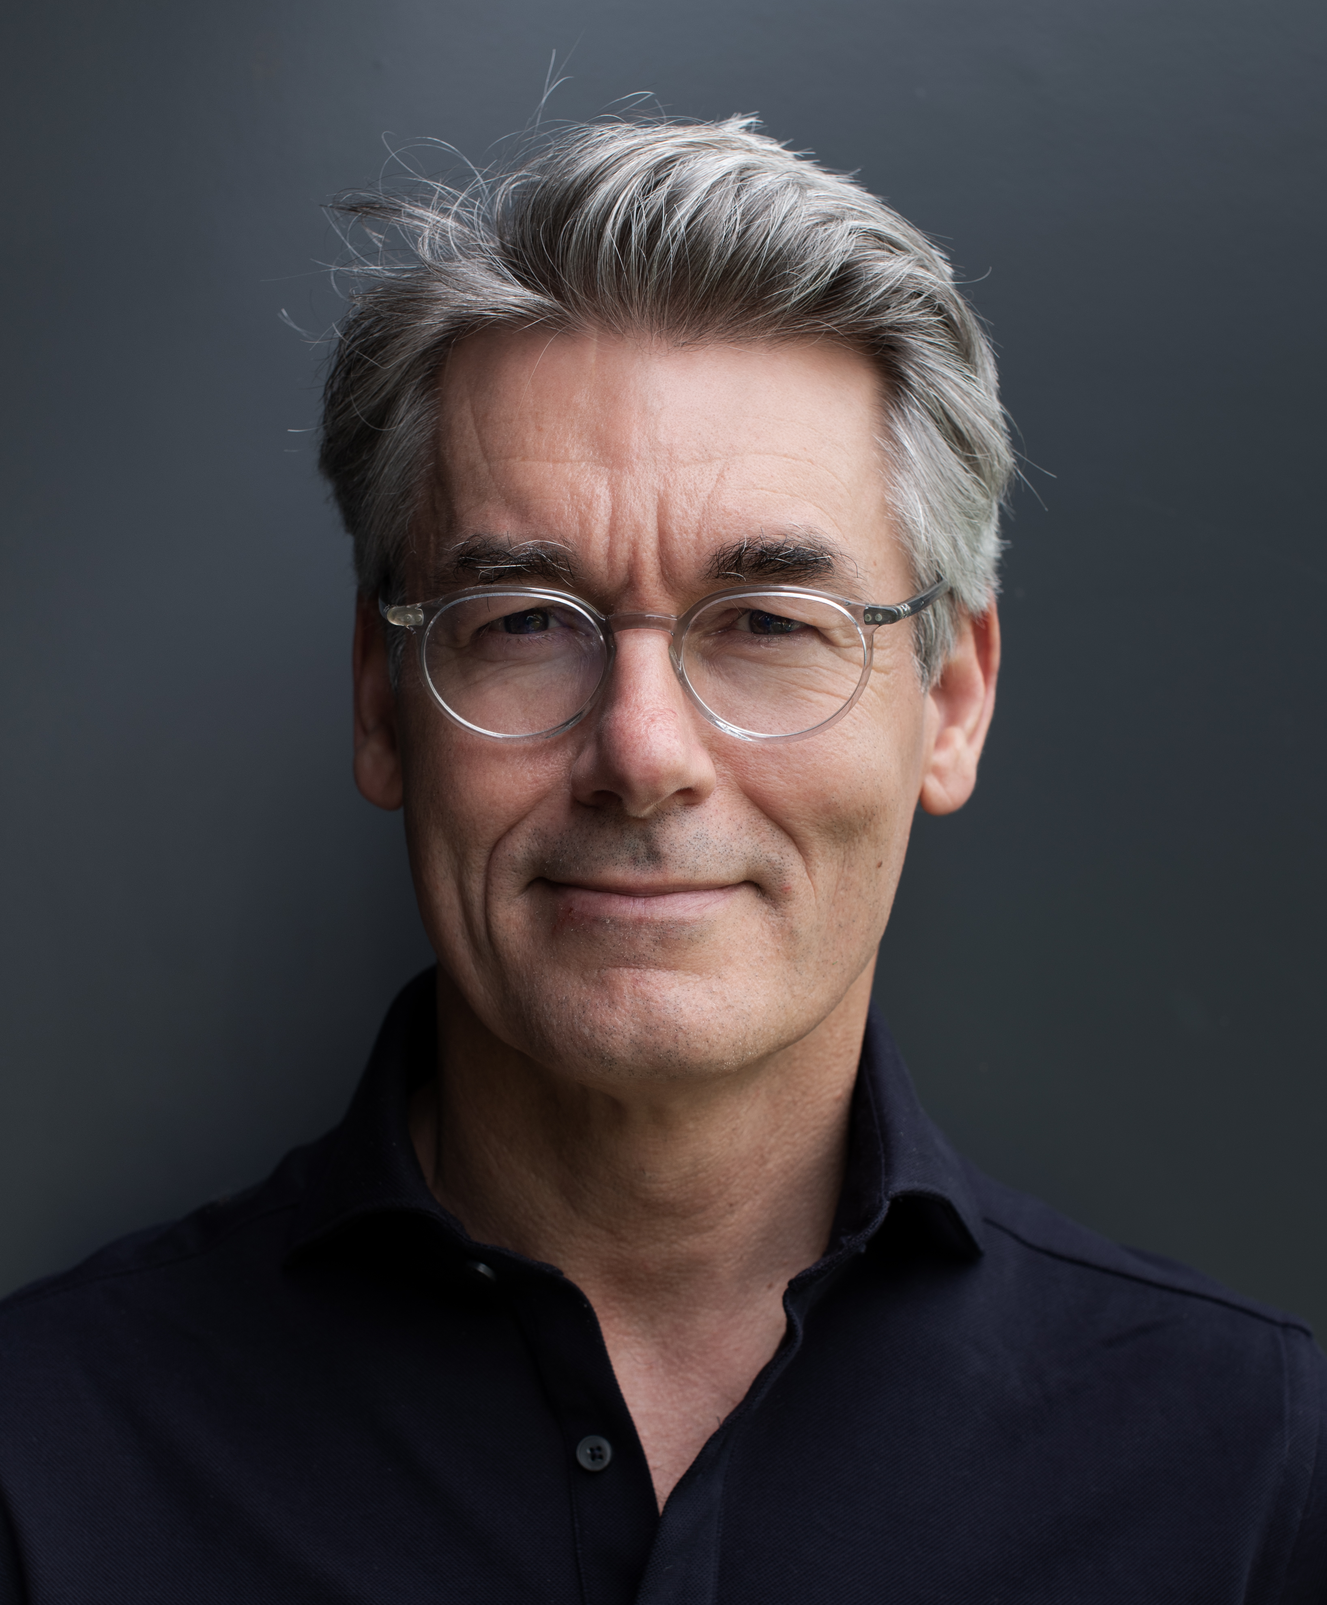
Ron Holtdijk started his career in audio at Bose Corporation in the Netherlands in 1994. Following a range of account management and sales roles within Bose’s Professional Systems Division, he was promoted to Director Professional Systems Division for the Netherlands in 1997. In 2009, he took on a regional role as Divisional Manager Professional Systems Division Middle East & Africa. From 2010-2014, he assumed P&L responsibility for the wider EMEA region as Business Director Professional Systems Division EMEA.

About Sennheiser
Shaping the future of audio and creating unique sound experiences for customers – this aim unites Sennheiser employees and partners worldwide. Founded in 1945, Sennheiser is one of the world’s leading manufacturers of headphones, microphones and wireless transmission systems. With 21 sales subsidiaries and long-established trading partners, the company is active in more than 50 countries and operates its own production facilities in Germany, Ireland, Romania and the USA. Since 2013, Sennheiser has been managed by Daniel Sennheiser and Dr. Andreas Sennheiser, the third generation of the family to run the company. In 2017, the Sennheiser Group generated turnover totaling €667.7 million. www.sennheiser.com

Global Press Contact
Mareike Oer
T +49 (0)5130 600-1719
mareike.oer@sennheiser.com

