**Discover the details you’ve been missing.**

**The new HD 550 brings a compelling new choice to audiophiles and gamers seeking next-level capability that outshines its price tag.**

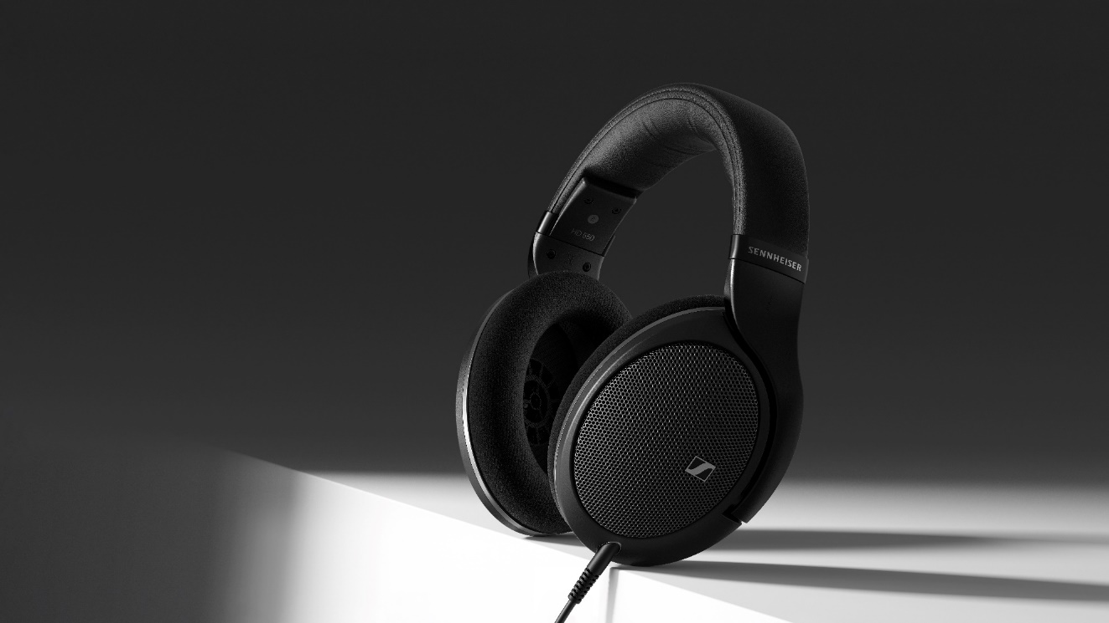

***Marlow, UK – March 19, 2025* – The Sennheiser brand today unveiled the HD 550, a hi-fi headphone that balances revealing performance with effortlessly smooth tuning.** Boasting sprawling stereo imaging and an ultra-light build, the HD 550 is an open invitation to unpack the lush layers of today’s music and games for hours on end.

*"Audiophiles looking for featherlight headphones with honest voicing and deep bass extension are in for a treat,” said Klaus Hanselmann, Sennheiser Audiophile Product Manager. "While the HD 550’s airy detail is obvious, customers will fall in love with its delightfully polite touch – perfect for listening for hours on end."*

**A Deeper Audiophile Experience**  
The heart of the HD 550 is its custom 38mm transducer, made at Sennheiser’s audiophile production facility in Tullamore, Ireland. Its speedy performance yields exceptional clarity from 6 Hz to 39.5 kHz, all whileproducing less than 0.2% total harmonic distortion. At 150 ohms, it’s an ideal match for a wide variety of hi-fi gear, scaling with ease when paired with premium audio gear such as Sennheiser’s own HDV 820.

*The HD 550 brings impressive performance to practically any audiophile setup*

The fully open-back design utilises a new acoustic mesh that protects the transducers while removing any remaining barriers between the listener and their music. Their angled arrangement creates an expansive soundstage that drops the listener into the epicenter of the recording. Gamers will experience superb, lag-free spatial awareness and immersion for both competitive and casual sessions. True to the Sennheiser brand’s heritage, the HD 550 delivers punchy bass, crystal-clear transients, and neutral mids without straying from the truthful voicing that audiophiles prefer.   
  
**Built for Comfort**   
Situated in chassis renowned for its long-term comfort, the HD 550 features a more relaxed clamping force compared to other 500-series stablemates. Weighing less than the most popular gaming controllers at a mere 237 grams [8.4 oz], the HD 550 practically disappears on the head. A soft-touch textured headband and ventilated metal mesh earcup covers keep the listener comfortable without sacrificing durability.

Like other models in the 500 series, the HD 550 features a modular design, allowing for easy swapping of cables and earpads. It ships with a 1.8 m cable terminating with a stereo 3.5 mm jack plug with a 6.35 mm adapter, making it compatible with a wide range of devices. A range of additional cables—sold separately—makes it easy for listeners to adapt to balanced sources and mic-enabled jacks, for example.

**Availability**

The all-new HD 550 is currently available for pre-order, shipping the first week of April at an MSRP of £249.99.

*The HD 550 is an immersive listening experience for games, music, and movies*

**About the Sennheiser** **brand**

We live and breathe audio. We are driven by the passion to create audio solutions that make a difference. Building the future of audio and bringing remarkable sound experiences to our customers – this is what the Sennheiser brand has represented for more than 75 years. While professional audio solutions such as microphones, meeting solutions, streaming technologies and monitoring systems are part of the business of Sennheiser electronic GmbH & Co. KG, the business with consumer devices such as headphones, soundbars and speech-enhanced hearables became part of the Sonova Holding AG group of companies in 2022, who have licensed the Sennheiser trademark for this purpose.

[www.sennheiser.com](http://www.sennheiser.com/)

[www.sennheiser-hearing.com](http://www.sennheiser-hearing.com/)

**About Sonova Consumer Hearing**  
Sonova Consumer Hearing offers premium headphones and hearables – primarily in the true wireless segment – as well as audiophile headphones, hearing solutions and soundbars under the Sennheiser brand. The business is part of the Sonova Group, a global leader in innovative hearing care solutions with headquarters in Switzerland and more than 17,000 employees worldwide.

**Press contact**

Sonova Consumer Hearing GmbH

Kate Smart

PR and Influencer Manager | EMEA

+44 7909 729925

Kate.smart@sonova.com