EVERYTHING IS RECORDED
RELEASES NEW SINGLE ‘SHOW LOVE FEAT. SYD & SAMPHA’
WATCH THE LYRIC VIDEO HERE
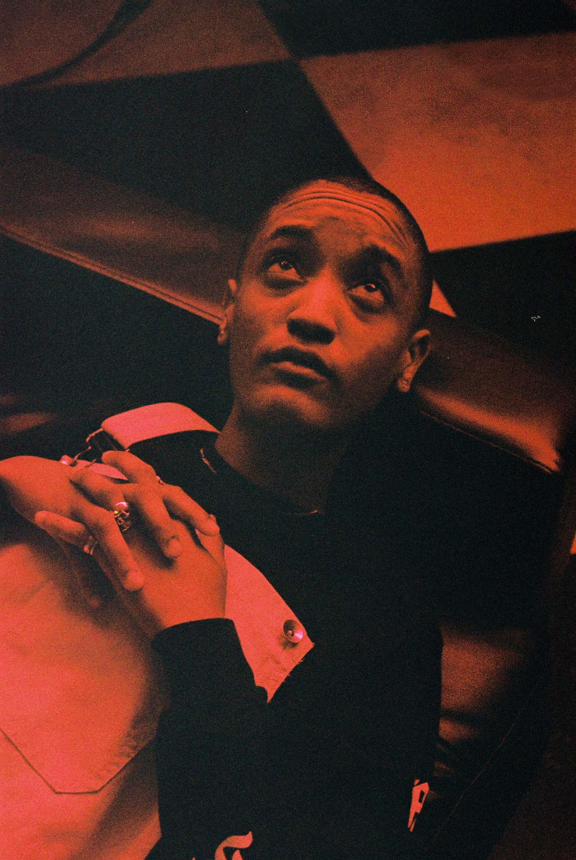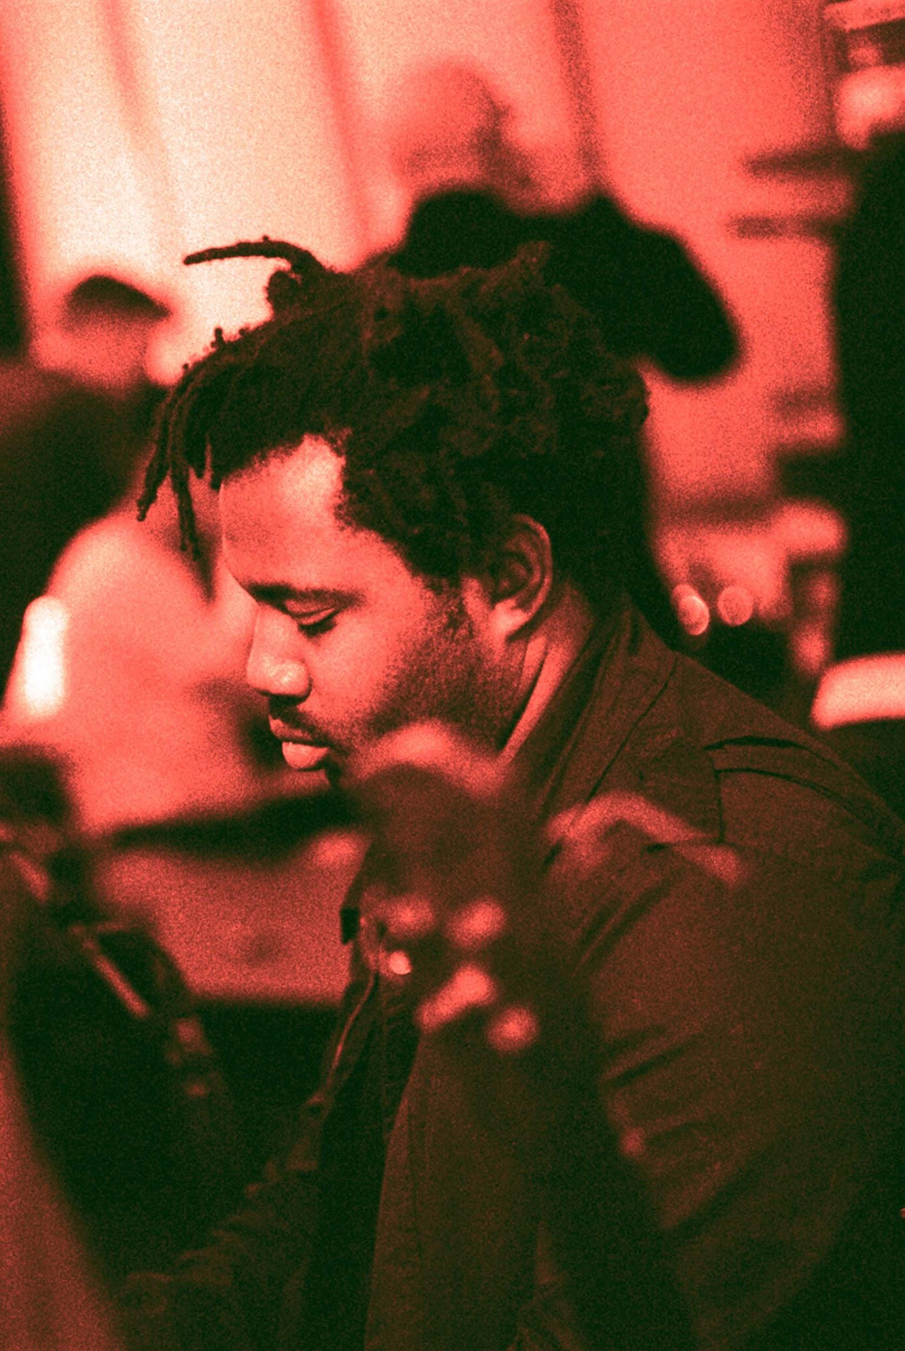
(High Res HERE)

Everything Is Recorded – the collaborative artist project from record producer and XL Recordings head Richard Russell – today has released a new single, ‘Show Love feat Syd & Sampha’ via XL Recordings. Back in August Richard Russell stopped by Zane Lowe’s Beats 1 radio show in which he discussed his respect for Syd and working with her for Everything Is Recorded: listen here. Bridging the gap between London and Los Angeles, ‘Show Love’ begins with Russell’s signature percussive instrumentation, interlaced with an introductory verse from London artist Sampha, then blissfully transitioning into Syd’s signature neo-soul R&B. The song premiered on BBC Radio 1Xtra show MistaJam on Wednesday and is now available on all digital services.

Listen to ‘Show Love feat. Syd & Sampha’ HERE

‘Show Love feat. Syd & Sampha’ is the follow up to Everything Is Recorded’s most recent single ‘Mountains Of Gold’ which features a diverse line-up of acclaimed artists in the form of Sampha, French-Cuban duo Ibeyi, NYC rapper WIki and Los Angeles jazz titan Kamasi Washington. Both releases provide a captivating snapshot of the kind of collaboration and experimentation that has taken place at Russell’s west London studio, The Copper House, over the past few years. This studio has become a creative second home for a revolving cast of vocalists and musicians who pass through to write, record and share ideas, mixing traditional recording sessions with extended, uninhibited live jams.

Russell, renowned for his album production work for Bobby Womack, Damon Albarn, Ibeyi and Gil Scott-Heron among others, released the debut Everything Is Recorded EP ‘Close But Not Quite’, which featured a similarly eclectic host of international artists including Sampha, Giggs, Obongjayar, Tic, Warren Ellis, Infinite, Mela Murder, Green Gartside and Baluji Shrivastav, in May of this year.

Look out for more Everything Is Recorded releases in the very near future.

‘Show Love feat. Syd & Sampha’ artwork: *download here

More on Everything Is Recorded:
https://www.instagram.com/everythingisrecorded

