SUPERIOR SOUND, TAILORED TO YOU
Sennheiser launches CX 400BT True Wireless

Wedemark, September 1, 2020 – Rules are there to be broken: With the new CX 400BT True Wireless, Sennheiser has rewritten the rulebook for true wireless audio by bringing its high-end acoustic technology to an exciting new pair of everyday earphones. With intuitive customizable controls, all-day comfort and a 7-hour battery life that can be extended to up to 20 hours using the supplied charging case, they are the ideal, uncompromised choice for anyone with a passion for great sound.

“The CX 400BT True Wireless makes astonishing sound quality incredibly accessible,” said Frank Foppe, Product Manager at Sennheiser. “First, our premium true wireless range set new standards in audio quality by introducing high-end acoustic technology to the true wireless market. Now, we are excited to be bringing this ’sound first’ ethos to everyday true wireless earphones as well. We believe that people shouldn't give up on sound quality when giving up cables – and with the CX 400BT True Wireless they don’t have to.”

The CX 400BT True Wireless delivers astonishing performance thanks to Sennheiser’s 7mm dynamic drivers which are also featured in the acclaimed MOMENTUM True Wireless 2 earphones that were introduced earlier this year. Developed for the audio specialist’s premium true wireless earphones, this bespoke acoustic system delivers high-fidelity stereo sound with deep bass, natural mids and clear, detailed treble. With the Sennheiser Smart Control app it is also possible to tailor the sound experience to one’s personal preference via the built-in equalizer. Support for codecs such as SBC, AAC and aptX assures exceptional sound quality with both iOS and Android mobile devices.

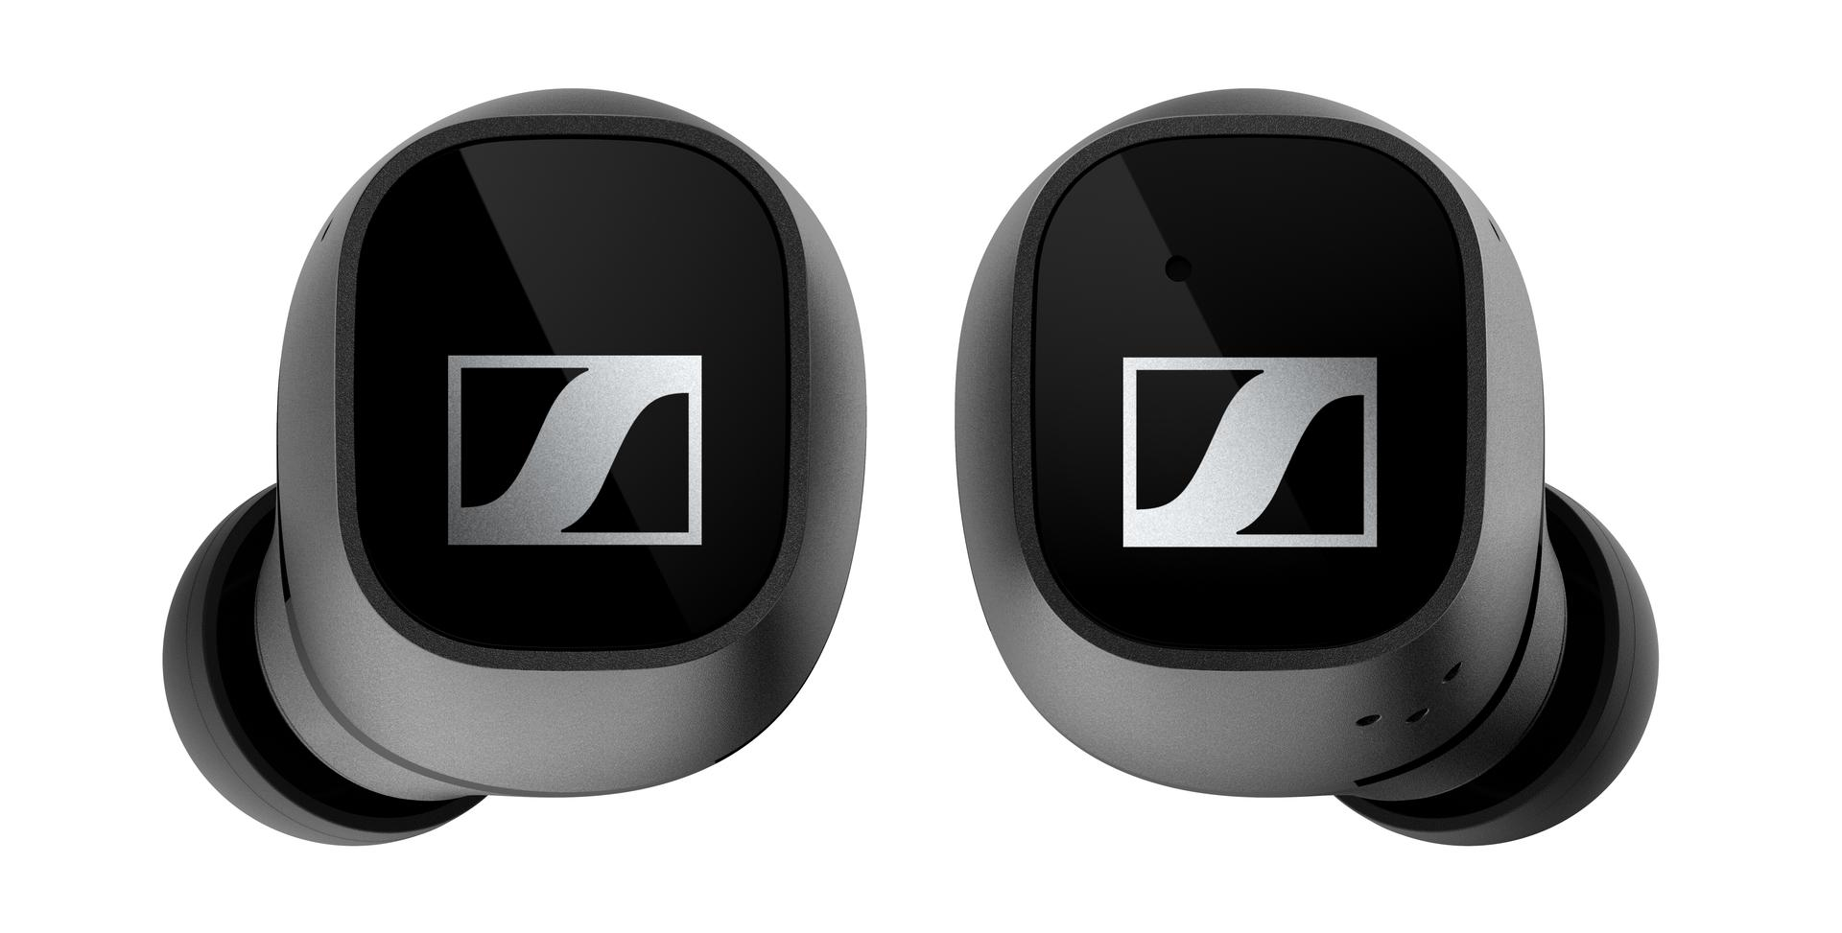

The CX 400BT True Wireless is powered by Sennheiser’s 7mm dynamic drivers

Intuitive and effortless to use
The CX 400BT True Wireless has been created for fast-paced, always-on lifestyles. Staying entertained, informed and connected is effortless and intuitive, thanks to the earbuds’ customizable touch controls that let the user define their preferred way of controlling audio, calls or accessing voice assistants such as Google Assistant or Siri.

For phone calls and when using smart assistants, the earbuds feature ambient noise reduction microphones to make voice interactions sound natural and crystal clear. With the CX 400BT True Wireless, device connectivity is fuss-free, thanks to Bluetooth 5.1 compatibility for reliable connectivity and easy management of Bluetooth connections using the Smart Control app.

Experience all day entertainment in total comfort
With 7 hours battery life and up to 20 hours available when charging on-the-go with the supplied case, the CX 400BT True Wireless keeps entertaining throughout the day – and comes with all-day comfort to match.
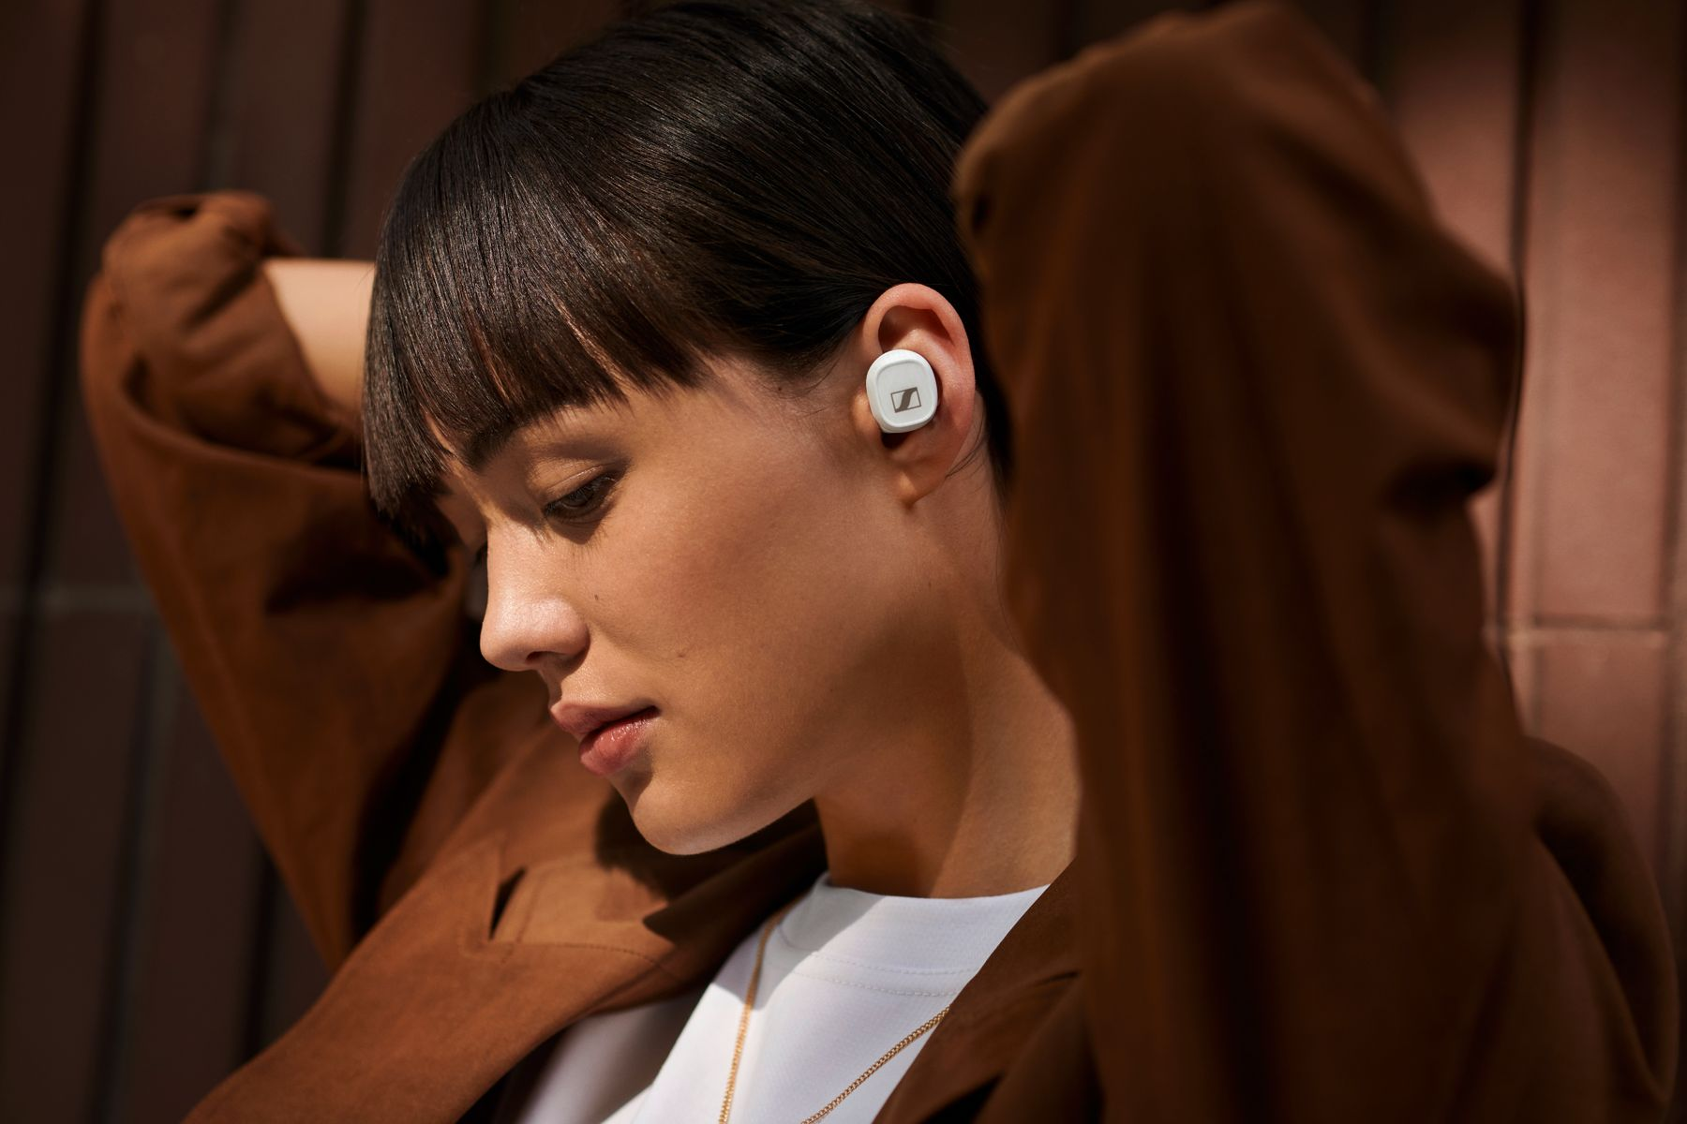

The stylish, minimalist design is available in white or black

Stylish, minimalist, and perfectly balanced, the earbuds’ ergonomic design – available in either black or white – assures all-day wearing comfort, while their exacting build quality ensures lasting take-anywhere durability. For a perfect fit in the ear that keeps the earbuds securely in place and effectively attenuates outside noise, adapters are provided in a choice of four sizes.

The CX 400BT True Wireless will be available in black and white from September 15 for 199 EUR (MSRP).

About Sennheiser
Founded in 1945, Sennheiser is celebrating its 75th anniversary this year. Shaping the future of audio and creating unique sound experiences for customers – this aim unites Sennheiser employees and partners worldwide. The independent family company, which is managed in the third generation by Dr. Andreas Sennheiser and Daniel Sennheiser, is today one of the world’s leading manufacturers of headphones, loudspeakers, microphones and wireless transmission systems. In 2019, the Sennheiser Group generated turnover totaling €756.7 million. www.sennheiser.com

Global Press Contact
Jacqueline Gusmag
Communications Manager Consumer
jacqueline.gusmag@sennheiser.com
T +49 (0)5130 600-1540

