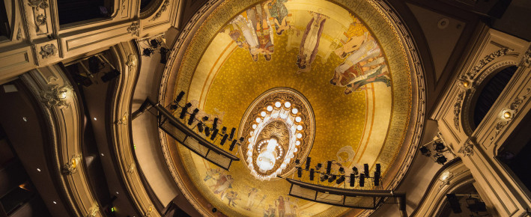From classic plays to modern drama, cabaret and musicals - Het Nationale Theater presents sound productions with Sennheiser
One of the biggest theatres in the Netherlands trusts in Digital 6000 to deliver more than 300 shows each year

Wedemark, March 29, 2022 – Created in 2017 as a merger of het Nationale Toneel (a theatre company), the Koninklijke Schouwburg (the Royal Theatre) and Theater aan het Spui (the City Theatre), Het Nationale Theater (HNT) is one of the Netherland’s most prominent theatres. With 90 percent of shows converting into touring productions, the team regularly travels to every major city in the Netherlands with its shows, covering a quarter of nearly 200 theatres spread all across the country. Last year, HNT’s audio inventory was upgraded with a fleet of Sennheiser’s Digital 6000 wireless microphone systems with SK 6212 mini-bodypack transmitters, bringing a new level of audio clarity, comfort and no-compromise transmission reliability to the theatre’s spectacular and varied programme.

Het Nationale Theater is one of the Netherland’s most prominent theatres, delivering about 300 productions every year  Photo credit: Phile Deprez | 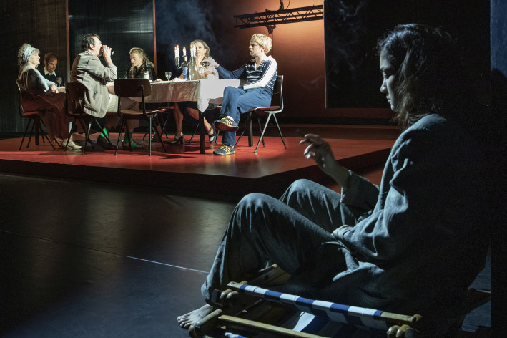

Every HNT production starts at the organisation’s home theatre in The Hague and then continues touring for 7 to 9 weeks across the Netherlands, visiting up to 30 different cities before returning to The Hague and passing the entertainment baton to the next show.

Ivo Pas, Senior Sound Engineer, and his colleague Robbert Weinen, also a sound engineer, both joined HNT back in 2014 and have been working in the touring department ever since, looking after the shows and rehearsals, and closely cooperating with responsible sound designers.

“We have a team of five sound engineers taking care of more than 300 productions between us, so we rarely see each other in person as we are constantly on the road with the cast,” jokes Weinen.

Whilst the theatres’ in-house PA systems are utilised, the majority of equipment travels with the HNT company, including high-end wireless equipment which comprises 20 channels of Digital 6000 complemented with SK 6212 mini-bodypack transmitters.

The Koninklijke Schouwburg in The Hague  Picture courtesy of Het Nationale Theater | 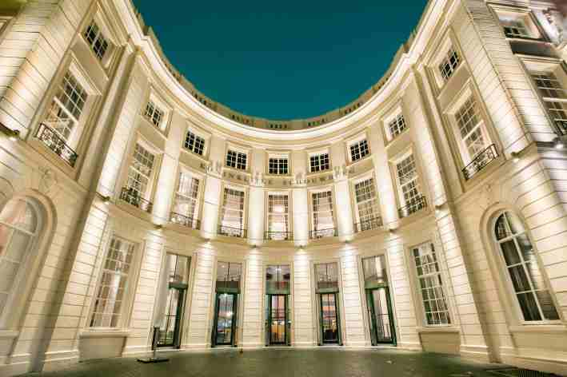

The Koninklijke Schouwburg and Theater aan het Spui both use the Digital 6000 series, too. They own five receivers with a combination of eight SKM 6000 handhelds and eight SK 6000 beltpacks, as well as four receivers with a combination of six SKM 6000 handhelds and six SK 6212 beltpacks, respectively.

“The actors love the SK 6212,” shares Weinen. “The previous SK 5212 transmitter was already quite small, but everyone’s now calling it ‘the big one’. Actors are constantly moving around the stage, and you could see the old bodypacks hidden within their tight outfits. With the SK 6212, this problem is now solved.”

Pas concurs, “These days, some of our shows can last up to five hours, or even more, with two breaks between acts for the audience. We call them ‘marathon shows’. We start using the SK 6212 for rehearsals in the morning and then use the same battery for the show, which can finish as late as 11pm at night. That’s simply amazing and saves us a lot of time and hassle.”

The ultra-compact SK 6212 on a guitar  Picture courtesy of Het Nationale Theater | 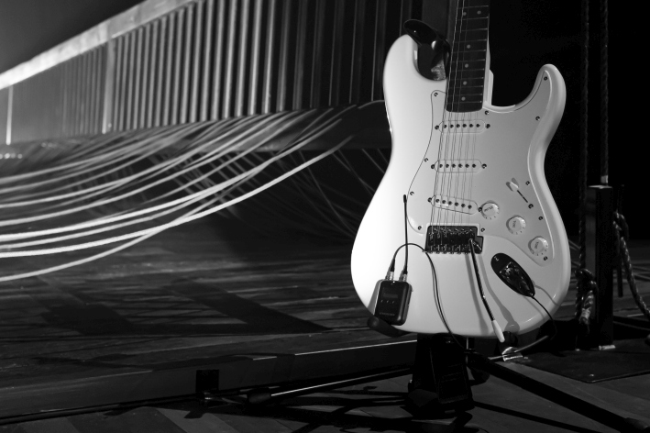

Longer battery life also means additional comfort for the cast as they can go through the entire day not worrying about needing to re-adjust things like clothes and wigs following a battery swap in their transmitters.

On top of that, the fact that frequencies can be packed very tightly with Digital 6000 helps the HNT team to achieve no-compromise transmission in every location – despite the spectrum becoming smaller and smaller. Digital 6000 does not generate any intermodulation products, therefore transmission frequencies can simply be arranged at 400 kHz intervals – or at 200 kHz, if Link Density mode is used, which has not yet been necessary. “Most of the time on a tour, the theatres have two or three auditoriums, so we often get a number of wireless bodypacks ‘on air’ from different shows in the same building. Digital 6000 offers a stress-free experience even in most congested RF environments, with its intelligent algorithms enabling the system to still transmit the signal flawlessly where other digital systems might struggle.”

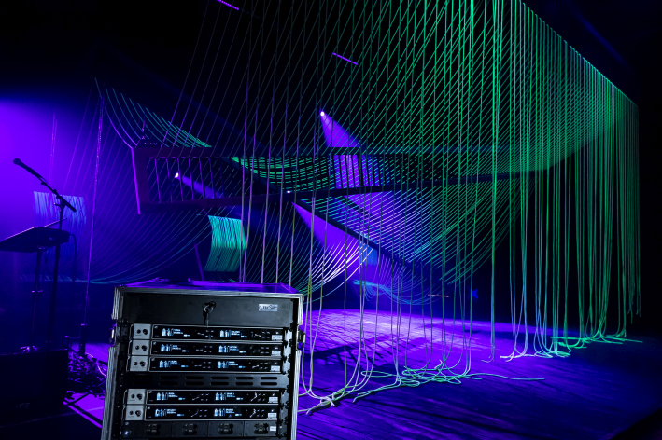 | Digital 6000 Rack at stage – the system offers a stress-free experience even in congested RF environments  Picture courtesy of Het Nationale Theater

When the pandemic struck, the HNT team was forced to find new creative ways of delivering their shows, for example, by utilising live streaming technologies and doing podcasts. With last year bringing some level of the old ‘normal’ back, HNT has been running at double speed delivering new shows every day, which included Trojan Wars, Tori, Hebriana and Yerma among others.

“From the start of the rehearsals until the tour ends, we have a maximum stretch of five months,” says Weinen. “Unlike some other theatres, we don’t run the same show for years. That’s something that sets us apart among international theatre groups and makes us unique in our offering. We deliver fresh content all the time, which is both thrilling and frightening; with each show we need to be able to deliver all the elements at 100 percent and there’s no room for error since the show will then move to another location and stay there for just a few days before continuing on to another venue.”

“With this in mind, the quality and reliability of our equipment is absolutely paramount,” concludes Pas. “We are really pleased with our investment in Digital 6000. It takes away the hassle and means that us – the technical crew - and the cast can fully focus on the most important part of our job: delivering a great show!”

(Ends)

The images accompanying this press release can be downloaded here.

About the Sennheiser brand
We live and breathe audio. We are driven by the passion to create audio solutions that make a difference. Building the future of audio and bringing remarkable sound experiences to our customers – this is what the Sennheiser brand has represented for more than 75 years. While professional audio solutions such as microphones, meeting solutions, streaming technologies and monitoring systems are part of the business of Sennheiser electronic GmbH & Co. KG, the business with consumer devices such as headphones, soundbars and speech-enhanced hearables is operated by Sonova Holding AG under the license of Sennheiser.

www.sennheiser.com
www.sennheiser-hearing.com

Global Press Contact

Stephanie Schmidt
Stephanie.schmidt@sennheiser.com
+49 (5130) 600 – 1275

