For more information, please contact Marta de Paco
On +34 670 780 664 or email press@comunicahair.com

Important:
These images are only available for editorial content and social media.
Credits must be included.
Notification of their publication is expected.

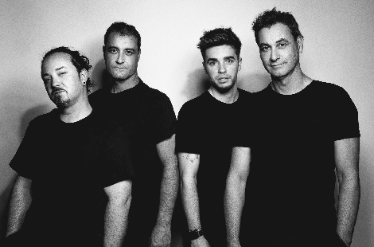
HAIRKRONE
DISCOVER Collection

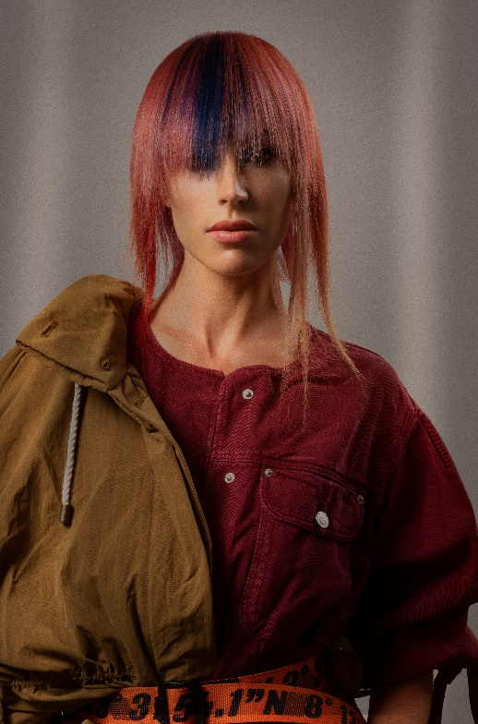
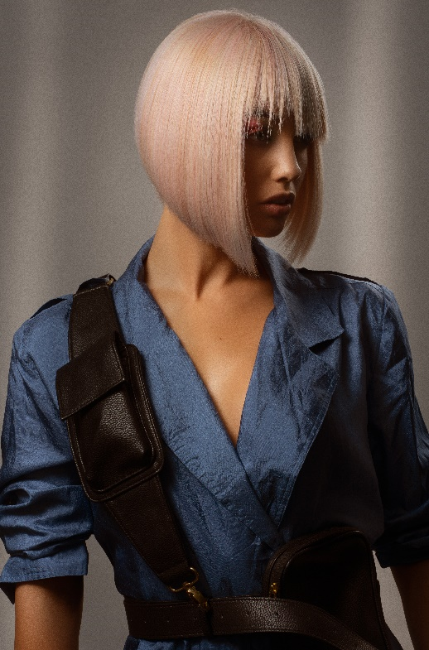
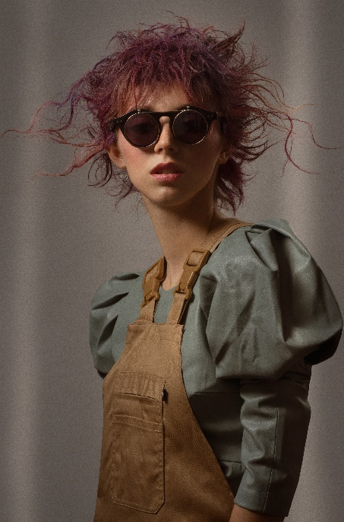

Hair: Hairkrone @hairkrone
Photography: David Arnal @davidarnalteam
MUA: Hairkrone @hairkrone
Styling: Visori FashionArt @visorifashionartstudio
Products: Wella Professionals @wellaproes

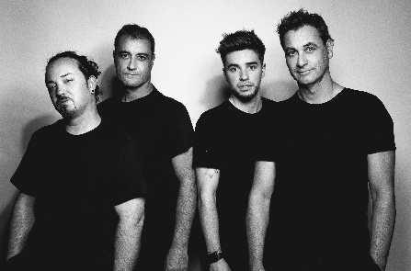
HAIRKRONE
DISCOVER Collection

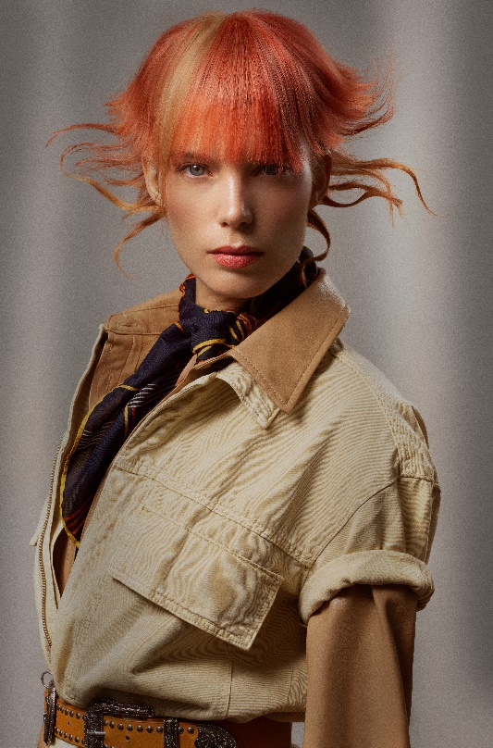

The collection is inspired by an intrepid explorer woman who seeks to discover new technologies, showing an elegant and very self-confident image. All this is reflected in surprising looks that don't go unnoticed, but rather show new femininity full of energy and eagerness to express. Tones are more or less distant from naturality, alternating oranges, platinum, red, violet, and champagne. Haircuts explore textures, blending or showing compactness. The result offers looks full of modernity and future.

