For immediate distribution

Robben Ford Revisits Chicago Blues with Made to Last
Recent five-song ep sees Ford returning to Sweetwater Studios following success of
Jing Chi’s Supremo album in 2017
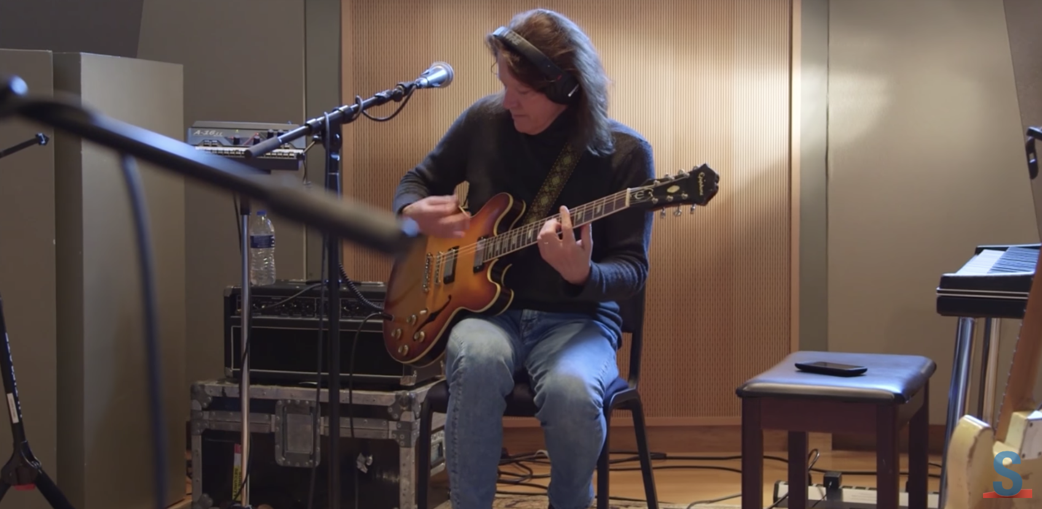
September 5, 2018, Fort Wayne, IN – Despite his working in the studio continuously since the early seventies, no two Robben Ford albums sound alike — including his latest five-track ep, Made To Last, which was released in April. The new ep sees Ford exploring the depths of the Chicago blues sound, taking a sonic cue from giants such as Lightnin’ Hopkins, Howlin’ Wolf and others. Recorded in a little over a day at Sweetwater Studios, the new songs feature sparse instrumentation — electric bass, drums, saxophone and Ford’s instantly recognizable blues guitar.
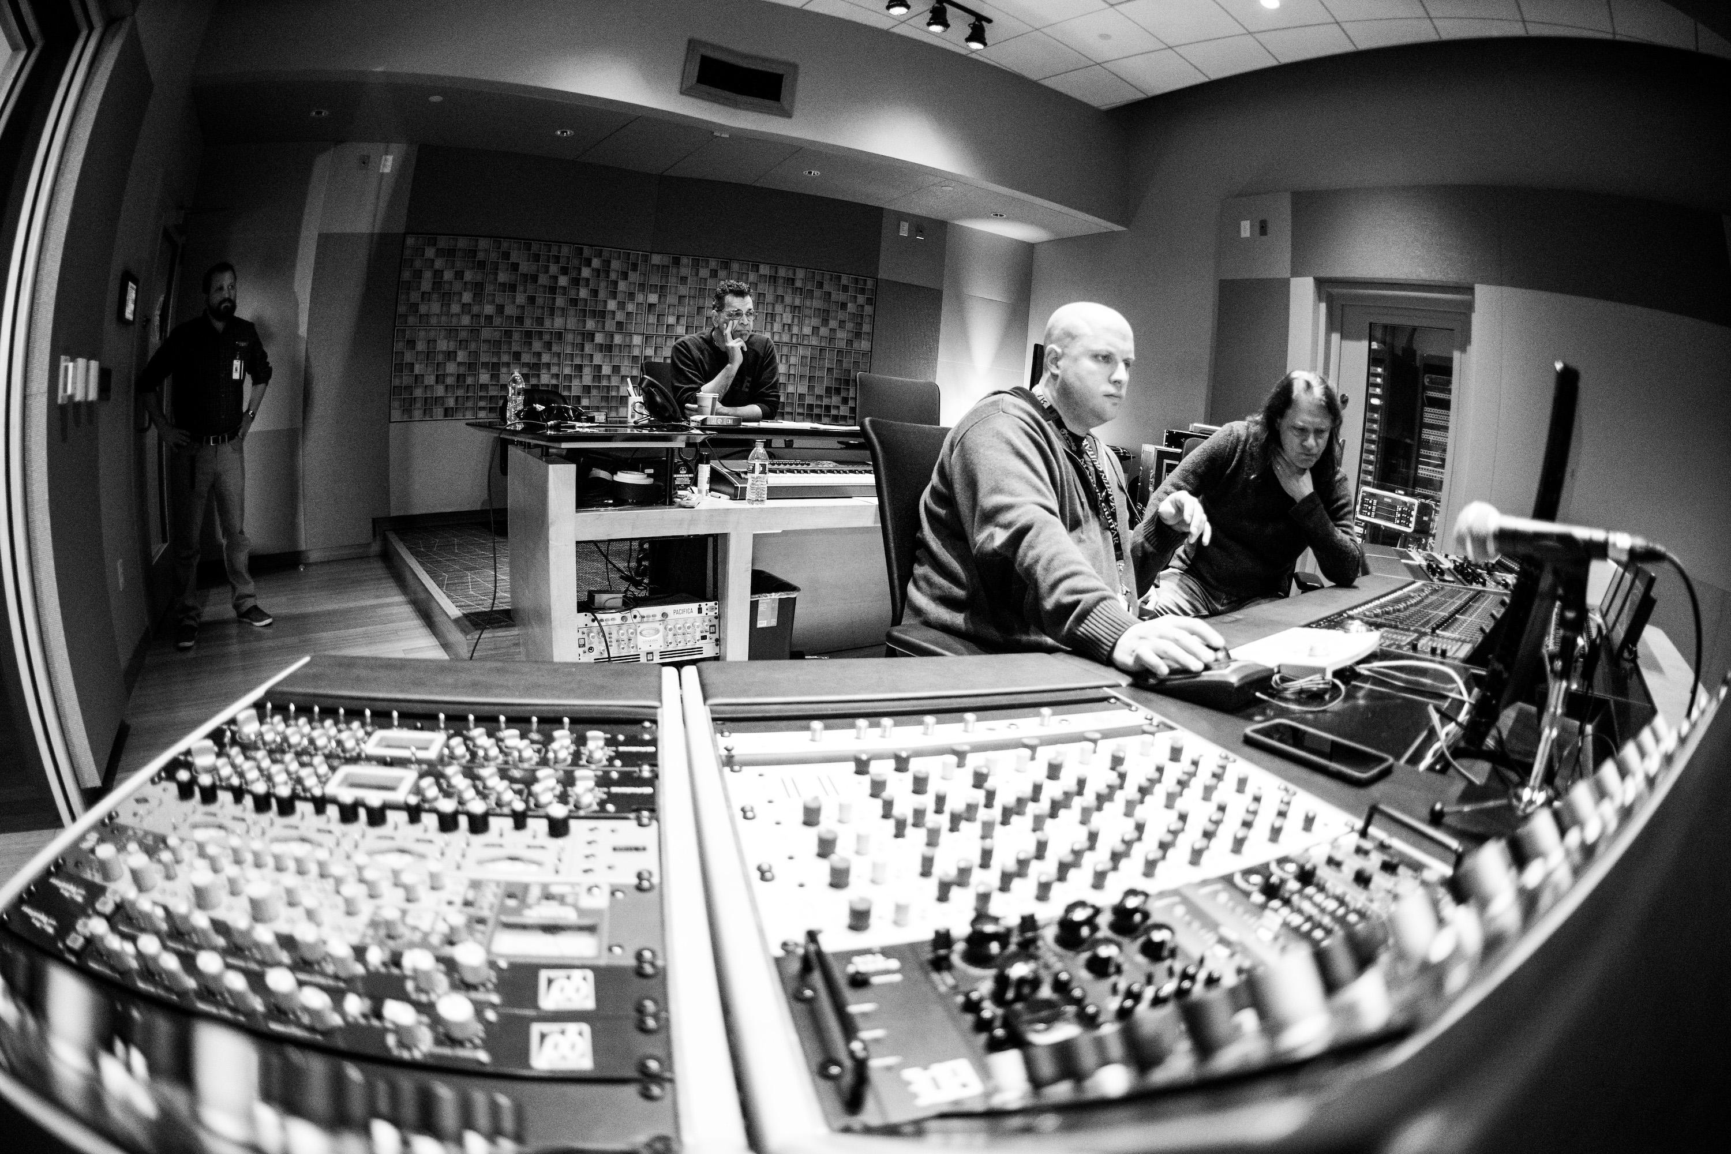
“I was itching to do something that was pared down and very blues oriented, and I was happy to do it at Sweetwater because I had a great time there with the Jing Chi project,” says Ford. “I went looking through my blues records and found two pieces of music that were both Lightnin’ Hopkins inspired: ‘Automobile Blues’ and ‘Good Times’. I also did a Little Walter tune called “Crazy for My Baby” which I have played before and was excited to record.”
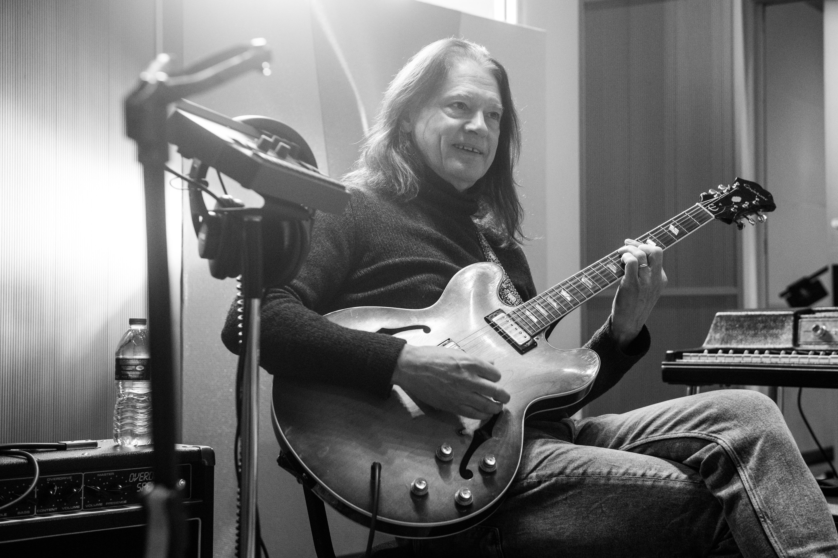
Working once again with Sweetwater Senior Producer / Engineer Mark Hornsby, who also recorded most of Jing Chi’s album Supremo at Sweetwater last year, the whole idea for this record was to keep things sparse and groove oriented. Ford called on bassist Brian Allen, drummer Wes Little, tenor saxophonist Jeff Coffin, and rhythm guitarist Casey Wasner. The closing track of the ep, “The Champion”, is a trio instrumental featuring Sweetwater Studio’s own Nick D’Virgilio (drums) and Dave Martin (acoustic bass).
One instrument that was deliberately omitted on the ep was keyboards. Instead, Ford relied on Casey Wasner’s rhythm guitar: “Casey has been playing in my working band and he is a jack of all trades. He’s been a guitar tech, a stage manager, a monitor man, he even played drums for Keb’ Mo’ for many years. He’s multitalented and a great guy to have around,” Ford explains.
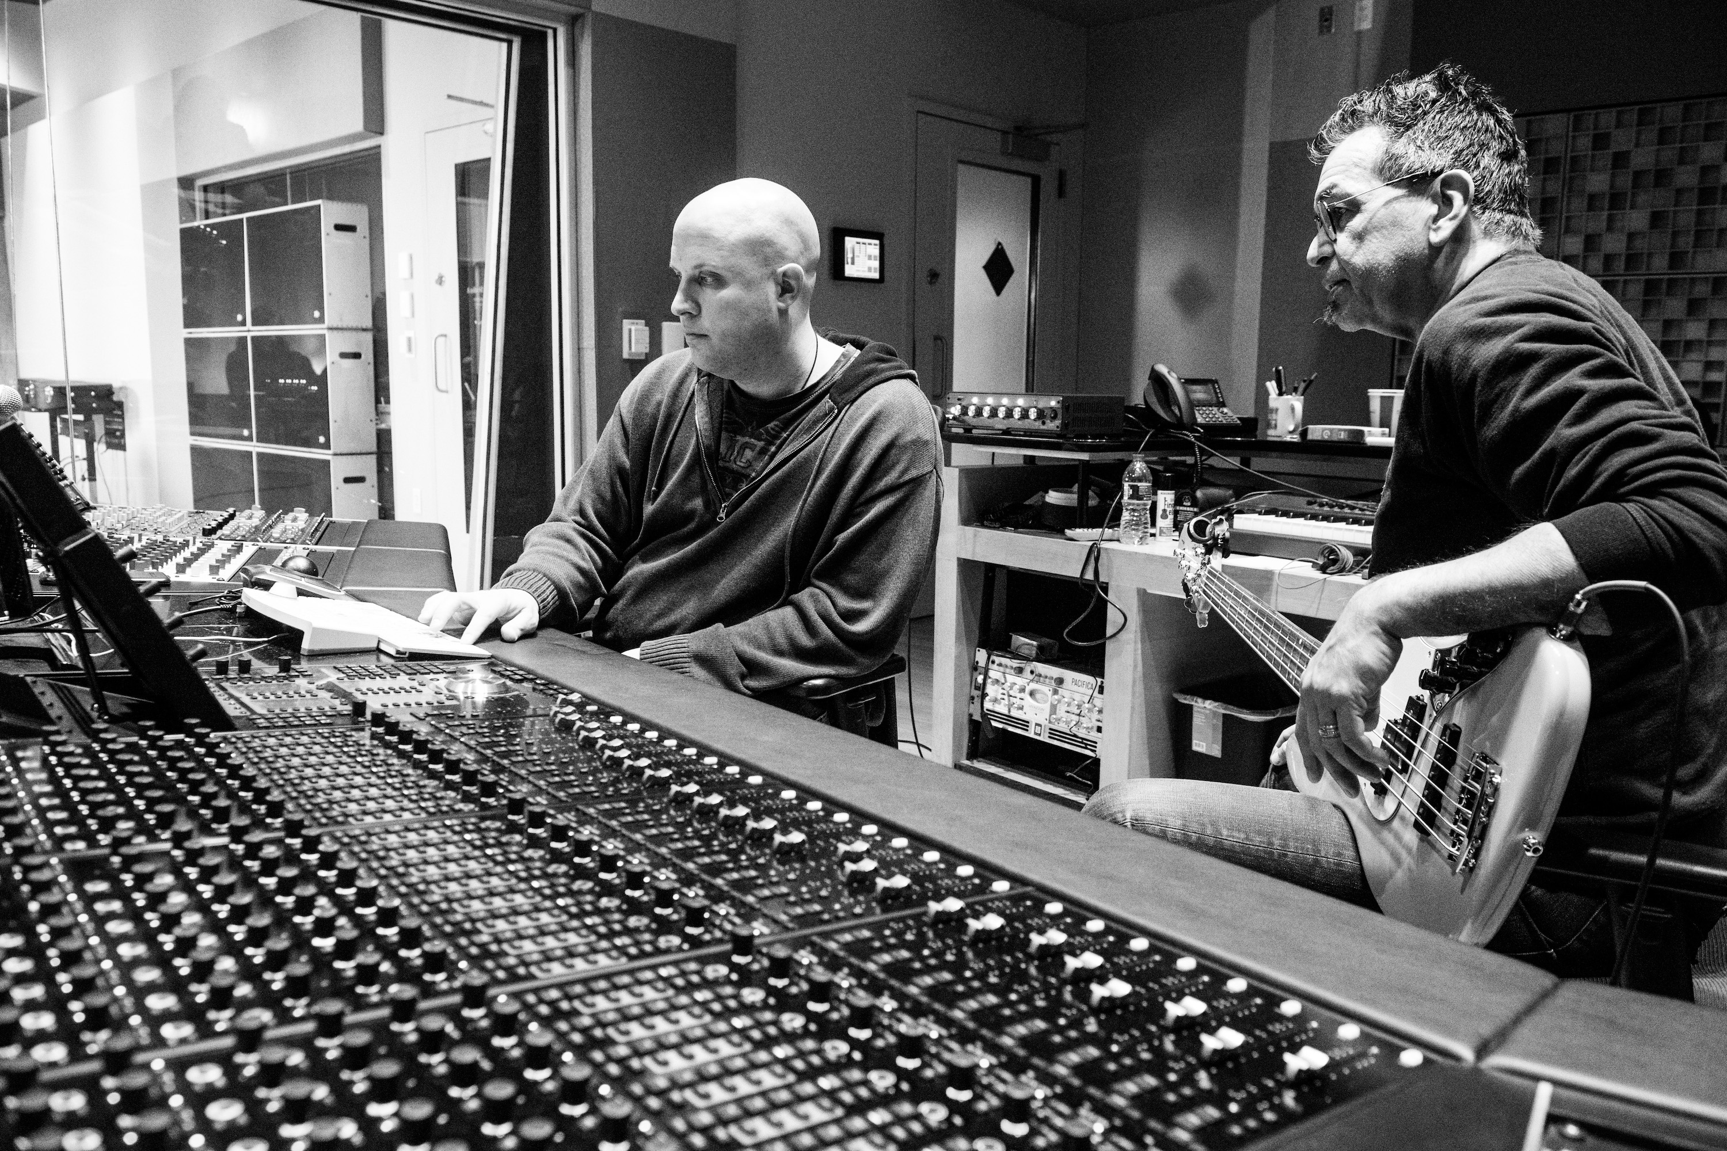
Chicago vibes in Fort Wayne
With almost a half-century of stage and studio experience under his belt, Ford knows what he likes: “I like a large room and a high ceiling, and Sweetwater absolutely fits that bill. There’s plenty of room for a grand piano, the bass player, me and my amp,” he says. “The drums were recorded in the booth, which is also a very good size.” Indeed, the drum booth worked well for the Jing Chi’s Supremo in which drummer Vinnie Colaiuta laid down rhythms for the exploratory, fusion-based recording. “Vinnie cut the Jing Chi record at Sweetwater with me, there is no one more finicky than that dude. He was more than happy there!”
For Ford, the studio experience is all about comfort and authenticity: “I like to have some room, and I like for the room to be a part of the sound,” he says. “I also like to be able to play my amplifier just as I would play it on a gig. These things are not necessarily readily available, even in great studios.” For the entire Made to Last recording, Ford ran a vintage ’53 Les Paul and a ’58 Les Paul reissue through his ‘go-to’ amp: a Dumbo Overdrive Special. To capture guitar tones — which Ford played ‘pedal-free’ save for a Colorsound Octivider he used on “Crazy for My Baby” because it sounded ‘wild and crazy’ — Hornsby relied on a Shure SM 57 dynamic and a Royer 121 ribbon microphone.
While his performances are very often close to perfection, Ford is constantly exploring sounds and tones to penetrate new boundaries: “I am at the stage where as soon as something sounds the way it is supposed to sound, I immediately want to change it. So I was working with Mark Hornsby to explore things a little bit. For instance, I might say, ‘put some distortion on the bass’ or ‘run the saxophone through an amplifier’. But all those things have been done before. For a lot of musicians like myself, and engineers like Mark, you work to refine your craft, perfect your sound and have it recorded a certain way. So sometimes when it comes to mixing, there you go! You’re kinda done.”
“It was very refreshing to work alongside Robben on this project, and also the Jing Chi project.” Hornsby said. “Working with this level of virtuoso musicians requires both focus and an open mind. We worked very hard to create a relaxing environment where Robben and his bandmates could comfortably explore both the Chicago blues for his Made to Last project, and fusion-based improvisation for Jing Chi.”

Jing Chi and the Art of Recording
In contrast to his Made to Last project, Ford’s fusion-based supergroup Jing Chi — which translates to ‘essence’ and ‘energy’ — was inspired by extended jam sessions among the band’s three highly accomplished members: Jimmy Haslip [Yellowjackets, Allan Holdsworth], on bass drummer Vinnie Colaiuta [Frank Zappa, Jeff Beck] on drums and Robben Ford [Joni Mitchell, Miles Davis] on guitar.
For Supremo, Ford drew his inspiration largely from his interest in vintage R&B film music, leaving plenty of room for he and his bandmates to color outside the lines during the sessions. Over the course of those sessions, Ford and company were joined by other top musicians including Coffin and Trumpet player Mike Haynes (Cage The Elephant, Brad Paisley). For the duration of the Supremo project, Ford’s band worked quickly and masterfully with Sweetwater Studio’s Hornsby at the helm.

Jing Chi session Drummer Vinnie Colaiuta echoed Ford’s exuberance on working at Sweetwater Studios for the making of the band’s latest album, Supremo — the band’s first album since 2004: “This whole place is like a self-contained ecosystem that’s amazing for musicians. I can show up, I can play my drums, they sound great, the recording sounds great, the people are great, and I’m happy.”

“The experience at Sweetwater Studios has been just incredible, five stars on every level,” Ford concludes. “I have never been more comfortable recording anywhere, anytime in my life.”

For more information on Made to Last, or to order a copy, please visit Sweetwater’s website at: https://www.sweetwater.com/store/detail/FordMtoLCD

Photo credit: Erick Anderson

About Sweetwater Studios
Sweetwater Studios is a wholly owned subsidiary of Sweetwater Sound, Inc., the largest online music instrument retailer in the country. With three world-class studios designed by Russ Berger and access to a greater diversity of musical equipment and professional audio gear than any other recording studio in the world, Sweetwater Studios is able to accommodate just about any recording, mixing or mastering project, no matter how simple or complex. With renowned staff producer Mark Hornsby at the helm, who has worked on many Grammy-award winning albums, Sweetwater Studios also has an exceptional staff of producers, engineers, session musicians and studio technicians. For more information on Sweetwater Studios, please visit http://www.sweetwaterstudios.com.

Media contacts

Jeff Touzeau
Public Relations
Hummingbird Media
+1 (914) 602 2913
jeff@hummingbirdmedia.com

