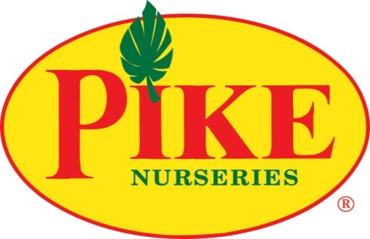

For more information:
Laurel Haislip
BRAVE Public Relations
404.233.3993
lhaislip@bravepublicrelations.com
FOR IMMEDIATE RELEASE

Pike Nurseries aflutter with activity during annual Ladybug Weekend April 21-23
Local garden center gives away two million FREE ladybugs; hosts classes and contest to honor beneficial bugs

ATLANTA (April 17, 2017) – Spring is in the air, which means gardens are growing and flowers are blooming. The return of warmer weather also means seasonal bugs are back. Instead of trying to spray them all away, the experts at Pike Nurseries actually recommend keeping some of them around! Beneficial bugs such as ladybugs are helpful in warding off aphids and other nuisance insects that threaten plants -- allowing gardens to grow healthy and strong!

To celebrate one of the most popular forms of organic pest control, Pike Nurseries is hosting its annual Ladybug Weekend Friday, April 21 through Sunday, April 23 at all store locations. The garden center will give away over 2 million FREE ladybugs (one 150-count packet per family with purchase) to provide customers with a little ladybug luck to keep gardens lively and bursting with color this season. Ladybug packets are limited, so guests are encouraged to fly over to their local Pike Nurseries store early before their luck runs out!

Customers will also have the opportunity to learn about the benefits of ladybugs and other helpful insects, such as praying mantis and hoverflies, during Pike Nurseries’ complimentary “Beneficial Bugs” class. Beginning at 9 a.m. on Saturday, April 22 at all store locations, the experts at Pike Nurseries will explain the differences between the “good” and “bad” bugs, how certain insects can act as organic pest control and how to attract beneficial bugs to ensure gardens remain healthy and happy. Children can even test their knowledge at home with take-home ladybug coloring sheets available after class.

The fun doesn’t stop at the store! Guests can also enter to win a $100 Pike Nurseries gift card by posting photos of their released ladybugs (or their costumed two-legged variety) on Instagram or on Pike’s Facebook page with the hashtag #pikeladybugs through Sunday, April 23.

In honor of this buzzworthy weekend, the Pike Nurseries garden experts have released some ladybug fun facts to help horticulturists of all levels connect the dots between these little bugs and their big reputation in the gardening world!

- LadyBeetles: Ladybugs are actually members of the beetle family, so they are sometimes referred to as “LadyBeetles.”
- Ladybug Legend: Legend has it that the Ladybug got its name from European farmers in the Middle Ages, whose crops were being devoured by damaging insects. To save their crops, the farmers prayed to the Virgin Mary. Soon, ladybugs appeared and ate all of the harmful insects! The farmers named these little insects “our Lady’s Beetles,” which eventually became “Ladybugs.”
- Lady Luck: Many countries consider a ladybug to be a sign of good luck.
- Beneficial Bugs: Because ladybugs are natural enemies of aphids and other pest insects, many gardeners and farmers use them for organic pest control instead of chemicals.
- Little Bug, Big Appetite: A single ladybug may eat as many as 5,000 aphids in its lifetime!
- International Insects: Over 400 types of ladybugs live in North America and over 4,500 in the world!
- Plain Jane: Different species of ladybugs have different numbers of spots, while others have no spots at all!
- Not Just Red: Ladybugs come in many colors, including pink, yellow, white, orange and black.
- Defense Mechanism: Ladybugs make a special chemical that smells and tastes bad so predators won’t eat them.

For more information on ladybugs, visit pikenursery.com/pages/connecting-the-dots-ladybug-fun-facts.

ABOUT PIKE NURSERIES:
Ever committed to its customers’ gardening success, Pike Nurseries takes pride in taking the guesswork out of gardening and helping its customers play in the dirt. Offering superior knowledge, quality and selection in a friendly, caring environment, Pike Nurseries has been an Atlanta icon for over 50 years. Founded in 1958 by Pete Pike, its ability to adapt to market conditions and community needs has made it a respected Southern institution. As Atlanta’s oldest garden chain, Pike Nurseries has 17 retail locations in the Atlanta, Ga. and Charlotte, N.C. areas. Now led by CEO Mike Kunce, Pike Nurseries looks forward to continued growth as it keeps Atlanta and Charlotte beautiful, one landscape at a time.

For more information, please visit Pike Nurseries online at www.pikenursery.com.
Visit Pike Nurseries on Facebook, Twitter, Pinterest and Instagram.

# # #

