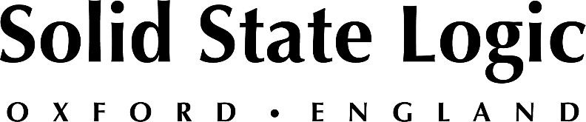

Solid State Logic Launches New Creative Tool With Vintage Vibes: SSL Native X-Echo Plug-In

Inspired by vintage hardware delays, brought up-to-date with SSL advanced workflow, X-Echo Plug-in is a new tool aimed at musicians, producers and engineers and is part of the growing SSL Complete Bundle Subscription

Oxford, England, October 28, 2021 — Solid State Logic announces its latest plug-in release: SSL Native X-Echo. The new plug-in, which is inspired by the sound of legendary tape delays of the ‘60s and ‘70s is available now in several formats including VST2, VST3, AAX and AU at a cost of $199 or as part of the SSL Complete Bundle Subscription from $14.99 per/m (Ts&Cs apply). X-Echo will be available for the first 30 days with an introductory 25% discount.

X-Echo is inspired by the distinctive sound of early tape delay hardware of the 1960s and 1970s, while introducing SSL's advanced workflow and host of forward-thinking production tools. Able to effortlessly deliver traditional tape delay effects like swirling echoes and classic slap back, X-Echo is also capable of more contemporary creative delays effects commonly found in electronic music. Practical and creative features include 4 switchable tape heads syncable to note value, DAW or MS with a single click, classic SSL style saturation, built-in de-esser, advanced waveform visualization and a brand-new ‘lo-fi’ SSL reverb processor.

Jonathan Sandman, Product Manager - SSL Studio Plug-in comments "The depth of different delay effects you can create with SSL Native X-Echo - from vintage grunge and shoegaze, to rhythmic and clean modern echoes - marks only the beginning of many more creative plug-in offerings from SSL that are currently in the works."

X-Echo combines tape-style signal degradation and soft compression with classic SSL-style distortion characteristics, accessible with dedicated 'Wow & Flutter' and 'Saturation' controls. The plug-in also features ‘Feedback’ control and 'Freeze' and 'Kill' functions, ideal for controlling delay length and buildups.

Other features of X-Echo include EQ Loop / filtering and SSL Mix Lock. There is a custom 'Diffusion' control, as well as a built-in in ‘De-esser’ — useful for controlling buildups of energy at certain frequencies and sibilance that tape echoes often accentuate. X-Echo's also includes unique ‘Stereo Width’ processor which uses a custom phase shifting technique, allowing users to control the width of their delay lines.

For more information on the SSL Native X-Echo plug-in, please visit SSL's new eCommerce site at https://bit.ly/SSLeStore.

Solid State Logic is the world’s leading manufacturer of analogue and digital audio consoles and provider of creative tools for music, broadcast, live and post production professionals. For more information about our award-winning products, please visit: www.solidstatelogic.com.

###
For further information contact:
Jeff Touzeau
+1 (914) 602-2913
jeff@hummingbirdmedia.com

Ross Gilbert
+44 (0) 1865 842300
rossg@solidstatelogic.com

