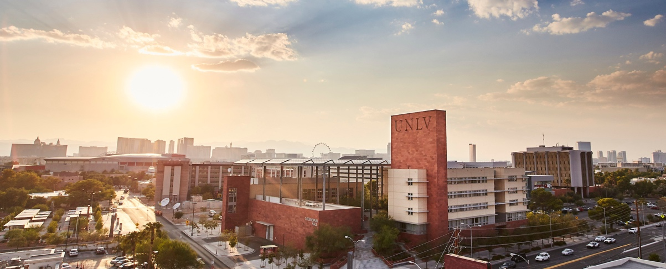

University of Nevada, Las Vegas Integrates Sennheiser TeamConnect Ceiling 2 as a Core Element in its Innovative 'RebelFlex' Classroom AV Solution
After a successful pilot phase, the internationally renowned University rolls out 58 multi-purpose classrooms with TeamConnect Ceiling 2

Las Vegas, November 16, 2021 – A world-class research university that prides itself on its diversity and competitive academic programs in hospitality, law and many other disciplines, University of Nevada, Las Vegas (UNLV) was faced with an unprecedented set of technical challenges amidst the global COVID-19 pandemic. With a diverse student population from around the world and a lingering uncertainty of how the pandemic would impact in-person learning, the University moved decisively to implement a hybrid, flexible classroom scenario that could accommodate both in-person and remote learning. The new solution featured several Sennheiser TeamConnect Ceiling 2 (TCC2) microphones, which are being deployed across 58 multi-purpose classrooms across the campus.

The provost requested a 'big, bold plan' that would help both faculty and students navigate a challenging learning environment, while providing lasting value to the university at large. Senior AV/IT Systems Specialist Frank Alaimo and Classroom Control Systems Specialist Michael Theil corralled the University’s IT team and came up with a plan. “It was what I like to call the Swiss Army Knife of classrooms because it’s a typical classroom, but we added lecture capture and web conferencing into the rooms,” Alaimo explains. “Now the room has synchronous and asynchronous capabilities, recording capabilities, live ‘in-the-room’ capabilities — it has everything.”

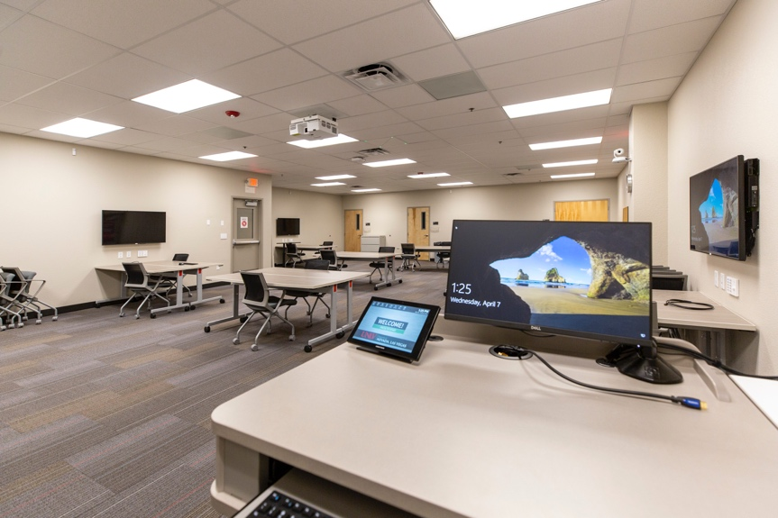 | University of Nevada, Las Vegas,  has rolled out 58 multi-purpose  classrooms — each including  Sennheiser’s TeamConnect Ceiling 2  microphone solution (photo courtesy UNLV)

One specific requirement from the administration was that each room had to be a technical ‘carbon copy’ of the other. “While the rooms might be different sizes and contain different furniture, it was important for us to deliver similar functionality in each room,” Alaimo says. “One thing we wanted to guarantee for our instructors was that when they go from one building to another, the touch panel would be exactly the same and they will be able to record lectures while experiencing top-quality A/V conferencing.”

The new hybrid classroom — affectionately dubbed RebelFlex after the University’s own mascot — was a natural evolution: “We already had Sennheiser's SpeechLine Digital Wireless and Sennheiser Control Cockpit in place, and we added the TCC2 as part of our overall web conferencing solution,” Alaimo says. “Now, the instructor has a mic at the lectern, and the TCC2 is able to capture both the students or the instructor, should he or she choose to lecture while moving around the room.”

The patented beamforming microphone technology on the TCC2 is particularly useful in a classroom with many student participants: “The microphones pick up voices really fast and are able to move to wherever a student is talking, and then is able to bounce back and forth as needed,” says Theil. “This also simplifies our lives in IT so we don’t have to make microphone adjustments. That is a huge time saver.”

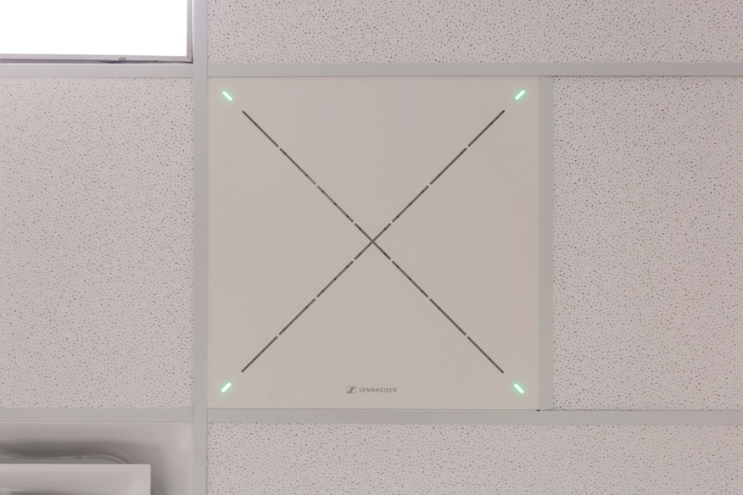 | The Sennheiser TeamConnect Ceiling 2 was easy to install and an integral part of UNLV’s RebelFlex hybrid classroom solution. (Photo courtesy UNLV)

RebelFlex with a cause
The ‘first’ RebelFlex was deployed in UNLV’s faculty center, and the IT team then provided recommendations on how to migrate both new and existing classrooms to newer, state-of-the-art ’high-flex’ environments. “The concept was little bit overwhelming for instructors at first, so as part of the RebelFlex pilot program, we included a RebelFlex assistant in each room to provide support, so instructors could remain focused on their agenda during the initial rollout,” says Alaimo.

The primary rollout consisted of 58 classrooms: “We took eight rooms that we had on campus that already had a camera and a Pasnapto recording device and converted those to RebelFlex rooms,” says Alaimo. “The remaining 50 classrooms are completely brand new, with equipment including the Sennheiser TCC2 microphones.” Now that the rollout is well underway, RebelFlex has caught on among the administration and student population: ”We are already getting positive feedback,” says Theil. “We have teachers calling us and saying, ’I need you to turn my room into a RebelFlex room by tomorrow’. Additionally, we are seeing a push from our administration to get more and more rooms online.”

The RebelFlex classrooms vary in size, ranging from 25 seats to 179 seats — the larger sized rooms being served by a pair of TCC2 units. In addition to several more RebelFlex classrooms that are currently in the planning stages, Alaimo and team are also looking at converting a campus auditorium that is currently undergoing renovation: “The auditorium has all the recording features already in place, so if the administration decides to move forward, we’ll be ready to roll and could easily deploy the TCC2 in there,” says Alaimo.

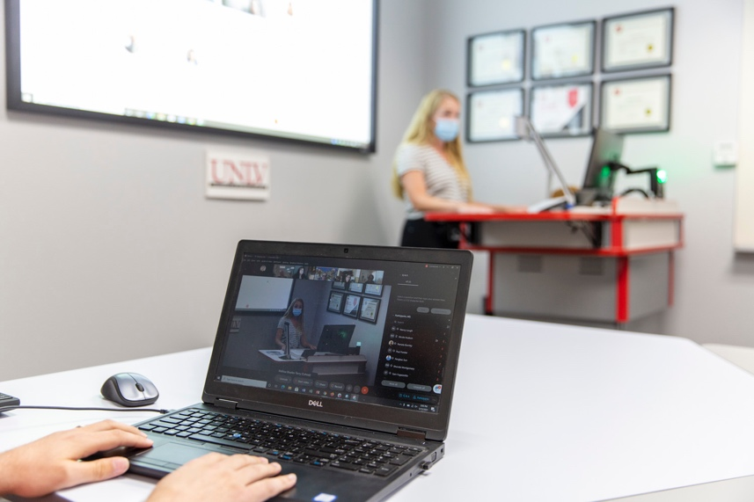 | TeamConnect Ceiling 2’s Dante compatibility makes it easy to control, monitor, add or remove devices on the network. (Photo courtesy UNLV)

Predictability and performance from Sennheiser
In a world that is unpredictable, the new RebelFlex rooms deliver predictability, ensuring a common experience for both instructors and students. “The most important thing is that the content from the microphone and any slides are captured,” Alaimo explains. “The TCC2 not only helps capture the lecture but also enables students to feel like they are part of the experience.” Theil agrees: “We wanted to be able to offer a similar experience for the student, whether they were in-person or remote,” he adds. “If you are at home and you’re getting a subpar lecture or feel that you can’t hear the other students, you won’t get the same degree of value. Our system was designed so that people at home have the same opportunities that students have on campus.”

TCC2’s network compatibility made installation seamless: “Using Dante with TCC2 makes it a lot easier, because everything shows up as a network device,” says Theil. “Being able to route all the devices with a simple click of a mouse simplifies everything, and it means that we can monitor the performance with Control Cockpit right here in the office. Also, with the Dante connectivity, I am able to merge the conferencing capabilities of two or more rooms quickly if needed.” Using Sennheiser Control Cockpit, the IT team can also monitor things like battery levels, muting functionality, and other features. “This kind of remote monitoring through Control Cockpit gives us added confidence that when someone walks into the room there won’t be issues. We know everything will just work as it should,” says Theil.

Theil also appreciates TCC2’s exclusion zone functionality, since each room comes with its own set of noise challenges: “If we are close to an HVAC register, we can bring the pickup pattern so we are no longer picking up noise from it,” he says. “Or if there is a door where the students are coming in and out, I can slice out that one little section of the room with an exclusion zone.” Once the exclusion zones are defined, Theil simply drops in a standard audio processor: “I don’t have time to make a custom DSP program for each room, and that’s what makes it really nice, it works wonderfully out of the box,” he says.

Alaimo says that the RebelFlex rollout — including the Sennheiser TCC2 solution — has set a new standard for the University’s classroom capabilities and he expects the trajectory to continue: “We have projects of all types and sizes, but we feel like every classroom will be RebelFlex by default going forward.”

About Sennheiser
Shaping the future of audio and creating unique sound experiences for customers – this aim unites Sennheiser employees and partners worldwide. The independent family company, which is managed in the third generation by Dr. Andreas Sennheiser and Daniel Sennheiser, is today one of the world’s leading manufacturers of headphones, loudspeakers, microphones and wireless transmission systems. In 2020, the Sennheiser Group generated turnover totaling €573.5 million. www.sennheiser.com

Local Press Contact

Daniella Kohan
daniella.kohan@sennheiser.com
+1 (860) 598 7514

