PRESS RELEASE
INTRODUCING URBANISTA LOS ANGELES: SOLAR POWERED HEADPHONES WITH VIRTUALLY INFINITE PLAYTIME
The world’s first active noise cancelling wireless headphones that use Powerfoyle™ technology to deliver a nonstop audio experience

UNDER EMBARGO UNTIL / APRIL 15 2021, STOCKHOLM, SWEDEN
Urbanista, the Swedish lifestyle audio brand, announces the launch of Urbanista Los Angeles -- the world’s first self-charging, wireless active noise cancelling headphones powered by Powerfoyle™ solar cell material. Using advanced green technology, Los Angeles converts all forms of light, outdoor and indoor, into energy to deliver virtually infinite playtime.

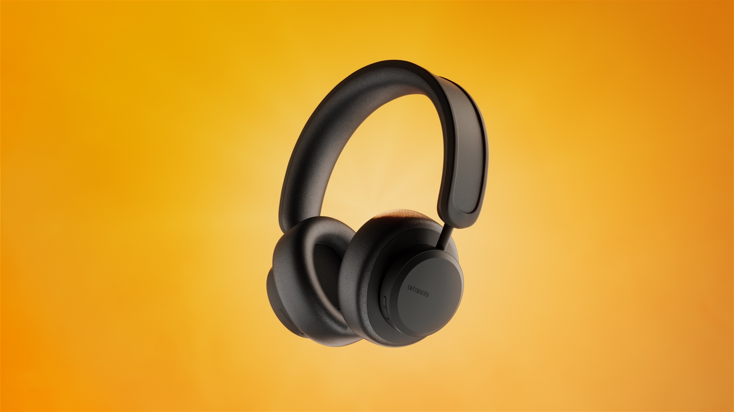

Priced at USD 199MRSP, Los Angeles boasts full compatibility with iOS, Android and Windows devices.

Welcome to the Dawn of a New Era
Urbanista Los Angeles brings revolutionary innovation to the headphone market and is designed to live up to the brand’s tagline, ‘Designed for Life in Motion’. For the first time ever, you can experience virtually unlimited listening with solar charging. Los Angeles never stops charging when exposed to light, both outdoors and indoors, providing a nonstop audio experience.

Just an hour spent outside on a sunny day with Urbanista Los Angeles generates three hours of playtime. Cloudy day? For every hour spent outside, you still get two hours of playtime. The headphones even charge in ambient light - wearing them indoors in a well-lit room or office will keep the headphones charging. When you’re not using Los Angeles, simply leave them by the window for an hour to add another full hour of playtime.*

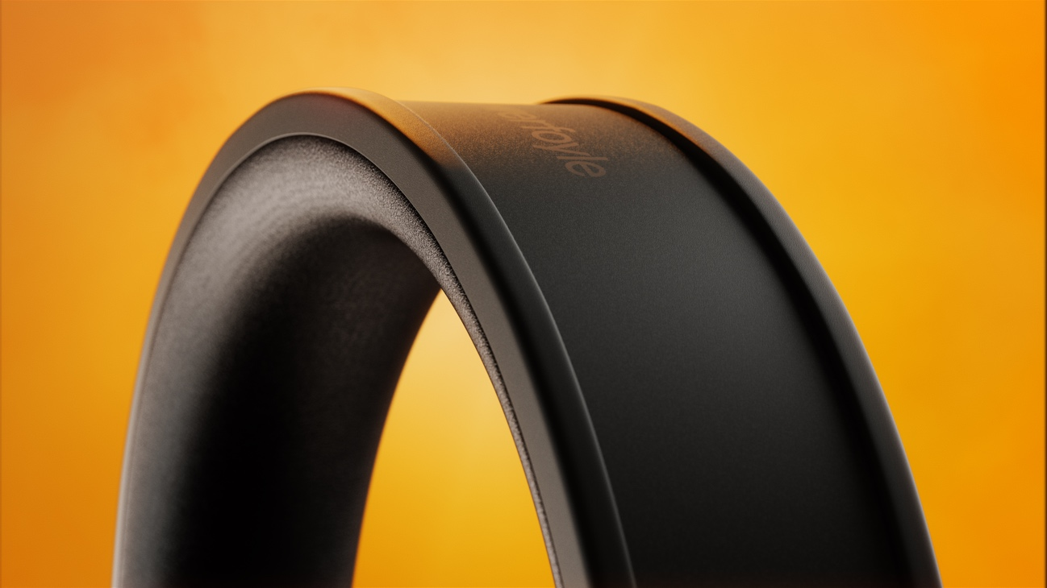

To deliver this limitless audio experience, Urbanista has teamed up with Exeger, a Swedish innovation company, that has created a groundbreaking solar cell technology. Exeger’s material, Powerfoyle™, converts any form of light into clean energy and can be seamlessly integrated into any design. For the first time, it is now powering headphones, enabling endless energy to music lovers around the world.

Urbanista CEO Anders Andreen comments: “Urbanista Los Angeles is everything we stand for as a brand, in a product. Bringing together innovation, sustainability and all the features you could wish for in a headphone, Urbanista Los Angeles is designed for someone who lives an on the go lifestyle. We are proud to partner with Exeger, and their cutting edge technology, to bring a world first to market.”

Exeger CEO Giovanni Fili says: “This is the start of a revolution in consumer electronics. In close collaboration with Urbanista, we now launch the world’s first self-powered wireless headphone. I strongly believe that once users experience the freedom of endless energy, there’s no way we’re going back to plugging a USB charger into the wall. We are extremely excited about this product and confident that people around the world are going to love it."

Take Complete Control of your Audio Experience
With Los Angeles, you are always in complete control of your audio experience. Just the press of a button activates advanced hybrid Active Noise Cancelling, instantly reducing unwanted background noise, or switches on Ambient Sound Mode so you can stay aware of important surrounding sounds.

Los Angeles’ wireless design gives you both freedom and control thanks to the on-ear detection feature that pauses the audio when the headphones are removed and restarts it when they are put back in place. Los Angeles is adjustable for an entirely custom fit. The smooth cushioned shells sit securely over the ear, allowing you to comfortably enjoy unlimited listening.

Inspired by the city in the heart of sunny California, Urbanista Los Angeles will be available in two exclusive colourways, including Midnight Black.

To be the first to know when the product will be available for pre-order, sign up at www.urbanista.com/losangeles

Watch the full Los Angeles product video here: https://www.youtube.com/watch?v=YLe8O8sNl8s

Urbanista Los Angeles Key Features

- Virtually infinite playtime
- Always charging when exposed to light, both outdoors and indoors
- 50h battery reserve
- Hybrid active noise cancelling
- Ambient sound mode
- On-ear detection
- USB type-C charging
- Bluetooth 5.0
- Siri and Google Assistant
- Compatible with iOS, Android and Windows

ENDS

Editors notes:

*Playtime calculations are estimations based on certain lighting, charging and usage conditions and an initially fully charged battery. Estimations for outdoor conditions are based on lux values of at least 30,000 lux, and for indoor conditions on lux values of at least 1,000 lux. Actual conditions and playtime may vary whilst using the product.

Press Contacts

Stephen Bailey
US Media Relations, Urbanista
(508) 596-9321
stephenb@olexcommunications.us

Marina Daniel
PR Coordinator
marina@urbanista.com

About Urbanista
Urbanista was born in 2010 in Stockholm, Sweden out of love for cities and urban life. Our products are rooted in Scandinavian tradition and inspired by music, arts, fashion and urban culture. We believe that lifestyle audio products should not only sound great, but also look good. Today, our products are available in over 90 countries, and sold in 30,000 stores worldwide.

For more information visit www.urbanista.com
Follow Urbanista on: Facebook | Instagram

About Exeger
Exeger is a Swedish company with a unique solar cell technology that converts all form of light into electrical energy. With its resilient and flexible design, the material named Powerfoyle can be seamlessly integrated into all products that benefit from being self-powered. Powerfoyle can enhance any consumer electronic product it’s integrated into with extended or even eternal battery life, putting the power of cutting edge solar technology directly into the hands of consumers. By revolutionizing the perception of available energy, Exeger makes products both smarter and more sustainable – with the vision to touch the everyday lives of a billion people.

For more information visit www.exeger.com | www.powerfoyle.com

