Quarter-century milestone for LIPA and Sennheiser
Audio specialist continues supporting world’s top performing arts school

Wedemark/Liverpool, 7 July 2020 – For the past 25 years, Sennheiser has been sponsoring one of the best performing arts school in the world, Liverpool Institute for Performing Arts (LIPA), with a Student Scholarship Programme, as well as its audio expertise and resources to the specialist institution.

The relationship between Sennheiser and LIPA goes back to 1996, when representatives from each organisation met to discuss the impending launch of an exciting new school to teach the performing arts and associated disciplines, from design and technology and management to sound technology. This cohesive combination allows different mindsets to work together right from the start, encouraging understanding of each element’s needs and ways of working. From that first meeting a quarter of a century ago and until the present day, Sennheiser has been an active partner of LIPA.

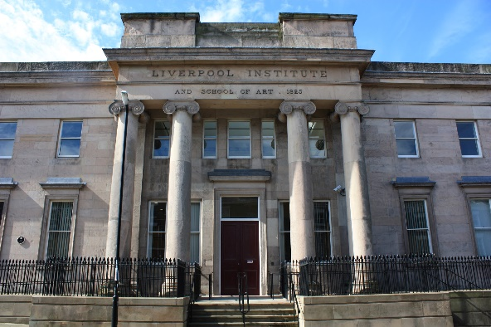 | LIPA and Sennheiser have been cooperating since the institute began teaching in 1996

The scholarship is a way of helping the students chosen to study freely and achieve their full potential by covering school fees, accommodation costs and, for international students, transport costs to be able to travel home to visit family and friends. It is available to the chosen students for their full three years at LIPA. Every year, a new first-year student is selected, meaning this revolving programme always has three students benefitting from Sennheiser support each year. In order to qualify for the scholarship, students already need to be enrolled at LIPA. The scholarship is for those taking part in the BA (Hons) Sound Technology Course.

From the 25 submissions received this year, 12 students were jointly chosen by LIPA and Sennheiser to continue to the next stage, where they were asked to create and submit an immersive audio piece.

The second round of the process, which comprised two full days of virtual interviews and the selection panel listening to pieces the students had created, has just been completed. Five candidates have been shortlisted: Joe Morgan, Rudolf Korp, Tay Hui Yun, Theo Tighe and William Stringer.

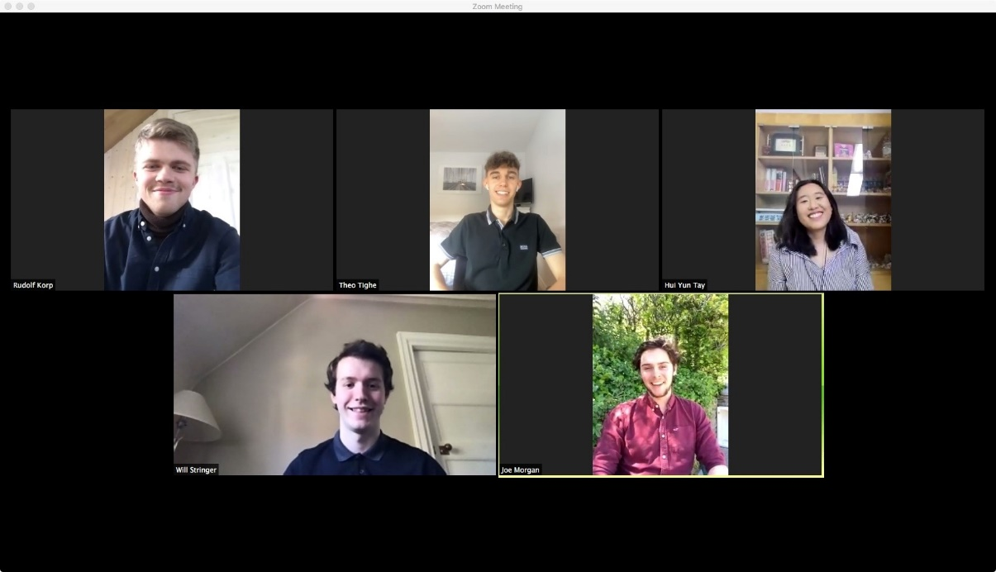
The shortlisted students have provided amazing 3D audio content: Rudolf Korp, Theo Tighe, Tay Hui Yun, William Stringer and Joe Morgan (from top left to bottom right)

“The quality of the submissions was excellent,” says Tim Sherratt, Manager Customer Development Application Engineering EMEA at Sennheiser. “We really liked how the students handled the creative process of capturing immersive 3D sound, and were pleasantly surprised with each entry’s out-of-the-box approach.”

With the five candidates selected, the last stage will take place on the 23rd of September with a final round of one-to-one interviews, after which the successful students will be announced.

LIPA’s 7.1.4 Atmos Home Entertainment studio with Neumann monitors | 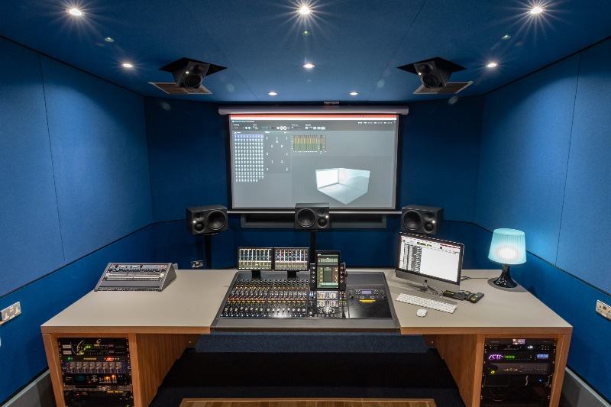

Sennheiser’s continuous provision of a high level of technical and product support to LIPA has manifested itself in different ways over the years. It includes the supply of wireless equipment for shows, equipping the new TV production facility, named the Sennheiser Studio, and a 7.1.4 Atmos Home Entertainment studio with Neumann monitors. This allows the students to work with 360 video, VR, AR workflows, and with Sennheiser’s AMBEO systems, for which LIPA is currently developing specific courses.

Jon Thornton, Head of Sound Technology at LIPA

“It has been a real honour to have been part of the relationship between LIPA, our students and Sennheiser, and to see that relationship flourish over more than two decades,” says Jon Thornton, Head of Sound Technology at LIPA. “From our inception as a new Higher Education Institution in 1996 to the present day, having a partner so committed and supportive has been truly exceptional, and of incalculable benefit – not only in the support for students, but in growing and learning as an organisation ourselves, and helping us be prepared for whatever the future of audio holds.”

“We feel deeply privileged to have been able to support such a haven for creativity and passionate individuals for the last 25 years, not just financially but also through our own 75 years of audio innovation and expertise,” concludes Sherratt. “We are proud to be able to help those who are keen to make their living from music, whether performing, creating or producing, or a combination of these. Once the current situation is over, we hope that we can all get together and celebrate this successful quarter-century partnership.”

The images accompanying this press release can be downloaded at https://sennheiser-brandzone.com/c/181/VGa1Jfcy.

About Sennheiser
Founded in 1945, Sennheiser is celebrating its 75th anniversary this year. Shaping the future of audio and creating unique sound experiences for customers – this aim unites Sennheiser employees and partners worldwide. The independent family company, which is managed in the third generation by Dr. Andreas Sennheiser and Daniel Sennheiser, is today one of the world’s leading manufacturers of headphones, loudspeakers, microphones and wireless transmission systems. In 2019, the Sennheiser Group generated turnover totaling €756.7 million.
www.sennheiser.com

Local Press Contacts

Sarah James Maik Robbe
sarahj@gasolinemedia.com maik.robbe@sennheiser.com
+44 (0) 1483 223333 +44 (0) 7393 462484

Global Press Contact

Stephanie Schmidt
Stephanie.schmidt@sennheiser.com
+49 (5130) 600 – 1275

