
P!NK opened the 79th Tony Awards with a powerful performance, captured on the Sennheiser Spectera handheld microphone and Neumann KK 204 capsule. Photo by John Nacion/Getty Images

Spectera valloitti 79. Tony Awards -gaalan – järjestelmän laajin käyttöönotto Yhdysvalloissa tähän mennessä
Sennheiserin kaksisuuntainen laajakaistainen ekosysteemi hallitsi koko shown kulkua avausnumerosta loppuhuipennukseen ja tarjosi isäntä P!NK:lle sekä kymmenille langattomille kanaville tehokkaan ratkaisun Tony Awards -gaalan suurella näyttämöllä.

Sennheiserin Spectera-ekosysteemi loisti 79. Tony Awards -gaalassa myös kulissien takana. Firehouse Productions otti järjestelmän käyttöön Radio City Music Hallin suoralähetystä varten 7. kesäkuuta, ja Spectera kantoi vastuun järjestelmän historian suurimmasta yhdysvaltalaisesta lähetystuotannosta. Supertähti-juontaja P!NK:n johdolla gaala tavoitti miljoonat katsojat ympäri maailmaa.
Lisää alla englanniksi.
This milestone follows Spectera’s debut at the Tony Awards in 2025, where Cynthia Erivo used a single Spectera bodypack to simultaneously transmit a lavalier microphone signal and receive stereo in-ear monitoring during her memorable entrance from an upper-level dressing room, through backstage corridors and stairwells, and onto the main stage. Her venue-spanning performance offered an early glimpse of the system’s seamless coverage and bidirectional capabilities.

The 79th Tony Awards showcased Spectera’s ability to meet the demanding requirements of a large-scale broadcast production, supporting handheld microphones, headsets, lavaliers, instrument wireless and in-ear monitoring across a fast-paced show where technical requirements can change in real time. Most notably, P!NK relied entirely on Spectera throughout the evening for her complete wireless setup, including headset, lavalier, in-ear monitoring and a handheld microphone equipped with a Neumann KK 204 capsule. With just one low-profile Spectera SEK bodypack, the setup seamlessly supported her high-flying entrance, a star-studded performance of “Lady Marmalade” from Moulin Rouge! The Musical, audience interactions and introductions throughout the broadcast, and a tribute to Chicago on the Broadway revival’s 30th anniversary. Spectera microphones were also used across additional performances throughout the evening, including featured performers from Schmigadoon! and Two Strangers (Carry a Cake Across New York), as well as instrument wireless during the In Memoriam tribute.

“We recently used Spectera for in ear monitors at our show in San Diego. With the Tony’s being a combination of in-ears and a headset mic for some of the performances, it was a no brainer for us to use the transceiver,” comments Jon Lewis, Monitor Engineer for P!NK. “The functionally of the Spectera system allowed us to constantly monitor the bodypacks, make changes remotely and lock volumes to allow them to be placed inside costumes without the worry of volumes being knocked during complex dance sequences. Spectera is a gamechanger when it comes to system management and functionality.”

The production team utilized two Spectera Base Stations providing venue-wide coverage throughout Radio City Music Hall. In total, Spectera carried what would be the equivalent to approximately 60 channels of audio within just 12 MHz of spectrum while operating alongside many traditional wireless systems on the same stage. Wireless monitoring, coordination and control for the production were managed entirely through SoundBase across all brands, giving the RF team centralized visibility across the show’s intricate and ever-changing wireless ecosystem.

“Spectera is going to change the whole game,” said Justin Milner, RF Technician for the 79th Tony Awards. “It brings a completely different headspace. Everything from spectrum management to transmitter deployment to antenna deployment is easier, faster and more robust than narrowband systems.”

Scott Hoskins, RF Coordinator, Firehouse Productions, shared that the system’s flexibility proved especially valuable in a production environment where requirements can change up until airtime. “We were able to adjust mic capacities and add more in-ear channels without having to worry about additional frequency management,” he said. “The ease and flexibility of EtherCON-based antennas greatly expands our ability to change areas of coverage on the fly, as well as reach remote areas where a traditional coax-based system would require additional hardware.”

Coverage throughout Radio City Music Hall remained reliable throughout rehearsals and the live broadcast. “The Spectera carriers have been rock solid all week,” said Hoskins. “We deployed four antennas on the first base and three on the second and have had great coverage throughout Radio City.” Milner added, “with the limited spectrum available these days, this breaks open a door to letting productions go wild with their demands for more and more RF on every show.”

Justin Milner, RF Tech, monitors the Tony Awards broadcast via SoundBase, listening with Sennheiser’s HD 480 PRO closed back headphones | 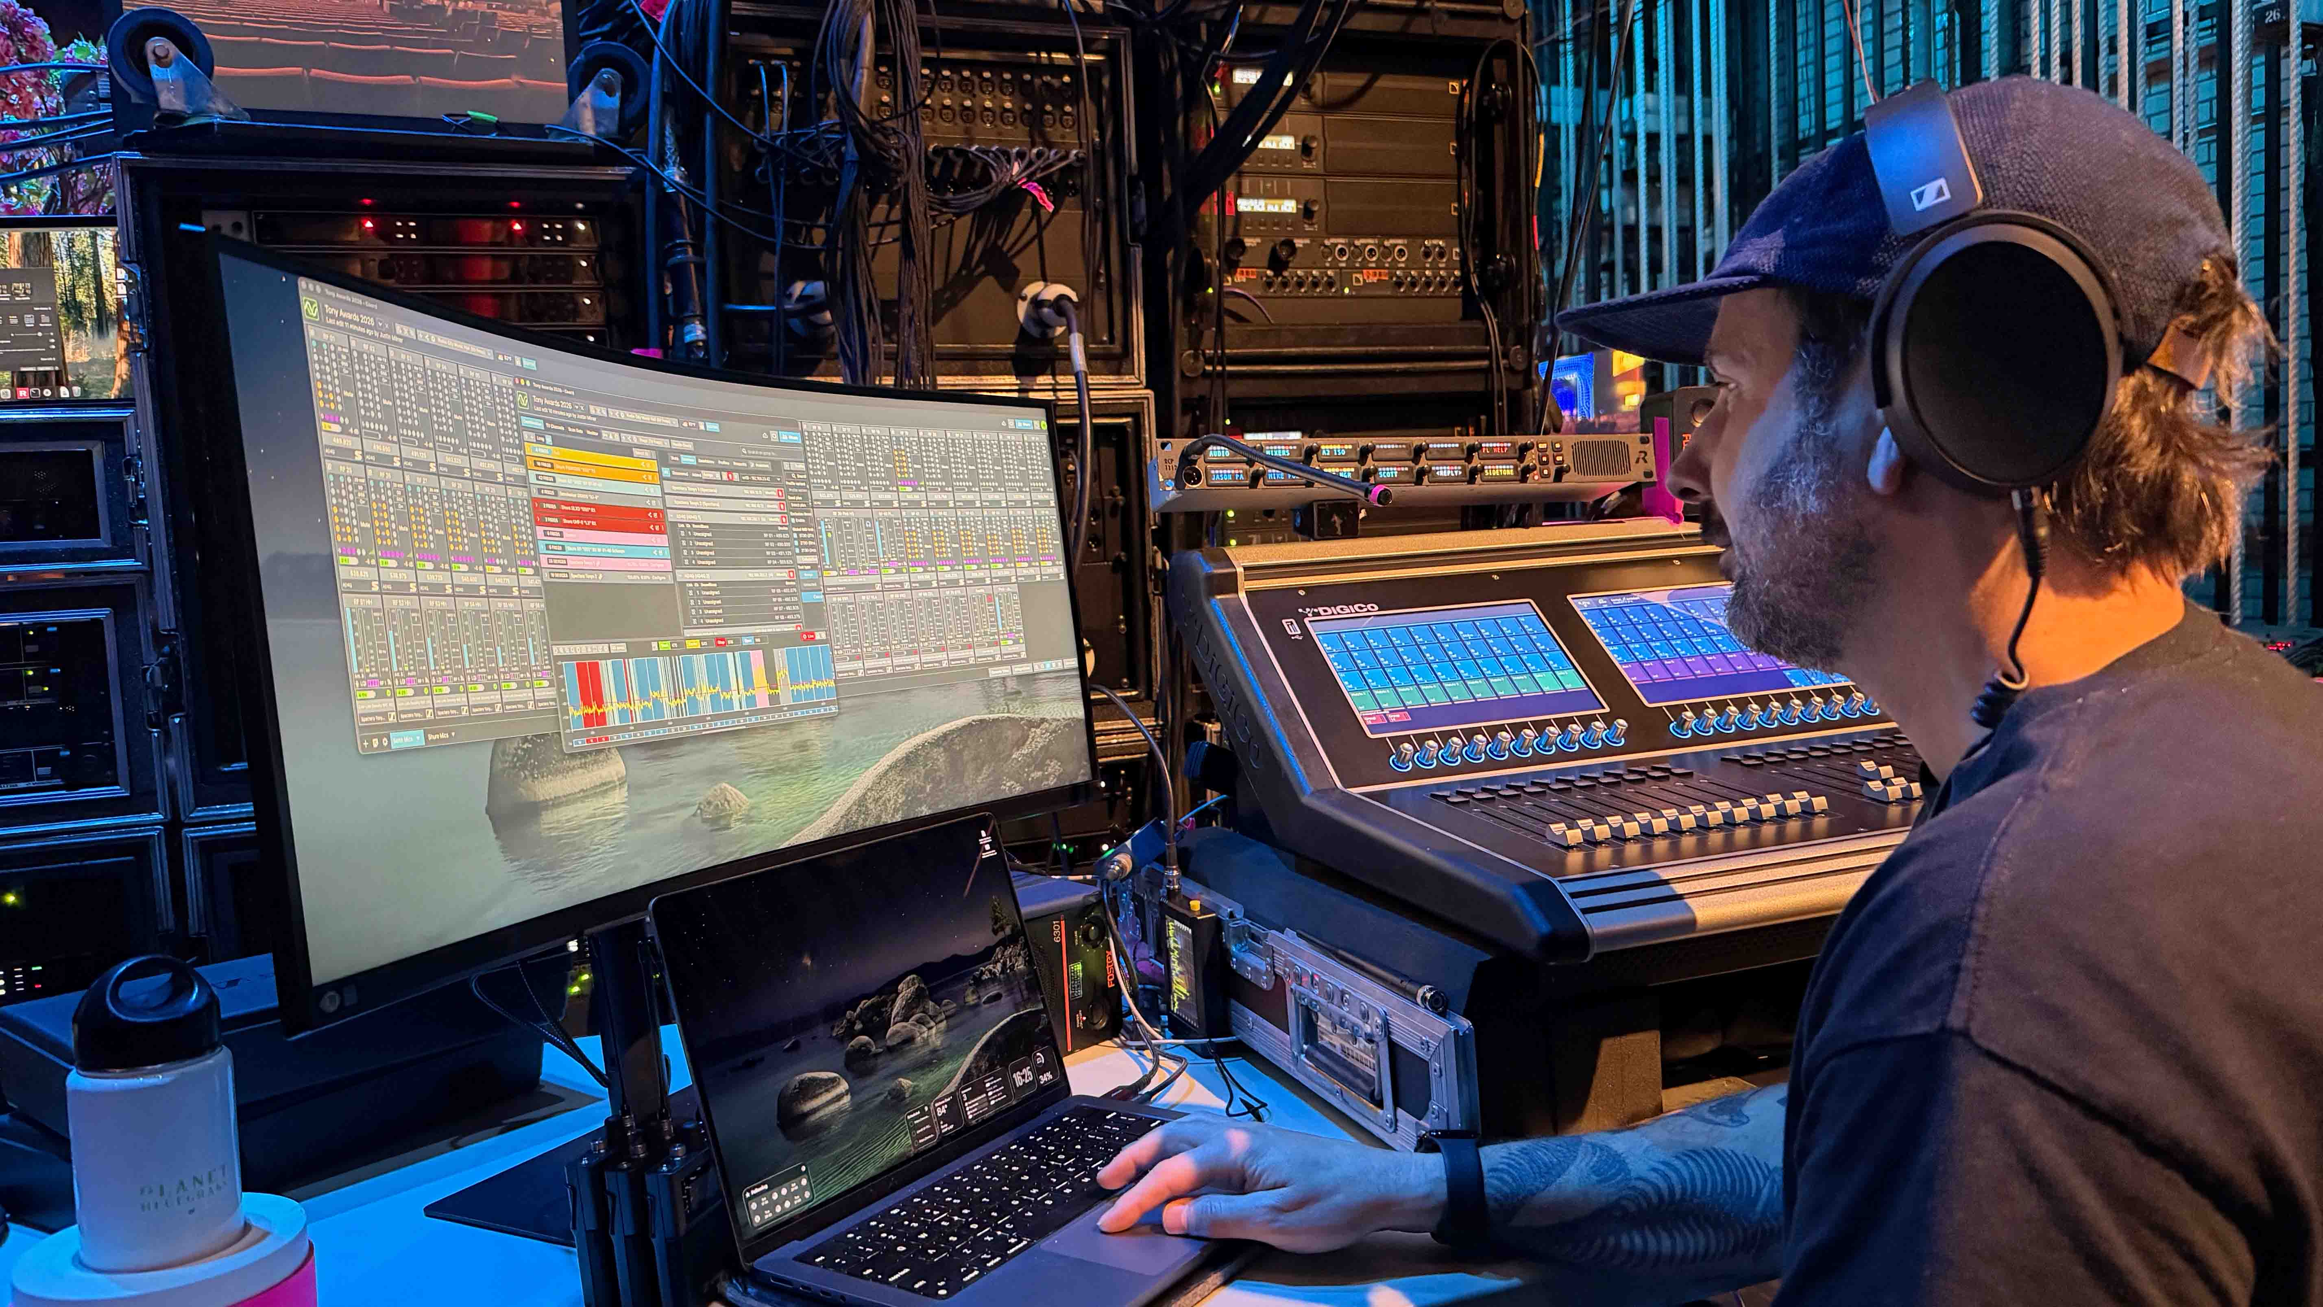

With broad venue coverage in one of the country’s most challenging RF environments, flexible infrastructure and the ability to support microphones and in-ear monitoring on the same wideband carrier, Spectera enabled the production team to adapt quickly to the evolving needs of the broadcast throughout rehearsals and the live show. Combined with SoundBase for wireless management, the team maintained oversight of both Spectera and conventional wireless systems from a unified platform. Hoskins emphasized, “the ability to see all our systems together regardless of brand has been a great advantage.”

The team particularly benefitted from SoundBase Pro’s new Remote View feature which enables production teams to use individually tailored dashboards on multiple devices, including phones, tablets or laptops, for monitoring anywhere in the venue, without needing multiple software licenses. Monitoring throughout rehearsals and the live broadcast was carried out using Sennheiser HD 480 PRO headphones. As Milner noted, “It was a pleasure listening to every mic transmitted through Spectera on the HD 480 PRO headphones. Everything sounded great.”

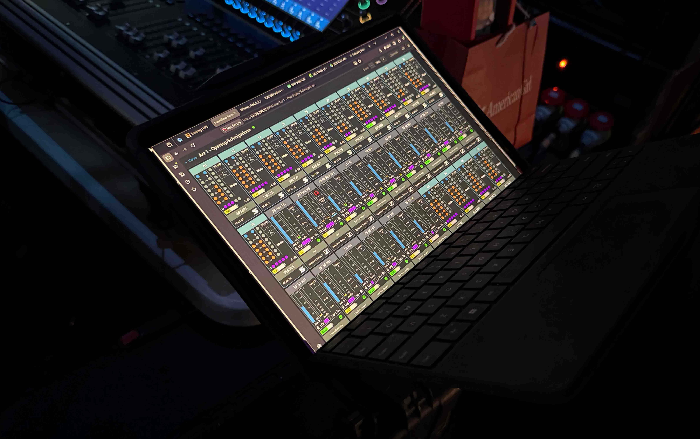 | Scott Hoskins’ personalized dashboard via SoundBase Pro’s Remote View feature, allowing teams to produce distinct dashboards across multiple endpoints on the same software

The 2026 Tony Awards broadcast offered a preview of the forthcoming Spectera SKM handheld microphone, with pre-production units used throughout the broadcast by P!NK and other performers. Looking ahead, Hoskins believes technologies like Spectera will be critical as live productions continue to evolve. “The amount of physical space and RF spectrum Spectera alleviates should help us keep up with how the shows are constantly increasing in their complexity,” says Hoskins. Greg Simon, Technical Applications Engineering Director, Sennheiser adds, “Spectera gives production teams the flexibility and scalability they need to meet the RF challenges of today while preparing for the demands of future broadcasts.”

The Spectera ecosystem, including bidirectional bodypack transmitters and receivers, is available now, while the handheld microphone is available for pre-order ahead of shipments beginning this fall.

(Ends)

Editor’s Note: Any usage of the photo featuring P!NK must be credited to John Nacion / Getty Images. The image must only be used in the context of this press release.

The high-resolution images accompanying this media release can be downloaded here.

About the Sennheiser brand
We live and breathe audio. We are driven by the passion to create audio solutions that make a difference. Building the future of audio and bringing remarkable sound experiences to our customers – this is what the Sennheiser brand has represented for more than 80 years. While professional audio solutions such as microphones, meeting solutions, streaming technologies and monitoring systems are part of the business of Sennheiser electronic SE & Co. KG, the business with consumer devices such as headphones, soundbars and speech-enhanced hearables is operated by Sonova Holding AG under the license of Sennheiser.
www.sennheiser.com
www.sennheiser-hearing.com

Local Press Contacts:
Daniella Kohan
daniella.kohan@sennheiser.com
+1 (860) 227-2235

InGear
Chloe Hildeman
chloe@ingearpr.com
+1 425-466-2264

