NAD Launches New C 700 BluOS Streaming Amplifier
  - A just-add-speakers compact and modern solution designed for the streaming age. New Classic Series features powerful HybridDigital UcD amplification, 80-watts per channel and integral BluOS app interface.

PICKERING, ONTARIO, CANADA SeptEMBER 30, 2021 – NAD Electronics, the highly regarded manufacturer of high-performance audio/video components, continues its expansion in the “just add speakers” category with the introduction of the C 700 BluOS Streaming Amplifier. The C 700 suggested retail price is US$1499 (£1299 / €1499 / CDN$1999 MSRP) and will ship globally in late October.

Housed in a compact and modern design, the C 700 was designed with a listener in mind who seeks an uncompromised listening experience with a focus on value. Inside the solid aluminium housing is a powerful HybridDigital UcD amplifier and BluOS Enabled network streamer. Using the intuitive BluOS app, the ability to cue music from a digital library, or stream from internet radio and online services like Spotify, Amazon Music HD, Tidal, and Qobuz could not be easier. The C 700 delivers an experience similar to the award-winning Masters Series M10 BluOS Music Streaming Amplifier.
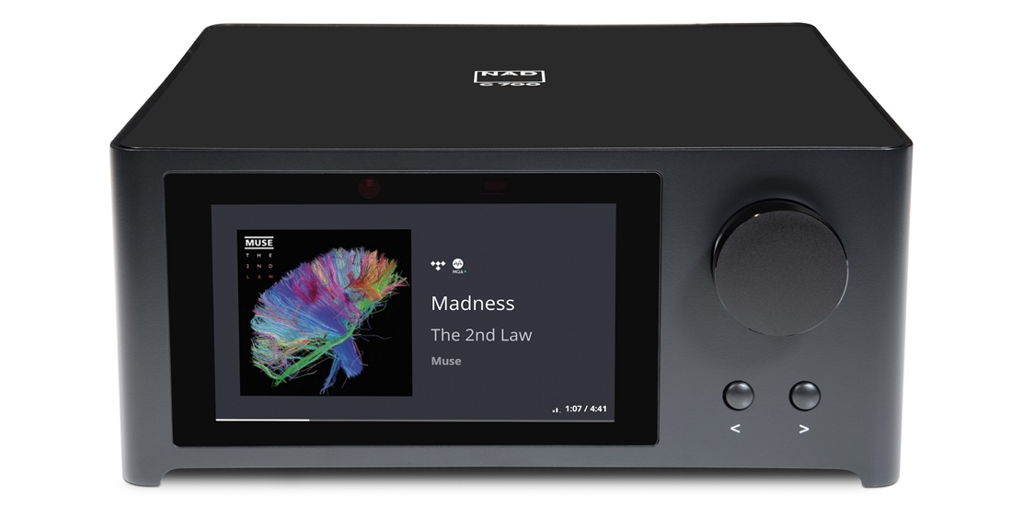
NAD Electronics C 700 BluOS Streaming Amplifier (front)

Compact and Modern Design
Thanks to its elegant, minimalist design and premium materials, the C 700 will engage the most demanding of listeners — audibly as well as visually. The C 700 is housed in a solid aluminium case, with a smooth glass front panel and 5” high-definition colour display that shows album artwork, track status, and system settings.
Via the C 700’s colour display, adjusting amplifier settings is quick and convenient with the added benefit of having the ability to learn commands from any pre-existing remote control.

“The C 700 creates exceptional value for those seeking a modern and easy-to-use standalone music system”, comments Cas Oostvogel, NAD’s Product Manager. “Ever since NAD introduced the legendary 3020 integrated amplifier in 1978, the NAD brand has been renowned for value, performance, and innovation. With the C 700 BluOS Streaming Amplifier, NAD has completely updated that tradition for the streaming era.”

Powerful HybridDigital UcD Amplification
The highly efficient UcD amplifier design is renowned for ultra-low noise and distortion through the entire frequency range, regardless of the loudspeaker load. Employing NAD’s proven HybridDigital UcD amplifier technology, the C 700 can deliver 2x80 watts of continuous power and 2x120 watts of instantaneous power, for effortless music reproduction.

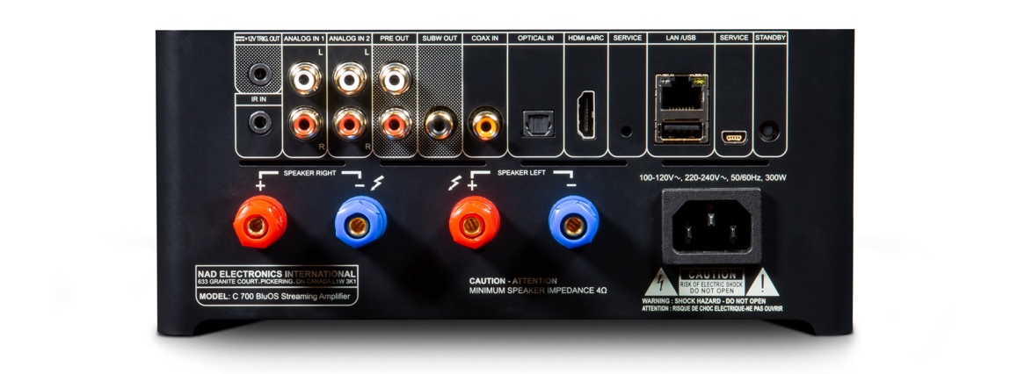
NAD Electronics C 700 BluOS Streaming Amplifier (rear)

Just Add Speakers
The C 700 has everything needed to play music, by just adding speakers. The BluOS app creates an intuitive way to select music from dozens of different streaming services, internet radio, or to play music stored on an external drive connected to the C 700’s USB port.
In addition to the audiophile grade speaker outputs, the C 700 has a subwoofer output
jack where it’s required. Convenient low and high-pass crossover settings in the BluOS app provide a seamless blend between the subwoofer and main speakers.

The C 700 has two pairs of RCA analogue inputs, as well as coaxial and optical digital inputs, for connecting disc players, game consoles, media adapters, and other components. There’s also an HDMI eARC port for connecting a HDTV with HDMI ARC support. This allows the
C 700’s volume setting to be adjusted from the TV’s remote. Two-way aptX HD Bluetooth provides a convenient way to listen to music through wireless headphones, and stream audio from any smart device.

Key Features of the NAD C 700 BluOS Streaming Amplifier
- HybridDigital UcD Amplifier
- Continuous Power: 80 Watts per channel into 8/4 ohms
- Instantaneous Power: 120 Watts per channel
- 5” high-definition colour information display shows album art, track progress, and system settings
- Solid aluminum body and glass front panel
- Works with intuitive BluOS Controller app for Android, iOS, macOS, and Windows
- BluOS multi-room streaming to 63 zones
- High-resolution audio to 24-bit/192Hz
- MQA decoding and rendering
- Lossless and high-resolution streaming from Amazon Music HD, Deezer, Idagio, Qobuz, and Tidal
- Support for Apple AirPlay 2, Spotify Connect, and Tidal Connect
- Voice control via Amazon Alexa, Apple Siri, and Google Assistant
- Optical and coaxial digital inputs
- HDMI eARC port
- Two-way aptX HD Bluetooth
- 12V Trigger output

About NAD Electronics
Founded in 1972 and now sold in over 80 countries, NAD Electronics is renowned for its
award-winning line of high-quality components for audio, home theatre and custom
installation applications. Since the beginning, NAD’s commitment to four core values –
innovation, simplicity, performance, and value – have earned it a cult-like
following that catapulted it to becoming a household name amongst audiophiles and
music lovers alike. To this day, the brand continues to design and manufacture some of
the most acclaimed and affordable hi-fi components that include modern features and
technologies meant to appeal to a new generation of audiophiles.

Links
Website: https://nadelectronics.com
Images: https://nadelectronics.webdamdb.com/bp/#/folder/10075751/
Facebook: https://www.facebook.com/nadelectronics
Twitter: https://twitter.com/NADElectronics
Instagram: https://www.instagram.com/nadelectronics/

# # #

