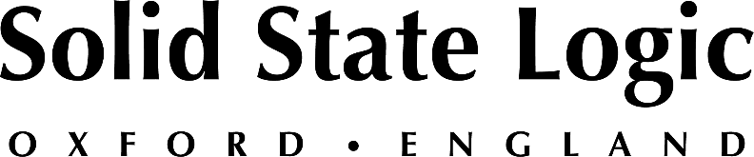

Solid State Logic is Finalist in Three Categories for 2026 NAMM TEC Awards, to be Held at Anaheim Hilton on January 22nd

SSL's new ORACLE is finalist in Large Format Console Technology, while System T Desktop Fader Tile Plus and SSL 18 get the nod in Small Format Console Technology and Computer Audio Hardware categories

Oxford, UK, December 1, 2025 — Solid State Logic was recognised as a finalist in three separate categories for the 2026 NAMM TEC Awards, to be held at the Anaheim Hilton on the evening of January 22nd during the 2026 NAMM Show. The company's new ORACLE future analogue mixing console is a finalist in the Large Format Console Technology category, while the System T Desktop Fader Tile Plus and SSL 18 are finalists in the respective categories of Small Format Console Technology and Computer Audio Hardware.

ORACLE: The future of analogue
ORACLE is a fully analogue in-line mixing console offering large-format features in a compact footprint, with instant, effortless, and complete recall of all processing, routing, gain and pan settings. With the ability to instantly switch between mixing or tracking set-ups, ORACLE is able to accommodate changing workflows quicky and effortlessly. Oracle features the company's new ActiveAnalogue™ technology, which significantly increases the potential throughput of any studio facility, while delivering the authentic analogue tone that artists and producers crave.

System T Desktop Fader Tile Plus: Uncompromising portable control
The System T Desktop Fader Tile Plus, TEC Award finalist in the category of Small Format Console Technology, provides portable control for powerful, compact System T installations. Used in conjunction with SSL's Tempest Control App, the DFT+ offers dedicated hands-on control for System T installations, with enhanced visual feedback to meet the needs of the most demanding operations. Additionally, a System T Desktop Fader Tile Plus and computer running TCA software can be combined within a single system along with main control surface(s), providing custom solutions to fit any application or environment.

SSL 18: the ultimate centrepiece to your studio
The SSL 18, TEC Award finalist in the category Computer Audio Hardware, represents a new era in rackmount production technology from SSL. Developed from the company's unmatched expertise in analogue and digital design, SSL 18 offers exceptional audio performance with a studio session-ready feature set, delivered with the signature SSL sound and premium quality that professionals trust. For recording, producing or mixing, SSL 18 is able to enhance production workflows while elevating performance and serving as the ultimate centrepiece for your studio.

Rick Naqvi, North American Senior Vice President of SSL Sales, commented: “We are honoured to be named a finalist for the 2026 NAMM TEC Awards and grateful to our customers who continue to trust SSL tools to deliver the unmistakable SSL-quality sound and workflow across every market we serve. We also thank the NAMM TEC Award nominating committee for this recognition, and we look forward to reconnecting with our friends and partners at the 2026 NAMM Show in Anaheim.”

For more information:
• SSL Oracle Future Analogue console: https://www.solidstatelogic.com/products/oracle
• System T Desktop Fader Tile Plus: https://solidstatelogic.com/products/desktop-fader-tile-plus
• SSL 18: https://solidstatelogic.com/products/ssl-18
• Details on the 2026 TEC Award nominations and voting, please visit www.tecawards.org

Solid State Logic is the world’s leading manufacturer of analogue and digital audio consoles and provider of creative tools for music, broadcast, live and post production professionals. For more information about our award-winning products, please visit: www.solidstatelogic.com.

For further information contact:
Ross Gilbert
+44 (0) 1865 842300
rossg@solidstatelogic.com

