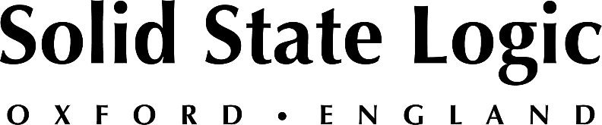

Solid State Logic Adds Extra Production Punch to its Audio Interfaces
Addition of SSL FlexVerb and X-comp Native plug-ins provide even more production power to the popular SSL 2 and SSL 2+ professional audio interfaces

OXFORD ENGLAND – From November 1st to December 31st, Solid State Logic is providing an expanded SSL Production Pack along with all new purchases of its professional personal studio interfaces, SSL 2 and SSL 2+. The addition of SSL’s premium FlexVerb and X-comp Native plug-ins imparts an unmistakable studio-quality polish alongside SSL mix favourites VocalStrip 2 and Drumstrip, along with an array of leading third-party DAW software and samples.

Nigel Beaumont, SSL Managing Director, enthuses “It’s been a pretty amazing year for SSL with the introduction of our professional studio interface range in January. The response to the products has been amazing, and as a thank you to new and current interface owners, we wanted to offer them all a pretty cool gift from the team.”

New and current owners of the SSL 2 or SSL2 + audio interface can receive the new plug-ins and the rest of the SSL Production Pack via their online registration.

For more information please contact your favourite reseller or go to our website: www.solidstatelogic.com/interfaces
###

Solid State Logic is the world’s leading manufacturer of analogue and digital audio consoles and provider of creative tools for music, broadcast, live and post production professionals. For more information about our award-winning products, please visit: www.solidstatelogic.com.

###
For further information contact:
Jeff Touzeau
+1 (914) 602-2913
jeff@hummingbirdmedia.com

Ross Gilbert
+44 (0) 1865 842300
rossg@solidstatelogic.com

