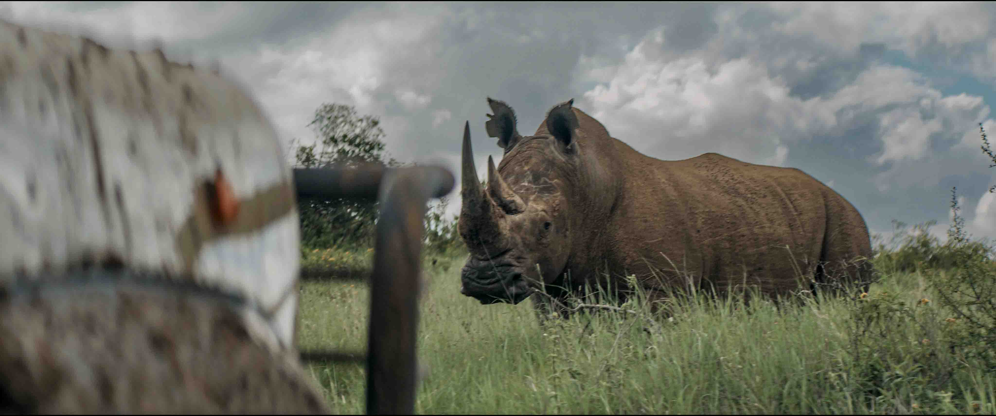

Rhino: Elevating storytelling with Sennheiser in the heart of Kenya’s wilderness
Tom Martienssen of Dustoff Films relies on MKH 8000 RF condenser microphones to capture every intricate sound detail for his latest documentary film

Wedemark, December 2025 — When it comes to wildlife filmmaking, capturing the essence of nature is not just about stunning visuals — sound plays an equally crucial role. In Rhino, the latest documentary by Tom Martienssen, founder of Dustoff Films, the sounds of the African wilderness become a key narrative tool. The documentary, which follows a group of elite wildlife rangers in Kenya who are working to protect the critically endangered black rhino, is garnering attention for both its powerful conservation message and its exceptional audio quality. At the heart of the film’s sound are Sennheiser’s cutting-edge MKH 8000 series microphones, which helped bring the film’s immersive world to life.

From the deep rumbles of rhino calls to the subtle rustling of the grasslands, the film’s soundscape is as critical to the narrative as its visuals. The use of Sennheiser’s MKH 8000 RF condenser microphones allowed Martienssen and his small production team to authentically capture the environment’s sounds on location. The microphones provided clarity and detail, even in the toughest conditions Kenya’s wilderness could throw at them.

Martienssen, who formerly worked in Combat Search and Rescue and was a qualified team medic, founded Dustoff Films around a decade ago. Inspired by his experiences on the frontlines of war and the pressing need for greater environmental awareness, his work quickly evolved to focus on wildlife conservation. Dustoff Films is now committed to producing powerful documentaries that tackle critical issues such as climate change, conservation, and human rights.

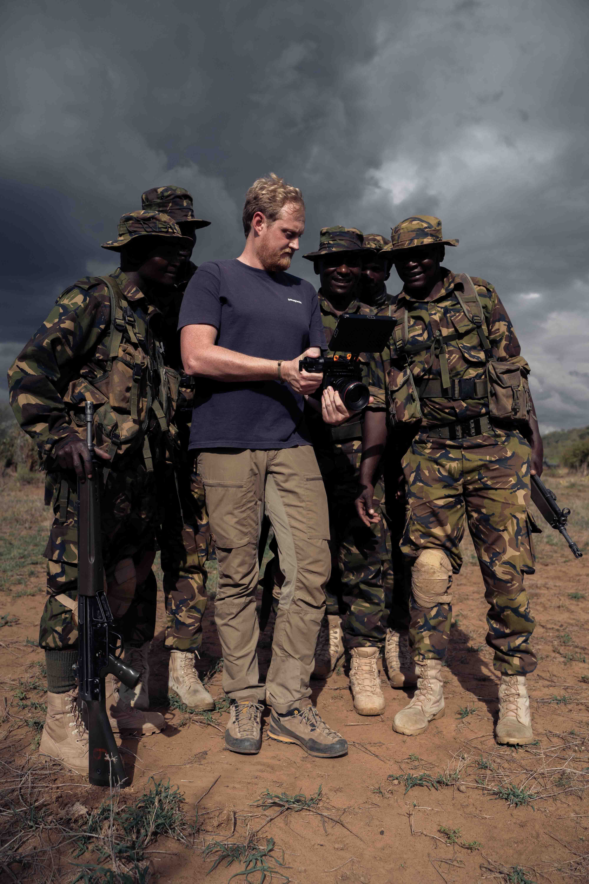 | Tom Martienssen sharing footage with the rangers (Photo credit: Dustofff Films)

In Rhino, Martienssen and his team have chosen to share a story of hope amidst environmental jeopardy. The film chronicles the extraordinary recovery of Kenya’s rhino population, which, after facing near extinction in the 1970s, is now thriving thanks to successful conservation efforts. However, this resurgence has come with its own set of challenges: the rhino population has outgrown its habitat, causing territorial disputes and aggression among the animals. In a groundbreaking move, wildlife rangers are now tasked with relocating the animals to new areas to ensure their survival and growth. The documentary shines a light on the tireless and dangerous work of the rangers, the positive outcomes of the conservation efforts, and the larger global importance of protecting endangered species.

Filming wildlife is inherently challenging, especially when it comes to capturing authentic sounds. While the breathtaking visuals often steal the spotlight in wildlife filmmaking, sound is just as essential in creating an immersive experience.

“We wanted the sound to be real,” says Martienssen. “We didn’t want to recreate wildlife calls or add in anything that wasn’t there in the moment. It was important that the sounds we recorded on location were the ones you’d hear if you were actually there with us, in the middle of the African savanna.”

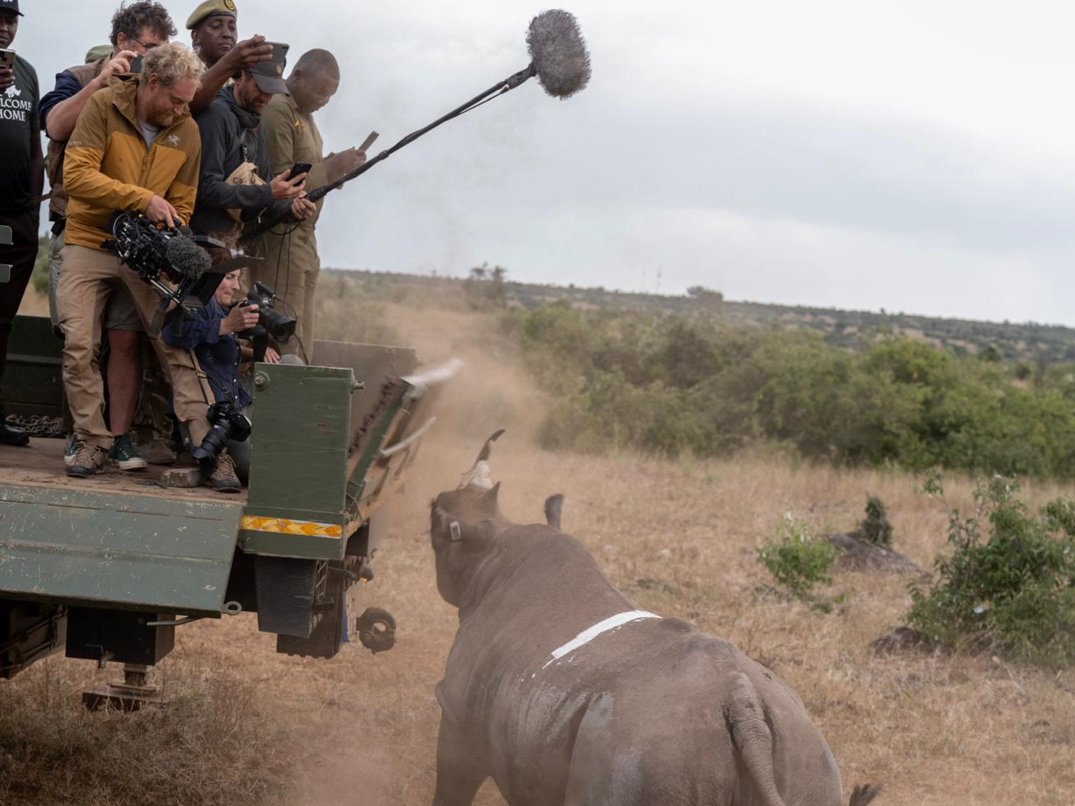 | The Rhino documentary follows a group of elite wildlife rangers in Kenya who are working to protect the critically endangered black rhino (Photo credit: David Chancellor)

This commitment to authentic sound led the team to use Sennheiser’s MKH 8000 series microphones to ensure every audio detail was captured with precision in the midst of dusty, windy, and sometimes dangerous conditions, and helping to preserve the raw, unfiltered sounds of the Kenyan wilderness.

The MKH 8060, known for its highly directional pickup and clarity, was used throughout the film to capture crisp, isolated sound from specific sources, such as animal calls and rangers’ conversations. Its compact size, incredible sensitivity and climate-proof robustness made it ideal for use in the field, even in challenging environments like the Kenyan savanna.

Martienssen first met Sennheiser’s Tim Constable while giving a lecture on using RED Digital Cinema cameras for storytelling. “Our conversation shifted to the film’s sound, and that’s when Sennheiser, through Tim, provided us with a double MS stereo rig, featuring two MKH 8040s and one MKH 8030 mic,” he says. “We used this setup to capture natural ambient sound from each location in the film to create an immersive soundscape.”

“The 8000 series mics, whether it’s the 8060, 8030, or 8040, all sound very similar, so you can easily mix and match them without any issues,” Constable adds. “The sound profile stays consistent, which meant there was no need for extensive post-production adjustments. Based on our discussions with Tom, we came up with a solution that worked seamlessly from the start.”

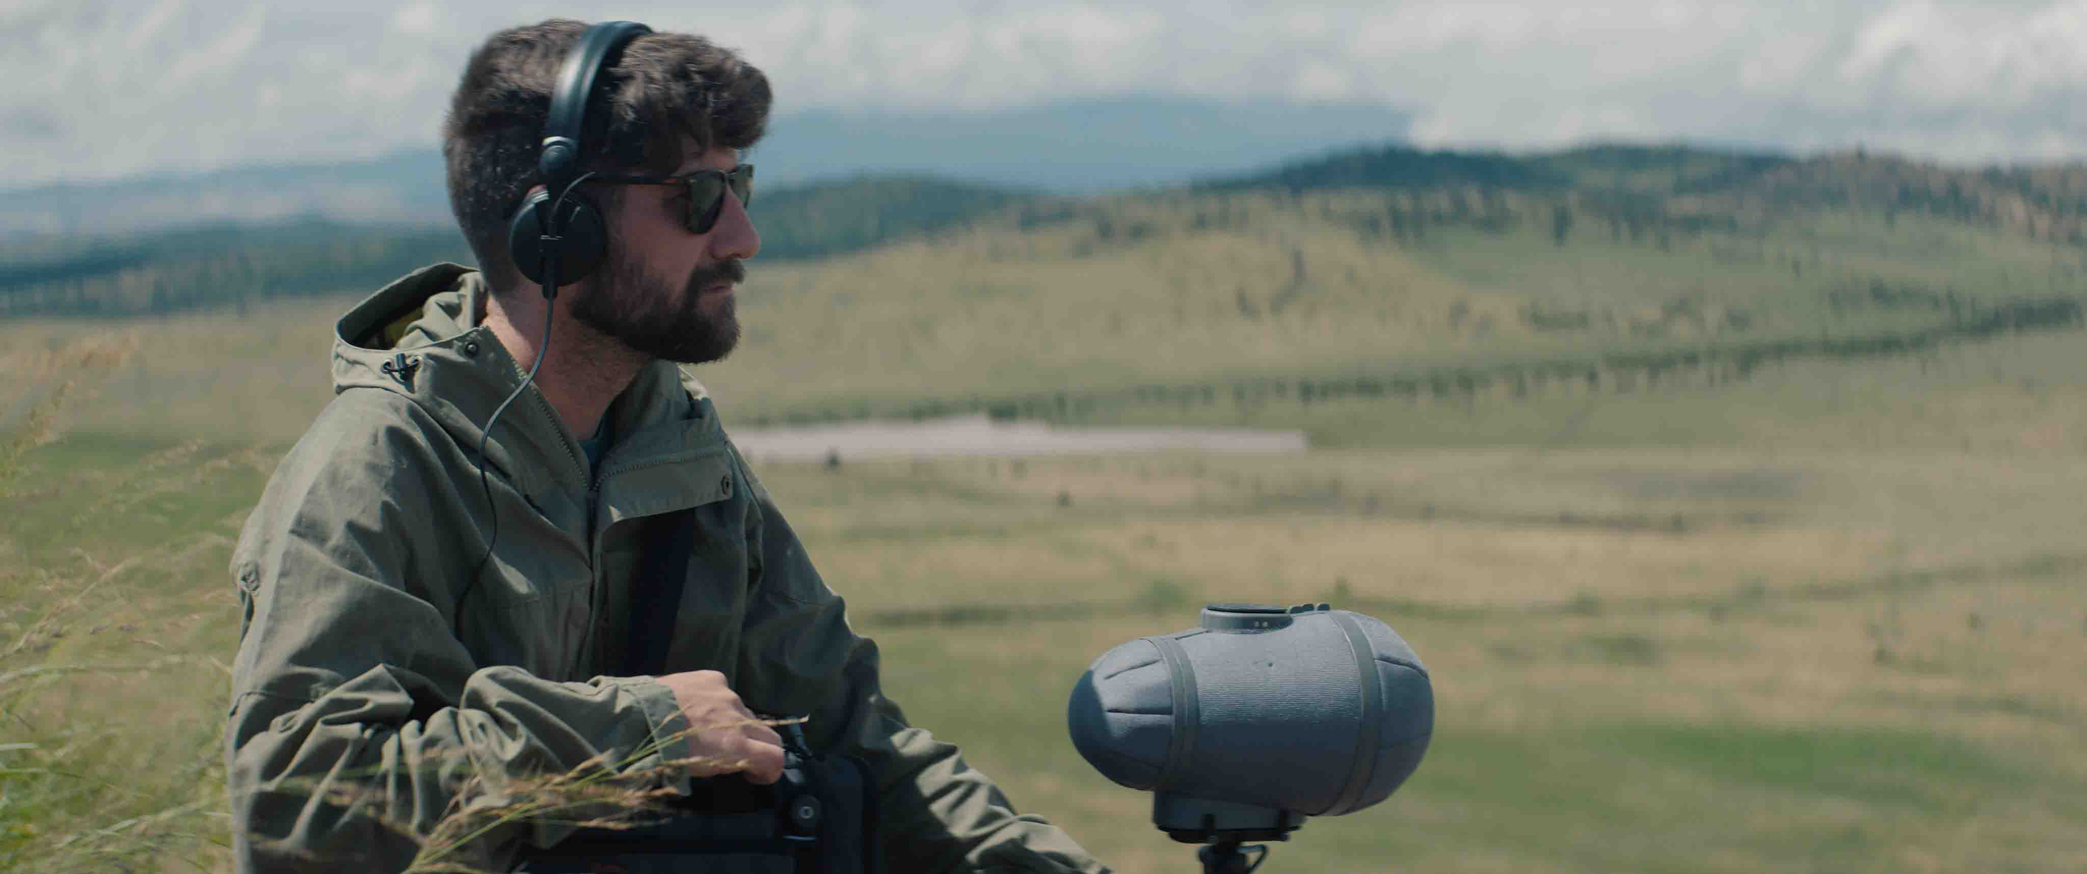 | Alongside the MKH 8060, James May worked with a double MS stereo rig to provide another layer of sonic richness (Photo credit: Dustoff Films)

Alongside the MKH 8060, the double MS stereo rig provided another layer of sonic richness, and allowed Martienssen and his team to record spatially immersive sound: “We used two main microphone setups,” explains Martienssen. “One was an MKH 8060 mounted on the camera, capturing audio wherever the camera pointed. The second setup involved a boom mic, where we alternated between the double MS stereo rig with two MKH 8040s and an MKH 8030, or just the MKH 8060. We did a side-by-side test with the 8060 we had from the start and another one we got about six months ago. After two and a half years of use, they sounded identical — just like the new one, straight out of the box.”

A closer look at the double MS rig (Photo credit: Dustoff Films) | 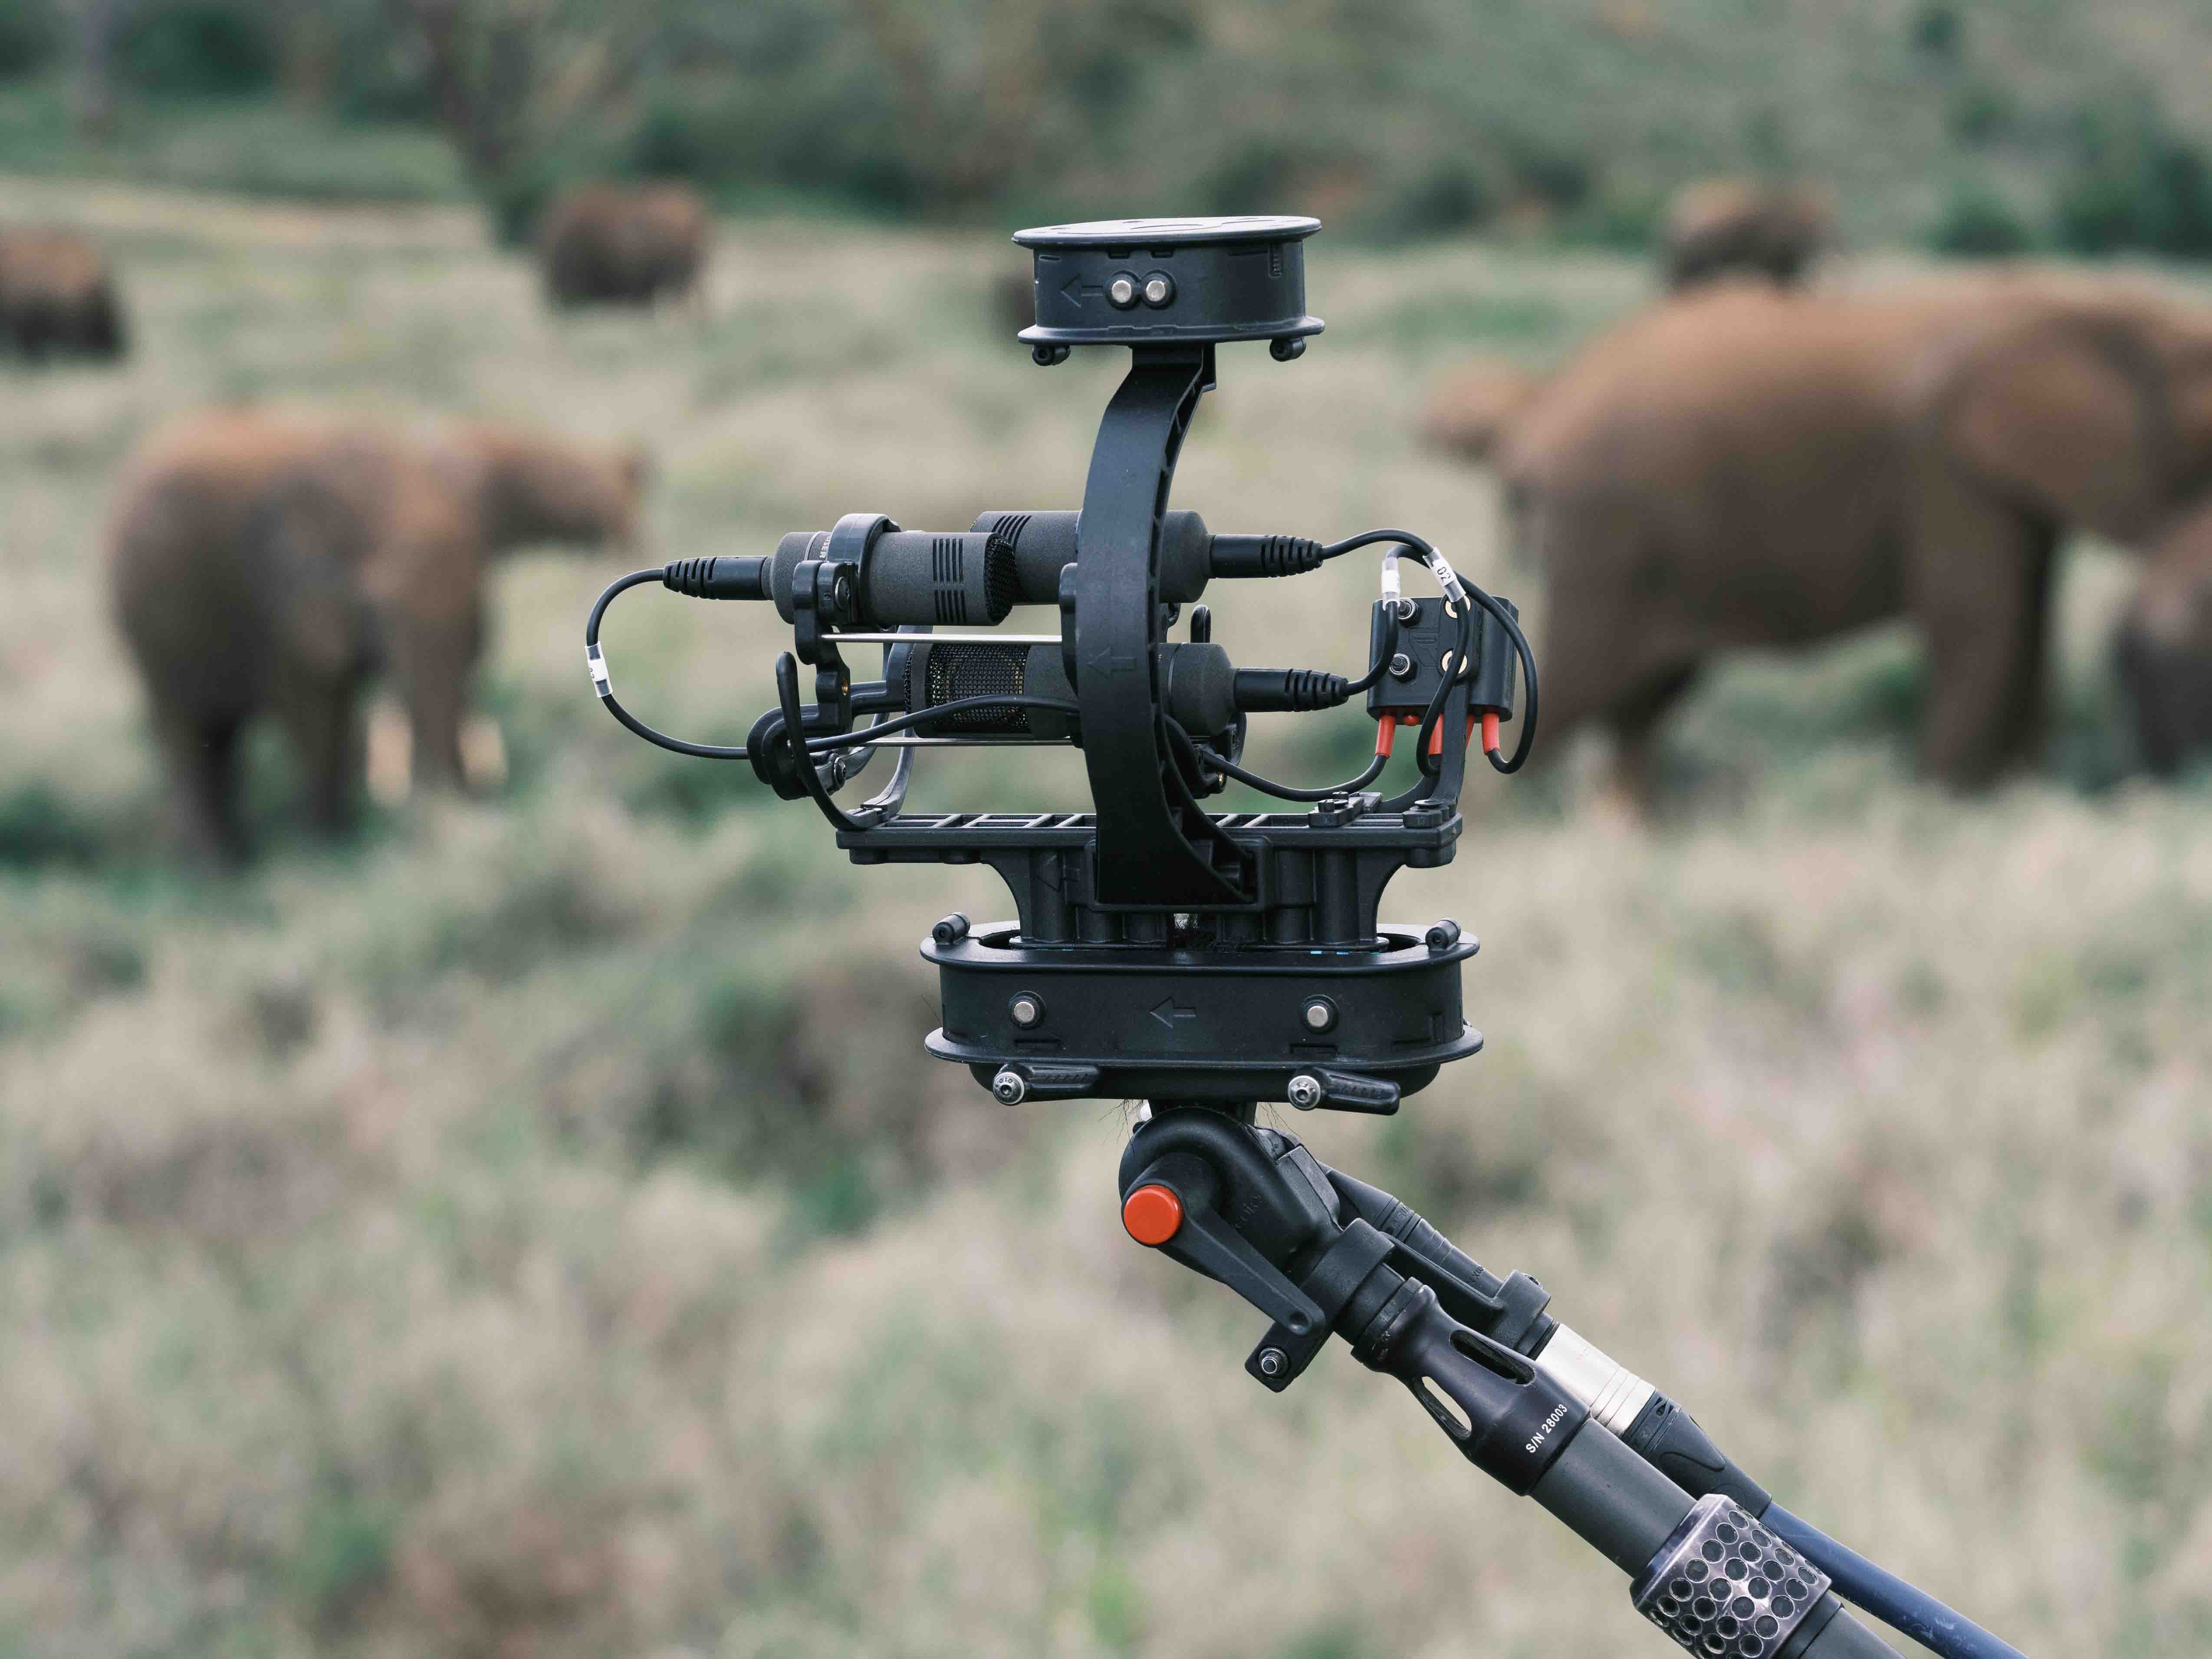

Before each shoot, they decided which setup would work best for the specific scene. They found the MKH 8060 was great for its directional focus and compact size, while the double MS stereo rig excelled in capturing the full surround sound of a scene by placing it in the middle of the action.

“We didn’t have the time to swap microphones between setups, so we committed to one system per shoot,” Martienssen continues. “We wanted to keep things simple. Instead of the usual setup with two cameras and one boom mic, we reversed it: we had two MKH 8060 mics — one on the camera and one on a boom following the person I wasn’t filming. This setup allowed us to capture great sound with a smaller crew, keeping costs down and making it easier to work closely with the rangers without getting in the way.”

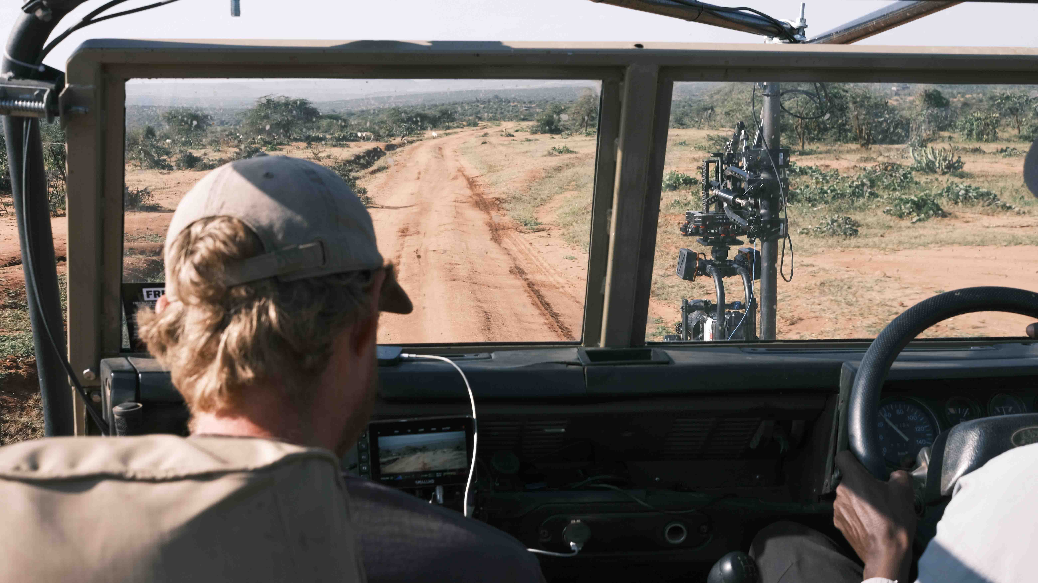 | Before each shoot, the team decided which setup would work best for which scene (Photo credit: Dustoff Films)

Filming in the remote wilderness of Kenya required Martienssen and his team to minimise their footprint and be resourceful with their equipment.

“Rhino was shot by just two people; I handled the camera, and James May took care of the audio,” he adds. “We did have some support through a trainee scheme with Kenyan film students, which was part of our effort to build resilience in the Kenyan film industry. However, they were only present for planned moments, like the rhino translocation and a few other key events. The rest of the time, it was just James and me.

“We used Sennheiser HD 25 headphones throughout, especially for James during recording. Many of the situations we were in were dangerous, with a lot of movement around us. We always recorded in 32-bit float to give us a larger dynamic range, so even if James couldn’t react quickly — like if he was running from a rhino — we’d still have clean audio without worrying about overmodulation. The HD 25s were key, offering clear audio while still allowing us to hear what was happening around us, which is crucial when you’re dealing with rhinos.”

The microphones maintained their high performance even in the toughest conditions of Kenya’s wilderness (Photo credit: Dustoff Films) | 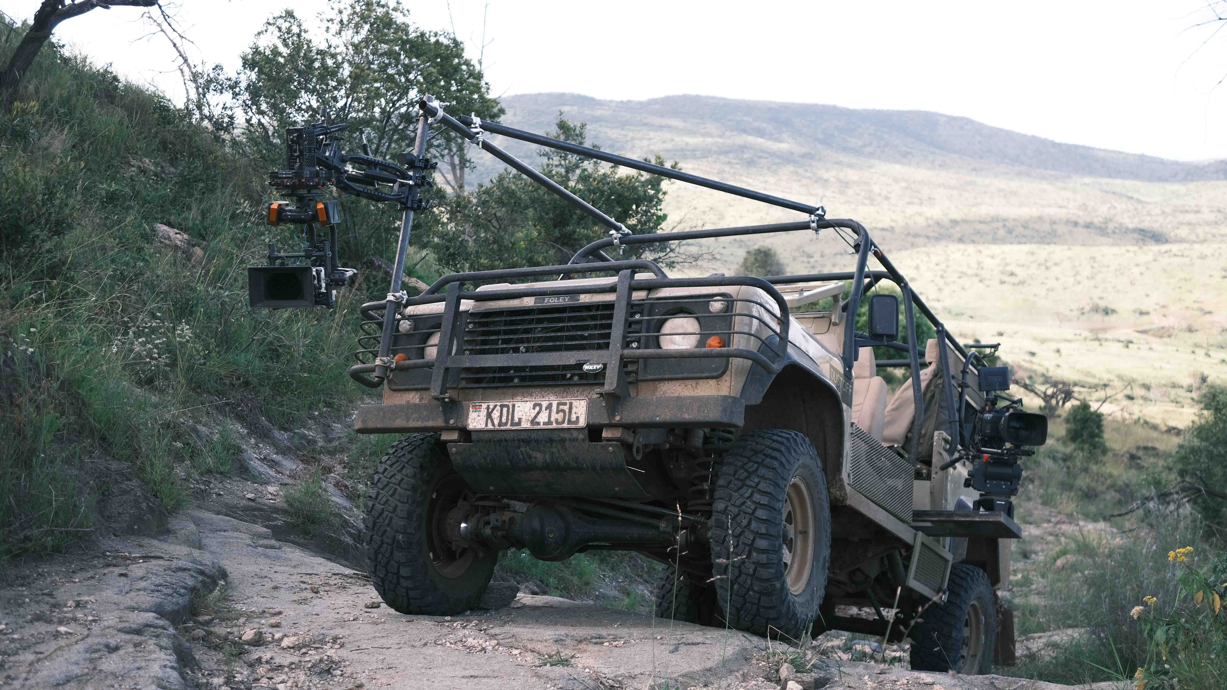

Sound Devices MixPre-3 II and MixPre-6 II recorders were also used, which provided enough channels for the double MS stereo rig. In line with maintaining a compact yet efficient setup on the visual side, Martienssen used RED KOMODO-X and V-RAPTOR cameras for shooting, the preamps on which he says were surprisingly effective.

“The amount of dust the camera managed to handle was incredible,” he recalls. “We filmed during Kenya’s worst drought, with rangers driving heavy vehicles that kicked up dust, which got into the cameras, audio equipment, and microphones. We used a Rycote Softie and Super-Blimp system for the double MS stereo rig, and they did an amazing job protecting everything. Then, when the drought ended, we got torrential rain and mud. Despite all that, the gear held up. I’ve taken these mics to places like Resolute Bay in Canada and Mount Everest at -35°C, and they’ve never let me down. We haven’t had a single issue because all the mics we used are RF condensers, so they’re built for harsh conditions.”

The documentary shines a light on the dangerous work of the rangers and the positive outcomes of their conservation efforts (Photo credit: Dustoff Films) | 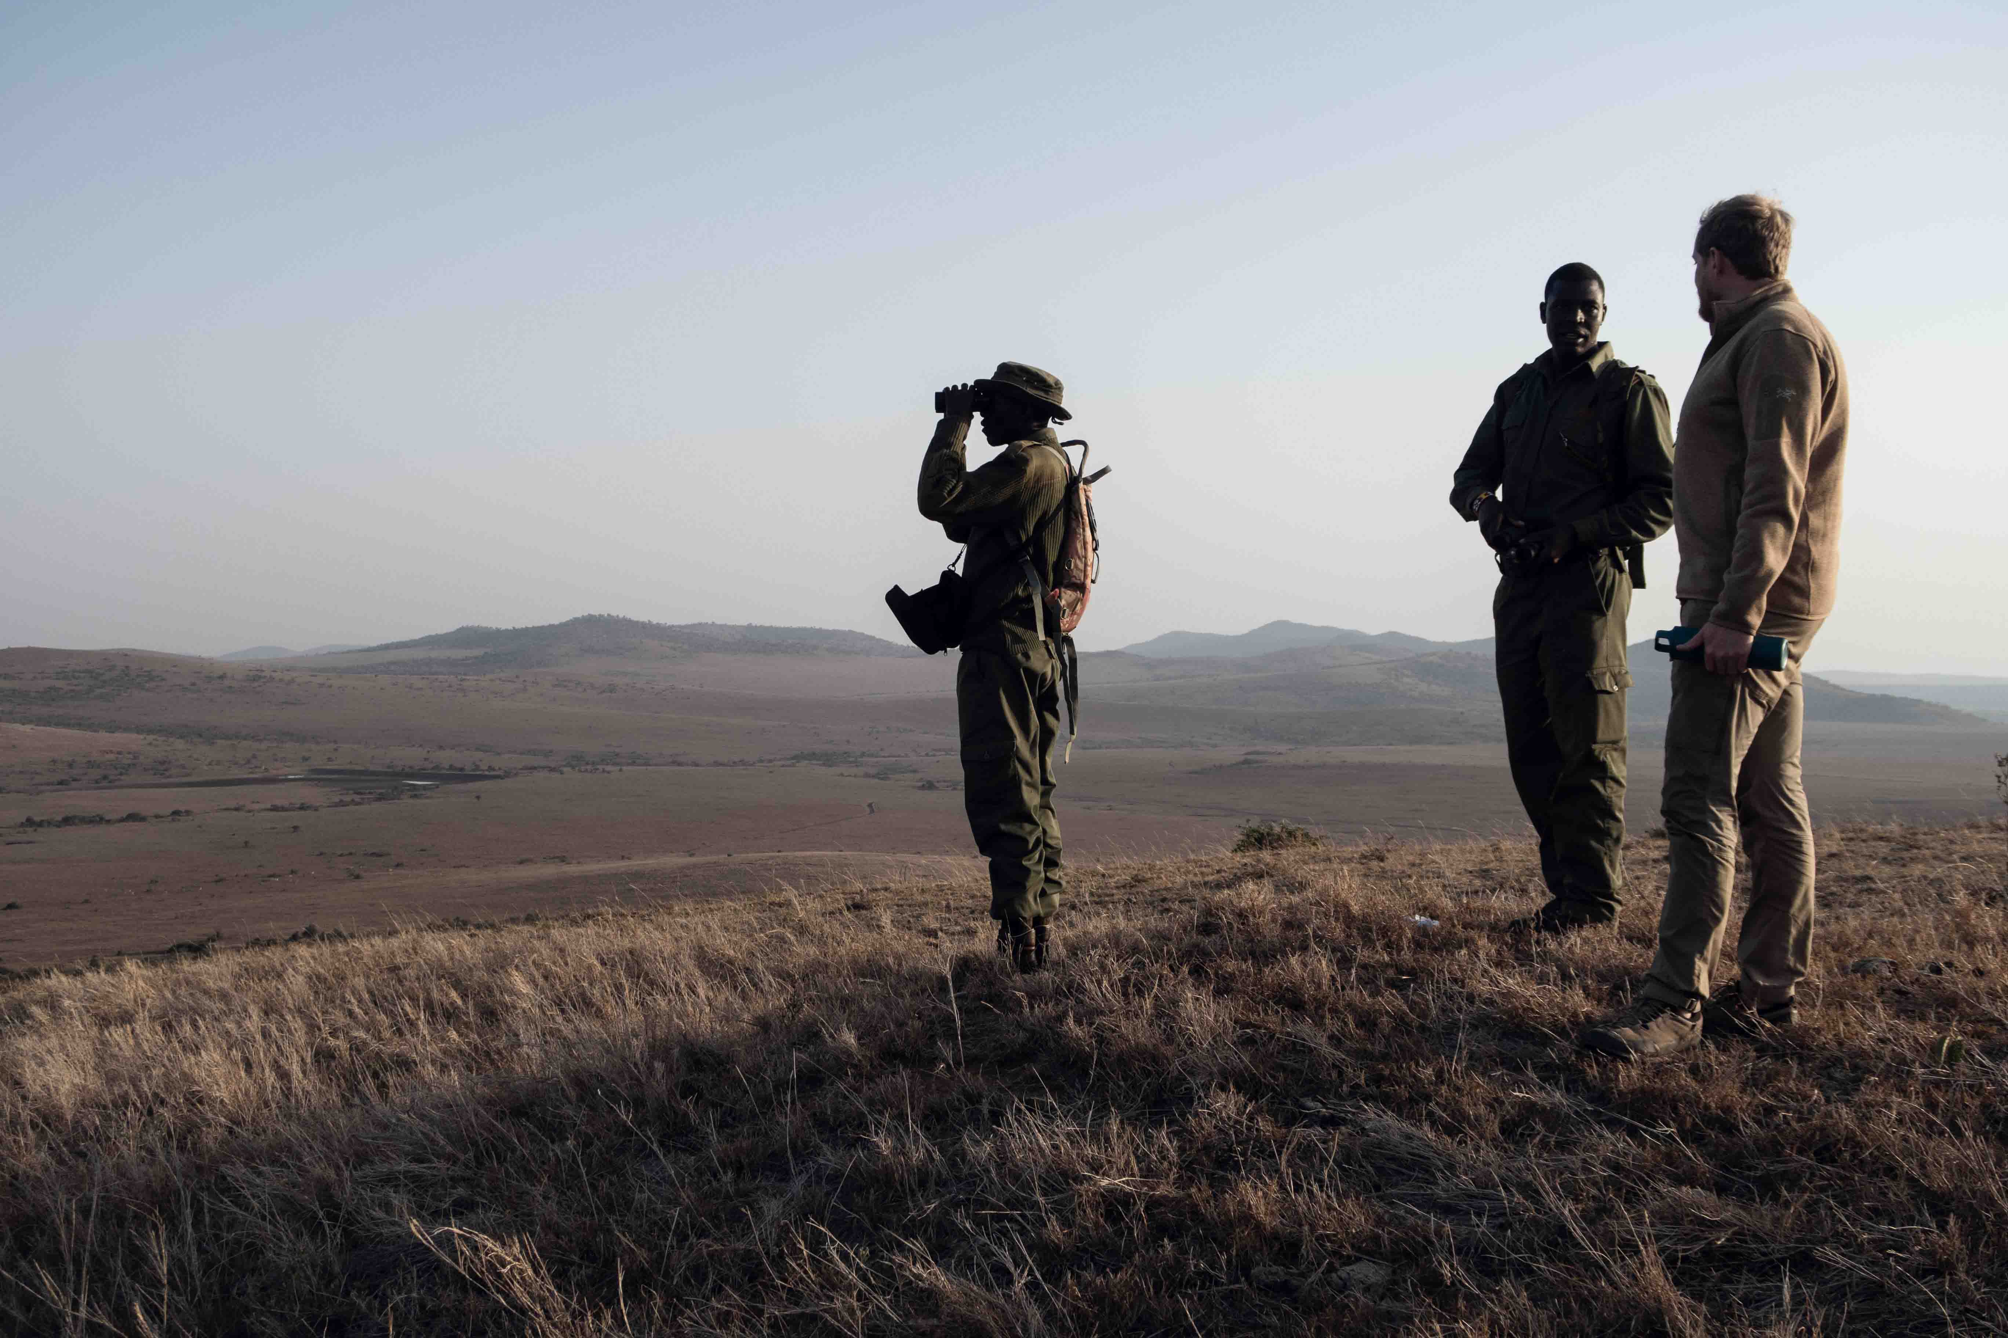

One of the standout features of the Rhino documentary is its Dolby Atmos sound mix, which was mixed using 70 speakers to create a rich, immersive experience.

“We wanted to push the boundaries of documentary filmmaking,” says Martienssen. “With Dolby Atmos, the audience is no longer just watching the film — they’re experiencing it. You can hear the rhinos moving behind you, feel the wind whipping through the trees, and become enveloped in the environment. It takes the documentary to a whole new level.

“While this level of sound design is rare for documentaries — typically reserved for high-end productions — we committed to it because we wanted the quality of the recording to match the final experience. Our sound mixer Nas, who works at Molinare, is a genius. He’s the best sound professional I’ve worked with. I gave him the guidelines, and he truly elevated the mix. I heard the final mix in Molinare’s Dolby Atmos cinema, and it was incredible.”

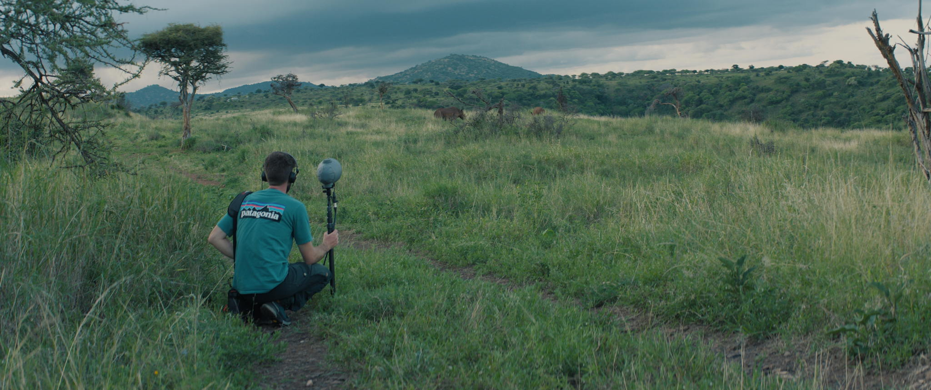
The film promises to be a standout example of how sound can elevate the documentary genre (Photo credit: Dustoff Films)

Martienssen’s background as a BBC journalist and director of photography has shown him how powerful visuals can be in making the audience feel part of the story. But he believes audio can do even more: “With headphone technology improving, it’s possible to create a highly immersive experience, even for those viewing on a laptop. They can truly be in the moment, which feels more practical than large-scale setups. While only a few hundred people might experience that kind of immersion in person, millions can enjoy it at home with good headphones.”

“Cassandra Roberts, the editor, was absolutely incredible,” Martienssen adds. “Towards the end of the film, I brought her to Kenya to experience the environment and get a feel for the characters and the reality of the story. She spent three months there, editing on location. I believe this had the biggest impact on the sound of the film. The sounds of the Borana Conservancy, especially, struck her deeply — sometimes more than the visuals. This helped her create an authentic atmosphere when working with Nas on the sound to ensure it captured the true essence of the place. We’ve also had a lot of support from various companies including Fujifilm, RED Digital Cinema and P+S TECHNIK, especially since we didn’t have the backing of a studio.”

Looking ahead, Martienssen hopes to continue blending high-end cinematic techniques with real-world environmental stories. “We want to create eco-thrillers,” he says. “Films that tell real, unscripted stories but with the same level of excitement and narrative drive as big-budget blockbusters. The next project will take that further, with an even bigger budget and more advanced sound and production techniques.

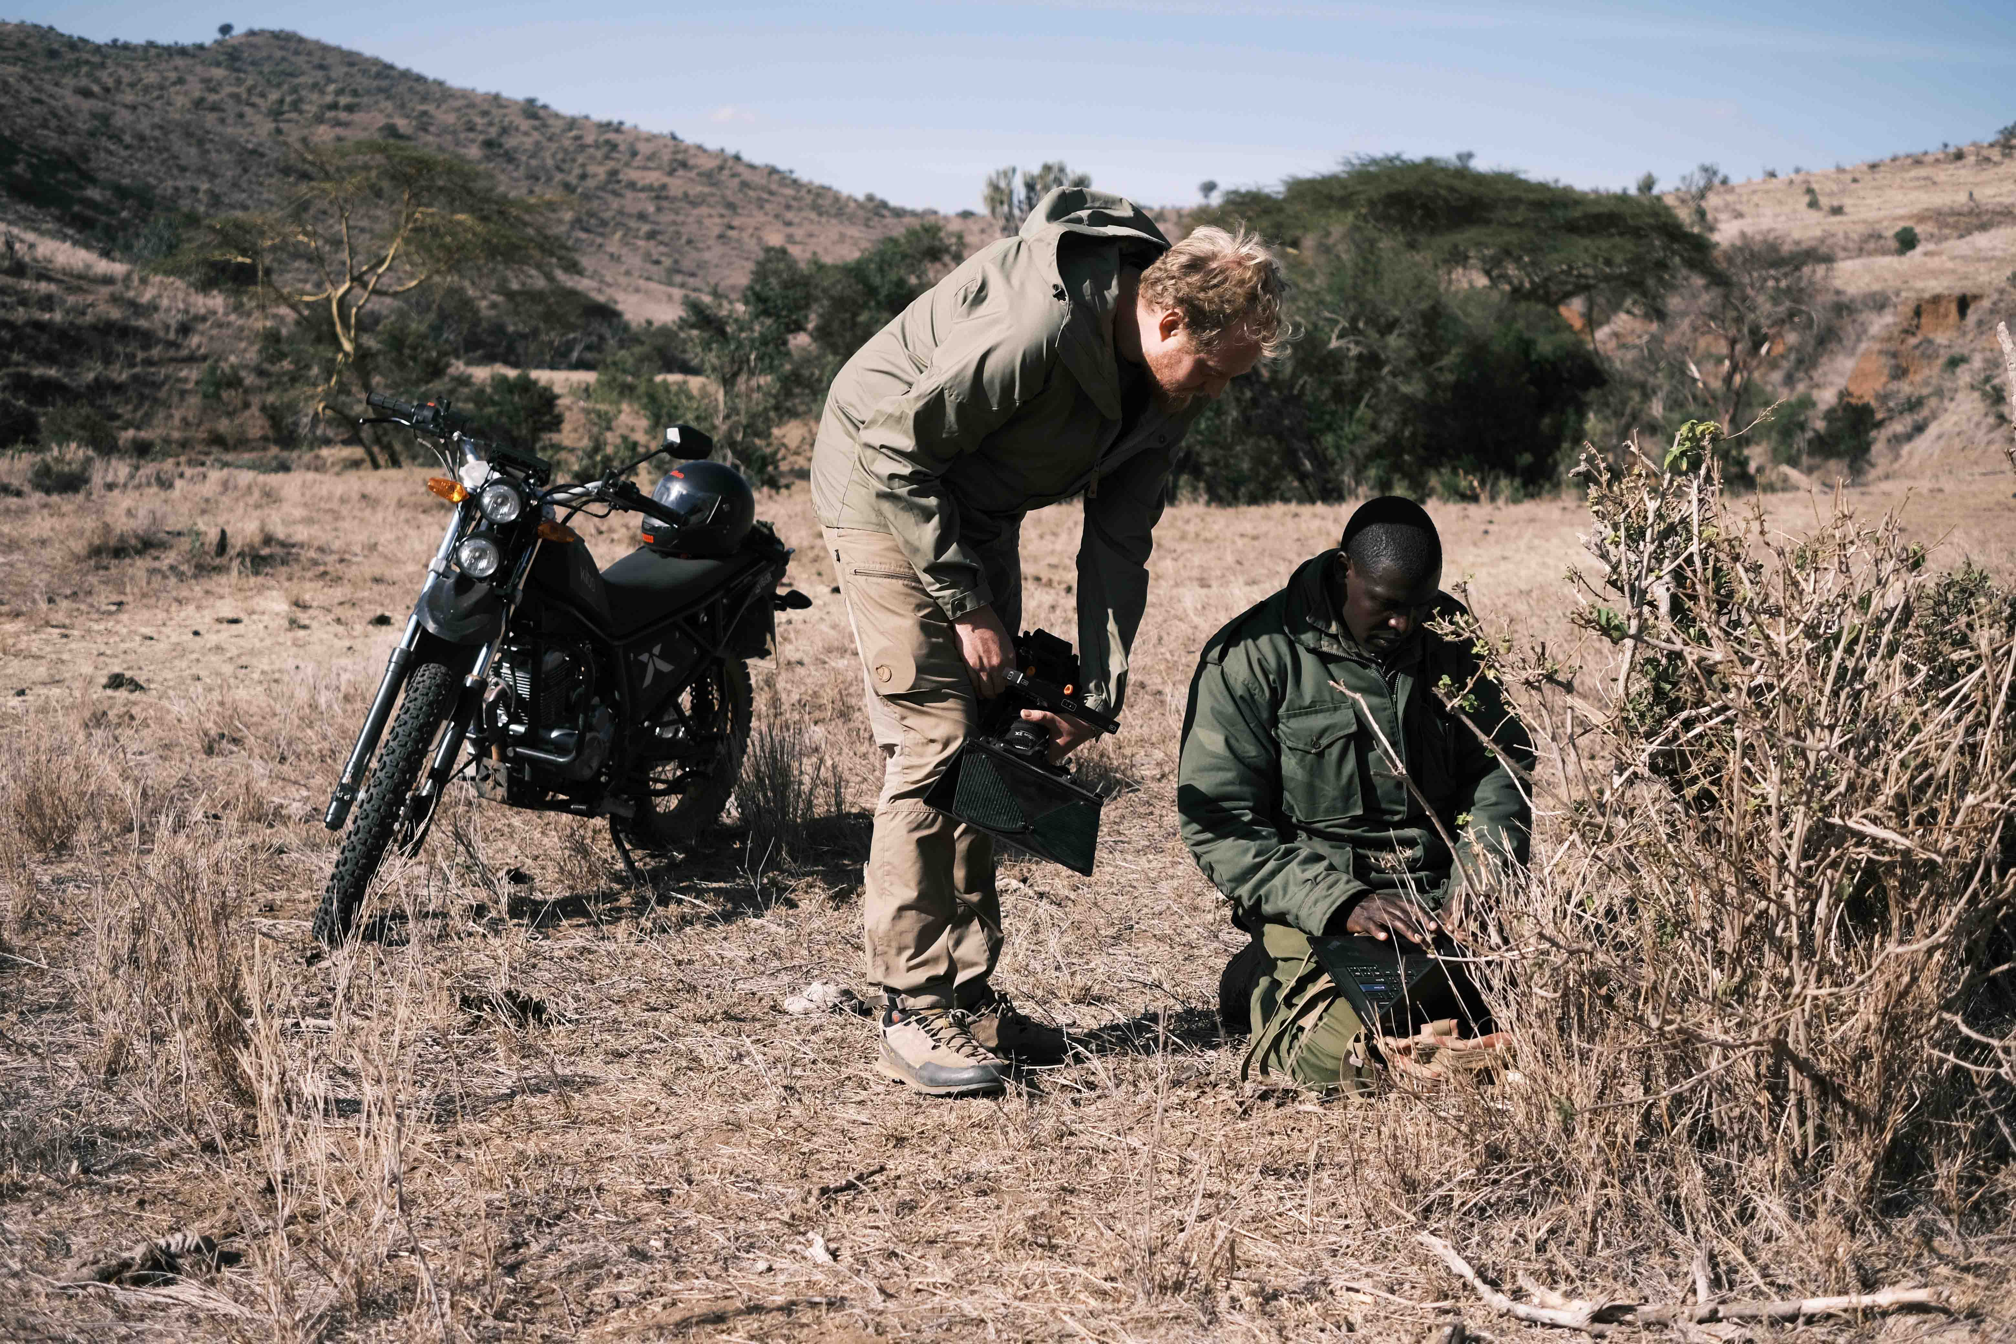 | Martienssen hopes to continue blending high-end cinematic techniques with real-world environmental stories (Photo credit: Dustoff Films)

“It was a fantastic opportunity to use the MKH series in various setups in the film and push its boundaries,” he says. “One of the biggest challenges in documentaries is getting people to connect with the characters and the environment, so they care and become fully immersed. Documentaries often struggle with introducing characters or bringing them into the story in a way that engages the audience. Anything that helps the audience feel more involved in the story is invaluable.”

“Collaborating with Dustoff Films on the Rhino documentary was an incredibly rewarding experience,” concludes Constable. “At Sennheiser, we’re always striving to push the boundaries of sound, and it was inspiring to see how our microphones helped to bring such a powerful story to life. The opportunity to equip Tom and his team with our high-end MKH series allowed them to capture the nuances of this important documentary with exceptional detail. It was a true partnership, and we’re proud to have been part of telling this crucial story of conservation and the majestic rhino.”

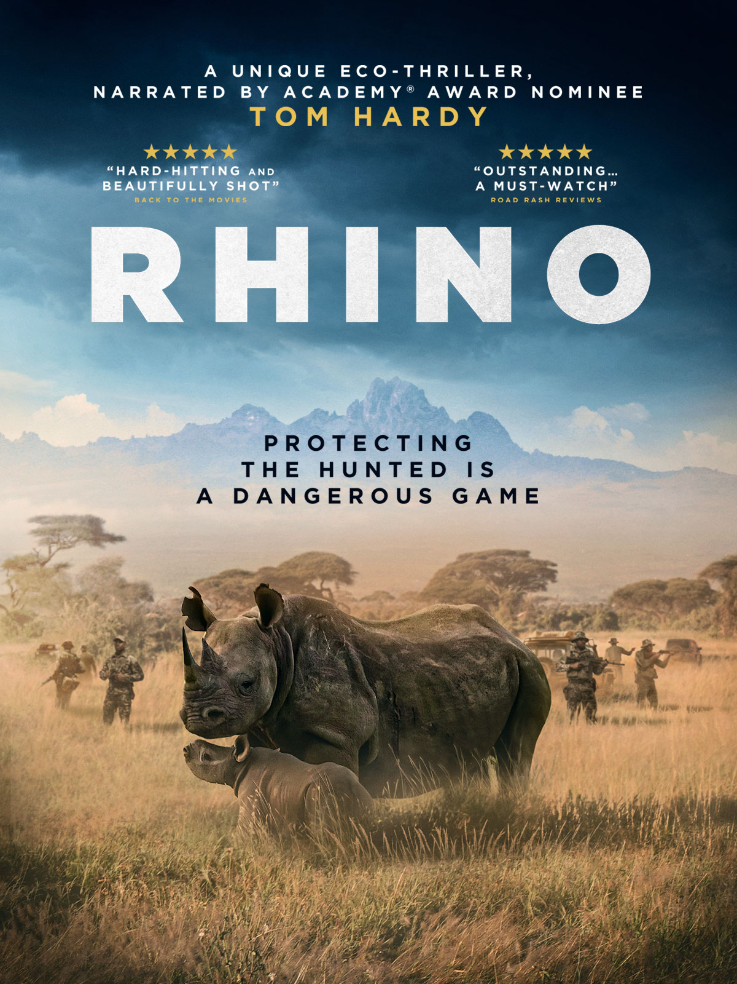 | The Rhino documentary is now screening nationwide in the UK, with plans to screen globally (Artwork courtesy of Dustoff Films)

The Rhino documentary is now screening nationwide in the UK, with plans to screen globally. With its commitment to high-quality sound, immersive storytelling, and a message of hope for endangered wildlife, the film promises to be a standout example of how sound can elevate the documentary genre.

Watch the documentary trailer here.

(Ends)

The images accompanying this media release plus additional photos can be downloaded here.

About the Sennheiser Brand – 80 Years of Building the Future of Audio
We live and breathe audio. We are driven by the passion to create audio solutions that make a difference. This passion has taken us from the world’s greatest stages to the quietest listening rooms – and made Sennheiser the name behind audio that doesn’t just sound good: It feels true. In 2025, the Sennheiser brand celebrates its 80th anniversary. Since 1945, we have stood for building the future of audio and bringing remarkable sound experiences to our customers. While professional audio solutions such as microphones, meeting solutions, streaming technologies and monitoring systems are part of the business of Sennheiser electronic SE & Co. KG, the business with consumer devices such as headphones, soundbars and speech-enhanced hearables is operated by Sonova Holding AG under the license of Sennheiser.
www.sennheiser.com
www.sennheiser-hearing.com

Global Pro Audio Press Contact
Stephanie Schmidt
stephanie.schmidt@sennheiser.com
+49 (5130) 600 – 1275

