EVOC PRODUCT HIGHLIGHT PREVIEW FALL/WINTER 2020/21:
Pathbreaking safety for freeride adventures

In the winter of 2020/2021 the EVOC LINE R.A.S. PROTECTOR premieres the combination of avalanche safety and back protection in one backpack, herby setting new standards for safety in snow sports. The versatile avalanche backpack is available as a 32- or 22-litre version.

- Mammut R.A.S. 3.0 avalanche-airbag-ready
- Protection through removable LITESHIELD level 1 back protector
- Perfect fit through bionic hip wings and AIROFLEX hip belt with “body hugging“ effect

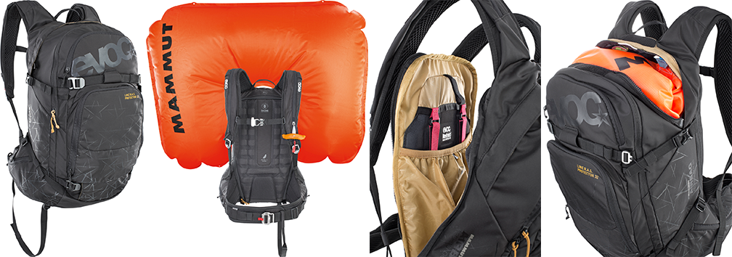
The times when optimum protection on freeride or backcountry trips meant choosing between avalanche backpack or back protector are over. As leading manufacturer of sports backpacks with protectors worldwide, EVOC is merging these features and for the winter season of 2020/2021 premiering the combination of the advantages of an avalanche airbag backpack with those of a removable back protector.

The spacious LINE R.A.S. PROTECTOR backpack with its intelligent compartment layout and integrated LITESHIELD back protector (level 1, EN 1621-2) provides spinal protection when falling in the snow. The removable, ultra-light and temperature-stable protector is situated in the fully-opening back portion of the main compartment, close to the spine and is replaced when damaged in a crash, thanks to the FREE CRASH REPLACEMENT.

In order to be optimally prepared for an avalanche, the R.A.S.-READY-compartment for the Mammut Removable Airbag System 3.0 is positioned in the upper section of the backpack. The lightweight airbag unit can easily be attached within the compartment thanks to the intuitive loop system and be removed whenever the backpack is in use off the mountains.

The best backpack is one you don’t even feel on your back. That’s why the combination of the NEUTRALITE SYSTEM with ergonomic shoulder straps and the wide AIROFLEX double hip belt provide perfect weight distribution as well as uncompromising fit coupled with a maximum of comfort. The extra-wide hip wings grow from the main volume and create the “body hugging“ effect - the backpack becomes one with the body. In addition, the intelligent ventilation channels ensure a dry back when climbing or descending.

Further convenient features:

- Height-adjustable attachment for the deployment handle
- Separate compartment with emergency plan for avalanche equipment
- Fully-opening, easily accessible main compartment
- Detachable straps to carry skis or snowboards
- Zippered pockets and carrying loops on the hip belt
- Goggle pocket with fleece lining to prevent scratches
- Pockets for mobile phones and maps
- Attachments for helmets and snowshoes
- Emergency whistle on the adjustable chest strap
- Key clip
- FREE CRASH REPLACEMENT
- Compatible with a 3-litre hydration bladder
- Aluminium safety buckles
- Leg strap

Volume, weight and sizes:

32 l, 1500 g, 29 x 55 x 22 cm
22 l, 1450 g, 29 x 55 x 19 cm
Colour: black
Material: Nylon 420/PU coated
Not included: cartridge und Removable Airbag System 3.0

Price: 270,- EUR (22l); 290,- EUR (32l)

Available from autumn 2020

Royalty free photos for download in the EVOC Press Room

Date: January 2020
Subject to changes.

Media Contact: Dani Odesser | press@evocsports.com | +49 (0)170 3131812

