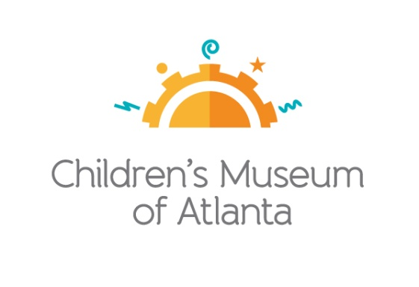

CONTACT
Becca Meyer/Jennifer Walker
BRAVE Public Relations, 404.233.3993
bmeyer@emailbrave.com/
jwalker@emailbrave.com

*MEDIA ADVISORY*
Children’s Museum of Atlanta to host first Family Free Day, February 13
Kick-off event to focus on various “maker” activities for children to learn how to design, create and build

ATLANTA (January 17, 2019) – Local families are invited to visit Children’s Museum of Atlanta free of charge during the first Family Free Day on Wednesday, February 13. Throughout the day, kids will be introduced to different “maker” activities to further develop design, creative and building skills. Made possible by the support of the PNC Foundation, The Coca-Cola Foundation and CareSource, the three sessions will also offer the chance for kids to explore the Museum’s six permanent, interactive exhibits as well as the new feature exhibit Run! Jump! Fly! Adventures in Action™.

To guarantee entrance, families must pre-register online, beginning at 7 a.m. on Tuesday, February 12 for Session One, Two or Three. Families may not register for multiple sessions.

WHAT: Family Free Days
Guests are invited to enjoy a maker-themed, admission-free visit to the only education venue of its kind in Atlanta

WHEN: Wednesday, February 13
Session One: 10 a.m.-12:30 p.m.
Session Two: 1 p.m.-3:30 p.m.
Session Three: 4 p.m.-6:30 p.m.

WHERE: Children’s Museum of Atlanta
275 Centennial Olympic Park Drive, NW
Atlanta, GA 30313

HOW: For more information or to register, visit childrensmuseumatlanta.org/familyfreeday.

For more information or to support Children's Museum of Atlanta, visit childrensmuseumatlanta.org
or call 404.659.KIDS [5437]

###

