**Media release**

**22 June 2016**

**Global household appliance manufacturer launches vacuum designed to speed up the clean up**

**-Vorwerk launches Kobold VK200 to help pet owners cut down on cleaning time-**

One of the world’s leading household appliance developers has launched a new vacuum cleaner designed specifically to help pet owners save time and clean up more effectively after their animals.

Vorwerk, the German brand behind other cult household gadgets including the Thermomix cooker/blender, has unveiled its new Kobold VK200 – a multi-functional upright vacuum cleaner that features a host of clever interchangeable attachments to quicken the cleaning regimes of pet owners across the country.

***Multi-functional attachments to make pet clean up easy***

The vacuum – which has taken over eight years to design at the company’s German headquarters –is based around a modular, upright cleaning system that can be adapted using up to six attachments to tackle the different mess left behind by the nation’s furry friends.

Handy features that pet owners will love include a clever, multi-purpose mop and vacuum head known as the SP530 DuoClean, that’s designed to suck up dry mud whilst washing the floor at the same time; a combination that is ideal for removing muddy paw prints and walking boot marks left after walking the dog.

Pet hair residue is also covered, and the Kobold VK200 uses a handy electric upholstery brush that makes a doddle out of removing malted fur from soft furnishings thanks to a brush that rotates over 4,000 times a minute to loosen the hair and then suck it away.

***Say goodbye to allergens from pets***

And for pet owners who suffer from animal allergies, the new VK200 also captures an impressive 99.99% of allergy causing substances in its premium three-in-one filter bag, meaning that they are trapped inside and not left lingering in the air. And for additional peace of mind, the vacuum is also accredited as suitable for allergy sufferers’ accreditation from its native German TUV Standards Company.

Other handy design features include an automatic, electric cleaning brush known as the EB400 that adjusts suction levels automatically when the VK200 moves from carpet to hard flooring, and an MR440 mattress vacuumer that works with a specially designed mattress freshening powder to deep clean mattress fibres and remove years’ worth of dirt.

Rather than requiring hours of assembly for each cleaning task, the Kobold VK200 takes just a few seconds to switch between each of the cleaning attachments, and weighing in at just over 3kg is extremely easy to manoeuvre – with a more than sufficient 700W of power that stops automatically when the system is in the park position.

Dr Thomas Rodemann, Chief Executive at Vorwerk Elektrowerke said:

“In our 24/7 society, people still want a clean home but it needs to be quick and easy for them – and that’s what the Kobold VK200 represents.

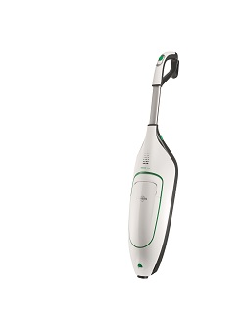“Our biggest design challenge was combining our high technical standards regarding performance, quality and energy efficiency with a design that customers would love. We want people to immediately recognise that the Kobold VK200 is a powerful, high performance appliance but one that is easy and convenient for them to use.”

**-ENDS-**

**The ‘tech spec’**

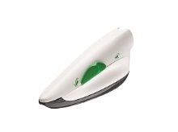

**Kobold VK200 body** – the main component of the upright system uses a series of optional attachments to deliver outstanding cleaning results across a range of surfaces.

**Kobold PB440 Electric Upholstery Brush –** the classic choice for cleaning upholstery with a highly effective approach that brushes and vacuums at the same time down to the very last fibre.

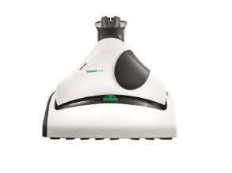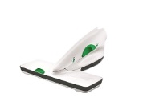

**Kobold SP530** **DuoClean –** the hard floor cleaner uses just 100 millilitres of water to pick up debris and then mop up to 20 square metres of hard floor.

**Kobold MR440 Mattress vacuum** – perfect for deep-cleaning mattresses with a cleaning agent and brush which effectively ‘beats’ the mattress and immediately picks up the dirt.

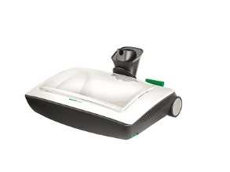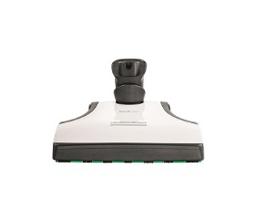

**Kobold VF200 Carpet Freshener** – a dual-action attachment which automatically sprinkles Kobosan Cleaning Agent and then works it into the carpet brushes the surface clean.

**Kobold EB400 Automatic Electric Brush** – including automatic floor detection which scans the floor 16 times per second to identify the surface and ensure each gets the right treatment.

**-ENDS-**

**For more information about the Vorwerk Kobold VK200 vacuum cleaner, go to** [**https://kobold.vorwerk.co.uk/home/**](https://kobold.vorwerk.co.uk/home/)

**To download this press release, go to** [**https://vorwerk-uk.prezly.com/**](https://vorwerk-uk.prezly.com/)

**To download hi-res images, go to** [**https://vorwerk-uk.prezly.com/media**](https://vorwerk-uk.prezly.com/media)

**For media enquiries or interviews with the Vorwerk UK team, please email** [**alex@faith-pr.co.uk/stefanie@faith-pr.co.uk**](mailto:alex@faith-pr.co.uk/stefanie@faith-pr.co.uk) **or call 01484 599 886**

**Follow Vorwerk UK on Twitter:** [**@VorwerkUK**](https://twitter.com/vorwerkuk)

**Find Vorwerk UK on Facebook:** [**Vorwerk UK**](https://www.facebook.com/KoboldVorwerkUK/)

**Cont.**

**Purchasing information**

**The Vorwerk VK200 can be purchased via an in-home demonstration booked online** [**here**](https://kobold.vorwerk.co.uk/demonstration/request-a-demonstration/?no_cache=1)**.**

**The Vorwerk VK200 ranges in price from £749 - £1,499 depending on specification, see below:**

**Specification and pricing information**

**Package One - £749**

* **Upright vacuum cleaner with EB400 Automatic Electric Brush**

**Package Two - £849**

* **Upright vacuum cleaner with EB400 Automatic Electric Brush & accessory pack including:**
* **Crevice nozzle set**
* **Flexo-nozzle**
* **Telescopic tube**
* **Soft nozzle**

**Package Three - £1,049**

* **The Standard Hard Floor System including:**
* **Upright vacuum cleaner with EB400 Automatic Electric Brush**
* **Accessory pack**
* **SP530 DuoClean**
* **PB440 Electric Upholstery Brush**
* **MR440 mattress vaccum**
* **Deep cleaning mattress attachment**

**Package Four - £1,199**

* **The Standard Carpet System including:**
* **Upright vacuum cleaner with EB400 Automatic Electric Brush**
* **Accessory pack**
* **PB440 Electric Upholstery Brush**
* **MR440 mattress vacuum**
* **Deep cleaning mattress attachment**
* **VF200 carpet freshener**

**Package Five - £1,499**

* **The Standard Carpet System including:**
* **Upright vacuum cleaner with EB400 Automatic Electric Brush**
* **Accessory pack**
* **SP530 DuoClean**
* **PB440 Electric Upholstery Brush**
* **MR440 mattress vacuum**
* **Deep cleaning mattress attachment**
* **VF200 carpet freshener**
* **SP530 DuoClean**

**The history of Vorwerk**

Vorwerk & Co. KG was founded in Wuppertal in 1883. During the course of its 130-year history, the company, originally a carpet factory, has grown into a highly diversified, global corporate group. Vorwerk nevertheless remains a family enterprise to this day.

Since 1930, Vorwerk’s core business has been the direct selling of high-quality products. The Vorwerk product range includes household appliances (the Kobold vacuum cleaner and the Thermomix kitchen appliance) and the first-class JAFRA cosmetics. The akf banking group, the Vorwerk carpet factories and the HECTAS Group as an associate company all belong to the Vorwerk entrepreneurial family. Superior products and a special customer approach are something all divisions have in common, and what makes Vorwerk so special.

Vorwerk provides jobs for 622,000 people worldwide, of whom 40,000 work as sales advisers and representatives in the household appliances segment, 570,000 as JAFRA Cosmetics consultants, and 12,545 as employees. Vorwerk generated a business volume totaling more than 3,1 billion euros in 2013 and operates in 70 countries.

Vorwerk products have been available in the UK market during the last 30 years.